|  |  |
| --- | --- |
| Sentara Healthcare. | |
| EIC Implementation | |
|  |  |
| Version Number: 0.1 |  |
|  |  |
| Date: December 28, 2023 |  |
|  |  |
| The information transmitted in this document is intended only for the addressee and may contain confidential and/or privileged material. Any interception, review, retransmission, dissemination, or other use of or taking of any action upon this information by persons or entities other than the intended recipient is prohibited by law and may subject them to criminal or civil liability. | |
|  | |

Table of Contents

Executive Summary 6

Objectives 6

Phases 6

Environment Overview 7

Sentara Environment Details 7

Connections 8

Workday All Users Import 8

Connection Details 8

IMPORTUSERJSON 8

MODIFYUSERDATAJSON 10

Workday NewHire Import 15

Connection details 15

IMPORTUSERJSON 15

MODIFYUSERDATAJSON 17

Workday_Rescind Connection 22

Connection details 22

IMPORTUSERJSON 22

MODIFYUSERDATAJSON 24

Workday User Update Connection 27

Connection Details 28

UPDATEUSERJSON 28

Workday User update on Termination 31

Connection Details 31

UPDATEUSERJSON 31

Active Directory Connection 32

Connection Details 32

ACCOUNT_ATTRIBUTE 34

CREATEACCOUNTJSON 35

UPDATEACCOUNTJSON 37

ENABLEACCOUNTJSON 38

ACCOUNTNAMERULE 39

REMOVEACCOUNTJSON 39

groupimportMapping 39

STATUS_THRESHOLD_CONFIG 40

DISABLEACCOUNTJSON 40

Active Directory O365 Sync Connection 41

Connection Details 41

ACCOUNT_ATTRIBUTE 42

STATUS_THRESHOLD_CONFIG 43

AD GRAVEYARD OU Connection 44

Connection Details 44

ACCOUNT_ATTRIBUTE 45

STATUS_THRESHOLD_CONFIG 46

Azure O365 Update Connection 47

Connection Details 47

DISABLEACCOUNTJSON 47

REMOVEACCOUNTJSON 48

DUO Connection 49

Connection Details 49

ACCOUNT_FIELD_MAPPING_JSON 50

DUO Provisioning Connection 51

Connection Details 51

IMPORTACCTENTJSON 51

UPDATEACCTJSON 54

ENABLEACCOUNTJSON 55

DISABLEACCOUNTJSON 55

ADDACCESSJSON 55

REMOVEACCESSJSON 56

MicrosoftGraph_RevokeSession Connection 57

Connection Details 57

UPDATEACCOUNTJSON 57

DISABLEACCOUNTJSON 58

ServiceNow Connection 59

Connection Details 59

IMPORTACCOUNTENTJSON 59

STATUS_THRESHOLD_CONFIG 61

CREATEACCOUNTJSON 61

UPDATEACCOUNTJSON 62

ENABLEACCOUNTJSON 63

DISABLEACCOUNTJSON 65

REMOVEACCOUNTJSON 65

Saviynt Connection 66

Connection Details 66

UPDATEUSERJSON 66

PSDB Provisioning Connection 67

Connection Details 67

UPDATEACCOUNTJSON 68

ADDACCESSJSON 70

REMOVEACCESSJSON 72

PSDB_Recon Connection 74

Connection Details 74

ACCOUNTSIMPORT 75

Security Systems 77

Active Directory System 77

Configuration Details 77

AD graveyard OU Security System 77

Configuration Details 77

Azure O365 Revoke Session Security System 78

Configuration Details 78

DUO Security System 79

Configuration Details 79

Privileged Application Security System 79

Configuration details 79

PSDB Security System 80

Configuration Details 80

Saviynt Security System 81

Configuration details 81

SaviyntForSaviynt Security System 82

Configuration details 82

ServiceNow Security System 82

Configuration Details 82

Endpoints 84

Active Directory Endpoint 84

Endpoint Details 84

AD GRAVEYARD OU Endpoint 86

Endpoint Details 86

Azure O365 Revoke Session Endpoint 88

Endpoint Details 88

DUO Endpoint 89

Endpoint Details 89

PSDB Endpoint 91

Endpoint Details 91

ServiceNow Endpoint 93

Endpoint details 93

Saviynt Endpoint 95

Endpoint Details 95

Technical Rules 97

Birthrights 97

TR: ENTRole_Credentialed Hospital Physician 97

TR: ENTRole_EVMS Resident Student 97

TR: ENTRole_Group Contact 98

TR: ENTRole_OHP Physician Office staff 98

TR: ENTRole_Ambulatory Scribe 99

TR: ENTRole_In Patient Scribe 99

TR: ENTRole_ED Scribe 99

TR: ENTRole_Research Monitor 100

TR: ENTRole_OHW Physician 100

TR: ENTRole_Employee 100

TR: ENTRole_NonEmployee 101

TR: ENTRole_Credentialed Amb Physician 101

TR: ENTRole_OHP Broker 102

TR: ENTRole_VAP Broker 102

TR: ENTRole_Benefits Administrators 103

TR: ENTRole_Community_Physician 103

TR: ENTRole_ Community_Clinical staff 104

TR: Assign PSDB Ent Employee 104

TR: Assign PSDB Ent NonEmployee 105

TR: Assign PSDB Physician 105

TR: ENTRole_Community Connect Scribes 106

TR: Birthright Access to Duo_PSDB 106

TR: Assign E3 License 107

TR: Assign E5 License 107

TR: Assign E5 License 108

TR: Birthright Access to SNOW 108

TR: Assign TEGS AD group 109

TR: ENTRole_Community Connect Staff 109

TR: ENTRole_Community Connect Physicians 110

TR: ENTRole_Community Staff 110

TR: ENTRole_EVMS 1st-2nd Yr Medical Student 111

TR: ENTRole_EVMS 3rd-4th Yr Medical Student 111

TR: Assign PSDB Physician Office Staff 112

TR: ENTRole_EVMS NP/PA Student 112

User Update Rules 113

UR: AD Update Account - API 113

UR : AD Update Account – Import 115

UR: DUO Update Account – API 117

UR: DUO Update Account – Import 118

UR: Emergency Suspension 119

UR: PSDB Update Account - API 120

UR:PSDB Update Account – Import 121

UR: Rehire After 30 Days – API 122

UR: Rehire After 30 Days – Import 123

UR: Rehire Within 30 Days – API 124

UR: Rehire Within 30 Days – Import 125

UR: Rehire Workday Update – API 126

UR: Rehire Workday Update – Import 127

UR: Retrigger Technical Rules for Persona – API 128

UR: Retrigger Technical Rules for Persona – Import 129

UR: Retrigger Technical Rules on HIRED – API 130

UR: Retrigger Technical Rules on HIRED – Import 131

UR: Retrigger Technical Rules on PREHIRE – API 132

UR: Retrigger Technical Rules on PREHIRE – Import 133

UR: Revoke_Suspension_ByAdmin 134

UR: ServiceNow Update Account – API 135

UR: ServiceNow Update Account – Import 137

UR: Suspension_By_Admin 139

UR: Termination – API 140

UR: Termination – Import 141

UR: Termination Workday Write Back – API 142

UR: Termination Workday Write Back – Import 143

UR: Workday Attribute Writeback for PREHIRE – API 144

UR: Workday Attribute Writeback for PREHIRE – Import 145

UR: Termination Cost Center – Import 146

UR: Termination Cost Center- API 147

Admin Configuration 148

SAV ROLES 148

ROLE_ENDUSER 150

Steps to Add Users to SAV Role 153

JobControl Panel 154

Scheduled Jobs 154

Global Configurations 157

Tasks 157

Rules 157

SMTP Email Configuration 159

Workflows 160

Auto Approval Workflow 160

Manager Approval Workflow 160

User Interface Branding 162

Email Templates 163

Steps to Configure Email Templates in SSM 163

List of Email Templates Configured 163

Account Claiming Email 165

Account Claiming Mail – Rehire 166

Account Password Expiry Email 166

AccountClaimingPreview 167

User termination email sent to the user manager 167

Analytics 168

Actionable Analytics - Create Deprovision Tasks on Graveyarding 168

Workday_Extended_Learner_Report 169

Transfers 170

Add SAV_ROLE to users 178

Use Cases – High level Flow 181

Create User – Workday 181

Update User : Workday 181

Terminate User : Workday 181

Create User : Seczetta 181

Update User : Seczetta 182

Terminate User : Seczetta 182

Rehire Scenario < 30 days : Workday 182

Rehire Scenario < 30 days : SecZetta 182

Rehire Scenario > 30 days : Workday 182

Rehire Scenario > 30 days : SecZetta 182

Hybrid Use Case : Workday user becomes Hybrid user ( with SecZetta Attributes) 183

Emergency Suspension 183

Revoke Emergency Suspension 183

General 184

Copyright 184

Version Control 184

Document Acknowledgement 185

# Executive Summary

Sentara Healthcare engaged Saviynt to implement Saviynt IGA as its comprehensive Identity Governance and Administration (“IGA”) solution that addresses its business and compliance needs around lifecycle management of healthcare workers and contractors.

## Objectives

The high-level objectives for this engagement were to:

* Configure Saviynt environments.
* Integrate with identity sources and target applications.

## Phases

The phases of this engagement included:

* Planning and Analysis
* Environment Configuration
* Implementation
* Migration to Production
* Deliverables

# Environment Overview

## Sentara Enviro**nment Details**

| Access Environment | URL |
| --- | --- |
| PROD | <https://sentara.saviyntcloud.com/ECM/login/auth> |
| DEV | <https://sentara-dev.saviyntcloud.com/ECM/login/auth> |
| UAT | https://sentara-test.saviyntcloud.com/ECM/login/auth |

# Connections

## Workday All Users Import

### Connection Details

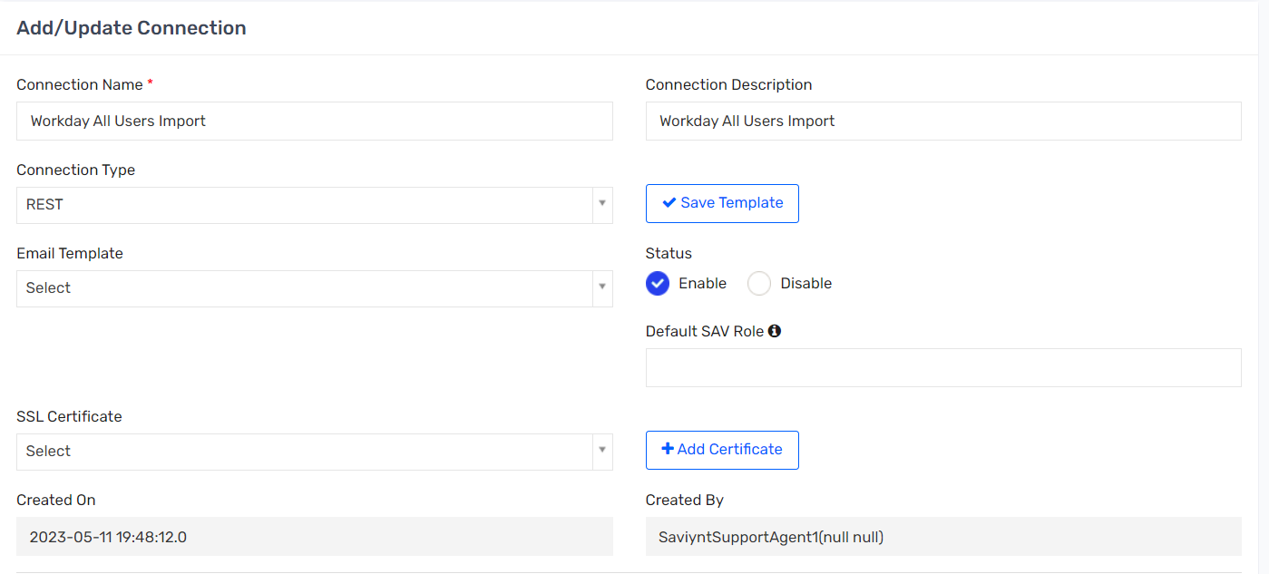

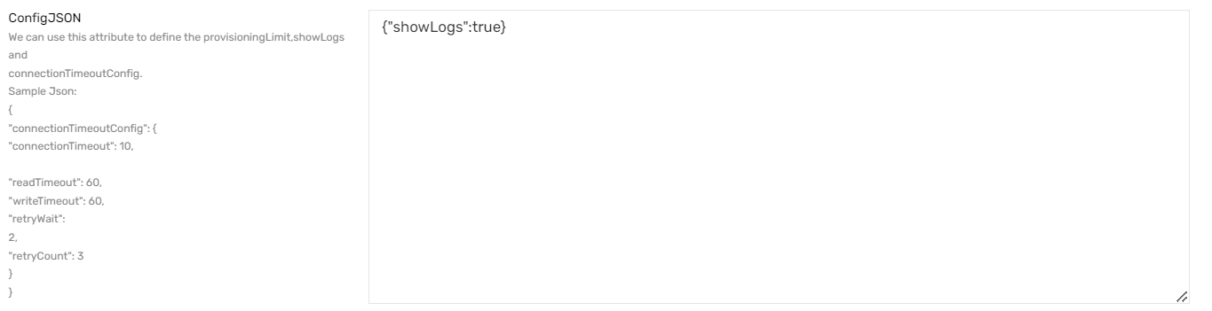

### IMPORTUSERJSON

|  |
| --- |
| {  "connection": "userAuth",  "url":"https://wd2-impl-services1.workday.com/ccx/service/customreport2/sentara1/ISU%20-%20INT0078A/INT0078A_-_Worker_Data_to_Saviynt_for_RAAS_Reconciliation?format=json",  "httpMethod": "GET",  "httpHeaders": {  "contentType": "application/json",  "Authorization": "${access_token}"},  "colsToPropsMap": {  "USERNAME": "username~#~string",  "EMPLOYEEID": "employeeid~#~string",  "EMPLOYEETYPE": "employeeType~#~string",  "FIRSTNAME": "firstname~#~string",  "LASTNAME": "lastname~#~string",  "MIDDLENAME": "middlename~#~string",  "PREFEREDFIRSTNAME": "preferedFirstName~#~string",  "DEPARTMENTNAME": "departmentname~#~string",  "PHONENUMBER": "phonenumber~#~string",  "JOBCODE": "jobCode~#~string",  "TITLE": "title~#~string",  "COMPANYNAME": "companyname~#~string",  "COSTCENTER": "costcenter~#~string",  "LOCATION": "location~#~string",  "LOCATIONNUMBER": "locationnumber~#~string",  "LOCATIONDESC": "locationdesc~#~string",  "MANAGER": "manager~#~String",  "SECONDARYEMAIL": "secondaryEmail~#~string",  "CITY": "city~#~string",  "STATE": "state~#~string",  "REGIONCODE": "regioncode~#~string",  "COUNTRY": "country~#~string",  "startdate": "startdate~#~string",  "termdate": "termdate~#~string",  "CUSTOMPROPERTY2": "customproperty2~#~string",  "CUSTOMPROPERTY4": "customproperty4~#~string",  "CUSTOMPROPERTY5": "#CONST#Workday~#~String",  "EMPLOYEECLASS": "#CONST#No~#~String",  "CUSTOMPROPERTY6": "customproperty6~#~string",  "CUSTOMPROPERTY7": "customproperty7~#~string",  "CUSTOMPROPERTY8": "customproperty8~#~string",  "CUSTOMPROPERTY9": "customproperty9~#~string",  "CUSTOMPROPERTY10": "customproperty10~#~string",  "CUSTOMPROPERTY11": "customproperty11~#~string",  "CUSTOMPROPERTY12": "customproperty12~#~string",  "CUSTOMPROPERTY13": "customproperty13~#~string",  "CUSTOMPROPERTY14": "customproperty14~#~string",  "CUSTOMPROPERTY15": "customproperty15~#~string",  "CUSTOMPROPERTY16": "customproperty16~#~string",  "CUSTOMPROPERTY17": "customproperty17~#~string",  "CUSTOMPROPERTY18": "customproperty18~#~string",  "CUSTOMPROPERTY19": "customproperty19~#~string",  "CUSTOMPROPERTY21": "customproperty21~#~string",  "CUSTOMPROPERTY22": "customproperty22~#~string",  "CUSTOMPROPERTY23": "customproperty23~#~string",  "CUSTOMPROPERTY24": "customproperty24~#~string",  "CUSTOMPROPERTY26": "customproperty26~#~string",  "CUSTOMPROPERTY27": "customproperty27~#~string",  "CUSTOMPROPERTY28": "customproperty28~#~string",  "CUSTOMPROPERTY29": "customproperty29~#~string",  "CUSTOMPROPERTY30": "customproperty30~#~string",  "CUSTOMPROPERTY31": "customproperty31~#~string",  "CUSTOMPROPERTY37": "customproperty37~#~string",  "CUSTOMPROPERTY38": "customproperty38~#~string",  "CUSTOMPROPERTY39": "customproperty39~#~string",  "CUSTOMPROPERTY40": "customproperty40~#~string",  "CUSTOMPROPERTY41": "customproperty41~#~string",  "CUSTOMPROPERTY42": "customproperty42~#~string",  "CUSTOMPROPERTY43": "customproperty43~#~string",  "CUSTOMPROPERTY44": "customproperty44~#~string",  "CUSTOMPROPERTY45": "customproperty45~#~string",  "CUSTOMPROPERTY46": "customproperty46~#~string",  "CUSTOMPROPERTY47": "customproperty47~#~string",  "CUSTOMPROPERTY48": "customproperty48~#~string",  "CUSTOMPROPERTY49": "customproperty49~#~string",  "CUSTOMPROPERTY50": "customproperty50~#~string",  "CUSTOMPROPERTY58": "customproperty58~#~string"  },  "userResponsePath": "Report_Entry"  } |

### MODIFYUSERDATAJSON

|  |
| --- |
| {  "ADDITIONALTABLES": {  "USERS": "SELECT USERNAME, SYSTEMUSERNAME,EMPLOYEECLASS,CUSTOMPROPERTY7,CUSTOMPROPERTY8,CUSTOMPROPERTY9,CUSTOMPROPERTY10,CUSTOMPROPERTY11,CUSTOMPROPERTY15,CUSTOMPROPERTY17,CUSTOMPROPERTY51, CUSTOMPROPERTY59, EMAIL,CUSTOMPROPERTY5,SECONDARYEMAIL, STATUSKEY, ENDDATE, FIRSTNAME, LASTNAME, CUSTOMPROPERTY58,PREFEREDFIRSTNAME,CUSTOMPROPERTY12,TERMDATE,EMPLOYEEID,EMPLOYEETYPE,DEPARTMENTNAME,JOBCODE,COMPANYNAME,COSTCENTER,LOCATION,LOCATIONNUMBER,LOCATIONDESC,COUNTRY,CUSTOMPROPERTY4,CUSTOMPROPERTY16,CUSTOMPROPERTY18,CUSTOMPROPERTY19,CUSTOMPROPERTY21,CUSTOMPROPERTY22,CUSTOMPROPERTY23,CUSTOMPROPERTY26,CUSTOMPROPERTY27,CUSTOMPROPERTY28,CUSTOMPROPERTY29,CUSTOMPROPERTY30,CUSTOMPROPERTY31,CUSTOMPROPERTY39,CUSTOMPROPERTY40,CUSTOMPROPERTY41,CUSTOMPROPERTY42,CUSTOMPROPERTY43,CUSTOMPROPERTY45,CUSTOMPROPERTY46,CUSTOMPROPERTY47,CUSTOMPROPERTY48,CUSTOMPROPERTY49,CUSTOMPROPERTY50 FROM USERS",  "ACCOUNTS": "SELECT NAME,CUSTOMPROPERTY31, ENDPOINTKEY FROM ACCOUNTS WHERE ENDPOINTKEY IN (2,3)"  },  "COMPUTEDCOLUMNS": [  "SYSTEMUSERNAME",  "CUSTOMPROPERTY25",  "CUSTOMPROPERTY59",  "CUSTOMPROPERTY51",  "EMAIL",  "MANAGER",  "TERMDATE",  "STATUSKEY",  "CUSTOMPROPERTY5",  "EMPLOYEECLASS",  "EMPLOYEEID",  "EMPLOYEETYPE",  "DEPARTMENTNAME",  "JOBCODE",  "COMPANYNAME",  "COSTCENTER",  "LOCATION",  "LOCATIONNUMBER",  "LOCATIONDESC",  "COUNTRY",  "CUSTOMPROPERTY4",  "CUSTOMPROPERTY7",  "CUSTOMPROPERTY8",  "CUSTOMPROPERTY9",  "CUSTOMPROPERTY10",  "CUSTOMPROPERTY11",  "CUSTOMPROPERTY15",  "CUSTOMPROPERTY16",  "CUSTOMPROPERTY17",  "CUSTOMPROPERTY18",  "CUSTOMPROPERTY19",  "CUSTOMPROPERTY21",  "CUSTOMPROPERTY22",  "CUSTOMPROPERTY23",  "CUSTOMPROPERTY26",  "CUSTOMPROPERTY27",  "CUSTOMPROPERTY28",  "CUSTOMPROPERTY29",  "CUSTOMPROPERTY30",  "CUSTOMPROPERTY31",  "CUSTOMPROPERTY39",  "CUSTOMPROPERTY40",  "CUSTOMPROPERTY41",  "CUSTOMPROPERTY42",  "CUSTOMPROPERTY43",  "CUSTOMPROPERTY45",  "CUSTOMPROPERTY46",  "CUSTOMPROPERTY47",  "CUSTOMPROPERTY48",  "CUSTOMPROPERTY49",  "CUSTOMPROPERTY50",  "CUSTOMPROPERTY58"  ],  "TABLEINDEXES": {  "CURRENTUSERS": [  "username"  ],  "NEWUSERDATA": [  "username"  ],  "CURRENTACCOUNTS": [  "name"  ]  },  "PREPROCESSQUERIES": [  "UPDATE NEWUSERDATA as NU SET NU.customproperty25 = case when STR_TO_DATE(NU.startdate, '%m-%d-%Y') between date(DATE_ADD(curdate(), INTERVAL 1 DAY)) and date(DATE_ADD(curdate(), INTERVAL 7 DAY)) then 'PREHIRE' when STR_TO_DATE(NU.startdate, '%m-%d-%Y') > date(DATE_ADD(curdate(), INTERVAL 7 DAY)) then 'FUTUREHIRE' else 'HIRED' end",  "UPDATE NEWUSERDATA LEFT JOIN CURRENTUSERS ON NEWUSERDATA.USERNAME = CURRENTUSERS.USERNAME SET NEWUSERDATA.statuskey=case when NEWUSERDATA.CUSTOMPROPERTY24='A' then 1 else 0 end",  "UPDATE NEWUSERDATA LEFT JOIN CURRENTUSERS ON NEWUSERDATA.USERNAME = CURRENTUSERS.USERNAME SET NEWUSERDATA.CUSTOMPROPERTY51 = CASE WHEN (((NEWUSERDATA.CUSTOMPROPERTY15 = 'CM101' AND NEWUSERDATA.CUSTOMPROPERTY17 = 'RD1004' AND NEWUSERDATA.COSTCENTER = 'CC27091004' AND NEWUSERDATA.EMPLOYEETYPE LIKE '%EMP%') OR (NEWUSERDATA.CUSTOMPROPERTY15 = 'CM117' AND NEWUSERDATA.CUSTOMPROPERTY17 = 'RD1004' AND NEWUSERDATA.COSTCENTER = 'CC27091004' AND NEWUSERDATA.EMPLOYEETYPE LIKE '%EMP%')) AND NEWUSERDATA.STATUSKEY = 1 AND NEWUSERDATA.CUSTOMPROPERTY25 IN ('HIRED' , 'PREHIRE')) THEN 'E5' WHEN (((NEWUSERDATA.CUSTOMPROPERTY8 IN ('Senior Leadership Team' , 'Executive Leadership Team', 'Business Professional', 'Manager', 'Director', 'Supervisor', 'Sr Clerical & Admin', 'Non-Medical Technician', 'Skilled Craft Worker', 'Non-Medical Service Worker', 'Sales Worker', 'CRNA')) OR (NEWUSERDATA.CUSTOMPROPERTY8 = 'Registered Nurse' AND NEWUSERDATA.CUSTOMPROPERTY11 IN( '101040','101041')) OR (NEWUSERDATA.CUSTOMPROPERTY8 = 'Advanced Practice Provider' AND (NEWUSERDATA.CUSTOMPROPERTY10 = 'Band 5 Leader' OR NEWUSERDATA.CUSTOMPROPERTY10 like 'Band 6%' OR NEWUSERDATA.CUSTOMPROPERTY10 like 'Band 7%' )) OR (NEWUSERDATA.CUSTOMPROPERTY8 = 'Chaplain' AND NEWUSERDATA.CUSTOMPROPERTY10 not like 'Band 1%' ) OR (NEWUSERDATA.CUSTOMPROPERTY8 = 'Allied Health Professional' AND NEWUSERDATA.CUSTOMPROPERTY9 IN ('Clinical Nursing' , 'Health Plan', 'Corporate')) OR (NEWUSERDATA.CUSTOMPROPERTY8 = 'Clerical-Business Support' AND (NEWUSERDATA.CUSTOMPROPERTY7 NOT LIKE '%Student%' OR NEWUSERDATA.CUSTOMPROPERTY11 != '102350')) OR (NEWUSERDATA.CUSTOMPROPERTY8 = 'Clerical-Patient Support' AND (NEWUSERDATA.CUSTOMPROPERTY7 NOT IN ('Student' , 'Intern', 'Scheduling Coordinator', 'Business Support') OR NEWUSERDATA.CUSTOMPROPERTY9 IN ('Corporate' , 'Health Plan')))) AND NEWUSERDATA.STATUSKEY = 1 AND NEWUSERDATA.CUSTOMPROPERTY25 IN ('HIRED' , 'PREHIRE')) THEN 'E3' WHEN (NEWUSERDATA.STATUSKEY = 0) THEN '' ELSE 'F3' END",  "UPDATE NEWUSERDATA INNER JOIN CURRENTUSERS ON NEWUSERDATA.USERNAME = CURRENTUSERS.USERNAME SET NEWUSERDATA.STATUSKEY=1, NEWUSERDATA.CUSTOMPROPERTY5='SecZetta',NEWUSERDATA.EMPLOYEETYPE=NULL,NEWUSERDATA.DEPARTMENTNAME=NULL,NEWUSERDATA.JOBCODE=NULL,NEWUSERDATA.COMPANYNAME=NULL,NEWUSERDATA.COSTCENTER=NULL,NEWUSERDATA.LOCATION=NULL,NEWUSERDATA.LOCATIONNUMBER=NULL,NEWUSERDATA.LOCATIONDESC=NULL,NEWUSERDATA.COUNTRY=NULL,NEWUSERDATA.CUSTOMPROPERTY4=NULL,NEWUSERDATA.CUSTOMPROPERTY7=NULL,NEWUSERDATA.CUSTOMPROPERTY8=NULL,NEWUSERDATA.CUSTOMPROPERTY9=NULL,NEWUSERDATA.CUSTOMPROPERTY10=NULL,NEWUSERDATA.CUSTOMPROPERTY11=NULL,NEWUSERDATA.CUSTOMPROPERTY15=NULL,NEWUSERDATA.CUSTOMPROPERTY16=NULL,NEWUSERDATA.CUSTOMPROPERTY17=NULL,NEWUSERDATA.CUSTOMPROPERTY18=NULL,NEWUSERDATA.CUSTOMPROPERTY19=NULL,NEWUSERDATA.CUSTOMPROPERTY21=NULL,NEWUSERDATA.CUSTOMPROPERTY22=NULL,NEWUSERDATA.CUSTOMPROPERTY23=NULL,NEWUSERDATA.CUSTOMPROPERTY26=NULL,NEWUSERDATA.CUSTOMPROPERTY27=NULL,NEWUSERDATA.CUSTOMPROPERTY28=NULL,NEWUSERDATA.CUSTOMPROPERTY29=NULL,NEWUSERDATA.CUSTOMPROPERTY30=NULL,NEWUSERDATA.CUSTOMPROPERTY31=NULL,NEWUSERDATA.CUSTOMPROPERTY39=NULL,NEWUSERDATA.CUSTOMPROPERTY40=NULL,NEWUSERDATA.CUSTOMPROPERTY41=NULL,NEWUSERDATA.CUSTOMPROPERTY42=NULL,NEWUSERDATA.CUSTOMPROPERTY43=NULL,NEWUSERDATA.CUSTOMPROPERTY45=NULL,NEWUSERDATA.CUSTOMPROPERTY46=NULL,NEWUSERDATA.CUSTOMPROPERTY47=NULL,NEWUSERDATA.CUSTOMPROPERTY48=NULL,NEWUSERDATA.CUSTOMPROPERTY49=NULL,NEWUSERDATA.CUSTOMPROPERTY50=NULL,NEWUSERDATA.CUSTOMPROPERTY58 = CURRENTUSERS.CUSTOMPROPERTY58,NEWUSERDATA.EMAIL= CASE WHEN(CURRENTUSERS.SECONDARYEMAIL IS NOT NULL) THEN CURRENTUSERS.SECONDARYEMAIL ELSE CONCAT(CURRENTUSERS.SYSTEMUSERNAME,'@testfakesentara.com') END,NEWUSERDATA.CUSTOMPROPERTY59 = NULL,NEWUSERDATA.MANAGER= NULL, NEWUSERDATA.SECONDARYEMAIL=CURRENTUSERS.SECONDARYEMAIL WHERE NEWUSERDATA.CUSTOMPROPERTY5='Workday' and CURRENTUSERS.CUSTOMPROPERTY5='SecZetta' and NEWUSERDATA.STATUSKEY=0 and CURRENTUSERS.STATUSKEY=1 AND CURRENTUSERS.EMPLOYEECLASS = 'No'",  "UPDATE NEWUSERDATA INNER JOIN CURRENTUSERS ON NEWUSERDATA.USERNAME = CURRENTUSERS.USERNAME SET NEWUSERDATA.CUSTOMPROPERTY58 = CURRENTUSERS.CUSTOMPROPERTY58,NEWUSERDATA.EMPLOYEECLASS = CURRENTUSERS.EMPLOYEECLASS WHERE NEWUSERDATA.STATUSKEY=1 AND CURRENTUSERS.EMPLOYEECLASS = 'Yes' AND CURRENTUSERS.STATUSKEY=1",  "CUSTOMFUNCTION###FUNCTION1"  ],  "CUSTOMFUNCTIONS": {  "FUNCTION1": {  "FULLCLASSNAME": "com.sentara.custom.preprocessor.Transformation",  "METHODNAME": "doCustomPreprocess"  }  }  } |

## Workday NewHire Import

### Connection details

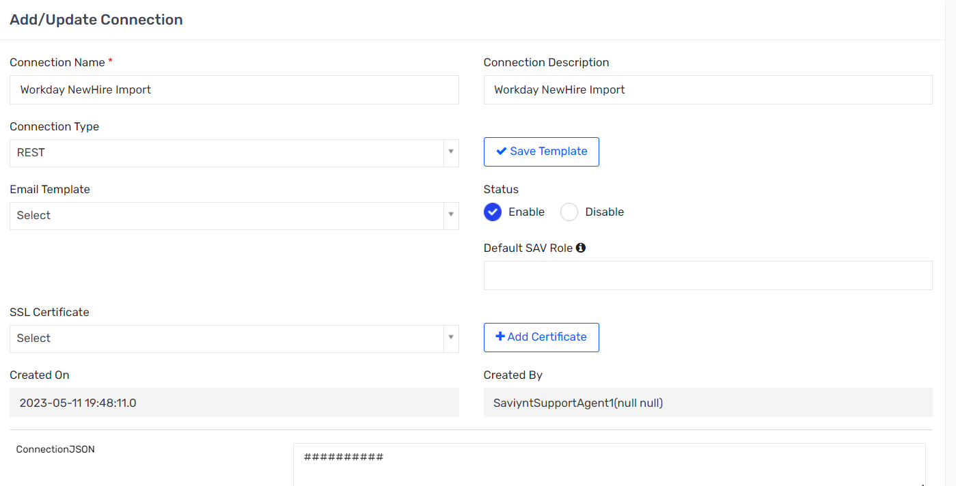

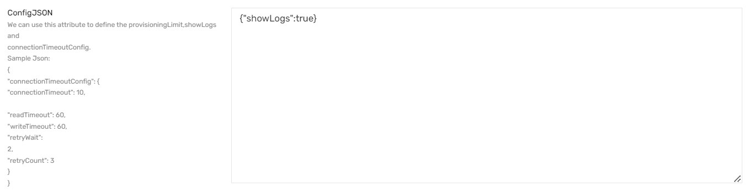

### IMPORTUSERJSON

|  |
| --- |
| {  "connection": "userAuth",  "url":"https://wd2-impl-services1.workday.com/ccx/service/customreport2/sentara1/ISU%20-%20INT0078B/INT0078B_-_Future_Dated_New_Hires_-_Worker_Data_to_Saviynt?format=json",  "httpMethod": "GET",  "httpHeaders": {  "contentType": "application/json",  "Authorization": "${access_token}"},  "colsToPropsMap": {  "USERNAME": "username~#~string",  "EMPLOYEEID": "employeeid~#~string",  "EMPLOYEETYPE": "employeeType~#~string",  "FIRSTNAME": "firstname~#~string",  "LASTNAME": "lastname~#~string",  "MIDDLENAME": "middlename~#~string",  "PREFEREDFIRSTNAME": "preferedFirstName~#~string",  "DEPARTMENTNAME": "departmentname~#~string",  "PHONENUMBER": "phonenumber~#~string",  "JOBCODE": "jobCode~#~string",  "TITLE": "title~#~string",  "COMPANYNAME": "companyname~#~string",  "COSTCENTER": "costcenter~#~string",  "LOCATION": "location~#~string",  "LOCATIONNUMBER": "locationnumber~#~string",  "LOCATIONDESC": "locationdesc~#~string",  "MANAGER": "manager~#~String",  "SECONDARYEMAIL": "secondaryEmail~#~string",  "CITY": "city~#~string",  "STATE": "state~#~string",  "REGIONCODE": "regioncode~#~string",  "COUNTRY": "country~#~string",  "startdate": "startdate~#~string",  "termdate": "termdate~#~string",  "CUSTOMPROPERTY2": "customproperty2~#~string",  "CUSTOMPROPERTY4": "customproperty4~#~string",  "CUSTOMPROPERTY5": "#CONST#Workday~#~String",  "EMPLOYEECLASS": "#CONST#No~#~String",  "CUSTOMPROPERTY6": "customproperty6~#~string",  "CUSTOMPROPERTY7": "customproperty7~#~string",  "CUSTOMPROPERTY8": "customproperty8~#~string",  "CUSTOMPROPERTY9": "customproperty9~#~string",  "CUSTOMPROPERTY10": "customproperty10~#~string",  "CUSTOMPROPERTY11": "customproperty11~#~string",  "CUSTOMPROPERTY12": "customproperty12~#~string",  "CUSTOMPROPERTY13": "customproperty13~#~string",  "CUSTOMPROPERTY14": "customproperty14~#~string",  "CUSTOMPROPERTY15": "customproperty15~#~string",  "CUSTOMPROPERTY16": "customproperty16~#~string",  "CUSTOMPROPERTY17": "customproperty17~#~string",  "CUSTOMPROPERTY18": "customproperty18~#~string",  "CUSTOMPROPERTY19": "customproperty19~#~string",  "CUSTOMPROPERTY21": "customproperty21~#~string",  "CUSTOMPROPERTY22": "customproperty22~#~string",  "CUSTOMPROPERTY23": "customproperty23~#~string",  "CUSTOMPROPERTY24": "customproperty24~#~string",  "CUSTOMPROPERTY26": "customproperty26~#~string",  "CUSTOMPROPERTY27": "customproperty27~#~string",  "CUSTOMPROPERTY28": "customproperty28~#~string",  "CUSTOMPROPERTY29": "customproperty29~#~string",  "CUSTOMPROPERTY30": "customproperty30~#~string",  "CUSTOMPROPERTY31": "customproperty31~#~string",  "CUSTOMPROPERTY37": "customproperty37~#~string",  "CUSTOMPROPERTY38": "customproperty38~#~string",  "CUSTOMPROPERTY39": "customproperty39~#~string",  "CUSTOMPROPERTY40": "customproperty40~#~string",  "CUSTOMPROPERTY41": "customproperty41~#~string",  "CUSTOMPROPERTY42": "customproperty42~#~string",  "CUSTOMPROPERTY43": "customproperty43~#~string",  "CUSTOMPROPERTY44": "customproperty44~#~string",  "CUSTOMPROPERTY45": "customproperty45~#~string",  "CUSTOMPROPERTY46": "customproperty46~#~string",  "CUSTOMPROPERTY47": "customproperty47~#~string",  "CUSTOMPROPERTY48": "customproperty48~#~string",  "CUSTOMPROPERTY49": "customproperty49~#~string",  "CUSTOMPROPERTY50": "customproperty50~#~string",  "CUSTOMPROPERTY58": "customproperty58~#~string"  },  "userResponsePath": "Report_Entry"  } |

### MODIFYUSERDATAJSON

|  |
| --- |
| {  "ADDITIONALTABLES": {  "USERS": "SELECT USERNAME, SYSTEMUSERNAME,EMPLOYEECLASS,CUSTOMPROPERTY7,CUSTOMPROPERTY8,CUSTOMPROPERTY9,CUSTOMPROPERTY10,CUSTOMPROPERTY11,CUSTOMPROPERTY15,CUSTOMPROPERTY17,CUSTOMPROPERTY51, CUSTOMPROPERTY59, EMAIL,CUSTOMPROPERTY5,SECONDARYEMAIL, STATUSKEY, ENDDATE, FIRSTNAME, LASTNAME, CUSTOMPROPERTY58,PREFEREDFIRSTNAME,CUSTOMPROPERTY12,TERMDATE,EMPLOYEEID,EMPLOYEETYPE,DEPARTMENTNAME,JOBCODE,COMPANYNAME,COSTCENTER,LOCATION,LOCATIONNUMBER,LOCATIONDESC,COUNTRY,CUSTOMPROPERTY4,CUSTOMPROPERTY16,CUSTOMPROPERTY18,CUSTOMPROPERTY19,CUSTOMPROPERTY21,CUSTOMPROPERTY22,CUSTOMPROPERTY23,CUSTOMPROPERTY26,CUSTOMPROPERTY27,CUSTOMPROPERTY28,CUSTOMPROPERTY29,CUSTOMPROPERTY30,CUSTOMPROPERTY31,CUSTOMPROPERTY39,CUSTOMPROPERTY40,CUSTOMPROPERTY41,CUSTOMPROPERTY42,CUSTOMPROPERTY43,CUSTOMPROPERTY45,CUSTOMPROPERTY46,CUSTOMPROPERTY47,CUSTOMPROPERTY48,CUSTOMPROPERTY49,CUSTOMPROPERTY50 FROM USERS",  "ACCOUNTS": "SELECT NAME,CUSTOMPROPERTY31, ENDPOINTKEY FROM ACCOUNTS WHERE ENDPOINTKEY IN (2,3)"  },  "COMPUTEDCOLUMNS": [  "SYSTEMUSERNAME",  "CUSTOMPROPERTY25",  "CUSTOMPROPERTY59",  "CUSTOMPROPERTY51",  "EMAIL",  "MANAGER",  "TERMDATE",  "STATUSKEY",  "CUSTOMPROPERTY5",  "EMPLOYEECLASS",  "EMPLOYEEID",  "EMPLOYEETYPE",  "DEPARTMENTNAME",  "JOBCODE",  "COMPANYNAME",  "COSTCENTER",  "LOCATION",  "LOCATIONNUMBER",  "LOCATIONDESC",  "COUNTRY",  "CUSTOMPROPERTY4",  "CUSTOMPROPERTY7",  "CUSTOMPROPERTY8",  "CUSTOMPROPERTY9",  "CUSTOMPROPERTY10",  "CUSTOMPROPERTY11",  "CUSTOMPROPERTY15",  "CUSTOMPROPERTY16",  "CUSTOMPROPERTY17",  "CUSTOMPROPERTY18",  "CUSTOMPROPERTY19",  "CUSTOMPROPERTY21",  "CUSTOMPROPERTY22",  "CUSTOMPROPERTY23",  "CUSTOMPROPERTY26",  "CUSTOMPROPERTY27",  "CUSTOMPROPERTY28",  "CUSTOMPROPERTY29",  "CUSTOMPROPERTY30",  "CUSTOMPROPERTY31",  "CUSTOMPROPERTY39",  "CUSTOMPROPERTY40",  "CUSTOMPROPERTY41",  "CUSTOMPROPERTY42",  "CUSTOMPROPERTY43",  "CUSTOMPROPERTY45",  "CUSTOMPROPERTY46",  "CUSTOMPROPERTY47",  "CUSTOMPROPERTY48",  "CUSTOMPROPERTY49",  "CUSTOMPROPERTY50",  "CUSTOMPROPERTY58"  ],  "TABLEINDEXES": {  "CURRENTUSERS": [  "username"  ],  "NEWUSERDATA": [  "username"  ],  "CURRENTACCOUNTS": [  "name"  ]  },  "PREPROCESSQUERIES": [  "UPDATE NEWUSERDATA as NU SET NU.customproperty25 = case when STR_TO_DATE(NU.startdate, '%m-%d-%Y') between date(DATE_ADD(curdate(), INTERVAL 1 DAY)) and date(DATE_ADD(curdate(), INTERVAL 7 DAY)) then 'PREHIRE' when STR_TO_DATE(NU.startdate, '%m-%d-%Y') > date(DATE_ADD(curdate(), INTERVAL 7 DAY)) then 'FUTUREHIRE' else 'HIRED' end",  "UPDATE NEWUSERDATA LEFT JOIN CURRENTUSERS ON NEWUSERDATA.USERNAME = CURRENTUSERS.USERNAME SET NEWUSERDATA.statuskey=case when NEWUSERDATA.CUSTOMPROPERTY24='A' then 1 else 0 end",  "UPDATE NEWUSERDATA LEFT JOIN CURRENTUSERS ON NEWUSERDATA.USERNAME = CURRENTUSERS.USERNAME SET NEWUSERDATA.CUSTOMPROPERTY51 = CASE WHEN (((NEWUSERDATA.CUSTOMPROPERTY15 = 'CM101' AND NEWUSERDATA.CUSTOMPROPERTY17 = 'RD1004' AND NEWUSERDATA.COSTCENTER = 'CC27091004' AND NEWUSERDATA.EMPLOYEETYPE LIKE '%EMP%') OR (NEWUSERDATA.CUSTOMPROPERTY15 = 'CM117' AND NEWUSERDATA.CUSTOMPROPERTY17 = 'RD1004' AND NEWUSERDATA.COSTCENTER = 'CC27091004' AND NEWUSERDATA.EMPLOYEETYPE LIKE '%EMP%')) AND NEWUSERDATA.STATUSKEY = 1 AND NEWUSERDATA.CUSTOMPROPERTY25 IN ('HIRED' , 'PREHIRE')) THEN 'E5' WHEN (((NEWUSERDATA.CUSTOMPROPERTY8 IN ('Senior Leadership Team' , 'Executive Leadership Team', 'Business Professional', 'Manager', 'Director', 'Supervisor', 'Sr Clerical & Admin', 'Non-Medical Technician', 'Skilled Craft Worker', 'Non-Medical Service Worker', 'Sales Worker', 'CRNA')) OR (NEWUSERDATA.CUSTOMPROPERTY8 = 'Registered Nurse' AND NEWUSERDATA.CUSTOMPROPERTY11 IN( '101040','101041')) OR (NEWUSERDATA.CUSTOMPROPERTY8 = 'Advanced Practice Provider' AND (NEWUSERDATA.CUSTOMPROPERTY10 = 'Band 5 Leader' OR NEWUSERDATA.CUSTOMPROPERTY10 like 'Band 6%' OR NEWUSERDATA.CUSTOMPROPERTY10 like 'Band 7%' )) OR (NEWUSERDATA.CUSTOMPROPERTY8 = 'Chaplain' AND NEWUSERDATA.CUSTOMPROPERTY10 not like 'Band 1%' ) OR (NEWUSERDATA.CUSTOMPROPERTY8 = 'Allied Health Professional' AND NEWUSERDATA.CUSTOMPROPERTY9 IN ('Clinical Nursing' , 'Health Plan', 'Corporate')) OR (NEWUSERDATA.CUSTOMPROPERTY8 = 'Clerical-Business Support' AND (NEWUSERDATA.CUSTOMPROPERTY7 NOT LIKE '%Student%' OR NEWUSERDATA.CUSTOMPROPERTY11 != '102350')) OR (NEWUSERDATA.CUSTOMPROPERTY8 = 'Clerical-Patient Support' AND (NEWUSERDATA.CUSTOMPROPERTY7 NOT IN ('Student' , 'Intern', 'Scheduling Coordinator', 'Business Support') OR NEWUSERDATA.CUSTOMPROPERTY9 IN ('Corporate' , 'Health Plan')))) AND NEWUSERDATA.STATUSKEY = 1 AND NEWUSERDATA.CUSTOMPROPERTY25 IN ('HIRED' , 'PREHIRE')) THEN 'E3' WHEN (NEWUSERDATA.STATUSKEY = 0) THEN '' ELSE 'F3' END",  "UPDATE NEWUSERDATA INNER JOIN CURRENTUSERS ON NEWUSERDATA.USERNAME = CURRENTUSERS.USERNAME SET NEWUSERDATA.STATUSKEY=1, NEWUSERDATA.CUSTOMPROPERTY5='SecZetta',NEWUSERDATA.EMPLOYEETYPE=NULL,NEWUSERDATA.DEPARTMENTNAME=NULL,NEWUSERDATA.JOBCODE=NULL,NEWUSERDATA.COMPANYNAME=NULL,NEWUSERDATA.COSTCENTER=NULL,NEWUSERDATA.LOCATION=NULL,NEWUSERDATA.LOCATIONNUMBER=NULL,NEWUSERDATA.LOCATIONDESC=NULL,NEWUSERDATA.COUNTRY=NULL,NEWUSERDATA.CUSTOMPROPERTY4=NULL,NEWUSERDATA.CUSTOMPROPERTY7=NULL,NEWUSERDATA.CUSTOMPROPERTY8=NULL,NEWUSERDATA.CUSTOMPROPERTY9=NULL,NEWUSERDATA.CUSTOMPROPERTY10=NULL,NEWUSERDATA.CUSTOMPROPERTY11=NULL,NEWUSERDATA.CUSTOMPROPERTY15=NULL,NEWUSERDATA.CUSTOMPROPERTY16=NULL,NEWUSERDATA.CUSTOMPROPERTY17=NULL,NEWUSERDATA.CUSTOMPROPERTY18=NULL,NEWUSERDATA.CUSTOMPROPERTY19=NULL,NEWUSERDATA.CUSTOMPROPERTY21=NULL,NEWUSERDATA.CUSTOMPROPERTY22=NULL,NEWUSERDATA.CUSTOMPROPERTY23=NULL,NEWUSERDATA.CUSTOMPROPERTY26=NULL,NEWUSERDATA.CUSTOMPROPERTY27=NULL,NEWUSERDATA.CUSTOMPROPERTY28=NULL,NEWUSERDATA.CUSTOMPROPERTY29=NULL,NEWUSERDATA.CUSTOMPROPERTY30=NULL,NEWUSERDATA.CUSTOMPROPERTY31=NULL,NEWUSERDATA.CUSTOMPROPERTY39=NULL,NEWUSERDATA.CUSTOMPROPERTY40=NULL,NEWUSERDATA.CUSTOMPROPERTY41=NULL,NEWUSERDATA.CUSTOMPROPERTY42=NULL,NEWUSERDATA.CUSTOMPROPERTY43=NULL,NEWUSERDATA.CUSTOMPROPERTY45=NULL,NEWUSERDATA.CUSTOMPROPERTY46=NULL,NEWUSERDATA.CUSTOMPROPERTY47=NULL,NEWUSERDATA.CUSTOMPROPERTY48=NULL,NEWUSERDATA.CUSTOMPROPERTY49=NULL,NEWUSERDATA.CUSTOMPROPERTY50=NULL,NEWUSERDATA.CUSTOMPROPERTY58 = CURRENTUSERS.CUSTOMPROPERTY58,NEWUSERDATA.EMAIL= CASE WHEN(CURRENTUSERS.SECONDARYEMAIL IS NOT NULL) THEN CURRENTUSERS.SECONDARYEMAIL ELSE CONCAT(CURRENTUSERS.SYSTEMUSERNAME,'@testfakesentara.com') END,NEWUSERDATA.CUSTOMPROPERTY59 = NULL,NEWUSERDATA.MANAGER= NULL, NEWUSERDATA.SECONDARYEMAIL=CURRENTUSERS.SECONDARYEMAIL WHERE NEWUSERDATA.CUSTOMPROPERTY5='Workday' and CURRENTUSERS.CUSTOMPROPERTY5='SecZetta' and NEWUSERDATA.STATUSKEY=0 and CURRENTUSERS.STATUSKEY=1 AND CURRENTUSERS.EMPLOYEECLASS = 'No'",  "UPDATE NEWUSERDATA INNER JOIN CURRENTUSERS ON NEWUSERDATA.USERNAME = CURRENTUSERS.USERNAME SET NEWUSERDATA.CUSTOMPROPERTY58 = CURRENTUSERS.CUSTOMPROPERTY58,NEWUSERDATA.EMPLOYEECLASS = CURRENTUSERS.EMPLOYEECLASS WHERE NEWUSERDATA.STATUSKEY=1 AND CURRENTUSERS.EMPLOYEECLASS = 'Yes' AND CURRENTUSERS.STATUSKEY=1",  "CUSTOMFUNCTION###FUNCTION1"  ],  "CUSTOMFUNCTIONS": {  "FUNCTION1": {  "FULLCLASSNAME": "com.sentara.custom.preprocessor.Transformation",  "METHODNAME": "doCustomPreprocess"  }  }  } |

## Workday_Rescind Connection

### Connection details

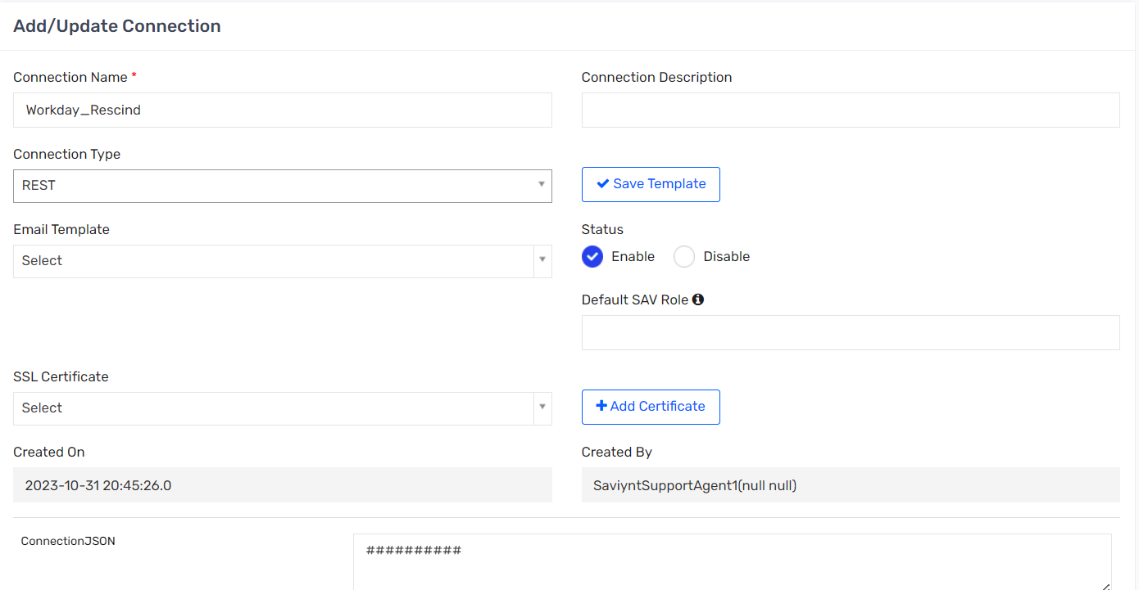

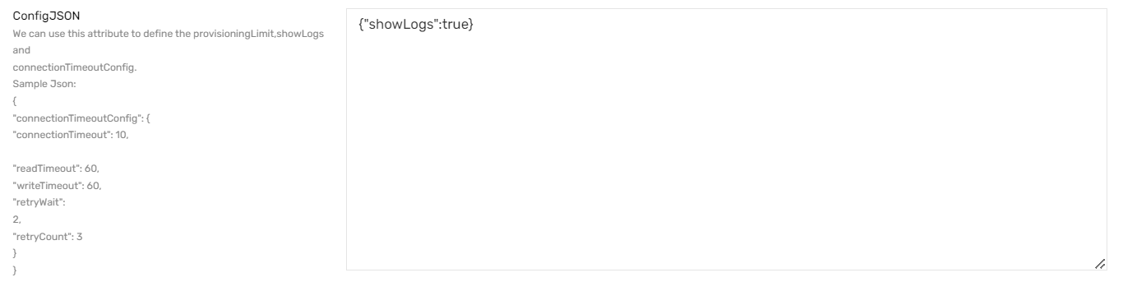

### IMPORTUSERJSON

|  |
| --- |
| {  "connection": "userAuth",  "url":"https://wd2-impl-services1.workday.com/ccx/service/customreport2/sentara1/ISU%20-%20INT0078E/INT0078E_-_Staffing_Business_Process_Transactions_in_Date_Range_-_Rescinded_or_Corrected_Transactions_-_Saviynt?format=json",  "httpMethod": "GET",  "httpHeaders": {  "contentType": "application/json",  "Authorization": "${access_token}"},  "colsToPropsMap": {  "USERNAME": "username~#~string",  "EMPLOYEEID": "employeeid~#~string",  "EMPLOYEETYPE": "employeeType~#~string",  "FIRSTNAME": "firstname~#~string",  "LASTNAME": "lastname~#~string",  "MIDDLENAME": "middlename~#~string",  "SITEID":"Business_Process~#~string",  "PREFEREDFIRSTNAME": "preferedFirstName~#~string",  "DEPARTMENTNAME": "departmentname~#~string",  "PHONENUMBER": "phonenumber~#~string",  "JOBCODE": "jobCode~#~string",  "TITLE": "title~#~string",  "COMPANYNAME": "companyname~#~string",  "COSTCENTER": "costcenter~#~string",  "LOCATION": "location~#~string",  "LOCATIONNUMBER": "locationnumber~#~string",  "LOCATIONDESC": "locationdesc~#~string",  "MANAGER": "manager~#~String",  "SECONDARYEMAIL": "secondaryEmail~#~string",  "CITY": "city~#~string",  "STATE": "state~#~string",  "REGIONCODE": "regioncode~#~string",  "COUNTRY": "country~#~string",  "startdate": "startdate~#~string",  "termdate": "termdate~#~string",  "CUSTOMPROPERTY2": "customproperty2~#~string",  "CUSTOMPROPERTY4": "customproperty4~#~string",  "CUSTOMPROPERTY5": "#CONST#Workday~#~String",  "EMPLOYEECLASS": "#CONST#No~#~String",  "CUSTOMPROPERTY6": "customproperty6~#~string",  "CUSTOMPROPERTY7": "customproperty7~#~string",  "CUSTOMPROPERTY8": "customproperty8~#~string",  "CUSTOMPROPERTY9": "customproperty9~#~string",  "CUSTOMPROPERTY10": "customproperty10~#~string",  "CUSTOMPROPERTY11": "customproperty11~#~string",  "CUSTOMPROPERTY12": "customproperty12~#~string",  "CUSTOMPROPERTY13": "customproperty13~#~string",  "CUSTOMPROPERTY14": "customproperty14~#~string",  "CUSTOMPROPERTY15": "customproperty15~#~string",  "CUSTOMPROPERTY16": "customproperty16~#~string",  "CUSTOMPROPERTY17": "customproperty17~#~string",  "CUSTOMPROPERTY18": "customproperty18~#~string",  "CUSTOMPROPERTY19": "customproperty19~#~string",  "CUSTOMPROPERTY21": "customproperty21~#~string",  "CUSTOMPROPERTY22": "customproperty22~#~string",  "CUSTOMPROPERTY23": "customproperty23~#~string",  "CUSTOMPROPERTY24": "customproperty24~#~string",  "CUSTOMPROPERTY26": "customproperty26~#~string",  "CUSTOMPROPERTY27": "customproperty27~#~string",  "CUSTOMPROPERTY28": "customproperty28~#~string",  "CUSTOMPROPERTY29": "customproperty29~#~string",  "CUSTOMPROPERTY30": "customproperty30~#~string",  "CUSTOMPROPERTY31": "customproperty31~#~string",  "CUSTOMPROPERTY37": "customproperty37~#~string",  "CUSTOMPROPERTY38": "customproperty38~#~string",  "CUSTOMPROPERTY39": "customproperty39~#~string",  "CUSTOMPROPERTY40": "customproperty40~#~string",  "CUSTOMPROPERTY41": "customproperty41~#~string",  "CUSTOMPROPERTY42": "customproperty42~#~string",  "CUSTOMPROPERTY43": "customproperty43~#~string",  "CUSTOMPROPERTY44": "customproperty44~#~string",  "CUSTOMPROPERTY45": "customproperty45~#~string",  "CUSTOMPROPERTY46": "customproperty46~#~string",  "CUSTOMPROPERTY47": "customproperty47~#~string",  "CUSTOMPROPERTY48": "customproperty48~#~string",  "CUSTOMPROPERTY49": "customproperty49~#~string",  "CUSTOMPROPERTY50": "customproperty50~#~string",  "CUSTOMPROPERTY58": "customproperty58~#~string"  },  "userResponsePath": "Report_Entry"  } |

### MODIFYUSERDATAJSON

|  |
| --- |
| {  "ADDITIONALTABLES": {  "USERS": "SELECT USERNAME, SYSTEMUSERNAME,EMPLOYEECLASS,CUSTOMPROPERTY7,CUSTOMPROPERTY8,CUSTOMPROPERTY9,CUSTOMPROPERTY10,CUSTOMPROPERTY11,CUSTOMPROPERTY15,CUSTOMPROPERTY17,CUSTOMPROPERTY51, CUSTOMPROPERTY59, EMAIL,CUSTOMPROPERTY5,SECONDARYEMAIL, STATUSKEY, ENDDATE, FIRSTNAME, LASTNAME, CUSTOMPROPERTY58,PREFEREDFIRSTNAME,CUSTOMPROPERTY12,TERMDATE,EMPLOYEEID,EMPLOYEETYPE,DEPARTMENTNAME,JOBCODE,COMPANYNAME,COSTCENTER,LOCATION,LOCATIONNUMBER,LOCATIONDESC,COUNTRY,CUSTOMPROPERTY4,CUSTOMPROPERTY16,CUSTOMPROPERTY18,CUSTOMPROPERTY19,CUSTOMPROPERTY21,CUSTOMPROPERTY22,CUSTOMPROPERTY23,CUSTOMPROPERTY26,CUSTOMPROPERTY27,CUSTOMPROPERTY28,CUSTOMPROPERTY29,CUSTOMPROPERTY30,CUSTOMPROPERTY31,CUSTOMPROPERTY39,CUSTOMPROPERTY40,CUSTOMPROPERTY41,CUSTOMPROPERTY42,CUSTOMPROPERTY43,CUSTOMPROPERTY45,CUSTOMPROPERTY46,CUSTOMPROPERTY47,CUSTOMPROPERTY48,CUSTOMPROPERTY49,CUSTOMPROPERTY50 FROM USERS"  },  "COMPUTEDCOLUMNS": [  "SYSTEMUSERNAME",  "CUSTOMPROPERTY25",  "CUSTOMPROPERTY59",  "CUSTOMPROPERTY51",  "EMAIL",  "MANAGER",  "TERMDATE",  "STATUSKEY",  "CUSTOMPROPERTY5",  "EMPLOYEECLASS",  "EMPLOYEEID",  "EMPLOYEETYPE",  "DEPARTMENTNAME",  "JOBCODE",  "COMPANYNAME",  "COSTCENTER",  "LOCATION",  "LOCATIONNUMBER",  "LOCATIONDESC",  "COUNTRY",  "CUSTOMPROPERTY4",  "CUSTOMPROPERTY7",  "CUSTOMPROPERTY8",  "CUSTOMPROPERTY9",  "CUSTOMPROPERTY10",  "CUSTOMPROPERTY11",  "CUSTOMPROPERTY15",  "CUSTOMPROPERTY16",  "CUSTOMPROPERTY17",  "CUSTOMPROPERTY18",  "CUSTOMPROPERTY19",  "CUSTOMPROPERTY21",  "CUSTOMPROPERTY22",  "CUSTOMPROPERTY23",  "CUSTOMPROPERTY26",  "CUSTOMPROPERTY27",  "CUSTOMPROPERTY28",  "CUSTOMPROPERTY29",  "CUSTOMPROPERTY30",  "CUSTOMPROPERTY31",  "CUSTOMPROPERTY39",  "CUSTOMPROPERTY40",  "CUSTOMPROPERTY41",  "CUSTOMPROPERTY42",  "CUSTOMPROPERTY43",  "CUSTOMPROPERTY45",  "CUSTOMPROPERTY46",  "CUSTOMPROPERTY47",  "CUSTOMPROPERTY48",  "CUSTOMPROPERTY49",  "CUSTOMPROPERTY50",  "CUSTOMPROPERTY58"  ],  "TABLEINDEXES": {  "CURRENTUSERS": [  "username"  ],  "NEWUSERDATA": [  "username"  ]  },  "PREPROCESSQUERIES": [  "DELETE FROM NEWUSERDATA WHERE NEWUSERDATA.SITEID NOT LIKE 'Hire:%'",  "UPDATE NEWUSERDATA INNER JOIN CURRENTUSERS ON NEWUSERDATA.USERNAME = CURRENTUSERS.USERNAME SET NEWUSERDATA.statuskey=0",  "UPDATE NEWUSERDATA INNER JOIN CURRENTUSERS ON NEWUSERDATA.USERNAME = CURRENTUSERS.USERNAME SET NEWUSERDATA.STATUSKEY=1, NEWUSERDATA.CUSTOMPROPERTY5='SecZetta',NEWUSERDATA.EMPLOYEETYPE=NULL,NEWUSERDATA.DEPARTMENTNAME=NULL,NEWUSERDATA.JOBCODE=NULL,NEWUSERDATA.COMPANYNAME=NULL,NEWUSERDATA.COSTCENTER=NULL,NEWUSERDATA.LOCATION=NULL,NEWUSERDATA.LOCATIONNUMBER=NULL,NEWUSERDATA.LOCATIONDESC=NULL,NEWUSERDATA.COUNTRY=NULL,NEWUSERDATA.CUSTOMPROPERTY4=NULL,NEWUSERDATA.CUSTOMPROPERTY7=NULL,NEWUSERDATA.CUSTOMPROPERTY8=NULL,NEWUSERDATA.CUSTOMPROPERTY9=NULL,NEWUSERDATA.CUSTOMPROPERTY10=NULL,NEWUSERDATA.CUSTOMPROPERTY11=NULL,NEWUSERDATA.CUSTOMPROPERTY15=NULL,NEWUSERDATA.CUSTOMPROPERTY16=NULL,NEWUSERDATA.CUSTOMPROPERTY17=NULL,NEWUSERDATA.CUSTOMPROPERTY18=NULL,NEWUSERDATA.CUSTOMPROPERTY19=NULL,NEWUSERDATA.CUSTOMPROPERTY21=NULL,NEWUSERDATA.CUSTOMPROPERTY22=NULL,NEWUSERDATA.CUSTOMPROPERTY23=NULL,NEWUSERDATA.CUSTOMPROPERTY26=NULL,NEWUSERDATA.CUSTOMPROPERTY27=NULL,NEWUSERDATA.CUSTOMPROPERTY28=NULL,NEWUSERDATA.CUSTOMPROPERTY29=NULL,NEWUSERDATA.CUSTOMPROPERTY30=NULL,NEWUSERDATA.CUSTOMPROPERTY31=NULL,NEWUSERDATA.CUSTOMPROPERTY39=NULL,NEWUSERDATA.CUSTOMPROPERTY40=NULL,NEWUSERDATA.CUSTOMPROPERTY41=NULL,NEWUSERDATA.CUSTOMPROPERTY42=NULL,NEWUSERDATA.CUSTOMPROPERTY43=NULL,NEWUSERDATA.CUSTOMPROPERTY45=NULL,NEWUSERDATA.CUSTOMPROPERTY46=NULL,NEWUSERDATA.CUSTOMPROPERTY47=NULL,NEWUSERDATA.CUSTOMPROPERTY48=NULL,NEWUSERDATA.CUSTOMPROPERTY49=NULL,NEWUSERDATA.CUSTOMPROPERTY50=NULL,NEWUSERDATA.CUSTOMPROPERTY58 = CURRENTUSERS.CUSTOMPROPERTY58,NEWUSERDATA.EMAIL= CASE WHEN(CURRENTUSERS.SECONDARYEMAIL IS NOT NULL) THEN CURRENTUSERS.SECONDARYEMAIL ELSE CONCAT(CURRENTUSERS.SYSTEMUSERNAME,'@testfakesentara.com') END,NEWUSERDATA.CUSTOMPROPERTY59 = NULL,NEWUSERDATA.MANAGER= NULL, NEWUSERDATA.EMPLOYEECLASS = 'No',NEWUSERDATA.SECONDARYEMAIL=CURRENTUSERS.SECONDARYEMAIL WHERE NEWUSERDATA.STATUSKEY=0 and CURRENTUSERS.STATUSKEY=1 AND CURRENTUSERS.EMPLOYEECLASS = 'Yes'"  ]  } |

## Workday User Update Connection

Saviynt EIC uses SOAP connector to update workday

### Connection Details

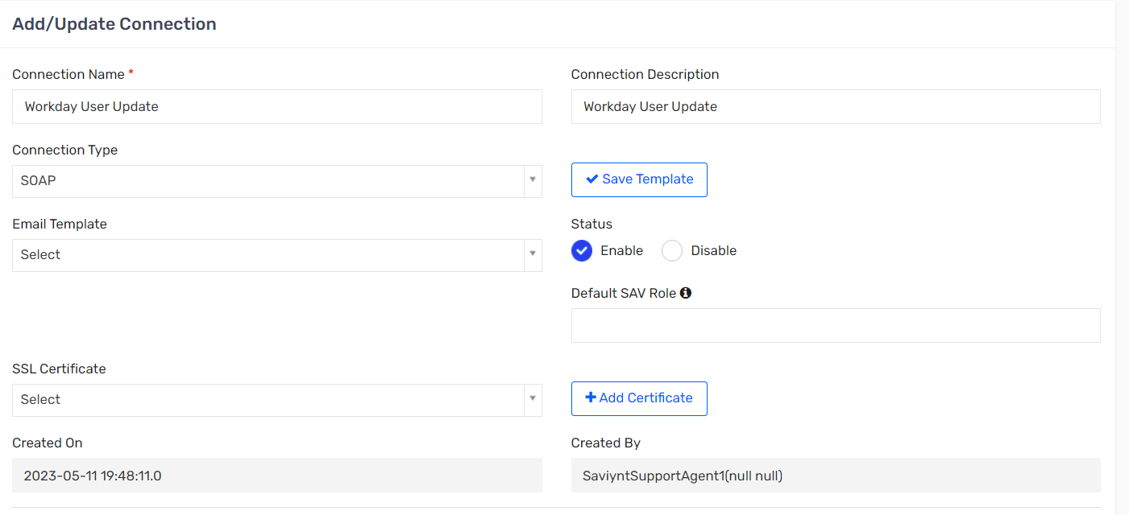

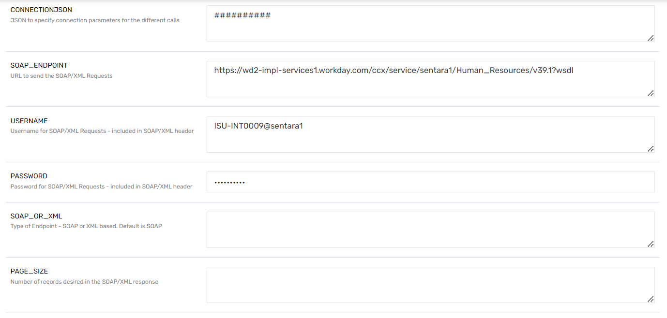

### UPDATEUSERJSON

|  |
| --- |
| [{"REQUESTXML": "<soapenv:Envelope xmlns:soapenv=\"http://schemas.xmlsoap.org/soap/envelope/\" xmlns:xsd=\"http://www.w3.org/2001/XMLSchema\"><soapenv:Header><wsse:Security soapenv:mustUnderstand=\"1\" xmlns:wsse=\"http://docs.oasis-open.org/wss/2004/01/oasis-200401-wss-wssecurity-secext-1.0.xsd\" xmlns:wsu=\"http://docs.oasis-open.org/wss/2004/01/oasis-200401-wss-wssecurity-utility-1.0.xsd\"><wsse:UsernameToken wsu:Id=\"UsernameToken-F7F64DF48AED80C79615338775610654\"><wsse:Username>${USERNAME}</wsse:Username><wsse:Password Type=\"http://docs.oasis-open.org/wss/2004/01/oasis-200401-wss-username-token-profile-1.0#PasswordText\">${PASSWORD}</wsse:Password><wsse:Nonce EncodingType=\"http://docs.oasis-open.org/wss/2004/01/oasis-200401-wss-soap-message-security-1.0#Base64Binary\">FHS6W8PaIZXkxRrdCdtzsw==</wsse:Nonce><wsu:Created>2018-08-10T05:06:01.062Z</wsu:Created></wsse:UsernameToken></wsse:Security></soapenv:Header><soapenv:Body><wd:Change_Work_Contact_Information_Request xmlns:wd=\"urn:com.workday/bsvc\" wd:version=\"v39.1\"><wd:Business_Process_Parameters><wd:Auto_Complete>true</wd:Auto_Complete><wd:Run_Now>true</wd:Run_Now><wd:Discard_On_Exit_Validation_Error>true</wd:Discard_On_Exit_Validation_Error></wd:Business_Process_Parameters><wd:Change_Work_Contact_Information_Data><wd:Person_Reference>${user.employeeType.equalsIgnoreCase('Emp')?'<wd:ID wd:type=\"Employee_ID\">' + user.employeeid + '</wd:ID>':'<wd:ID wd:type=\"Contingent_Worker_ID\">' + user.employeeid + '</wd:ID>'}</wd:Person_Reference><wd:Event_Effective_Date>2023-06-17</wd:Event_Effective_Date><wd:Person_Contact_Information_Data><wd:Person_Email_Information_Data wd:Replace_All=\"false\"><wd:Email_Information_Data wd:Delete=\"false\"><wd:Email_Data><wd:Email_Address>${user?.email}</wd:Email_Address><wd:Email_Comment>Updated by Saviynt Integration using Change_Work_Contact_Information_Request</wd:Email_Comment></wd:Email_Data><wd:Usage_Data wd:Public=\"true\"><wd:Type_Data wd:Primary=\"true\"><wd:Type_Reference><wd:ID wd:type=\"Communication_Usage_Type_ID\">Work</wd:ID></wd:Type_Reference></wd:Type_Data></wd:Usage_Data></wd:Email_Information_Data></wd:Person_Email_Information_Data></wd:Person_Contact_Information_Data></wd:Change_Work_Contact_Information_Data></wd:Change_Work_Contact_Information_Request></soapenv:Body></soapenv:Envelope>"},{"REQUESTXML": "<soapenv:Envelope xmlns:soapenv=\"http://schemas.xmlsoap.org/soap/envelope/\" xmlns:bsvc=\"urn:com.workday/bsvc\"><soapenv:Header><wsse:Security soapenv:mustUnderstand=\"1\" xmlns:wsse=\"http://docs.oasis-open.org/wss/2004/01/oasis-200401-wss-wssecurity-secext-1.0.xsd\" xmlns:wsu=\"http://docs.oasis-open.org/wss/2004/01/oasis-200401-wss-wssecurity-utility-1.0.xsd\"><wsse:UsernameToken wsu:Id=\"UsernameToken-F7F64DF48AED80C79615338775610654\"><wsse:Username>${USERNAME}</wsse:Username><wsse:Password Type=\"http://docs.oasis-open.org/wss/2004/01/oasis-200401-wss-username-token-profile-1.0#PasswordText\">${PASSWORD}</wsse:Password><wsse:Nonce EncodingType=\"http://docs.oasis-open.org/wss/2004/01/oasis-200401-wss-soap-message-security-1.0#Base64Binary\">FHS6W8PaIZXkxRrdCdtzsw==</wsse:Nonce><wsu:Created>2018-08-10T05:06:01.062Z</wsu:Created></wsse:UsernameToken></wsse:Security><bsvc:Workday_Common_Header> <bsvc:Include_Reference_Descriptors_In_Response>1</bsvc:Include_Reference_Descriptors_In_Response></bsvc:Workday_Common_Header></soapenv:Header><soapenv:Body><wd:Workday_Account_for_Worker_Update xmlns:wd=\"urn:com.workday/bsvc\" wd:version=\"v39.1\">${user.employeeType.equalsIgnoreCase('Emp')?'<wd:Worker_Reference><wd:Employee_Reference><wd:Integration_ID_Reference><wd:ID wd:System_ID=\"WD-EMPLID\">' + user.employeeid + '</wd:ID></wd:Integration_ID_Reference></wd:Employee_Reference></wd:Worker_Reference>':' <wd:Non_Worker_Reference><wd:ID wd:type=\"Contingent_Worker_ID\">' + user.employeeid + '</wd:ID></wd:Non_Worker_Reference>'}<wd:Workday_Account_for_Worker_Data><wd:User_Name>${user?.systemUserName}</wd:User_Name></wd:Workday_Account_for_Worker_Data></wd:Workday_Account_for_Worker_Update></soapenv:Body></soapenv:Envelope>"}]        [{"REQUESTXML": "<soapenv:Envelope xmlns:soapenv=\"http://schemas.xmlsoap.org/soap/envelope/\" xmlns:xsd=\"http://www.w3.org/2001/XMLSchema\"><soapenv:Header><wsse:Security soapenv:mustUnderstand=\"1\" xmlns:wsse=\"http://docs.oasis-open.org/wss/2004/01/oasis-200401-wss-wssecurity-secext-1.0.xsd\" xmlns:wsu=\"http://docs.oasis-open.org/wss/2004/01/oasis-200401-wss-wssecurity-utility-1.0.xsd\"><wsse:UsernameToken wsu:Id=\"UsernameToken-F7F64DF48AED80C79615338775610654\"><wsse:Username>${USERNAME}</wsse:Username><wsse:Password Type=\"http://docs.oasis-open.org/wss/2004/01/oasis-200401-wss-username-token-profile-1.0#PasswordText\">${PASSWORD}</wsse:Password><wsse:Nonce EncodingType=\"http://docs.oasis-open.org/wss/2004/01/oasis-200401-wss-soap-message-security-1.0#Base64Binary\">FHS6W8PaIZXkxRrdCdtzsw==</wsse:Nonce><wsu:Created>2018-08-10T05:06:01.062Z</wsu:Created></wsse:UsernameToken></wsse:Security></soapenv:Header><soapenv:Body><wd:Change_Work_Contact_Information_Request xmlns:wd=\"urn:com.workday/bsvc\" wd:version=\"v39.1\"><wd:Business_Process_Parameters><wd:Auto_Complete>true</wd:Auto_Complete><wd:Run_Now>true</wd:Run_Now><wd:Discard_On_Exit_Validation_Error>true</wd:Discard_On_Exit_Validation_Error></wd:Business_Process_Parameters><wd:Change_Work_Contact_Information_Data><wd:Person_Reference>${user.employeeType.equalsIgnoreCase('Emp')?'<wd:ID wd:type=\"Employee_ID\">' + user.employeeid + '</wd:ID>':'<wd:ID wd:type=\"Contingent_Worker_ID\">' + user.employeeid + '</wd:ID>'}</wd:Person_Reference><wd:Event_Effective_Date>2023-06-17</wd:Event_Effective_Date><wd:Person_Contact_Information_Data><wd:Person_Email_Information_Data wd:Replace_All=\"false\"><wd:Email_Information_Data wd:Delete=\"false\"><wd:Email_Data><wd:Email_Address>${user?.email}</wd:Email_Address><wd:Email_Comment>Updated by Saviynt Integration using Change_Work_Contact_Information_Request</wd:Email_Comment></wd:Email_Data><wd:Usage_Data wd:Public=\"true\"><wd:Type_Data wd:Primary=\"true\"><wd:Type_Reference><wd:ID wd:type=\"Communication_Usage_Type_ID\">Work</wd:ID></wd:Type_Reference></wd:Type_Data></wd:Usage_Data></wd:Email_Information_Data></wd:Person_Email_Information_Data></wd:Person_Contact_Information_Data></wd:Change_Work_Contact_Information_Data></wd:Change_Work_Contact_Information_Request></soapenv:Body></soapenv:Envelope>"},{"REQUESTXML": "<soapenv:Envelope xmlns:soapenv=\"http://schemas.xmlsoap.org/soap/envelope/\" xmlns:bsvc=\"urn:com.workday/bsvc\"><soapenv:Header><wsse:Security soapenv:mustUnderstand=\"1\" xmlns:wsse=\"http://docs.oasis-open.org/wss/2004/01/oasis-200401-wss-wssecurity-secext-1.0.xsd\" xmlns:wsu=\"http://docs.oasis-open.org/wss/2004/01/oasis-200401-wss-wssecurity-utility-1.0.xsd\"><wsse:UsernameToken wsu:Id=\"UsernameToken-F7F64DF48AED80C79615338775610654\"><wsse:Username>${USERNAME}</wsse:Username><wsse:Password Type=\"http://docs.oasis-open.org/wss/2004/01/oasis-200401-wss-username-token-profile-1.0#PasswordText\">${PASSWORD}</wsse:Password><wsse:Nonce EncodingType=\"http://docs.oasis-open.org/wss/2004/01/oasis-200401-wss-soap-message-security-1.0#Base64Binary\">FHS6W8PaIZXkxRrdCdtzsw==</wsse:Nonce><wsu:Created>2018-08-10T05:06:01.062Z</wsu:Created></wsse:UsernameToken></wsse:Security><bsvc:Workday_Common_Header> <bsvc:Include_Reference_Descriptors_In_Response>1</bsvc:Include_Reference_Descriptors_In_Response></bsvc:Workday_Common_Header></soapenv:Header><soapenv:Body><wd:Workday_Account_for_Worker_Update xmlns:wd=\"urn:com.workday/bsvc\" wd:version=\"v39.1\">${user.employeeType.equalsIgnoreCase('Emp')?'<wd:Worker_Reference><wd:Employee_Reference><wd:Integration_ID_Reference><wd:ID wd:System_ID=\"WD-EMPLID\">' + user.employeeid + '</wd:ID></wd:Integration_ID_Reference></wd:Employee_Reference></wd:Worker_Reference>':' <wd:Non_Worker_Reference><wd:ID wd:type=\"Contingent_Worker_ID\">' + user.employeeid + '</wd:ID></wd:Non_Worker_Reference>'}<wd:Workday_Account_for_Worker_Data><wd:User_Name>${user?.systemUserName}</wd:User_Name></wd:Workday_Account_for_Worker_Data></wd:Workday_Account_for_Worker_Update></soapenv:Body></soapenv:Envelope>"}] |

## Workday User update on Termination

### Connection Details

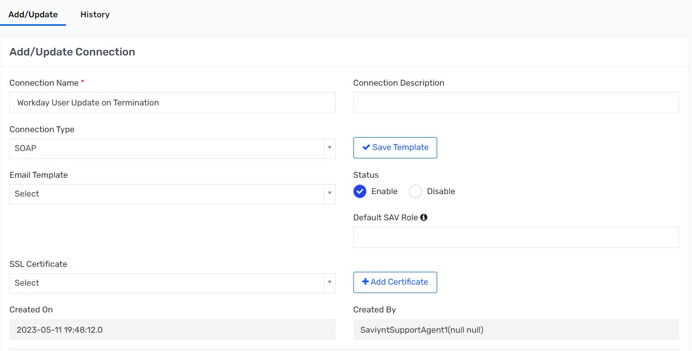

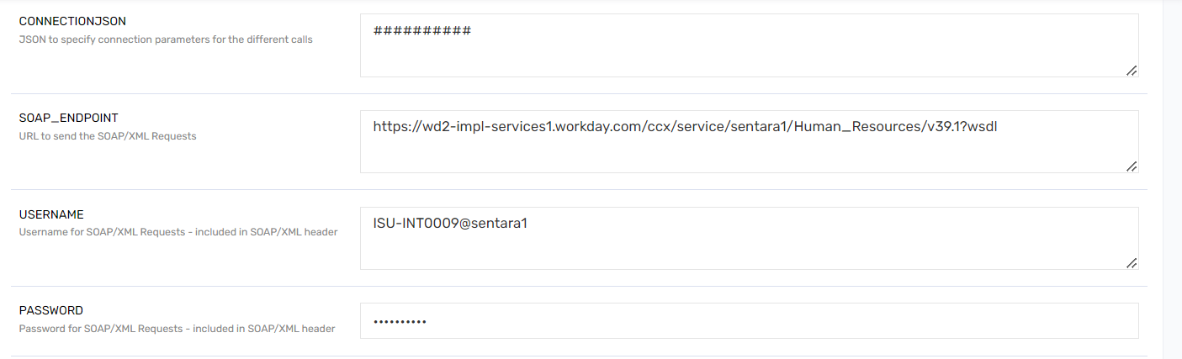

### UPDATEUSERJSON

|  |
| --- |
| [{"REQUESTXML": "<soapenv:Envelope xmlns:soapenv=\"http://schemas.xmlsoap.org/soap/envelope/\" xmlns:bsvc=\"urn:com.workday/bsvc\"><soapenv:Header><wsse:Security soapenv:mustUnderstand=\"1\" xmlns:wsse=\"http://docs.oasis-open.org/wss/2004/01/oasis-200401-wss-wssecurity-secext-1.0.xsd\" xmlns:wsu=\"http://docs.oasis-open.org/wss/2004/01/oasis-200401-wss-wssecurity-utility-1.0.xsd\"><wsse:UsernameToken wsu:Id=\"UsernameToken-F7F64DF48AED80C79615338775610654\"><wsse:Username>${USERNAME}</wsse:Username><wsse:Password Type=\"http://docs.oasis-open.org/wss/2004/01/oasis-200401-wss-username-token-profile-1.0#PasswordText\">${PASSWORD}</wsse:Password><wsse:Nonce EncodingType=\"http://docs.oasis-open.org/wss/2004/01/oasis-200401-wss-soap-message-security-1.0#Base64Binary\">FHS6W8PaIZXkxRrdCdtzsw==</wsse:Nonce><wsu:Created>2018-08-10T05:06:01.062Z</wsu:Created></wsse:UsernameToken></wsse:Security><bsvc:Workday_Common_Header> <bsvc:Include_Reference_Descriptors_In_Response>1</bsvc:Include_Reference_Descriptors_In_Response></bsvc:Workday_Common_Header></soapenv:Header><soapenv:Body><wd:Workday_Account_for_Worker_Update xmlns:wd=\"urn:com.workday/bsvc\" wd:version=\"v39.1\">${user.employeeType.equalsIgnoreCase('Emp')?'<wd:Worker_Reference><wd:Employee_Reference><wd:Integration_ID_Reference><wd:ID wd:System_ID=\"WD-EMPLID\">' + user.employeeid + '</wd:ID></wd:Integration_ID_Reference></wd:Employee_Reference></wd:Worker_Reference>':'<wd:Non_Worker_Reference><wd:ID wd:type=\"Contingent_Worker_ID\">' + user.employeeid + '</wd:ID></wd:Non_Worker_Reference>'} <wd:Workday_Account_for_Worker_Data><wd:User_Name>${user.employeeType.toLowerCase().contains('emp')? user.systemUserName+ '_EXE':(user.employeeType.equalsIgnoreCase('CWR')? user.systemUserName+ '_EXC':(user.employeeType.equalsIgnoreCase('EXL')? user.systemUserName+ '_EXL':user.systemUserName))}</wd:User_Name></wd:Workday_Account_for_Worker_Data></wd:Workday_Account_for_Worker_Update></soapenv:Body></soapenv:Envelope>"}] |

## Active Directory Connection

Active Directory Connection is LDAP based, and AG used the AD connector to reconcile the account/access data and to provision and deprovision AD account and accesses.

### Connection Details

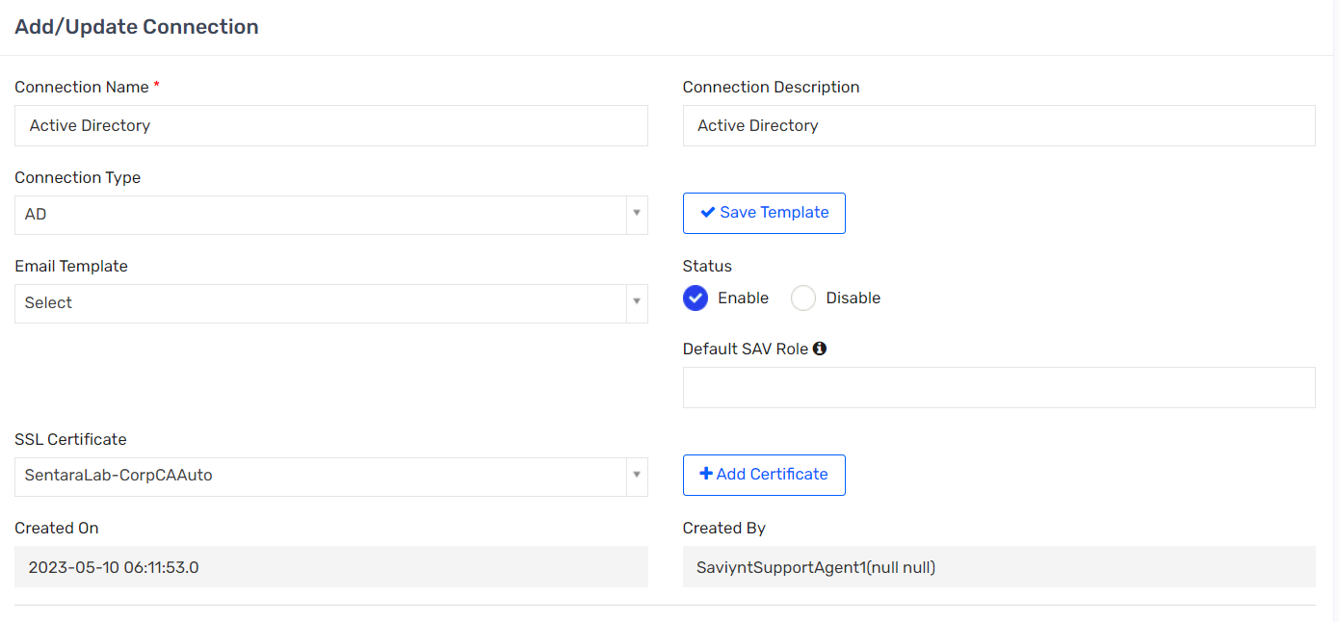

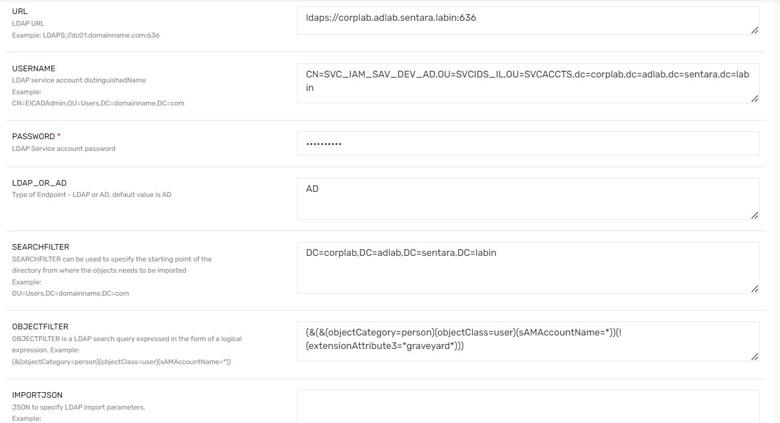

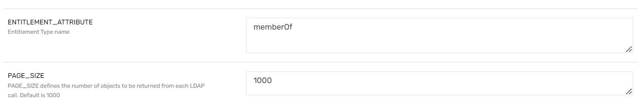

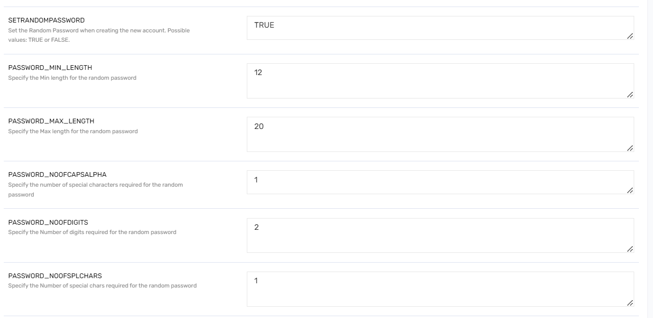



### ACCOUNT_ATTRIBUTE

|  |
| --- |
| [  name::samAccountName#String,  displayname::displayName#String,  description::description#String,  accountID::distinguishedName#String,  customproperty1::cn#String,  customproperty2::givenName#String,  customproperty3::sn#String,  customproperty4::userPrincipalName#String,  customproperty5::extensionAttribute13#String,  customproperty6::uidNumber#String,  customproperty8::userAccountControl#String,  customproperty10::objectGUID#Binary,  customproperty11::employeeType#String,  customproperty12::employeeNumber#String,  customproperty13::employeeID#String,  customproperty14::accountNameHistory#String,  customproperty15::mail#String,  customproperty16::extensionAttribute4#String,  customproperty17::extensionAttribute5#String,  customproperty18::extensionAttribute6#String,  customproperty19::extensionAttribute7#String,  customproperty20::extensionAttribute8#String,  customproperty21::extensionAttribute13#String,  customproperty22::departmentNumber#String,  customproperty23::department#String,  customproperty24::physicalDeliveryOfficeName#String,  customproperty31::proxyAddresses#String,  customproperty34::manager#String,  customproperty35::mobile#String,  customproperty36::telephoneNumber#String,  customproperty30::objectClass#String,  customproperty32::objectCategory#String,  customproperty33::accountExpires#String,  customproperty34::pwdLastSet#String,  customproperty35::extensionAttribute2#String,  LASTLOGONDATE::lastLogon#millisec,  LASTPASSWORDCHANGE::pwdLastSet#millisec,  INCORRECTLOGONS::badPwdCount#number,  UPDATEDATE::whenChanged#date,  CREATED_ON::whenCreated#date,  RECONCILATION_FIELD::customproperty10  ] |

### CREATEACCOUNTJSON

|  |
| --- |
| {  "objectClass":[  "top",  "person",  "organizationalPerson",  "user"  ],  "sAMAccountName":"${user.systemUserName}",  "employeeNumber":"${user.employeeid}",  "employeeType":"${user.employeeType}",  "givenName":"${if(user.preferedFirstName == null && user.middlename == null){user.firstname}else if(user.preferedFirstName != null && user.preferedFirstName.length() > 0 && user.middlename !=null && user.middlename.length() >0){user.preferedFirstName + ' ' + user.middlename.charAt(0)}else if(user.preferedFirstName != null && user.preferedFirstName.length() > 0 && (user.middlename == null || user.middlename.length() == 0)){user.preferedFirstName}else if(user.preferedFirstName ==null && user.middlename != null && user.middlename.length() > 0){user.firstname + ' ' + user.middlename.charAt(0)}}",  "sn":"${if(user.customproperty12!=null && user.customproperty12!='') {user.customproperty12} else {user.lastname}}",  "cn":"${user.systemUserName}", "displayName":"${if(user.customproperty12==null||user.customproperty12.length()==0){if(user.preferedFirstName==null&&user.middlename==null){user.firstname+' '+user.lastname}else if(user.preferedFirstName!=null&&user.preferedFirstName.length()>0&&user.middlename!=null&&user.middlename.length()>0){user.preferedFirstName+' '+user.middlename.charAt(0)+' '+user.lastname}else if(user.preferedFirstName!=null&&user.preferedFirstName.length()>0&&(user.middlename==null||user.middlename.length()==0)){user.preferedFirstName+' '+user.lastname}else if(user.preferedFirstName==null&&user.middlename!=null&&user.middlename.length()>0){user.firstname+' '+user.middlename.charAt(0)+' '+user.lastname}}else{if(user.preferedFirstName==null&&user.middlename==null){user.firstname+' '+user.customproperty12}else if(user.preferedFirstName!=null&&user.preferedFirstName.length()>0&&user.middlename!=null&&user.middlename.length()>0){user.preferedFirstName+' '+user.middlename.charAt(0)+' '+user.customproperty12}else if(user.preferedFirstName!=null&&user.preferedFirstName.length()>0&&(user.middlename==null||user.middlename.length()==0)){user.preferedFirstName+' '+user.customproperty12}else if(user.preferedFirstName==null&&user.middlename!=null&&user.middlename.length()>0){user.firstname+' '+user.middlename.charAt(0)+' '+user.customproperty12}}}",  "title":"${if(user.customproperty46 !=null) {user.customproperty46} else {user.title}}",  "mail":"${user.email}",  "userPrincipalName":"${user.systemUserName+ '@sentara-dev.com'}",  "pwdLastSet":"0",  "telephoneNumber":"${user.phonenumber}",  "extensionAttribute4":"${user.customproperty8}",  "extensionAttribute5":"${user.customproperty9}",  "extensionAttribute6":"${user.customproperty10}",  "extensionAttribute7":"${user.customproperty11}",  "extensionAttribute8":"${user.username}",  "extensionAttribute13":"${if(user.customproperty5!=null && user.customproperty5.equalsIgnoreCase('SecZetta')) {''} else if(user.employeeType!= null && (user.employeeType.toLowerCase().contains('emp') || user.employeeType.toLowerCase().contains('cwr'))) {'O365Sync'} else {''}}",  "scriptPath": "${if(user.employeeType!=null) {'logon.vbs'} else {''}}",  "departmentNumber":"${if(user.customproperty5!=null && user.customproperty5.equalsIgnoreCase('SecZetta')) {''} else if((user.employeeType!= null &&(user.employeeType.toLowerCase().contains('emp') || user.employeeType.toLowerCase().contains('cwr'))) && (user.customproperty15=='CM117' || user.customproperty15=='CM170' || user.customproperty15=='CM176')){user.customproperty15 + '-' + user.customproperty43 + '-' + user.costcenter} else if(user.employeeType.toLowerCase().contains('emp') || user.employeeType.toLowerCase().contains('cwr')) {user.customproperty15 + '-' + user.customproperty17 + '-' + user.costcenter} else {''}}",  "department":"${if(user.customproperty16!=null && user.customproperty16.length()>64) {user.customproperty16.substring(0,63)} else {user.customproperty16}}",  "physicalDeliveryOfficeName":"${user.locationnumber}",  "manager":"${if(user.manager!=null && managerAccount.accountID != null) {managerAccount.accountID} else {''}}",  "proxyAddresses": [  "${if(user.customproperty5!=null && user.customproperty5.equalsIgnoreCase('Workday') && user.customproperty59!=null && user.email!=null) {def pa='SMTP:' + user.email + ',smtp:' + user.customproperty59; pa.toString().replace(',','\",\"') } else {''}}"  ],  "accountExpires":"${if(user.customproperty5!=null && user.customproperty5.equalsIgnoreCase('SecZetta') && user.termDate!= null){10000*(user.termDate.getTime() + 28800000 + 11644473600000)} else if(user.customproperty25=='HIRED' || user.customproperty4=='VP' || user.customproperty4=='CEO' || user.customproperty4=='CVP' || user.customproperty4=='EVP' || user.customproperty4=='Divisional President'){'0'} else {'126227375990000000'}}"  } |

### UPDATEACCOUNTJSON

|  |
| --- |
| {  "sAMAccountName":"${user.systemUserName}",  "employeeNumber":"${user.employeeid}",  "employeeType":"${user.employeeType}",  "givenName":"${if(user.preferedFirstName == null && user.middlename == null){user.firstname}else if(user.preferedFirstName != null && user.preferedFirstName.length() > 0 && user.middlename !=null && user.middlename.length() >0){user.preferedFirstName + ' ' + user.middlename.charAt(0)}else if(user.preferedFirstName != null && user.preferedFirstName.length() > 0 && (user.middlename == null || user.middlename.length() == 0)){user.preferedFirstName}else if(user.preferedFirstName ==null && user.middlename != null && user.middlename.length() > 0){user.firstname + ' ' + user.middlename.charAt(0)}}",  "sn":"${if(user.customproperty12!=null && user.customproperty12!='') {user.customproperty12} else {user.lastname}}",  "cn":"${user.systemUserName}", "displayName":"${if(user.customproperty12==null||user.customproperty12.length()==0){if(user.preferedFirstName==null&&user.middlename==null){user.firstname+' '+user.lastname}else if(user.preferedFirstName!=null&&user.preferedFirstName.length()>0&&user.middlename!=null&&user.middlename.length()>0){user.preferedFirstName+' '+user.middlename.charAt(0)+' '+user.lastname}else if(user.preferedFirstName!=null&&user.preferedFirstName.length()>0&&(user.middlename==null||user.middlename.length()==0)){user.preferedFirstName+' '+user.lastname}else if(user.preferedFirstName==null&&user.middlename!=null&&user.middlename.length()>0){user.firstname+' '+user.middlename.charAt(0)+' '+user.lastname}}else{if(user.preferedFirstName==null&&user.middlename==null){user.firstname+' '+user.customproperty12}else if(user.preferedFirstName!=null&&user.preferedFirstName.length()>0&&user.middlename!=null&&user.middlename.length()>0){user.preferedFirstName+' '+user.middlename.charAt(0)+' '+user.customproperty12}else if(user.preferedFirstName!=null&&user.preferedFirstName.length()>0&&(user.middlename==null||user.middlename.length()==0)){user.preferedFirstName+' '+user.customproperty12}else if(user.preferedFirstName==null&&user.middlename!=null&&user.middlename.length()>0){user.firstname+' '+user.middlename.charAt(0)+' '+user.customproperty12}}}",  "title":"${if(user.title!=null){user.title}}",  "mail":"${user.email}",  "telephoneNumber":"${user.phonenumber}",  "extensionAttribute4":"${user.customproperty8}",  "extensionAttribute5":"${user.customproperty9}",  "extensionAttribute6":"${user.customproperty10}",  "extensionAttribute7":"${user.customproperty11}",  "extensionAttribute8":"${user.username}",  "extensionAttribute13":"${if(user.customproperty3!=null && user.customproperty3.equalsIgnoreCase('Suspend')){''} else if(user.customproperty5!=null && user.customproperty5=='SecZetta') {''} else if(user.employeeType!= null && (user.employeeType.toLowerCase().contains('emp') || user.employeeType.toLowerCase().contains('cwr'))) {'O365Sync'} else {''}}",  "departmentNumber":"${if(user.customproperty5!=null && user.customproperty5=='SecZetta') {''} else if((user.employeeType!= null &&(user.employeeType.toLowerCase().contains('emp') || user.employeeType.toLowerCase().contains('cwr'))) && (user.customproperty15=='CM117' || user.customproperty15=='CM170' || user.customproperty15=='CM176')){user.customproperty15 + '-' + user.customproperty43 + '-' + user.costcenter} else if(user.employeeType.toLowerCase().contains('emp') || user.employeeType.toLowerCase().contains('cwr')) {user.customproperty15 + '-' + user.customproperty17 + '-' + user.costcenter} else {''}}",  "department":"${if(user.customproperty16!=null && user.customproperty16.length()>64) {user.customproperty16.substring(0,63)} else {user.customproperty16}}",  "physicalDeliveryOfficeName":"${user.locationnumber}",  "scriptPath": "${if(user.employeeType!=null) {'logon.vbs'} else {''}}",  "manager":"${if(user.manager!=null && managerAccount.accountID != null) {managerAccount.accountID} else {''}}",  "proxyAddresses": [ "${if(user.customproperty5!=null && user.customproperty5.equalsIgnoreCase('Workday') && user.customproperty59!=null ) {'smtp:'+user.customproperty59} else {''}}" ],  "accountExpires":"${if(user.customproperty3!=null && user.customproperty3.equalsIgnoreCase('Suspend')){'126227375990000000'} else if(user.customproperty5!=null && user.customproperty5=='SecZetta' && user.termDate!= null){10000*(user.termDate.getTime() + 28800000 + 11644473600000)} else if(user.customproperty25=='HIRED' || user.customproperty4=='VP' || user.customproperty4=='CEO' || user.customproperty4=='CVP' || user.customproperty4=='EVP' || user.customproperty4=='Divisional President'){'0'}else{'126227375990000000'}}"  } |

### ENABLEACCOUNTJSON

|  |
| --- |
| {  "ENABLEACCOUNTOU":"${if(user.customproperty20!= null && (user.customproperty20.contains('Benefits Administrator') || user.customproperty20.contains('Broker') || user.customproperty20.contains('Group Contact')) && user.employeeType!='EMP')('OU=BA_BROKERS,DC=corplab, DC=adlab, DC=sentara, DC=labin') else ('OU=ADO, OU=USER,DC=corplab, DC=adlab, DC=sentara, DC=labin')}",  "ATTRIBUTESTOCHECK": {  "userAccountControl": "514"  },  "REMOVEGROUPS":"NO",  "USEDNFROMACCOUNT":"YES",  "MOVEDN":"YES",  "AFTERMOVEACTIONS": {  "userAccountControl":"544",  "description":"Enabled by IAM on ${(new java.text.SimpleDateFormat('yyyy-MM-dd HH:mm:ss').format(new Date()))} UTC"  }  } |

### ACCOUNTNAMERULE

|  |
| --- |
| ${if(user.customproperty20!= null && (user.customproperty20.contains('Benefits Administrator') || user.customproperty20.contains('Broker') || user.customproperty20.contains('Group Contact')) && user.employeeType!='EMP') {'CN='+user.systemUserName+',OU=BA_BROKERS,DC=corplab, DC=adlab, DC=sentara, DC=labin' } else {'CN='+user.systemUserName+',OU=ADO,OU=USER,DC=corplab,DC=adlab,DC=sentara, DC=labin' }} |

### REMOVEACCOUNTJSON

|  |
| --- |
| {  "removeAction": "SUSPEND",  "moveUsertoOU": "OU=Z_GRAVEYARD,DC=corplab,DC=adlab,DC=sentara,DC=labin",  "deleteAllGroups": "Yes",  "description": "Removed by Saviynt on ${(new java.text.SimpleDateFormat('yyyy-MM-dd HH:mm:ss').format(new Date()))} UTC",  "userAccountControl": "514",  "extensionAttribute13": "",  "extensionAttribute3": "graveyard"  } |

### groupimportMapping

|  |
| --- |
| {  "importGroupHierarchy": "true",  "performGroupAccountLinking": "true",  "incrementalTimeField": "whenChanged",  "groupObjectClass": "(objectCategory=group)",  "mapping": "memberHash:member_char,customproperty1:sAMAccountType_char,customproperty2:cn_char,customproperty3:distinguishedName_char,customproperty4:name_char,customproperty5:managedBy_char,customproperty6:uidNumber_char,customproperty7:mail_char,customproperty8:uSNCreated_char,customproperty9:objectCategory_char,customproperty10:objectGUID_Binary,customproperty11:objectSID_Binary,customproperty18:extensionAttribute8_char,customproperty20:extensionAttribute10_char,customproperty21:extensionAttribute11_char,customproperty32:extensionAttribute12_char,customproperty33:extensionAttribute13_char,customproperty34:extensionAttribute4_char,customproperty36:extensionAttribute6_char,customproperty37:extensionAttribute7_char,lastscandate:whenCreated_date,entitlement_glossary:description_char,description:description_char,displayname:displayName_char,entitlement_value:nameinnamespace_char,entitlementid:distinguishedName_char,updatedate:whenChanged_date,RECONCILATION_FIELD:customproperty10",  "activeGroupPossibleValues": ["active", "a", "l", "TRUE" ]  } |

### STATUS_THRESHOLD_CONFIG

|  |
| --- |
| {  "statusAndThresholdConfig": {  "statusColumn": "customproperty8",  "activeStatus": [  "512",  "544",  "66048"  ],  "accountThresholdValue": 5000,  "deleteLinks": false,  "correlateInactiveAccounts": true,  "inactivateAccountsNotInFile": false  }  } |

### DISABLEACCOUNTJSON

|  |
| --- |
| {  "description":"Disabled by IAM on ${(new java.text.SimpleDateFormat('yyyy-MM-dd HH:mm:ss').format(new Date()))} UTC",  "userAccountControl":"514",  "extensionAttribute13": "",  "deleteAllGroups": "No"  } |

## Active Directory O365 Sync Connection

### Connection Details

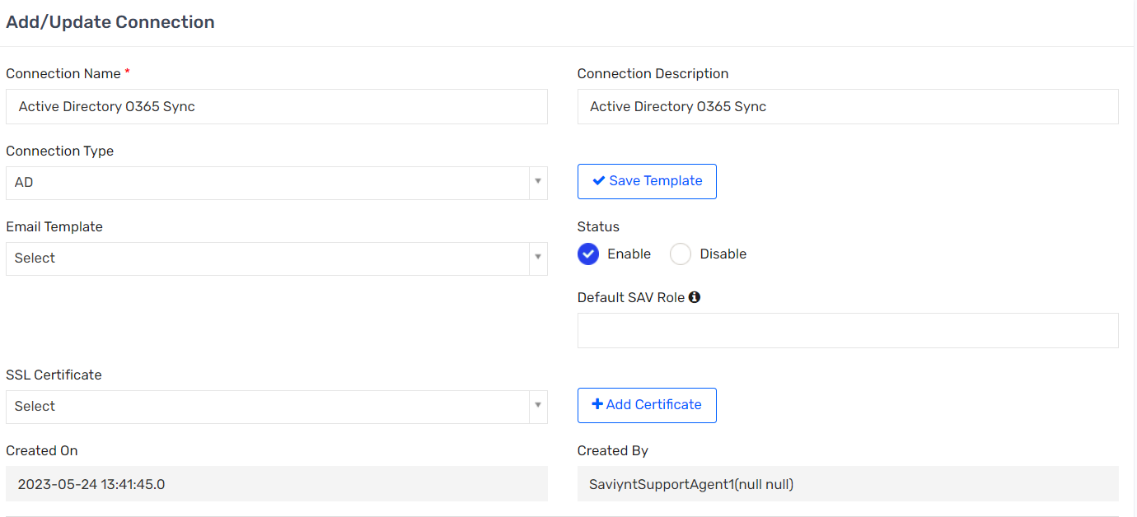

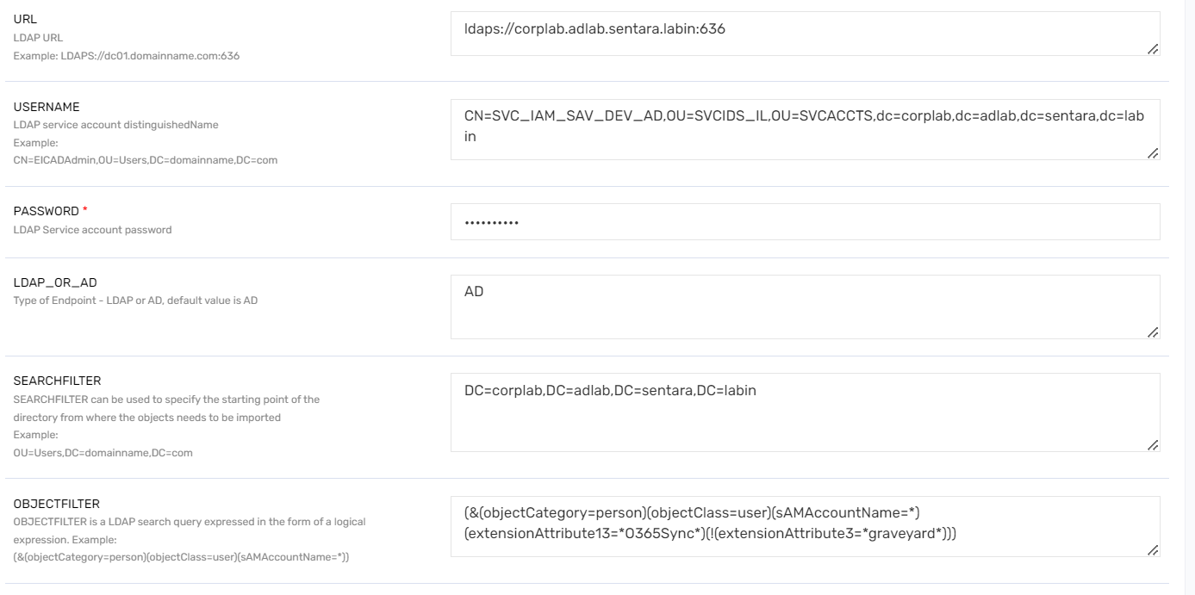

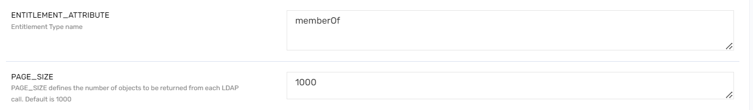



### ACCOUNT_ATTRIBUTE

|  |
| --- |
| [  name::samAccountName#String,  displayname::displayName#String,  description::description#String,  accountID::distinguishedName#String,  customproperty1::cn#String,  customproperty2::givenName#String,  customproperty3::sn#String,  customproperty4::userPrincipalName#String,  customproperty5::extensionAttribute13#String,  customproperty6::uidNumber#String,  customproperty8::userAccountControl#String,  customproperty10::objectGUID#Binary,  customproperty11::employeeType#String,  customproperty12::employeeNumber#String,  customproperty13::employeeID#String,  customproperty14::accountNameHistory#String,  customproperty15::mail#String,  customproperty16::extensionAttribute4#String,  customproperty17::extensionAttribute5#String,  customproperty18::extensionAttribute6#String,  customproperty19::extensionAttribute7#String,  customproperty20::extensionAttribute8#String,  customproperty21::extensionAttribute13#String,  customproperty22::departmentNumber#String,  customproperty23::department#String,  customproperty24::physicalDeliveryOfficeName#String,  customproperty31::proxyAddresses#String,  customproperty34::manager#String,  customproperty35::mobile#String,  customproperty36::telephoneNumber#String,  customproperty30::objectClass#String,  customproperty32::objectCategory#String,  customproperty33::accountExpires#String,  customproperty34::pwdLastSet#String,  customproperty35::extensionAttribute2#String,  LASTLOGONDATE::lastLogon#millisec,  LASTPASSWORDCHANGE::pwdLastSet#millisec,  INCORRECTLOGONS::badPwdCount#number,  UPDATEDATE::whenChanged#date,  CREATED_ON::whenCreated#date,  RECONCILATION_FIELD::customproperty10  ] |

### STATUS_THRESHOLD_CONFIG

|  |
| --- |
| {  "statusAndThresholdConfig": {  "statusColumn": "customproperty8",  "activeStatus": [  "512",  "544",  "66048"  ],  "accountThresholdValue": 30000,  "deleteLinks": false,  "correlateInactiveAccounts": true,  "inactivateAccountsNotInFile": false  }  } |

## AD GRAVEYARD OU Connection

### Connection Details

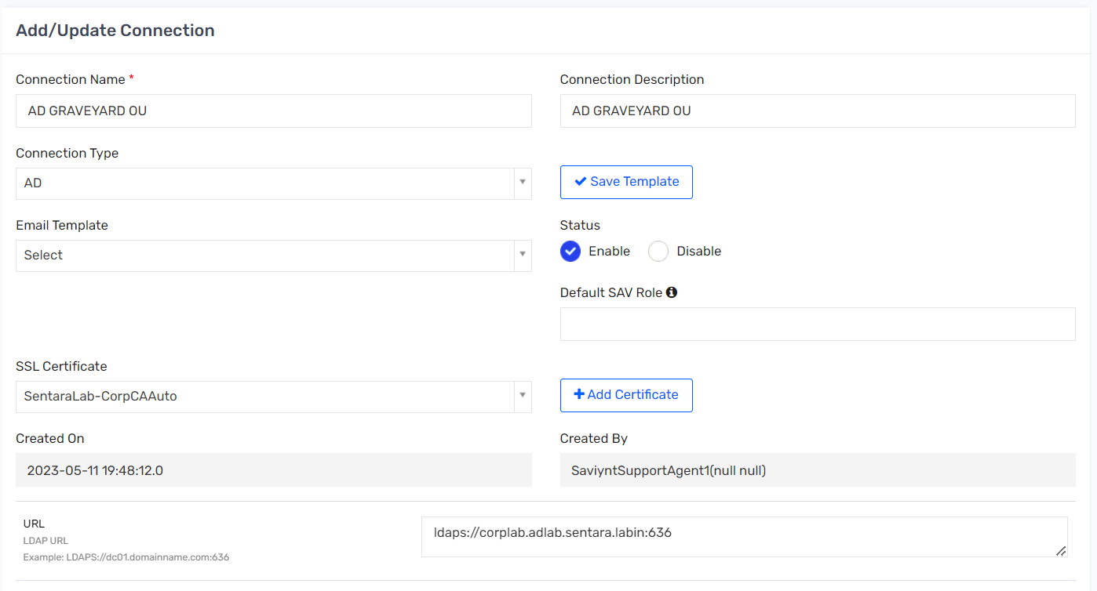

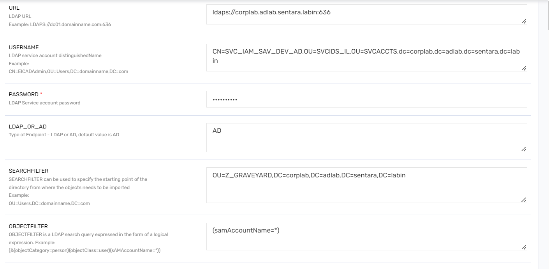

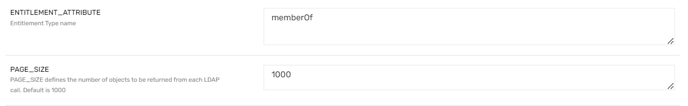



### ACCOUNT_ATTRIBUTE

|  |
| --- |
| [  name::samAccountName#String,  displayname::displayName#String,  description::description#String,  accountID::distinguishedName#String,  customproperty1::cn#String,  customproperty2::givenName#String,  customproperty3::sn#String,  customproperty4::userPrincipalName#String,  customproperty5::extensionAttribute13#String,  customproperty6::uidNumber#String,  customproperty8::userAccountControl#String,  customproperty10::objectGUID#Binary,  customproperty11::employeeType#String,  customproperty12::employeeNumber#String,  customproperty13::employeeID#String,  customproperty14::accountNameHistory#String,  customproperty15::mail#String,  customproperty16::extensionAttribute4#String,  customproperty17::extensionAttribute5#String,  customproperty18::extensionAttribute6#String,  customproperty19::extensionAttribute7#String,  customproperty20::extensionAttribute8#String,  customproperty21::extensionAttribute13#String,  customproperty22::departmentNumber#String,  customproperty23::department#String,  customproperty24::physicalDeliveryOfficeName#String,  customproperty31::proxyaddresses#String,  customproperty34::manager#String,  customproperty35::mobile#String,  customproperty36::telephoneNumber#String,  customproperty30::objectClass#String,  customproperty32::objectCategory#String,  customproperty33::accountExpires#String,  LASTLOGONDATE::lastLogon#millisec,  LASTPASSWORDCHANGE::pwdLastSet#millisec,  INCORRECTLOGONS::badPwdCount#number,  UPDATEDATE::whenChanged#date,  CREATED_ON::whenCreated#date,  RECONCILATION_FIELD::customproperty10  ] |

### STATUS_THRESHOLD_CONFIG

|  |
| --- |
| {  "statusAndThresholdConfig": {  "statusColumn": "customproperty8",  "activeStatus": [  "512",  "544",  "66048"  ],  "accountThresholdValue": 1000,  "deleteLinks": false,  "correlateInactiveAccounts": true,  "inactivateAccountsNotInFile": false  }  } |

## Azure O365 Update Connection

### Connection Details

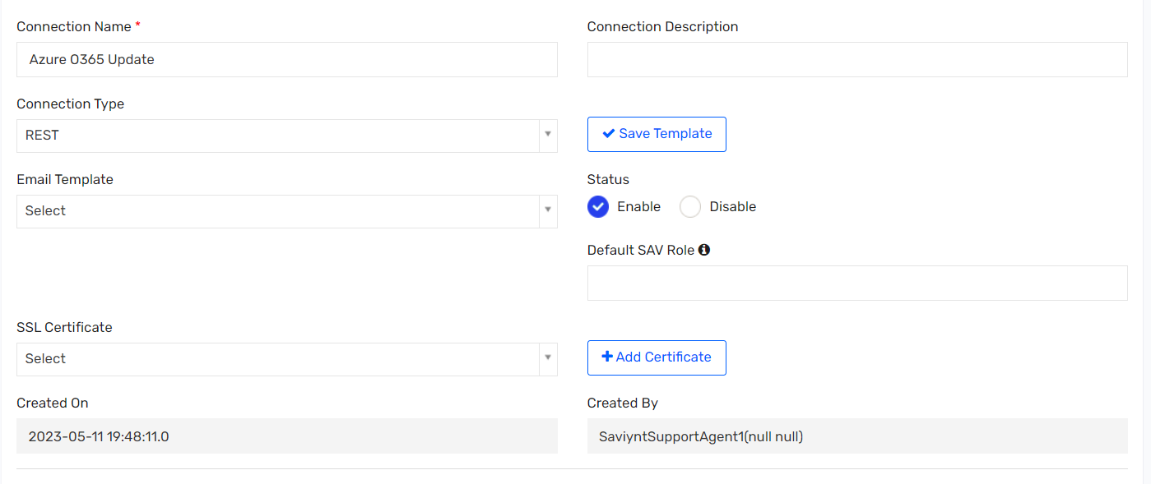

### DISABLEACCOUNTJSON

|  |
| --- |
| {  "responseColsToPropsMap": {},  "call": [  {  "name": "call1",  "connection": "userAuth",  "url": "http://10.12.58.116:80/Saviynt_APP/PS/ExecutePSScript",  "httpMethod": "POST",  "httpParams": "{\"Script\": \"cd D:\\\\\\\\Saviynt\\\\\\\\Powershell;.\\\\\\\\Azure-RevokeSession.ps1 ${arsTasks.accountName}\"}",  "httpHeaders": {  "Authorization": "${access_token}"  },  "httpContentType": "application/x-www-form-urlencoded",  "successResponses":{  "statusCode": [  200,  201,  204,  205  ]  },  "unsuccessResponses":{  "statusCode": [  500,  401  ]  }  }  ]  } |

### REMOVEACCOUNTJSON

|  |
| --- |
| {  "responseColsToPropsMap": {},  "call": [  {  "name": "call1",  "connection": "userAuth",  "url": "http://10.12.58.116:80/Saviynt_APP/PS/ExecutePSScript",  "httpMethod": "POST",  "httpParams": "{\"Script\": \"cd D:\\\\\\\\Saviynt\\\\\\\\Powershell;.\\\\\\\\Azure-RevokeSession.ps1 ${arsTasks.accountName}\"}",  "httpHeaders": {  "Authorization": "${access_token}"  },  "httpContentType": "application/x-www-form-urlencoded",  "successResponses":{  "statusCode": [  200,  201,  204,  205  ]  },  "unsuccessResponses":{  "statusCode": [  500,  401  ]  }  }  ]  } |

## DUO Connection

### Connection Details

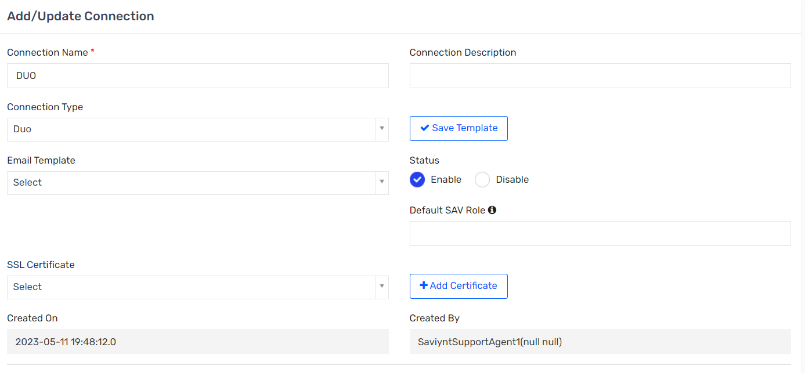

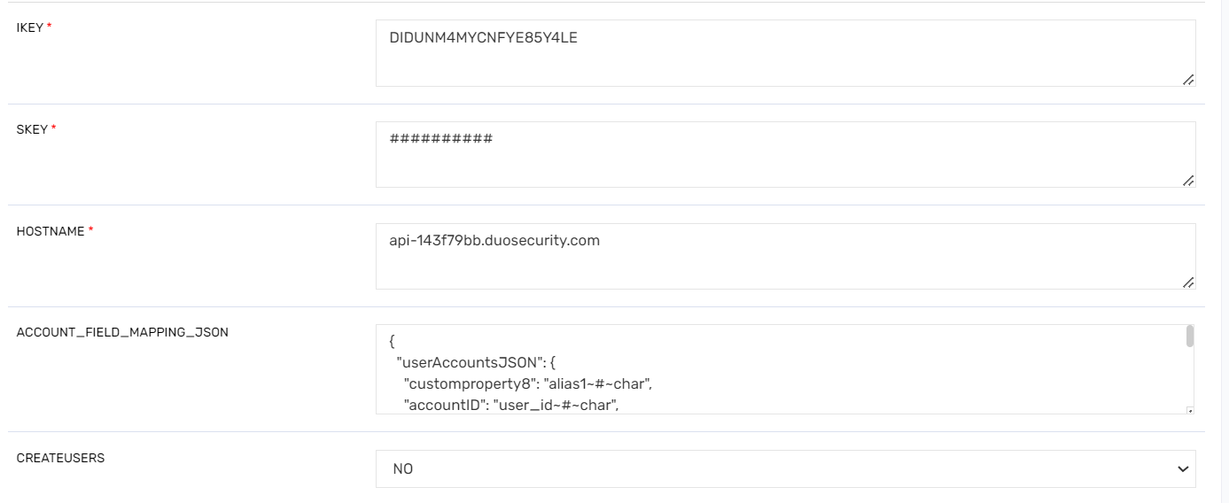

### ACCOUNT_FIELD_MAPPING_JSON

|  |
| --- |
| {  "userAccountsJSON": {  "customproperty8": "alias1~#~char",  "accountID": "user_id~#~char",  "name": "username~#~char",  "displayName": "c~#~char",  "customproperty4": "email~#~char",  "customproperty5": "username~#~char",  "comments": "username~#~char",  "customproperty6": "last_login~#~datemillis",  "customproperty7": "notes~#~char",  "customproperty9": "realname~#~char",  "customproperty14": "status~#~char",  "customproperty13": "groups.name~#~longtext",  "customproperty20": "alias2~#~char",  "customproperty11": "firstname~#~char",  "customproperty12": "lastname~#~char"  }  } |

## DUO Provisioning Connection

### Connection Details

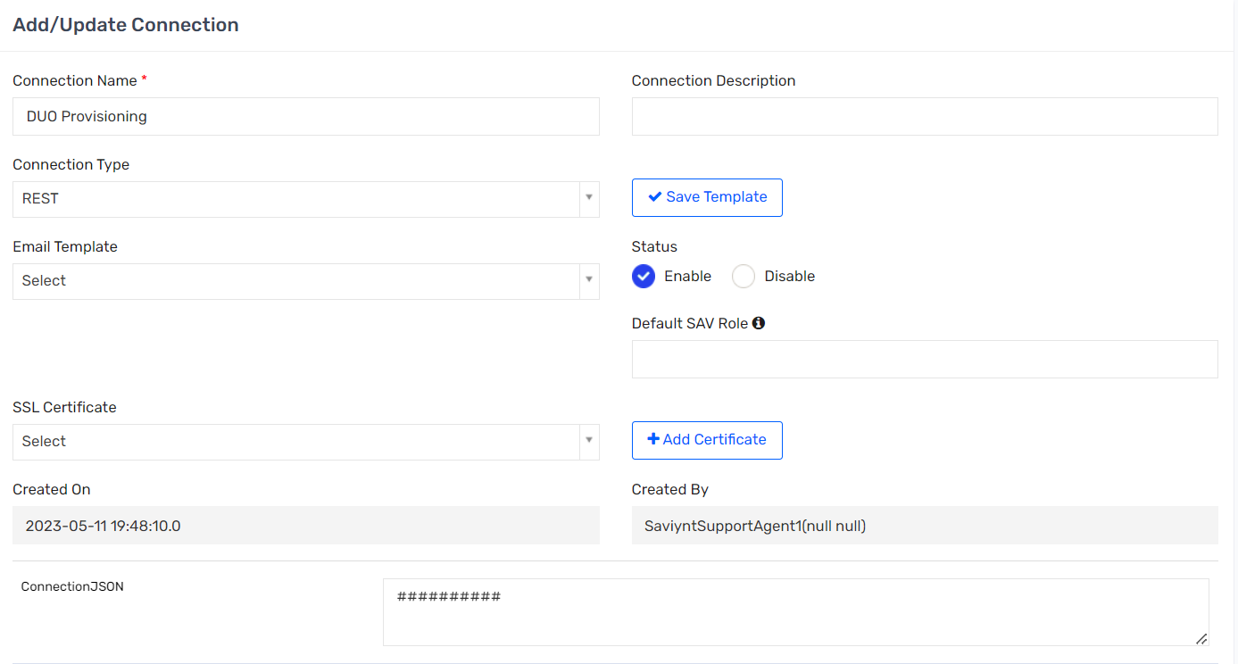

### IMPORTACCTENTJSON

|  |
| --- |
| {  "accountParams": {  "connection": "acctAuth",  "processingType": "SequentialAndIterative",  "call": {  "call1": {  "callOrder": 0,  "stageNumber": 0,  "http": {  "url": "https://api-143f79bb.duosecurity.com/admin/v1/users",  "httpMethod": "GET",  "httpHeaders": {  "Accept": "application/json",  "Authorization": "${access_token}"  }  },  "listField": "response",  "keyField": "accountID",  "colsToPropsMap": {  "accountID": "user_id~#~char",  "name": "username~#~char",  "displayName": "realname~#~char",  "customproperty1": "firstname~#~char",  "customproperty2": "lastname~#~char",  "customproperty4": "email~#~char",  "customproperty5": "username~#~char",  "comments": "email~#~char",  "customproperty7": "notes~#~char",  "customproperty9": "email~#~char",  "customproperty14": "status~#~char"  }  }  },  "statusConfig": {  "active": "active",  "inactive": "disabled"  },  "successResponses": {  "statusCode": [  200,  201,  202,  203,  204,  205  ]  }  },  "entitlementParams": {  },  "acctEntParams": {  }  } |

CREATEACCOUNTJSON

|  |
| --- |
| {  "accountIdPath": "${(requestAccessAttributes?.get('Account Type') != null && requestAccessAttributes?.get('Account Type')?.equals('AdminUser')) ? 'call1.message.response.admin_id' :'call1.message.response.user_id'}",  "dateFormat": "ddd, DD MMM YYYY HH:mm:ss ZZ",  "responseColsToPropsMap": {  "accountsStatus": "${(requestAccessAttributes?.get('Account Type') != null && requestAccessAttributes?.get('Account Type')?.equals('AdminUser')) ? '#CONST#Active~#~char' : 'call1.message.status~#~char'}",  "displayName": "call1.message.response.realname~#~char",  "name": "${(requestAccessAttributes?.get('Account Type') != null && requestAccessAttributes?.get('Account Type')?.equals('AdminUser'))?'call1.message.response.name~#~char' : 'call1.message.response.username~#~char'}",  "accountType": "${(requestAccessAttributes?.get('Account Type') != null && requestAccessAttributes?.get('Account Type')?.equals('AdminUser')) ? '#CONST#AdminUser~#~char' :'#CONST#EndUser~#~char'}",  "accountRole": "call1.message.response.role~#~char"  },  "call": [  {  "name": "call1",  "connection": "acctAuth",  "basicUrl": "api-143f79bb.duosecurity.com",  "hostUrl": "/admin/v1/users",  "url": "https://api-143f79bb.duosecurity.com/admin/v1/users",  "httpMethod": "POST",  "httpParams": "{\"username\":\"${user.systemUserName}\", \"email\": \"${user.email}\", \"status\": \"active\", \"notes\": \"${user.username}\", \"realname\": \"${user.firstname} ${user.lastname}\"}"  },  {  "name": "call2",  "connection": "acctAuth",  "basicUrl": "api-143f79bb.duosecurity.com",  "hostUrl": "/admin/v1/users/enroll",  "url": "https://api-143f79bb.duosecurity.com/admin/v1/users/enroll",  "httpMethod": "POST",  "httpParams": "{\"email\": \"${user.email}\", \"username\": \"${user.systemUserName}\"}",  "successResponses": {  "statusCode": [  200,  400  ]  }  }  ]  } |

### UPDATEACCTJSON

|  |
| --- |
| {  "dateFormat": "ddd, DD MMM YYYY HH:mm:ss ZZ",  "responseColsToPropsMap": {  "accountsStatus": "${(requestAccessAttributes?.get('Account Type') != null && requestAccessAttributes?.get('Account Type')?.equals('AdminUser')) ? '#CONST#Active~#~char' : 'call1.message.status~#~char'}",  "displayName": "call1.message.response.realname~#~char",  "name": "${(requestAccessAttributes?.get('Account Type') != null && requestAccessAttributes?.get('Account Type')?.equals('AdminUser'))?'call1.message.response.name~#~char' :'call1.message.response.username~#~char'}",  "accountType": "${(requestAccessAttributes?.get('Account Type') != null && requestAccessAttributes?.get('Account Type')?.equals('AdminUser')) ? '#CONST#AdminUser~#~char' :'#CONST#EndUser~#~char'}",  "accountRole": "call1.message.response.role~#~char"  },  "call": [  {  "name": "call1",  "connection": "acctAuth",  "basicUrl": "api-143f79bb.duosecurity.com",  "hostUrl": "/admin/v1/users/${account.accountID}",  "url": "https://api-143f79bb.duosecurity.com/admin/v1/users/${account.accountID}",  "httpMethod": "POST",  "httpParams": "{\"username\": \"${user.systemUserName}\", \"realname\": \"${user.firstname} ${user.lastname}\", \"email\": \"${user.email}\"}"  }  ]  } |

### ENABLEACCOUNTJSON

|  |
| --- |
| {  "call": [  {  "name": "call1",  "connection": "acctAuth",  "basicUrl":"api-143f79bb.duosecurity.com",  "hostUrl":"/admin/v1/users/${account.accountID}",  "url":"https://api-143f79bb.duosecurity.com/admin/v1/users/${account.accountID}",  "httpMethod": "POST",  "httpParams": "{\"status\": \"active\",\"username\": \"${user.systemUserName}\"}"  }  ]  } |

### DISABLEACCOUNTJSON

|  |
| --- |
| {  "call": [  {  "name": "call1",  "connection": "acctAuth",  "basicUrl":"api-143f79bb.duosecurity.com",  "hostUrl":"/admin/v1/users/${account.accountID}",  "url":"https://api-143f79bb.duosecurity.com/admin/v1/users/${account.accountID}",  "httpMethod": "POST",  "httpParams": "{\"status\": \"disabled\"}"  }  ]  } |

### ADDACCESSJSON

|  |
| --- |
| {  "call": [  {  "name": "Group",  "connection": "acctAuth",  "basicUrl":"https://api-143f79bb.duosecurity.com",  "hostUrl":"/admin/v1/users/${account.accountID}/groups",  "url": "https://api-143f79bb.duosecurity.com/admin/v1/users/${account.accountID}/groups",  "httpMethod": "POST",  "httpParams": "{\"group_id\": \"${entitlementValue.entitlementID}\"}"  }  ]  } |

### REMOVEACCESSJSON

|  |
| --- |
| {  "call": [  {  "name": "call1",  "connection": "acctAuth",  "basicUrl": "api-143f79bb.duosecurity.com",  "hostUrl": "/admin/v1/users/${account.accountID}",  "url": "https://api-143f79bb.duosecurity.com/admin/v1/users/${account.accountID}",  "httpMethod": "DELETE"  }  ]  } |

## MicrosoftGraph_RevokeSession Connection

### Connection Details

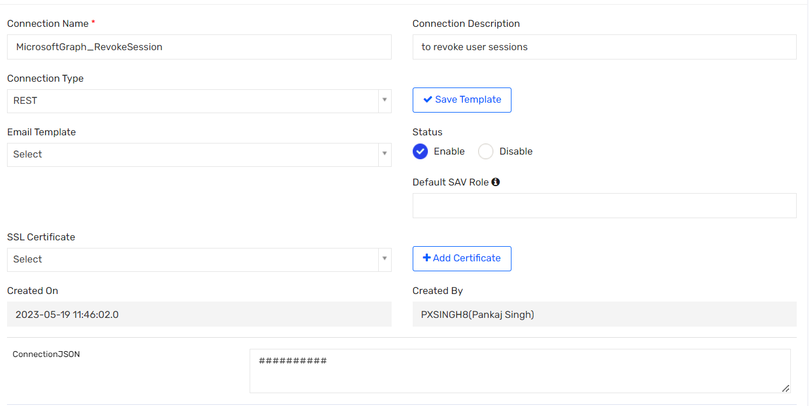

### UPDATEACCOUNTJSON

|  |
| --- |
| {  "call": [{  "name": "call1",  "connection": "acctAuth",  "url": "https://graph.microsoft.com/v1.0/users/${account.customproperty4}/revokeSignInSessions",  "httpMethod": "POST",  "httpParams": "",  "httpHeaders": {  "Authorization": "${access_token}",  "Accept": "application/json"  },  "httpContentType": "application/json",  "successResponses": {  "statusCode": [  200,  201  ]  }  }]  } |

### DISABLEACCOUNTJSON

|  |
| --- |
| {  "call": [{  "name": "call1",  "connection": "acctAuth",  "url": "https://graph.microsoft.com/v1.0/users/${account.customproperty4}/revokeSignInSessions",  "httpMethod": "POST",  "httpParams": "",  "httpHeaders": {  "Authorization": "${access_token}",  "Accept": "application/json"  },  "httpContentType": "application/json",  "successResponses": {  "statusCode": [  200,  201  ]  }  }]  } |

## ServiceNow Connection

### Connection Details

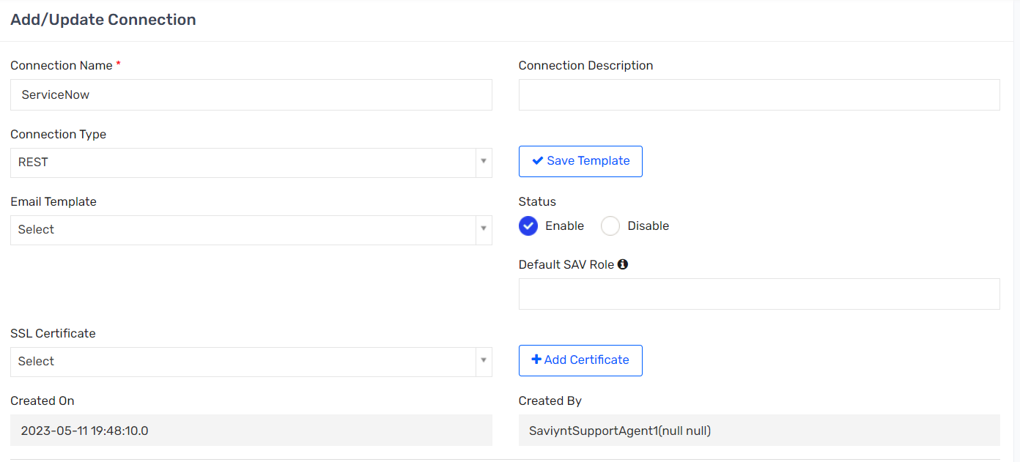

### IMPORTACCOUNTENTJSON

|  |
| --- |
| {  "accountParams": {  "connection": "acctAuth",  "processingType": "SequentialAndIterative",  "call": {  "call1": {  "callOrder": 0,  "stageNumber": 0,  "http": {  "url": "https://sentarasubdev01.service-now.com/api/now/table/sys_user?sysparm_limit=100",  "httpHeaders": {  "Authorization": "${access_token}"  },  "httpContentType": "application/x-www-form-urlencoded",  "httpMethod": "GET"  },  "statusConfig": {  "active": "true",  "inactive": "false"  },  "listField": "result",  "keyField": "accountID",  "colsToPropsMap": {  "customproperty1": "employee_number~#~char",  "CUSTOMPROPERTY2": "last_name~#~char",  "customproperty3": "name~#~char",  "CUSTOMPROPERTY4": "first_name~#~char",  "CUSTOMPROPERTY5": "department~#~char",  "CUSTOMPROPERTY6": "location~#~char",  "CUSTOMPROPERTY7": "email~#~char",  "CUSTOMPROPERTY8": "manager~#~char",  "CUSTOMPROPERTY9": "country~#~char",  "CUSTOMPROPERTY10": "phone~#~char",  "CUSTOMPROPERTY11": "title~#~char",  "CUSTOMPROPERTY12": "u_iam_id~#~char",  "name": "user_name~#~char",  "status": "active~#~char",  "accountID": "sys_id~#~char"  },  "pagination": {  "nextUrl": {  "nextUrlPath": "${headers?.Link?.split(';')?.size()==5?headers?.Link?.split(';')[2]?.replace('rel=\"prev\",<', '')?.replace('>','')?.trim():headers?.Link?.split(';')?.size()==4 && headers?.Link?.split(';')[2].contains('rel=\"next\",<')?headers?.Link?.split(';')[1]?.replace('rel=\"first\",<', '')?.replace('>','')?.trim():null}"  }  }  }  }  },  "entitlementParams": {  },  "acctEntParams": {  }  } |

### STATUS_THRESHOLD_CONFIG

|  |
| --- |
| {  "statusAndThresholdConfig": {  "accountThresholdValue": 500000,  "deleteLinks": false,  "correlateInactiveAccounts": true,  "inactivateAccountsNotInFile": false  }  } |

### CREATEACCOUNTJSON

|  |
| --- |
| {  "accountIdPath":"call1.message.result.sys_id",  "responseColsToPropsMap":{  "name":"call1.message.result.user_name~#~char"  },  "call":[  {  "name":"call1",  "connection":"acctAuth",  "url":"https://sentarasubdev01.service-now.com/api/now/table/sys_user",  "httpMethod":"POST",  "httpParams":"{\"city\":\"${if(user.customproperty22 != null) {user.customproperty22} else {''}}\", \"active\":\"true\", \"country\":\"${if(user.country != null) {user.country} else {''}}\",\"u_account_number\":\"${if(user.costcenter != null) {user.costcenter} else {''}}\",\"department\":\"${if(user.departmentname!= null) {user.departmentname} else if(user.customproperty2 != null) {user.customproperty2} else {''}}\", \"email\":\"${if(user.email != null) {user.email} else {''}}\", \"employee_number\":\"${if(user.employeeid != null) {user.employeeid} else {''}}\", \"first_name\":\"${if(user.firstname != null) {user.firstname} else {''}}\", \"last_name\":\"${if(user.lastname != null) {user.lastname} else {''}}\", \"middle_name\":\"${if(user.middlename != null) {user.middlename} else {''}}\", \"source\":\"${if(user.customproperty5 != null) {user.customproperty5} else {''}}\", \"name\":\"${if(user.preferedFirstName != null) {user.preferedFirstName} else {''}} ${if(user.customproperty12 != null) {user.customproperty12} else {''}}\", \"phone\":\"${if(user.phonenumber != null) {user.phonenumber} else {''}}\", \"state\":\"${if(user.customproperty21 != null) {user.customproperty21} else {''}}\", \"street\":\"${if(user.locationdesc != null) {user.locationdesc} else {''}}\", \"title\":\"${if(user.title != null) {user.title} else {''}}\", \"u_type\":\"${if(user.employeeType != null) {user.employeeType} else {''}}\", \"manager\":\"${if(managerAccount !=null){managerAccount.accountID} else {''}}\",\"u_pager\":\"${if(user.customproperty41 != null) {user.customproperty41} else {''}}\", \"u_company_role\":\"${if(user.customproperty4 != null) {user.customproperty4} else {''}}\", \"u_contingent_worker\":\"${if(user.employeeType=='CWR') {'true'} else {'false'}}\",\"location\":\"${if(user.location != null) {user.location} else {''}}\", \"u_iam_id\":\"${if(user.username != null) {user.username} else {''}}\", \"u_job_code\":\"${if(user.jobCode != null) {user.jobCode} else {''}}\", \"u_hire_date\":\"${if(user.startdate != null) {user.startdate} else {''}}\", \"u_is_manager\":\"${if(user.customproperty31 != null && user.customproperty31.equalsIgnoreCase('true')){'1'} else {''}}\", \"u_status\":\"A\",\"mobile_phone\":\"${if(user.customproperty38 != null) {user.customproperty38} else {''}}\", \"u_department_id\":\"${if(user.customproperty17 != null) {user.customproperty17} else {''}}\", \"company\":\"${if(user.companyname != null) {user.companyname} else {''}}\", \"u_location_id\":\"${if(user.locationnumber != null) {user.locationnumber} else {''}}\",\"u_fax\":\"${if(user.customproperty40 != null) {user.customproperty40} else {''}}\", \"user_name\":\"${if(user.systemUserName != null) {user.systemUserName} else {''}}\", \"zip\":\"${if(user.regioncode != null) {user.regioncode} else {''}}\", \"u_preferred_first_name\":\"${if(user.preferedFirstName != null) {user.preferedFirstName } else {''}}\", \"u_preferred_middle_name\":\"${if(user.middlename != null) {user.middlename } else {''}}\", \"u_preferred_last_name\":\"${if(user.customproperty12 != null) {user.customproperty12 } else {''}}\"}",  "httpHeaders":{  "Authorization":"${access_token}"  },  "httpContentType":"application/json",  "successResponses": {"statusCode": [200,201,204]},  "unsuccessResponses": {"statusCode": [401,403,404,405,406,415]}  }  ]  } |

### UPDATEACCOUNTJSON

|  |
| --- |
| {  "accountIdPath":"call1.message.result.sys_id",  "responseColsToPropsMap":{  "name":"call1.message.result.user_name~#~char"  },  "call":[  {  "name":"call1",  "connection":"acctAuth",  "url":"https://sentarasubdev01.service-now.com/api/now/table/sys_user/${account.accountID}",  "httpMethod":"PUT",  "httpParams":"{\"city\":\"${if(user.customproperty22 != null) {user.customproperty22} else {''}}\", \"active\":\"true\", \"country\":\"${if(user.country != null) {user.country} else {''}}\",\"u_account_number\":\"${if(user.costcenter != null) {user.costcenter} else {''}}\",\"department\":\"${if(user.departmentname!= null) {user.departmentname} else if(user.customproperty2 != null) {user.customproperty2} else {''}}\", \"email\":\"${if(user.email != null) {user.email} else {''}}\", \"employee_number\":\"${if(user.employeeid != null) {user.employeeid} else {''}}\", \"first_name\":\"${if(user.firstname != null) {user.firstname} else {''}}\", \"last_name\":\"${if(user.lastname != null) {user.lastname} else {''}}\", \"middle_name\":\"${if(user.middlename != null) {user.middlename} else {''}}\", \"source\":\"${if(user.customproperty5 != null) {user.customproperty5} else {''}}\", \"name\":\"${if(user.preferedFirstName != null) {user.preferedFirstName} else {''}} ${if(user.customproperty12 != null) {user.customproperty12} else {''}}\", \"phone\":\"${if(user.phonenumber != null) {user.phonenumber} else {''}}\", \"state\":\"${if(user.customproperty21 != null) {user.customproperty21} else {''}}\", \"street\":\"${if(user.locationdesc != null) {user.locationdesc} else {''}}\", \"title\":\"${if(user.title != null) {user.title} else {''}}\", \"u_type\":\"${if(user.employeeType != null) {user.employeeType} else {''}}\", \"manager\":\"${if(managerAccount !=null){managerAccount.accountID} else {''}}\",\"u_pager\":\"${if(user.customproperty41 != null) {user.customproperty41} else {''}}\", \"u_company_role\":\"${if(user.customproperty4 != null) {user.customproperty4} else {''}}\", \"u_contingent_worker\":\"${if(user.employeeType=='CWR') {'true'} else {'false'}}\",\"location\":\"${if(user.location != null) {user.location} else {''}}\", \"u_iam_id\":\"${if(user.username != null) {user.username} else {''}}\", \"u_job_code\":\"${if(user.jobCode != null) {user.jobCode} else {''}}\", \"u_hire_date\":\"${if(user.startdate != null) {user.startdate} else {''}}\", \"u_is_manager\":\"${if(user.customproperty31 != null && user.customproperty31.equalsIgnoreCase('true')){'1'} else {''}}\", \"u_status\":\"A\",\"mobile_phone\":\"${if(user.customproperty38 != null) {user.customproperty38} else {''}}\", \"u_department_id\":\"${if(user.customproperty17 != null) {user.customproperty17} else {''}}\", \"company\":\"${if(user.companyname!= null) {user.companyname} else {''}}\", \"u_location_id\":\"${if(user.locationnumber != null) {user.locationnumber} else {''}}\",\"u_fax\":\"${if(user.customproperty40 != null) {user.customproperty40} else {''}}\", \"user_name\":\"${if(user.systemUserName != null) {user.systemUserName} else {''}}\", \"zip\":\"${if(user.regioncode != null) {user.regioncode} else {''}}\", \"u_nickname\":\"${if(user.preferedFirstName != null) {user.preferedFirstName } else {''}}\", \"u_preferred_first_name\":\"${if(user.preferedFirstName != null) {user.preferedFirstName } else {''}}\", \"u_preferred_middle_name\":\"${if(user.middlename != null) {user.middlename } else {''}}\", \"u_preferred_last_name\":\"${if(user.customproperty12 != null) {user.customproperty12 } else {''}}\"}",  "httpHeaders":{  "Authorization":"${access_token}"  },  "httpContentType":"application/json",  "successResponses": {"statusCode": [200,201,204]},  "unsuccessResponses": {"statusCode": [401,403,404,405,406,415]}  }  ]  } |

### ENABLEACCOUNTJSON

|  |
| --- |
| {  "accountIdPath":"call1.message.result.sys_id",  "responseColsToPropsMap":{  "name":"call1.message.result.user_name~#~char"  },  "call":[  {  "name":"call1",  "connection":"acctAuth",  "url":"https://sentarasubdev01.service-now.com/api/now/table/sys_user/${account.accountID}",  "httpMethod":"PUT",  "httpParams":"{\"city\":\"${if(user.customproperty22 != null) {user.customproperty22} else {''}}\", \"active\":\"true\", \"country\":\"${if(user.country != null) {user.country} else {''}}\",\"u_account_number\":\"${if(user.costcenter != null) {user.costcenter} else {''}}\",\"department\":\"${if(user.departmentname!= null) {user.departmentname} else if(user.customproperty2 != null) {user.customproperty2} else {''}}\", \"email\":\"${if(user.email != null) {user.email} else {''}}\", \"employee_number\":\"${if(user.employeeid != null) {user.employeeid} else {''}}\", \"first_name\":\"${if(user.firstname != null) {user.firstname} else {''}}\", \"last_name\":\"${if(user.lastname != null) {user.lastname} else {''}}\", \"middle_name\":\"${if(user.middlename != null) {user.middlename} else {''}}\", \"source\":\"${if(user.customproperty5 != null) {user.customproperty5} else {''}}\", \"name\":\"${if(user.preferedFirstName != null) {user.preferedFirstName} else {''}} ${if(user.customproperty12 != null) {user.customproperty12} else {''}}\", \"phone\":\"${if(user.phonenumber != null) {user.phonenumber} else {''}}\", \"state\":\"${if(user.customproperty21 != null) {user.customproperty21} else {''}}\", \"street\":\"${if(user.locationdesc != null) {user.locationdesc} else {''}}\", \"title\":\"${if(user.title != null) {user.title} else {''}}\", \"u_type\":\"${if(user.employeeType != null) {user.employeeType} else {''}}\", \"manager\":\"${if(managerAccount !=null){managerAccount.accountID} else {''}}\",\"u_pager\":\"${if(user.customproperty41 != null) {user.customproperty41} else {''}}\", \"u_company_role\":\"${if(user.customproperty4 != null) {user.customproperty4} else {''}}\", \"u_contingent_worker\":\"${if(user.employeeType=='CWR') {'true'} else {'false'}}\",\"location\":\"${if(user.location != null) {user.location} else {''}}\", \"u_iam_id\":\"${if(user.username != null) {user.username} else {''}}\", \"u_job_code\":\"${if(user.jobCode != null) {user.jobCode} else {''}}\", \"u_hire_date\":\"${if(user.startdate != null) {user.startdate} else {''}}\", \"u_is_manager\":\"${if(user.customproperty31 != null && user.customproperty31.equalsIgnoreCase('true')){'1'} else {''}}\", \"u_status\":\"A\",\"mobile_phone\":\"${if(user.customproperty38 != null) {user.customproperty38} else {''}}\", \"u_department_id\":\"${if(user.customproperty17 != null) {user.customproperty17} else {''}}\", \"company\":\"${if(user.companyname!= null) {user.companyname} else {''}}\", \"u_location_id\":\"${if(user.locationnumber != null) {user.locationnumber} else {''}}\",\"u_fax\":\"${if(user.customproperty40 != null) {user.customproperty40} else {''}}\", \"user_name\":\"${if(user.systemUserName != null) {user.systemUserName} else {''}}\", \"zip\":\"${if(user.regioncode != null) {user.regioncode} else {''}}\", \"u_nickname\":\"${if(user.preferedFirstName != null) {user.preferedFirstName } else {''}}\",\"locked_out\":\"false\", \"u_preferred_first_name\":\"${if(user.preferedFirstName != null) {user.preferedFirstName } else {''}}\", \"u_preferred_middle_name\":\"${if(user.middlename != null) {user.middlename } else {''}}\", \"u_preferred_last_name\":\"${if(user.customproperty12 != null) {user.customproperty12 } else {''}}\"}",  "httpHeaders":{  "Authorization":"${access_token}"  },  "httpContentType":"application/json",  "successResponses": {"statusCode": [200,201,204]},  "unsuccessResponses": {"statusCode": [401,403,404,405,406,415]}  }  ]  } |

### DISABLEACCOUNTJSON

|  |
| --- |
| {  "call": [{  "name": "call",  "connection": "acctAuth",  "url": "https://sentarasubdev01.service-now.com/api/now/table/sys_user/${account.accountID}",  "httpMethod": "PUT",  "httpContentType": "application/json",  "httpParams": "{\"active\":\"false\"}",  "httpHeaders": {  "Authorization": "${access_token}" }  }]  } |

### REMOVEACCOUNTJSON

|  |
| --- |
| {  "call": [  {  "name": "call1",  "connection": "userAuth",  "url":"https://sentarasubdev01.service-now.com.service-now.com/api/now/v1/table/sys_user/${account.accountID}",  "httpMethod": "DELETE",  "httpHeaders": {  "Authorization": "${access_token}"  },  "httpContentType": "application/json",  "successResponses": {  "statusCode": [  204  ]  },  "unsuccessResponses": {  "statusCode": [  403  ]  }  }  ]  } |

## Saviynt Connection

### Connection Details

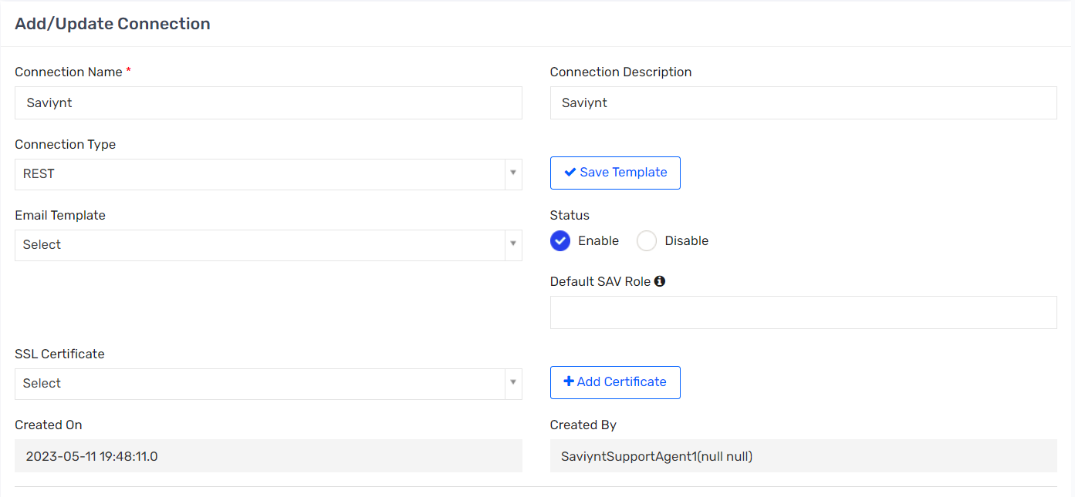

### UPDATEUSERJSON

|  |
| --- |
| {  "actions": {  "Update Login": {  "call": [  {  "name": "Update Login",  "connection": "acctAuth",  "url": "https://sentara-test.saviyntcloud.com/ECM/api/v5/updateUser",  "httpMethod": "POST",  "httpParams": "{\"username\":\"${user.username}\",\"enddate\":\"${new java.text.SimpleDateFormat('MM-dd-yyyy').format(arsTasks?.taskdate)}\"}",  "httpHeaders": {  "contentType": "application/json",  "Accept": "application/json",  "Authorization": "${access_token}"  },  "httpContentType": "application/json",  "successResponses": {"statusCode": [200,201,204]},  "unsuccessResponses": {"statusCode": [401,403,404,405,406,415]}  }  ]  }  }  } |

## PSDB Provisioning Connection

### Connection Details

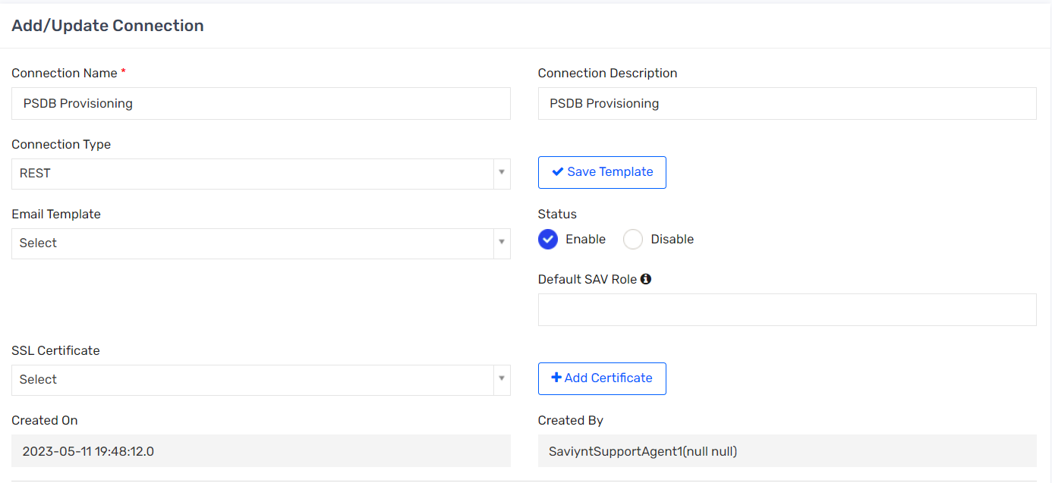

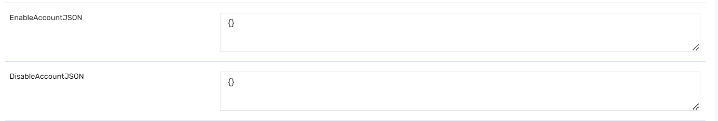

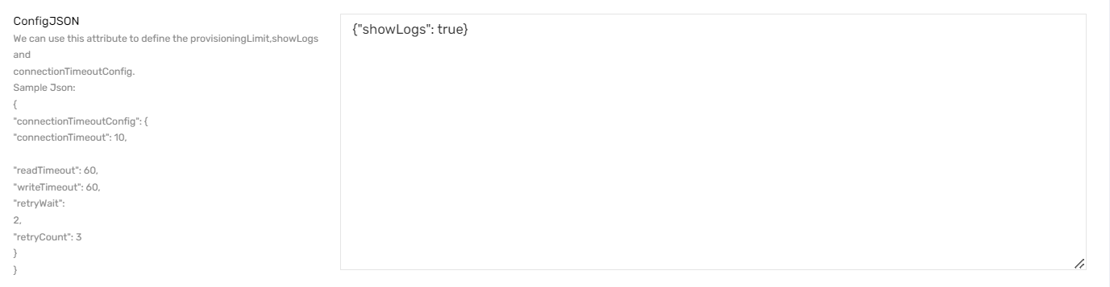

### UPDATEACCOUNTJSON

|  |
| --- |
| {  "call": [  {  "name": "call1",  "connection": "acctAuth",  "showResponse": true,  "url": "https://workday-api-dev.sentara.com/workday-inbound/InboundWorkerFile",  "httpMethod": "POST",  "httpParams": "[{\"Action\":\"Update\",\"RelationshipExpirationDate\":\"${if(user.employeeType!=null && user.employeeType.toLowerCase().contains('emp')){''} else if(user.employeeType!=null && user.employeeType.toLowerCase().contains('cwr')){''} else if(user.termDate!=null && user.customproperty20!=null && (user.customproperty20.toLowerCase().contains('staff') || user.customproperty20.toLowerCase().contains('scribe') ||user.customproperty20.toLowerCase().contains('medical student') ||user.customproperty20.toLowerCase().contains('research monitor'))){def sdf=new java.text.SimpleDateFormat('yyyy-MM-dd\\'T\\'HH:mm:ss.SSS\\'Z\\''); String dat=sdf.format(user.termDate); return dat;} else if (user.customproperty20!=null && (user.customproperty20.toLowerCase().contains('credentialed hospital physician'))){''} else if(user.termDate!=null && user.customproperty20!=null && (user.customproperty20.toLowerCase().contains('physician') || user.customproperty20.toLowerCase().contains('student'))){def sdf=new java.text.SimpleDateFormat('yyyy-MM-dd\\'T\\'HH:mm:ss.SSS\\'Z\\''); String dat=sdf.format(user.termDate); return dat;} else if(user.termDate!=null && user.customproperty20!=null && (user.customproperty20.toLowerCase().contains('group contact') ||user.customproperty20.toLowerCase().contains('benefits administrator'))){def sdf=new java.text.SimpleDateFormat('yyyy-MM-dd\\'T\\'HH:mm:ss.SSS\\'Z\\''); String dat=sdf.format(user.termDate); return dat;} else if(user.termDate!=null && user.customproperty20!=null && user.customproperty20.toLowerCase().contains('broker')){def sdf=new java.text.SimpleDateFormat('yyyy-MM-dd\\'T\\'HH:mm:ss.SSS\\'Z\\''); String dat=sdf.format(user.termDate); return dat;} else{''}}\",\"ADDN\":\"${if(user.customproperty20!= null && (user.customproperty20.contains('Benefits Administrator') || user.customproperty20.contains('Broker') || user.customproperty20.contains('Group Contact')) && user.employeeType!='EMP') {'CN='+user.systemUserName+',OU=BA_BROKERS,DC=corplab,DC=adlab,DC=sentara,DC=labin'} else {'CN='+user.systemUserName+',OU=ADO,OU=USER,DC=corplab,DC=adlab,DC=sentara,DC=labin'}}\", \"Relationship\":\"${if(user.employeeType!=null && user.employeeType.toLowerCase().contains('emp')){'Employee'} else if(user.employeeType!=null && user.employeeType.toLowerCase().contains('cwr')){'Non-Employee'} else if(user.customproperty20!=null && (user.customproperty20.toLowerCase().contains('staff') || user.customproperty20.toLowerCase().contains('scribe') ||user.customproperty20.toLowerCase().contains('medical student') ||user.customproperty20.toLowerCase().contains('research monitor'))){'Physician Office Staff'} else if(user.customproperty20!=null && (user.customproperty20.toLowerCase().contains('physician') || user.customproperty20.toLowerCase().contains('student'))){'Physician'} else if(user.customproperty20!=null && (user.customproperty20.toLowerCase().contains('group contact') ||user.customproperty20.toLowerCase().contains('benefits administrator'))){'Benefits Administrator'} else if(user.customproperty20!=null && user.customproperty20.toLowerCase().contains('broker')){'Broker'} else{''}}\",\"EmployeeStatus\":\"${if(user.customproperty24!=null) {user.customproperty24} else {''}}\", \"EmplID\":\"${if(user.employeeid!=null) {user.employeeid} else {''}}\",\"FirstName\":\"${user.firstname}\",\"LastName\": \"${user.lastname}\",\"MiddleName\":\"${if(user.middlename!=null) {user.middlename} else {''}}\",\"Suffix\":\"${if(user.customproperty37!=null) {user.customproperty37} else {''}}\",\"PreferredName\": \"${if(user.preferedFirstName!=null) {user.preferedFirstName} else {''}}\",\"UID\":\"${user.username}\",\"BirthDate\": \"${if(user.customproperty6!=null) {user.customproperty6} else {''}}\",\"Gender\":\"${if(user.customproperty13!=null) {user.customproperty13} else {''}}\",\"LoginID\":\"${user.systemUserName}\",\"EmailAddresses\":[{\"EmailType\":\"Personal\",\"EmailAddress\": \"${if(user.secondaryEmail!=null) {user.secondaryEmail} else {''}}\"},{ \"EmailType\":\"Business\",\"EmailAddress\":\"${if(user.email!=null) {user.email} else {''}}\"}],\"Phones\":[ {\"PhoneType\":\"Business\",\"PhoneNumber\":\"${if(user.phonenumber!=null) {user.phonenumber} else {''}}\"},{ \"PhoneType\":\"Cell\",\"PhoneNumber\":\"${if(user.customproperty38!=null) {user.customproperty38} else {''}}\"},{ \"PhoneType\":\"Fax\",\"PhoneNumber\":\"${if(user.customproperty40!=null) {user.customproperty40} else {''}}\"},{\"PhoneType\":\"TextPager\",\"PhoneNumber\":\"${if(user.customproperty41!=null) {user.customproperty41} else {''}}\"}],\"Addresses\":[{\"AddressType\":\"Home\",\"Address1\":\"${if(user.customproperty14!=null) {user.customproperty14} else {''}}\",\"City\": \"${if(user.city!=null) {user.city} else {''}}\",\"State\":\"${if(user.state!=null) {user.state} else {''}}\",\"Zip\":\"${if(user.regioncode!=null) {user.regioncode} else {''}}\"}],\"Job\":{\"JobCode\":\"${if(user.jobCode!=null) {user.jobCode} else {''}}\",\"JobTitle\":\"${if(user.title!=null) {user.title} else {''}}\",\"CostCenterID\":\"${if(user.costcenter!=null) {user.costcenter} else {''}}\",\"CostCenterDescription\":\"${if(user.customproperty16!=null) {user.customproperty16} else {''}}\",\"CompanyID\":\"${if(user.customproperty15!=null) {user.customproperty15} else {''}}\",\"CompanyDescription\":\"${if(user.companyname!=null) {user.companyname} else {''}}\",\"ReportingID\":\"${if(user.customproperty17!=null) {user.customproperty17} else if(user.customproperty15=='CM176' || user.customproperty15=='CM170'){user.customproperty43} else {''}}\",\"ReportingDescription\":\"${if(user.departmentname!=null) {user.departmentname} else if(user.customproperty15=='CM176' || user.customproperty15=='CM170'){user.customproperty2} else {''}}\",\"LocationID\":\"${if(user.locationnumber!=null) {user.locationnumber} else {''}}\",\"LocationName\":\"${if(user.location!=null) {user.location} else {''}}\", \"LocationAddress1\":\"${if(user.locationdesc!=null) {user.locationdesc} else {''}}\",\"LocationAddress2\":\"${if(user.customproperty49!=null) {user.customproperty49} else {''}}\", \"LocationCity\":\"${if(user.customproperty22!=null) {user.customproperty22} else {''}}\",\"LocationState\":\"${if(user.customproperty21!=null) {user.customproperty21} else {''}}\", \"LocationZip\":\"${if(user.customproperty23!=null) {user.customproperty23} else {''}}\",\"WorkShift\":\"${if(user.customproperty19!=null) {user.customproperty19} else {''}}\",\"ManagerID\": \"${if(user.manager!=null) {userManager.username} else {''}}\",\"ManagementLevel\":\"${if(user.customproperty4!=null) {user.customproperty4} else {''}}\"}}]",  "httpHeaders": {  "Authorization": "${access_token}"  },  "httpContentType": "application/json",  "successResponses": {  "statusCode": [  200,  201  ]  },  "unsuccessResponses": {  "statusCode": [  400,  500,  401,  503,  403  ]  }  }  ]  } |

### ADDACCESSJSON

|  |
| --- |
| {  "call": [  {  "name": "Relationship",  "connection": "acctAuth",  "showResponse": true,  "url": "https://workday-api-dev.sentara.com/workday-inbound/InboundWorkerFile",  "httpMethod": "POST",  "httpParams": "[{\"Action\":\"Create\",\"Relationship\":\"${entitlementValue.entitlementID}\",\"RelationshipExpirationDate\":\"${if(entitlementValue.entitlementID=='Employee' || entitlementValue.entitlementID=='Non-Employee'){''} else if((entitlementValue.entitlementID=='Physician') && (user.customproperty20.toLowerCase().contains('credentialed hospital physician'))){''}else if(user.termDate!=null) {def sdf=new java.text.SimpleDateFormat('yyyy-MM-dd\\'T\\'HH:mm:ss.SSS\\'Z\\''); String dat=sdf.format(user.termDate); return dat;}else{''}}\",\"ADDN\":\"${if(user.customproperty20!= null && (user.customproperty20.contains('Benefits Administrator') || user.customproperty20.contains('Broker') || user.customproperty20.contains('Group Contact')) && user.employeeType!='EMP') {'CN='+user.systemUserName+',OU=BA_BROKERS,DC=corplab,DC=adlab,DC=sentara,DC=labin' } else {'CN='+user.systemUserName+',OU=ADO,OU=USER,DC=corplab,DC=adlab,DC=sentara,DC=labin' }}\",\"EmployeeStatus\":\"${if(user.customproperty24!=null) {user.customproperty24} else {''}}\", \"EmplID\":\"${if(user.employeeid!=null) {user.employeeid} else {''}}\",\"FirstName\":\"${user.firstname}\",\"LastName\": \"${user.lastname}\",\"MiddleName\":\"${if(user.middlename!=null) {user.middlename} else {''}}\",\"Suffix\":\"${if(user.customproperty37!=null) {user.customproperty37} else {''}}\",\"PreferredName\": \"${if(user.preferedFirstName!=null) {user.preferedFirstName} else {''}}\",\"UID\":\"${user.username}\",\"BirthDate\": \"${if(user.customproperty6!=null) {user.customproperty6} else {''}}\",\"Gender\":\"${if(user.customproperty13!=null) {user.customproperty13} else {''}}\",\"LoginID\":\"${user.systemUserName}\",\"EmailAddresses\":[{\"EmailType\":\"Personal\",\"EmailAddress\": \"${if(user.secondaryEmail!=null) {user.secondaryEmail} else {''}}\"},{ \"EmailType\":\"Business\",\"EmailAddress\":\"${if(user.email!=null) {user.email} else {''}}\"}],\"Phones\":[ {\"PhoneType\":\"Business\",\"PhoneNumber\":\"${if(user.phonenumber!=null) {user.phonenumber} else {''}}\"},{ \"PhoneType\":\"Cell\",\"PhoneNumber\":\"${if(user.customproperty38!=null) {user.customproperty38} else {''}}\"},{ \"PhoneType\":\"Fax\",\"PhoneNumber\":\"${if(user.customproperty40!=null) {user.customproperty40} else {''}}\"},{\"PhoneType\":\"TextPager\",\"PhoneNumber\":\"${if(user.customproperty41!=null) {user.customproperty41} else {''}}\"}],\"Addresses\":[{\"AddressType\":\"Home\",\"Address1\":\"${if(user.customproperty14!=null) {user.customproperty14} else {''}}\",\"City\": \"${if(user.city!=null) {user.city} else {''}}\",\"State\":\"${if(user.state!=null) {user.state} else {''}}\",\"Zip\":\"${if(user.regioncode!=null) {user.regioncode} else {''}}\"}],\"Job\":{\"JobCode\":\"${if(user.jobCode!=null) {user.jobCode} else {''}}\",\"JobTitle\":\"${if(user.title!=null) {user.title} else {''}}\",\"CostCenterID\":\"${if(user.costcenter!=null) {user.costcenter} else {''}}\",\"CostCenterDescription\":\"${if(user.customproperty16!=null) {user.customproperty16} else {''}}\",\"CompanyID\":\"${if(user.customproperty15!=null) {user.customproperty15} else {''}}\",\"CompanyDescription\":\"${if(user.companyname!=null) {user.companyname} else {''}}\",\"ReportingID\":\"${if(user.customproperty17!=null) {user.customproperty17} else if(user.customproperty15=='CM176' || user.customproperty15=='CM170'){user.customproperty43} else {''}}\",\"ReportingDescription\":\"${if(user.departmentname!=null) {user.departmentname} else if(user.customproperty15=='CM176' || user.customproperty15=='CM170'){user.customproperty2} else {''}}\",\"LocationID\":\"${if(user.locationnumber!=null) {user.locationnumber} else {''}}\",\"LocationName\":\"${if(user.location!=null) {user.location} else {''}}\", \"LocationAddress1\":\"${if(user.locationdesc!=null) {user.locationdesc} else {''}}\",\"LocationAddress2\":\"${if(user.customproperty49!=null) {user.customproperty49} else {''}}\", \"LocationCity\":\"${if(user.customproperty22!=null) {user.customproperty22} else {''}}\",\"LocationState\":\"${if(user.customproperty21!=null) {user.customproperty21} else {''}}\", \"LocationZip\":\"${if(user.customproperty23!=null) {user.customproperty23} else {''}}\",\"WorkShift\":\"${if(user.customproperty19!=null) {user.customproperty19} else {''}}\",\"ManagerID\": \"${if(user.manager!=null) {userManager.username} else {''}}\",\"ManagementLevel\":\"${if(user.customproperty4!=null) {user.customproperty4} else {''}}\"}}]",  "httpHeaders": {  "Authorization": "${access_token}"  },  "httpContentType": "application/json",  "successResponses": {  "statusCode": [  200,  201  ]  },  "unsuccessResponses": {  "statusCode": [  400,  500,  401,  503,  403  ]  }  }  ]  } |

### REMOVEACCESSJSON

|  |
| --- |
| {  "call": [  {  "name": "Relationship",  "connection": "acctAuth",  "showResponse": true,  "url": "https://workday-api-dev.sentara.com/workday-inbound/InboundWorkerFile",  "httpMethod": "POST",  "httpParams": "[{\"Action\":\"Terminate\",\"Relationship\":\"${entitlementValue.entitlementID}\",\"Relationship\":\"${entitlementValue.entitlementID}\",\"RelationshipExpirationDate\":\"${if(entitlementValue.entitlementID=='Employee' || entitlementValue.entitlementID=='Non-Employee'){''} else if((entitlementValue.entitlementID=='Physician') && (user.customproperty20.toLowerCase().contains('credentialed hospital physician'))){''}else if(user.termDate!=null) {def sdf=new java.text.SimpleDateFormat('yyyy-MM-dd\\'T\\'HH:mm:ss.SSS\\'Z\\''); String dat=sdf.format(user.termDate); return dat;}else{''}}\",\"ADDN\":\"${if(user.customproperty20!= null && (user.customproperty20.contains('Benefits Administrator') || user.customproperty20.contains('Broker') || user.customproperty20.contains('Group Contact')) && user.employeeType!='EMP') {'CN='+user.systemUserName+',OU=BA_BROKERS,DC=corplab,DC=adlab,DC=sentara,DC=labin' } else {'CN='+user.systemUserName+',OU=ADO,OU=USER,DC=corplab,DC=adlab,DC=sentara,DC=labin' }}\",\"EmployeeStatus\":\"${if(user.customproperty24!=null) {user.customproperty24} else {''}}\", \"EmplID\":\"${if(user.employeeid!=null) {user.employeeid} else {''}}\",\"FirstName\":\"${user.firstname}\",\"LastName\": \"${user.lastname}\",\"MiddleName\":\"${if(user.middlename!=null) {user.middlename} else {''}}\",\"Suffix\":\"${if(user.customproperty37!=null) {user.customproperty37} else {''}}\",\"PreferredName\": \"${if(user.preferedFirstName!=null) {user.preferedFirstName} else {''}}\",\"UID\":\"${user.username}\",\"BirthDate\": \"${if(user.customproperty6!=null) {user.customproperty6} else {''}}\",\"Gender\":\"${if(user.customproperty13!=null) {user.customproperty13} else {''}}\",\"LoginID\":\"${user.systemUserName}\",\"EmailAddresses\":[{\"EmailType\":\"Personal\",\"EmailAddress\": \"${if(user.secondaryEmail!=null) {user.secondaryEmail} else {''}}\"},{ \"EmailType\":\"Business\",\"EmailAddress\":\"${if(user.email!=null) {user.email} else {''}}\"}],\"Phones\":[ {\"PhoneType\":\"Business\",\"PhoneNumber\":\"${if(user.phonenumber!=null) {user.phonenumber} else {''}}\"},{ \"PhoneType\":\"Cell\",\"PhoneNumber\":\"${if(user.customproperty38!=null) {user.customproperty38} else {''}}\"},{ \"PhoneType\":\"Fax\",\"PhoneNumber\":\"${if(user.customproperty40!=null) {user.customproperty40} else {''}}\"},{\"PhoneType\":\"TextPager\",\"PhoneNumber\":\"${if(user.customproperty41!=null) {user.customproperty41} else {''}}\"}],\"Addresses\":[{\"AddressType\":\"Home\",\"Address1\":\"${if(user.customproperty14!=null) {user.customproperty14} else {''}}\",\"City\": \"${if(user.city!=null) {user.city} else {''}}\",\"State\":\"${if(user.state!=null) {user.state} else {''}}\",\"Zip\":\"${if(user.regioncode!=null) {user.regioncode} else {''}}\"}],\"Job\":{\"JobCode\":\"${if(user.jobCode!=null) {user.jobCode} else {''}}\",\"JobTitle\":\"${if(user.title!=null) {user.title} else {''}}\",\"CostCenterID\":\"${if(user.costcenter!=null) {user.costcenter} else {''}}\",\"CostCenterDescription\":\"${if(user.customproperty16!=null) {user.customproperty16} else {''}}\",\"CompanyID\":\"${if(user.customproperty15!=null) {user.customproperty15} else {''}}\",\"CompanyDescription\":\"${if(user.companyname!=null) {user.companyname} else {''}}\",\"ReportingID\":\"${if(user.customproperty17!=null) {user.customproperty17} else if(user.customproperty15=='CM176' || user.customproperty15=='CM170'){user.customproperty43} else {''}}\",\"ReportingDescription\":\"${if(user.departmentname!=null) {user.departmentname} else if(user.customproperty15=='CM176' || user.customproperty15=='CM170'){user.customproperty2} else {''}}\",\"LocationID\":\"${if(user.locationnumber!=null) {user.locationnumber} else {''}}\",\"LocationName\":\"${if(user.location!=null) {user.location} else {''}}\", \"LocationAddress1\":\"${if(user.locationdesc!=null) {user.locationdesc} else {''}}\",\"LocationAddress2\":\"${if(user.customproperty49!=null) {user.customproperty49} else {''}}\", \"LocationCity\":\"${if(user.customproperty22!=null) {user.customproperty22} else {''}}\",\"LocationState\":\"${if(user.customproperty21!=null) {user.customproperty21} else {''}}\", \"LocationZip\":\"${if(user.customproperty23!=null) {user.customproperty23} else {''}}\",\"WorkShift\":\"${if(user.customproperty19!=null) {user.customproperty19} else {''}}\",\"ManagerID\": \"${if(user.manager!=null) {userManager.username} else {''}}\",\"ManagementLevel\":\"${if(user.customproperty4!=null) {user.customproperty4} else {''}}\"}}]",  "httpHeaders": {  "Authorization": "${access_token}"  },  "httpContentType": "application/json",  "successResponses": {  "statusCode": [  200,  201  ]  },  "unsuccessResponses": {  "statusCode": [  400,  500,  401,  503,  403  ]  }  }  ]  } |

## PSDB_Recon Connection

### Connection Details

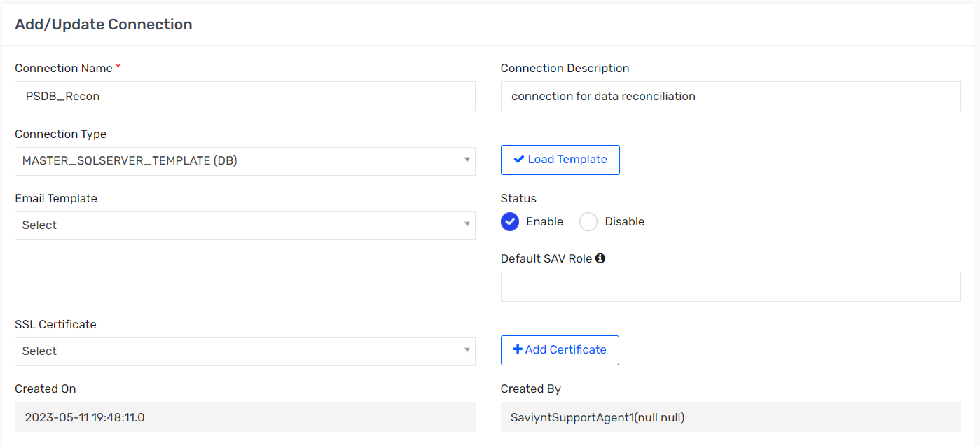

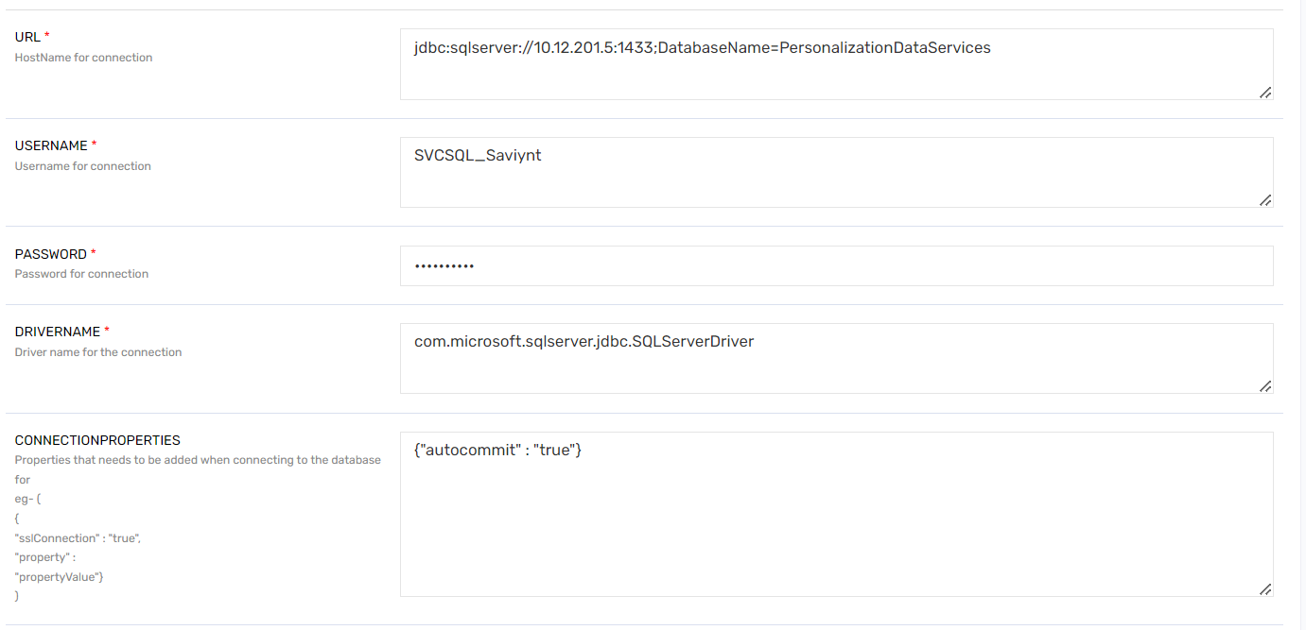

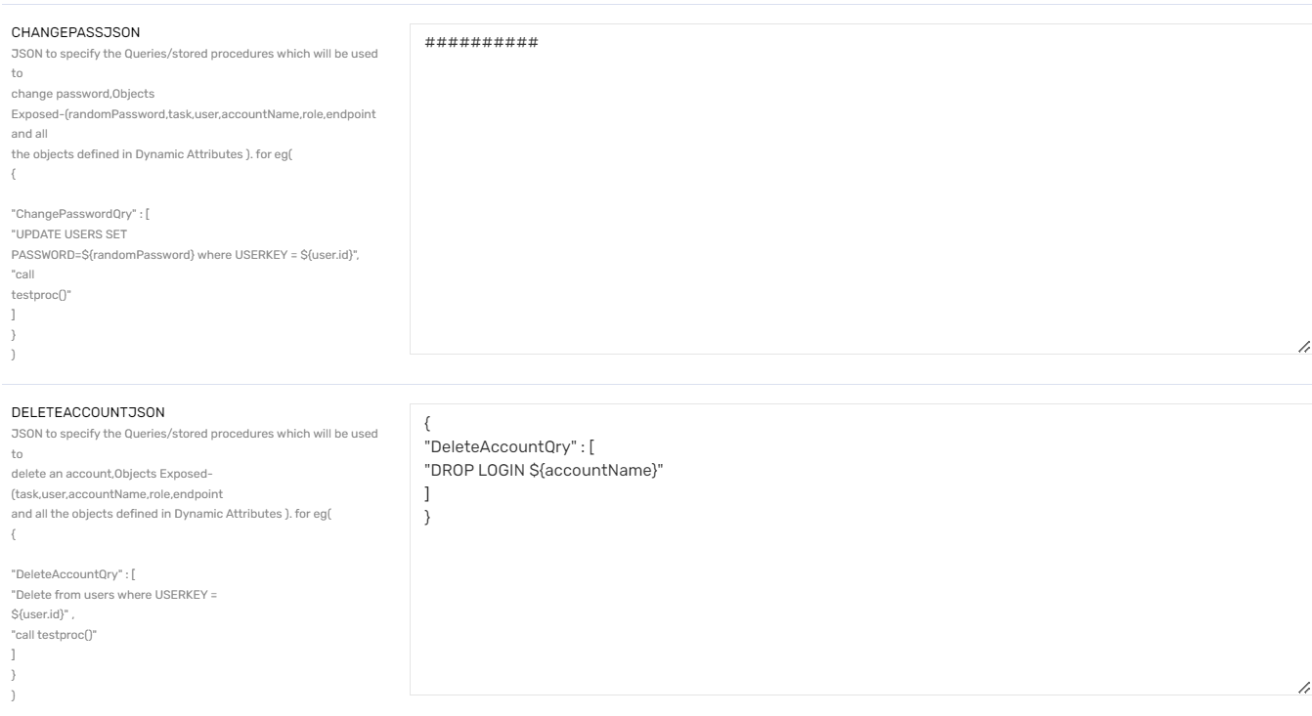

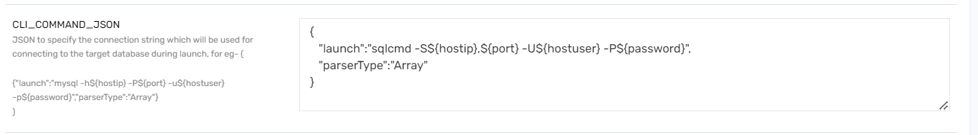

### ACCOUNTSIMPORT

|  |
| --- |
| <dataMapping>  <before-import>  </before-import>  <sql-query description="This is the Source DB Query" uniquecolumnsascommaseparated="name" >  <![CDATA[  exec dbo.SaviyntReconciliation;  ]]>  </sql-query>  <mapper description="This is the mapping field for Saviynt Field name" accountnotinfileaction="Suspend" deleteaccountentitlement="false" ifusernotexists="noaction" systems="'PSDB'">  <mapfield saviyntproperty="accounts.name" sourceproperty="SecZettaUID" type="character"/>  <mapfield saviyntproperty="accounts.accountid" sourceproperty="SecZettaUID" type="character"/>  <mapfield saviyntproperty="securitysystems.systemname" sourceproperty="application" type="character"/>  <mapfield saviyntproperty="endpoints.endpointname" sourceproperty="application" type="character"/>  <mapfield saviyntproperty="accounts.customproperty1" sourceproperty="FirstName" type="character"/>  <mapfield saviyntproperty="accounts.customproperty2" sourceproperty="MidName" type="character"/>  <mapfield saviyntproperty="accounts.customproperty3" sourceproperty="LastName" type="character"/>  <mapfield saviyntproperty="accounts.customproperty5" sourceproperty="JobTitle" type="character"/>  <mapfield saviyntproperty="accounts.customproperty6" sourceproperty="EmailAddress" type="character"/>  <mapfield saviyntproperty="accounts.customproperty7" sourceproperty="ItemDesc" type="character"/>  <mapfield saviyntproperty="accounts.status" sourceproperty="Status" type="number"/>  </mapper>  </dataMapping> |

# Security Systems

## Active Directory System

### Configuration Details

| Name | Value |
| --- | --- |
| System Name | Active Directory |
| Display Name | Active Directory |
| Create Task Action | <blank> |
| Port | <blank> |
| Connection | Active Directory |
| Provisioning Connection | Active Directory |
| Service Desk Connection | <blank> |
| Password Management Connection | <blank> |
| External Risk Connection | <blank> |
| Provisioning Comments | <blank> |
| Policy Rule | <blank> |
| Access Add Workflow | AOBAutoApproveWF |
| Access Remove Workflow | AOBAutoApproveWF |
| Add Service Account Workflow | <blank> |
| Remove Service Account Workflow | <blank> |
| Proposed Accounts Workflow | <blank> |
| Emergency Access ID Request Workflow | <blank> |
| Emergency Access Request Workflow | <blank> |
| Number of tries for provisioning | <blank> |
| Node Mac ID | <blank> |
| Policy Rule Service Account | <blank> |
| Inherent SOD Report Fields | <blank> |
| Default System | No |
| Automated Provisioning | Enable |
| Manage Entity | No |
| Persistent Data | No |
| Use open connector | No |
| Recon Application | Yes |
| Provisioning Limit | <blank> |
| Instant Provisioning | Disable |

## AD graveyard OU Security System

### Configuration Details

| Name | Value |
| --- | --- |
| System Name | AD GRAVEYARD OU |
| Display Name | AD GRAVEYARD OU |
| Create Task Action | <blank> |
| Port | <blank> |
| Connection | AD GRAVEYARD OU |
| Provisioning Connection | Azure O365 Update |
| Service Desk Connection | <blank> |
| Password Management Connection | <blank> |
| External Risk Connection | <blank> |
| Provisioning Comments | <blank> |
| Policy Rule | <blank> |
| Access Add Workflow | No Workflow |
| Access Remove Workflow | No Workflow |
| Add Service Account Workflow | <blank> |
| Remove Service Account Workflow | <blank> |
| Proposed Accounts Workflow | <blank> |
| Emergency Access ID Request Workflow | <blank> |
| Emergency Access Request Workflow | <blank> |
| Number of tries for provisioning | <blank> |
| Node Mac ID | <blank> |
| Policy Rule Service Account | <blank> |
| Inherent SOD Report Fields | <blank> |
| Default System | No |
| Automated Provisioning | Enable |
| Manage Entity | No |
| Persistent Data | No |
| Use open connector | No |
| Recon Application | Yes |
| Provisioning Limit | <blank> |
| Instant Provisioning | Disable |

## Azure O365 Revoke Session Security System

### Configuration Details

| Name | Value |
| --- | --- |
| System Name | Azure O365 Revoke Session |
| Display Name | Azure O365 Revoke Session |
| Create Task Action | <blank> |
| Port | <blank> |
| Connection | Active Directory O365 Sync |
| Provisioning Connection | MicrosoftGraph_RevokeSession |
| Service Desk Connection | <blank> |
| Password Management Connection | <blank> |
| External Risk Connection | <blank> |
| Provisioning Comments | <blank> |
| Policy Rule | <blank> |
| Access Add Workflow | No Workflow |
| Access Remove Workflow | No Workflow |
| Add Service Account Workflow | <blank> |
| Remove Service Account Workflow | <blank> |
| Proposed Accounts Workflow | <blank> |
| Emergency Access ID Request Workflow | <blank> |
| Emergency Access ID Access Request Workflow | <blank> |
| Number of tries for provisioning | <blank> |
| Node Mac ID | <blank> |
| Inherent SOD Report Fields | <blank> |
| Policy Rule Service Account | <blank> |
| Default System | No |
| Automated Provisioning | Enable |
| Manage Entity | No |
| Persistent Data | No |
| Use open connector | No |
| Recon Application | Yes |
| Provisioning Limit | None |
| Instant Provisioning | Disable |

## DUO Security System

### Configuration Details

| Name | Value |
| --- | --- |
| System Name | DUO |
| Display Name | DUO |
| Create Task Action | <blank> |
| Port | <blank> |
| Connection | DUO |
| Provisioning Connection | DUO Provisioning |
| Service Desk Connection | <blank> |
| Password Management Connection | <blank> |
| External Risk Connection | <blank> |
| Provisioning Comments | <blank> |
| Policy Rule | <blank> |
| Access Add Workflow | AOBAutoApproveWF |
| Access Remove Workflow | AOBAutoApproveWF |
| Add Service Account Workflow | <blank> |
| Remove Service Account Workflow | <blank> |
| Proposed Accounts Workflow | <blank> |
| Emergency Access ID Request Workflow | <blank> |
| Emergency Access Request Workflow | <blank> |
| Number of tries for provisioning | <blank> |
| Node Mac ID | <blank> |
| Policy Rule Service Account | <blank> |
| Inherent SOD Report Fields | <blank> |
| Default System | No |
| Automated Provisioning | Enable |
| Manage Entity | No |
| Persistent Data | No |
| Use open connector | No |
| Recon Application | Yes |
| Provisioning Limit | <blank> |
| Instant Provisioning | Disable |

## Privileged Application Security System

### Configuration details

| Name | Value |
| --- | --- |
| System Name | Privileged_Application |
| Display Name | Privileged_Application |
| Create Task Action | <blank> |
| Port | <blank> |
| Connection | Privileged_Application |
| Provisioning Connection | Privileged_Application |
| Service Desk Connection | <blank> |
| Password Management Connection | <blank> |
| External Risk Connection | <blank> |
| Provisioning Comments | <blank> |
| Policy Rule | <blank> |
| Access Add Workflow | No Workflow |
| Access Remove Workflow | No Workflow |
| Add Service Account Workflow | <blank> |
| Remove Service Account Workflow | <blank> |
| Proposed Accounts Workflow | <blank> |
| Emergency Access ID Request Workflow | <blank> |
| Emergency Access Request Workflow | <blank> |
| Number of tries for provisioning | <blank> |
| Node Mac ID | <blank> |
| Policy Rule Service Account | <blank> |
| Inherent SOD Report Fields | <blank> |
| Default System | No |
| Automated Provisioning | Enable |
| Manage Entity | No |
| Persistent Data | No |
| Use open connector | No |
| Recon Application | Yes |
| Provisioning Limit | <blank> |
| Instant Provisioning | Disable |

## PSDB Security System

### Configuration Details

| Name | Value |
| --- | --- |
| System Name | PSDB |
| Display Name | PSDB |
| Create Task Action | <blank> |
| Port | <blank> |
| Connection | PSDB_Recon |
| Provisioning Connection | PSDB Provisioning |
| Service Desk Connection | <blank> |
| Password Management Connection | <blank> |
| External Risk Connection | <blank> |
| Provisioning Comments | <blank> |
| Policy Rule | <blank> |
| Access Add Workflow | No Workflow |
| Access Remove Workflow | No Workflow |
| Add Service Account Workflow | <blank> |
| Remove Service Account Workflow | <blank> |
| Proposed Accounts Workflow | <blank> |
| Emergency Access ID Request Workflow | <blank> |
| Emergency Access Request Workflow | <blank> |
| Number of tries for provisioning | <blank> |
| Node Mac ID | <blank> |
| Policy Rule Service Account | <blank> |
| Inherent SOD Report Fields | <blank> |
| Default System | No |
| Automated Provisioning | Enable |
| Manage Entity | No |
| Persistent Data | No |
| Use open connector | No |
| Recon Application | Yes |
| Provisioning Limit | <blank> |
| Instant Provisioning | Disable |

## Saviynt Security System

### Configuration details

| Name | Value |
| --- | --- |
| System Name | Saviynt |
| Display Name | Saviynt |
| Create Task Action | <blank> |
| Port | <blank> |
| Connection | <blank> |
| Provisioning Connection | Saviynt |
| Service Desk Connection | <blank> |
| Password Management Connection | <blank> |
| External Risk Connection | <blank> |
| Provisioning Comments | <blank> |
| Policy Rule | <blank> |
| Access Add Workflow | No Workflow |
| Access Remove Workflow | No Workflow |
| Add Service Account Workflow | <blank> |
| Remove Service Account Workflow | <blank> |
| Proposed Accounts Workflow | <blank> |
| Emergency Access ID Request Workflow | <blank> |
| Emergency Access Request Workflow | <blank> |
| Number of tries for provisioning | <blank> |
| Node Mac ID | <blank> |
| Policy Rule Service Account | <blank> |
| Inherent SOD Report Fields | <blank> |
| Default System | No |
| Automated Provisioning | Disable |
| Manage Entity | No |
| Persistent Data | No |
| Use open connector | No |
| Recon Application | Yes |
| Provisioning Limit | <blank> |
| Instant Provisioning | Disable |

## SaviyntForSaviynt Security System

### Configuration details

| Name | Value |
| --- | --- |
| System Name | SaviyntForSaviynt |
| Display Name | SaviyntForSaviynt |
| Create Task Action | <blank> |
| Port | <blank> |
| Connection | <blank> |
| Provisioning Connection | <blank> |
| Service Desk Connection | <blank> |
| Password Management Connection | <blank> |
| External Risk Connection | <blank> |
| Provisioning Comments | <blank> |
| Policy Rule | <blank> |
| Access Add Workflow | No Workflow |
| Access Remove Workflow | No Workflow |
| Add Service Account Workflow | <blank> |
| Remove Service Account Workflow | <blank> |
| Proposed Accounts Workflow | <blank> |
| Emergency Access ID Request Workflow | <blank> |
| Emergency Access Request Workflow | <blank> |
| Number of tries for provisioning | <blank> |
| Node Mac ID | <blank> |
| Policy Rule Service Account | <blank> |
| Inherent SOD Report Fields | <blank> |
| Default System | No |
| Automated Provisioning | <blank> |
| Manage Entity | <blank> |
| Persistent Data | <blank> |
| Use open connector | No |
| Recon Application | Yes |
| Provisioning Threshold | <blank> |
| Instant Provisioning | Disable |

## ServiceNow Security System

### Configuration Details

| Name | Value |
| --- | --- |
| System Name | ServiceNow |
| Display Name | ServiceNow |
| Create Task Action | <blank> |
| Port | <blank> |
| Connection | ServiceNow |
| Provisioning Connection | ServiceNow |
| Service Desk Connection | <blank> |
| Password Management Connection | <blank> |
| External Risk Connection | <blank> |
| Provisioning Comments | <blank> |
| Policy Rule | <blank> |
| Access Add Workflow | No Workflow |
| Access Remove Workflow | No Workflow |
| Add Service Account Workflow | <blank> |
| Remove Service Account Workflow | <blank> |
| Proposed Accounts Workflow | <blank> |
| Emergency Access ID Request Workflow | <blank> |
| Emergency Access Request Workflow | <blank> |
| Number of tries for provisioning | <blank> |
| Node Mac ID | <blank> |
| Policy Rule Service Account | <blank> |
| Inherent SOD Report Fields | <blank> |
| Default System | No |
| Automated Provisioning | Enable |
| Manage Entity | No |
| Persistent Data | No |
| Use open connector | No |
| Recon Application | Yes |
| Provisioning Limit | <blank> |
| Instant Provisioning | Disable |

# Endpoints

## Active Directory Endpoint

### Endpoint Details

| Name | | Value | | | | | | | |
| --- | --- | --- | --- | --- | --- | --- | --- | --- | --- |
| End Point Name | | Active Directory | | | | | | | |
| Display Name | | Active Directory | | | | | | | |
| Security System | | Active Directory | | | | | | | |
| Parent Account Name Pattern | |  | | | | | | | |
| Add Email Templates | | New Account – Task Complete – Account Claiming Email  Disable Account – Task Complete – User termination email sent to User manager  Enable Account – Task Complete – Account Claiming Email - Rehire  New Account – Task Complete – AccountClaimingPreview | | | | | | | |
| Parent Endpoint | | <blank> | | | | | | | |
| Description | | <blank> | | | | | | | |
| Owner Type | | <blank> | | | | | | | |
| Owner | | <blank> | | | | | | | |
| Resource Owner Type | | <blank> | | | | | | | |
| Resource Owner | | <blank> | | | | | | | |
| Config For AllowChangePassword | | <blank> | | | | | | | |
| Custom Property 1 | | <blank> | | | | | | | |
| Custom Property 2 | | <blank> | | | | | | | |
| Custom Property 3 | | <blank> | | | | | | | |
| Custom Property 4 | | <blank> | | | | | | | |
| Custom Property 5 | | <blank> | | | | | | | |
| Access Query | | <blank> | | | | | | | |
| Entitlement Filter Query for Request Start/End Date | | <blank> | | | | | | | |
| User Account Correlation Rule | | **Users** | | | **InitialChar** | | | **Accounts** | |
| UserName | | | <blank> | | | Customproperty20 | |
| ACCOUNT NAME RULE | | **Users** | | | |  | | | |
| systemUserName | | | |  | | | |
| Account Type for which Deprovisioning Tasks should not get created | | <blank> | | | | | | | |
| Account Type for which Password should not change | | <blank> | | | | | | | |
| Enable Copy Access | | OFF | | | | | | | |
| Disable Remove Account | | OFF | | | | | | | |
| Disable Modify Account | | OFF | | | | | | | |
| Disable New Account Request If Account Already Exists | | OFF | | | | | | | |
| Block any new request due to existing request inflight | | OFF | | | | | | | |
| Disable Remove Service Account | | OFF | | | | | | | |
| Disable Modify Service Account | | OFF | | | | | | | |
| Disable New Account Request If Service Account Already Exists | | OFF | | | | | | | |
| Block any new request due to existing request inflight | | OFF | | | | | | | |
| Service Account Type | | <blank> | | | | | | | |
| Action For Out of Band Access Detection | | <blank> | | | | | | | |
| Create Dependent Entitlement Task for Remove Access | | OFF | | | | | | | |
| Ask For Start Date End Date While Adding Application Role along with Entitlements Request | | OFF | | | | | | | |
| Ask For Start Date While Removing Application Role along with Entitlements Request | | OFF | | | | | | | |
| Service Account Name Rule | | <blank> | | | | | | | |
| Service Account Access Query | | <blank> | | | | | | | |
| Primary Account Type | | <blank> | | | | | | | |
| Account Name validator Regex | | <blank> | | | | | | | |
| Copy Service Account Request Data | | ON | | | | | | | |
| Disable Sorting for selected entitlements for step 2 page of request form | | OFF | | | | | | | |
| Allow remove all roles by request | | OFF | | | | | | | |
| Requestable | | ON | | | | | | | |
| Status and Status Fields | | Enable . Disable | | | | | | | |
| Plugin Configuration | | <blank> | | | | | | | |
| Change Password Access query | | <blank> | | | | | | | |
| Application Experience | | None | | | | | | | |
| CONNECTION CONFIGURATION | | {"conf":[{"ADDUSERTOENT":"TRUE"},{"ADDMEMBERTOENT":"TRUE"}]} | | | | | | | |
| Update Date | |  | | | | | | | |
| **Entitlement Type** | | | | | | | | | |
| **Certifiable** | **Entitlement Type** | | **Request-Option** | **Hierarchy** | | | **\* Required** | | **Order Index** |
| Check | Groups | | None | Not Required | | | False | | 0 |

## AD GRAVEYARD OU Endpoint

### Endpoint Details

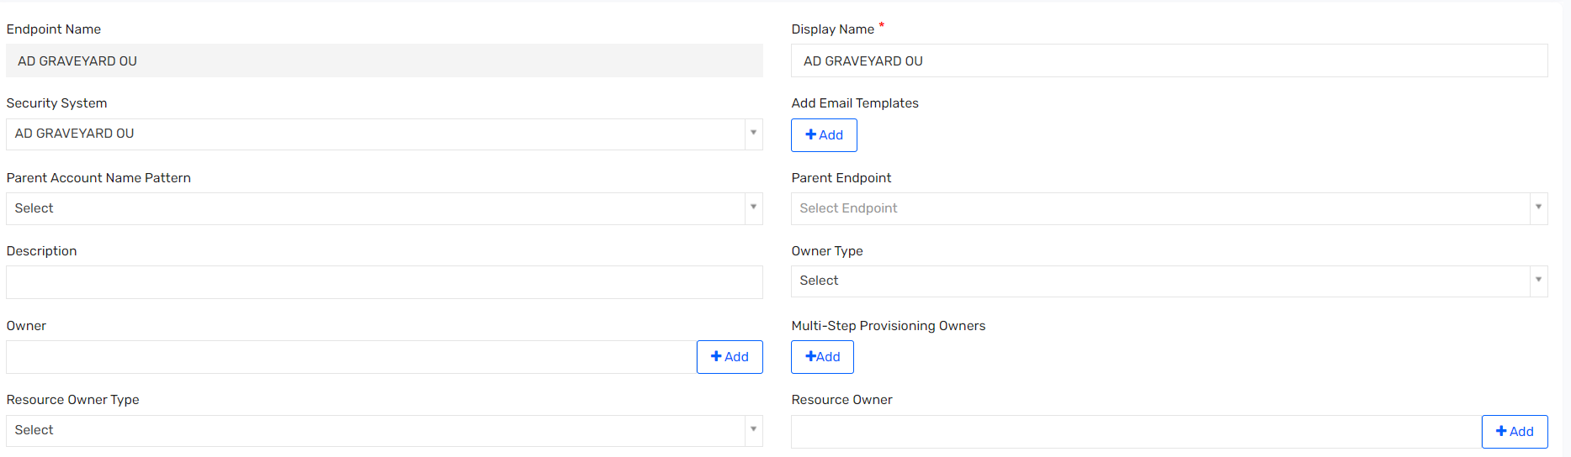

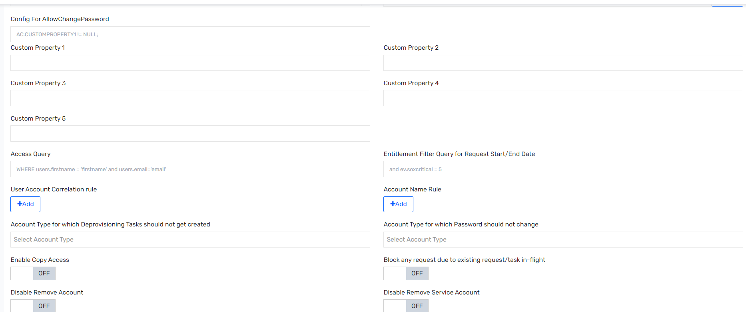

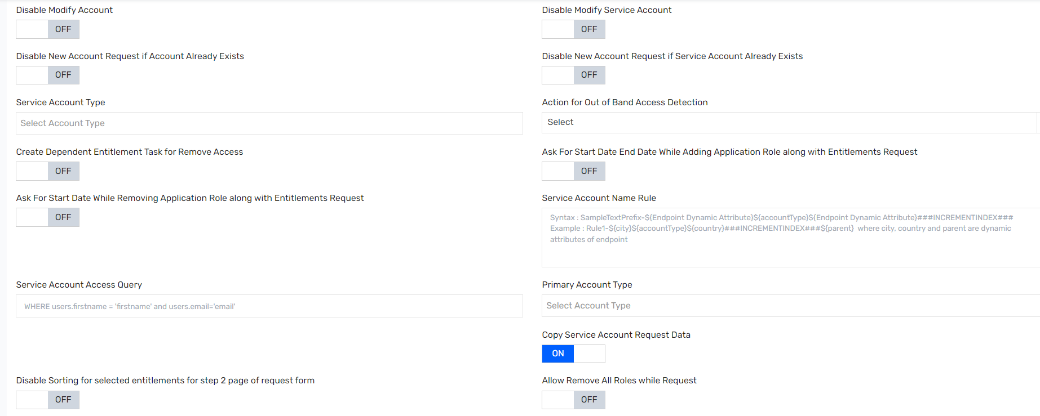

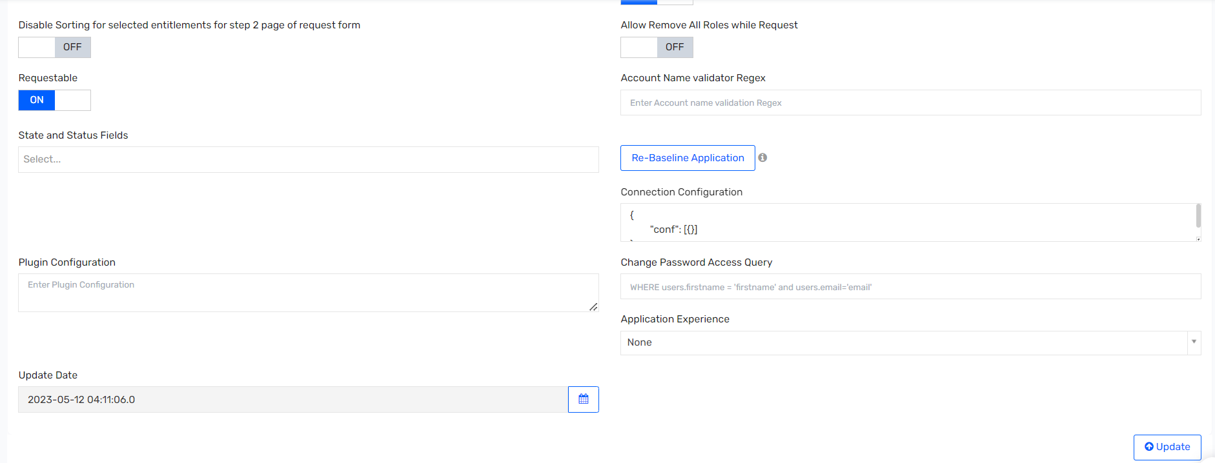

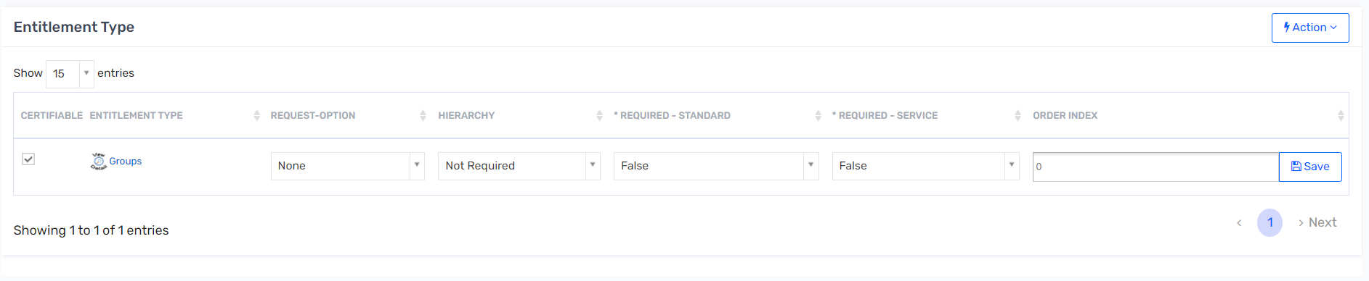

## Azure O365 Revoke Session Endpoint

### Endpoint Details

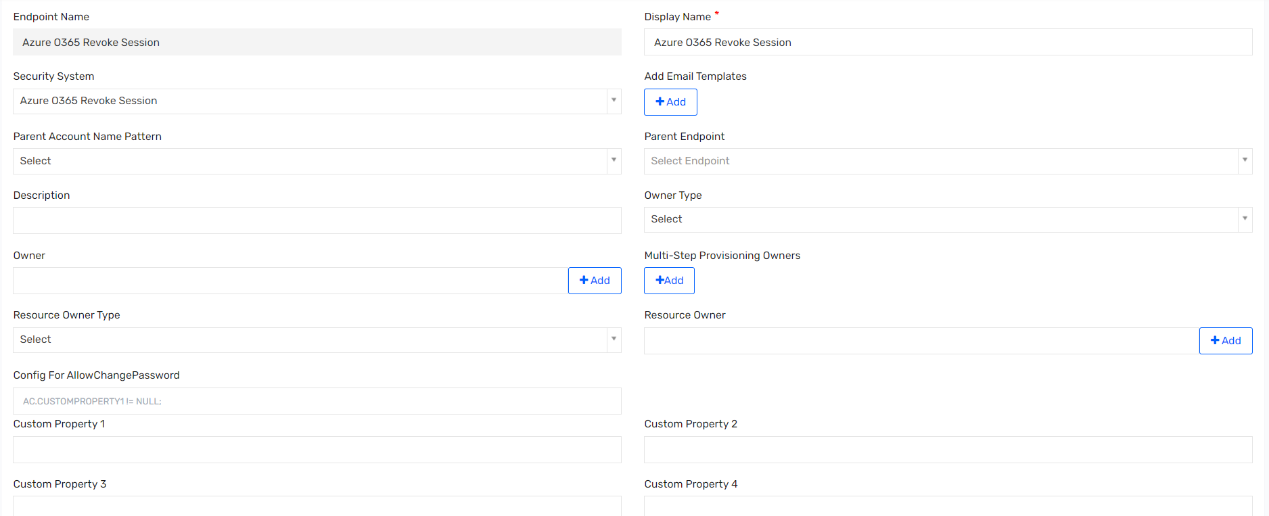

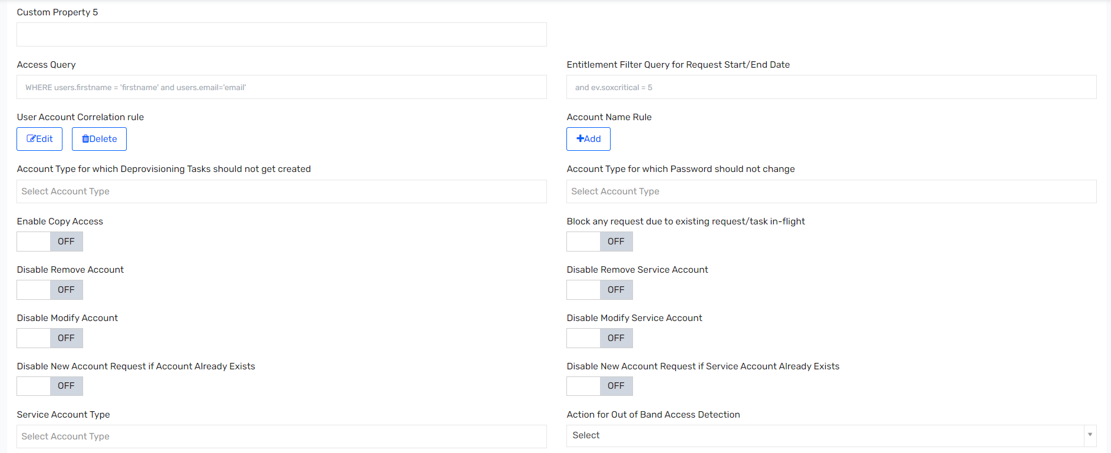

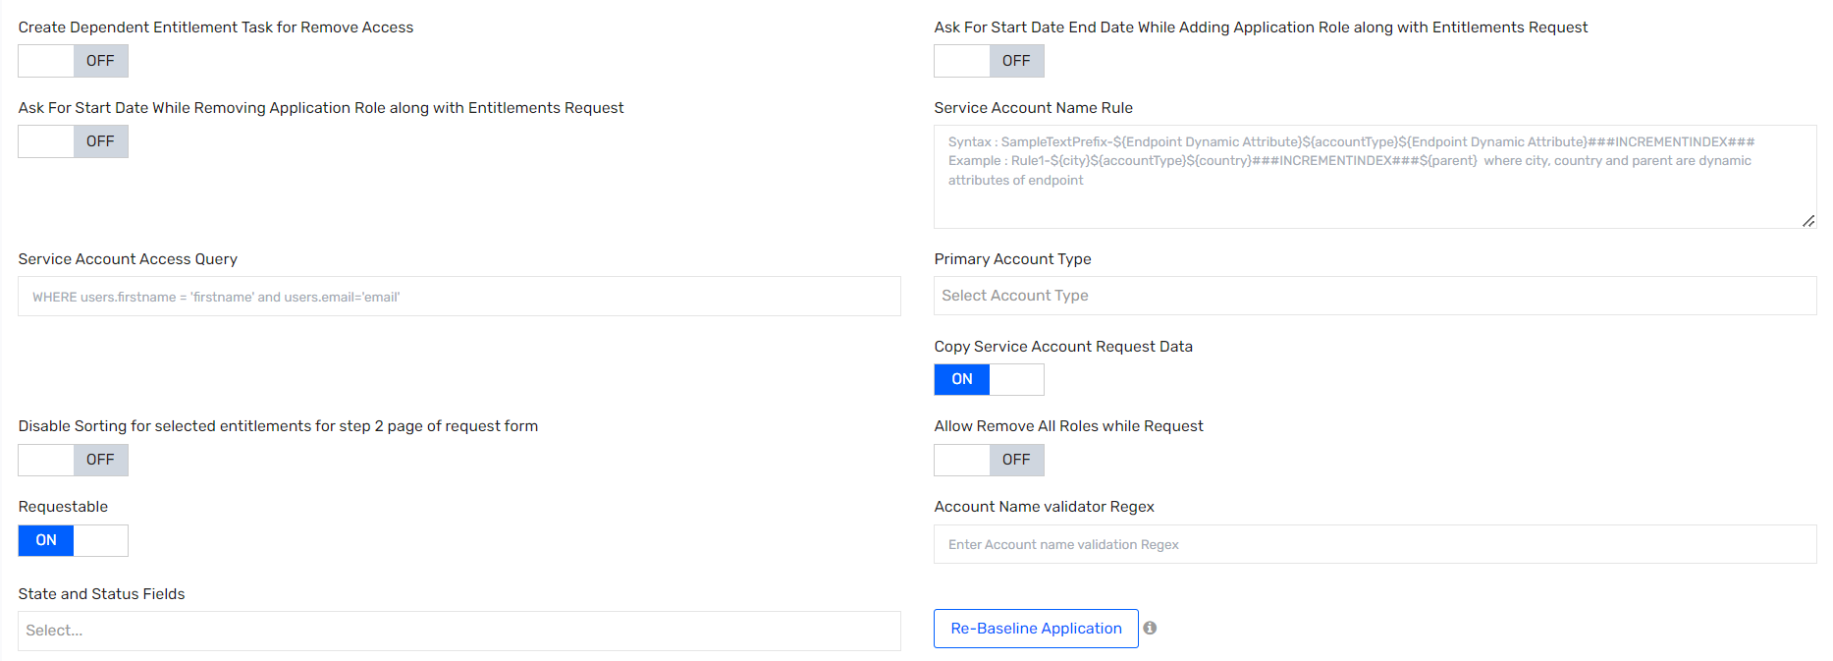

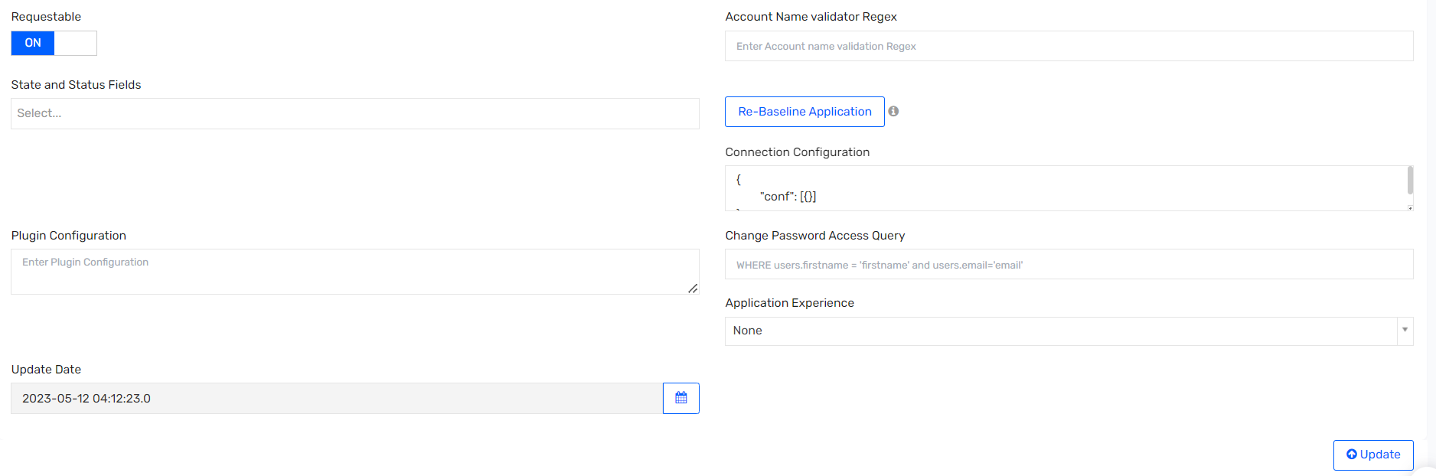

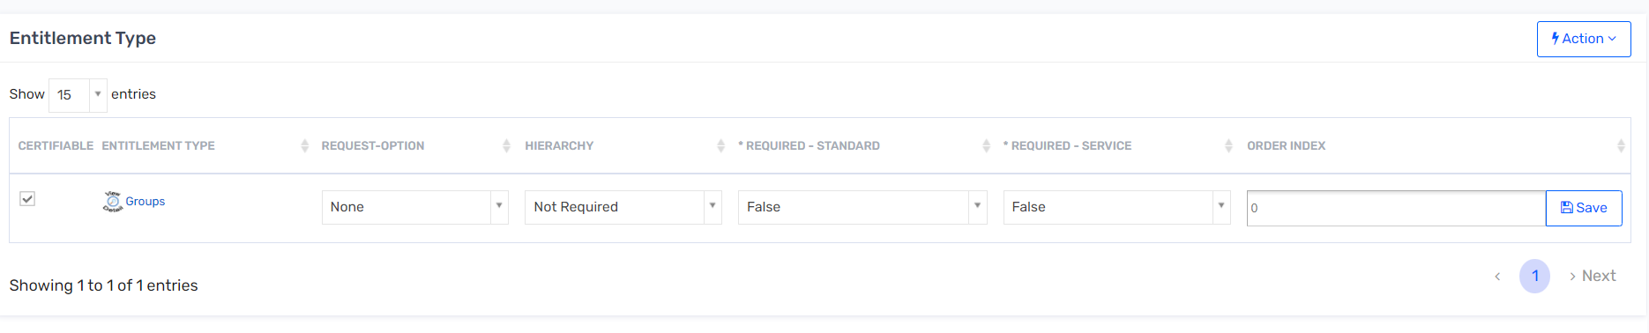

## DUO Endpoint

### Endpoint Details

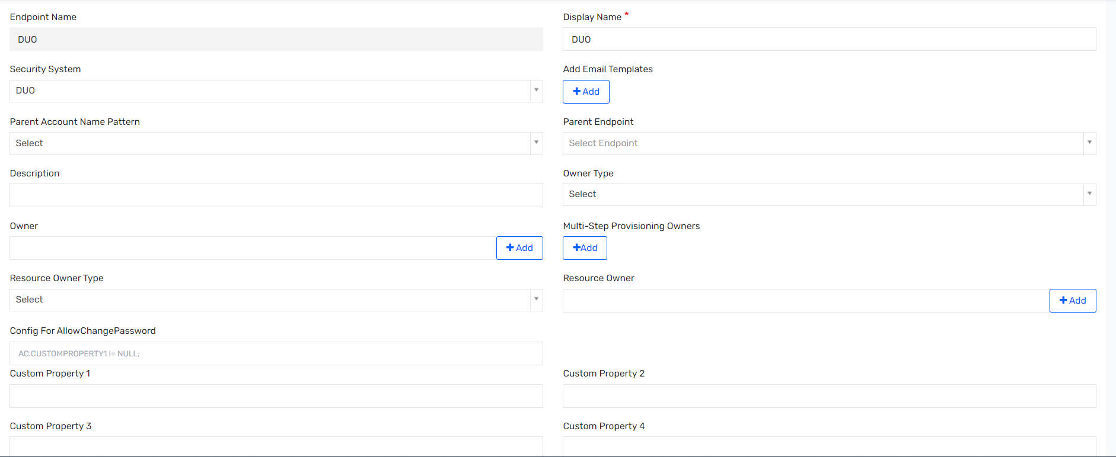

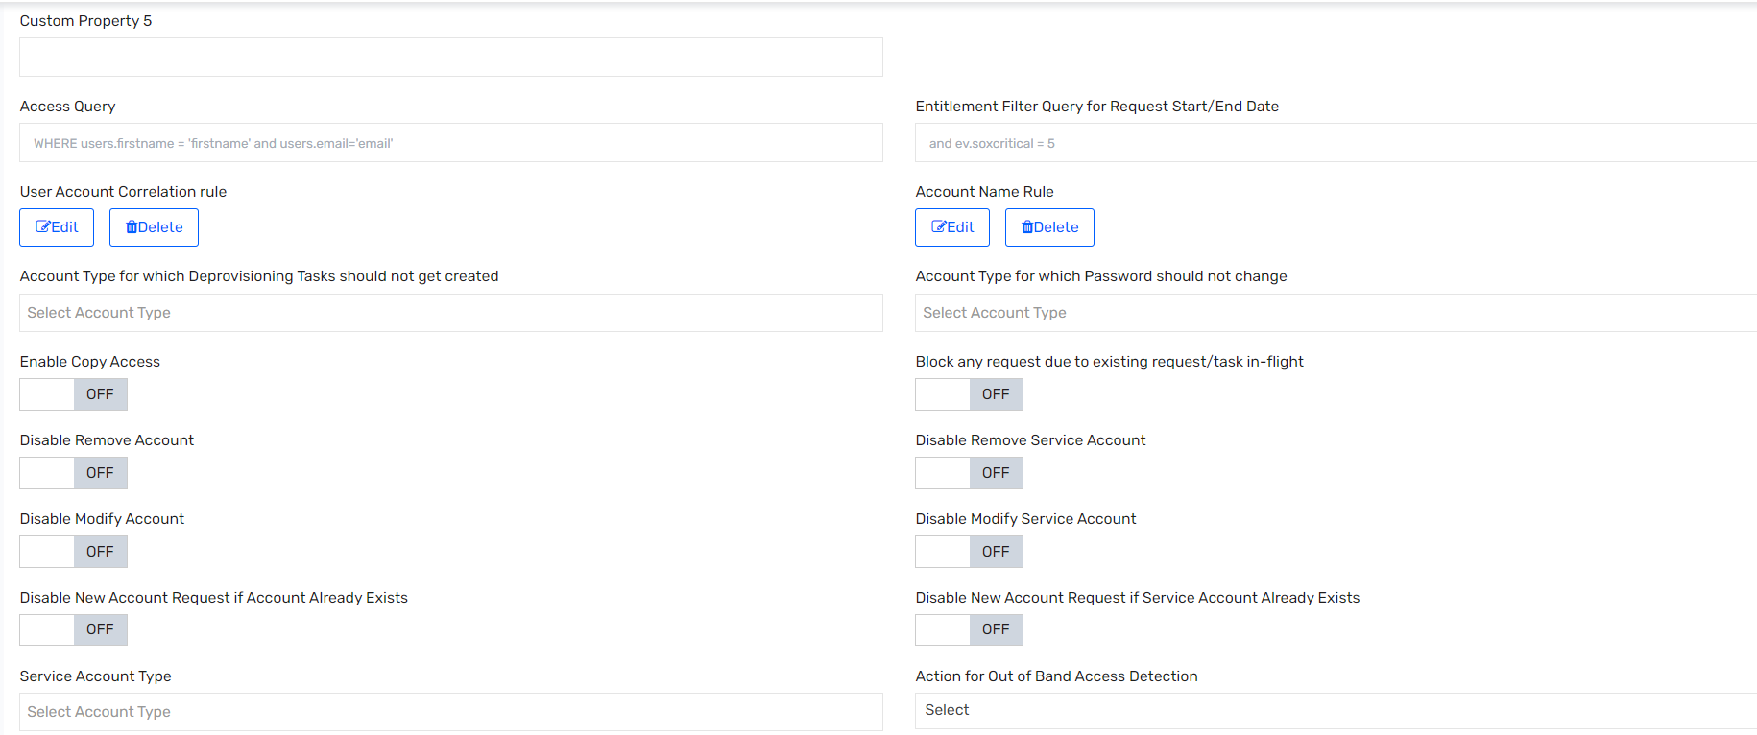

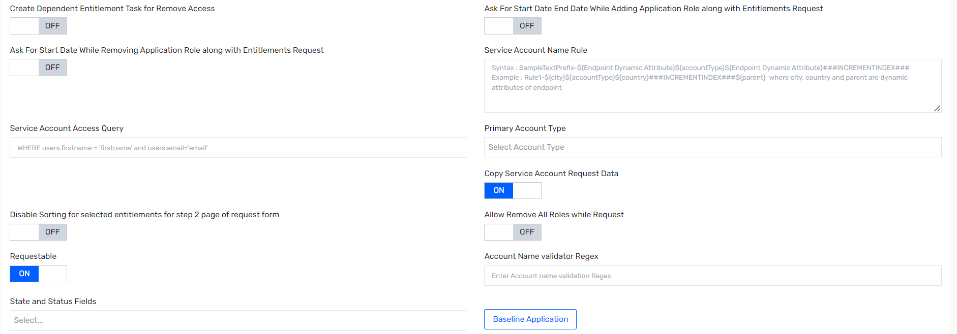

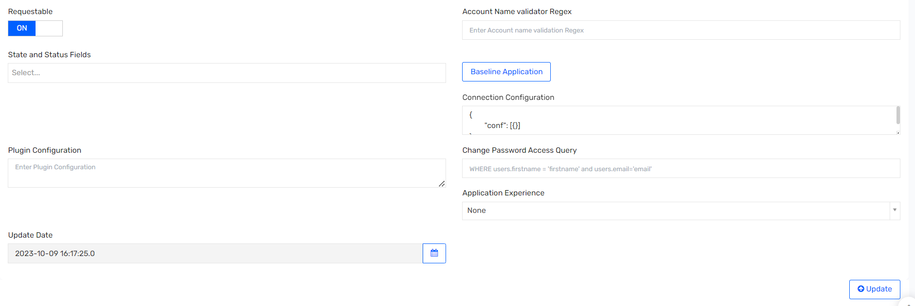

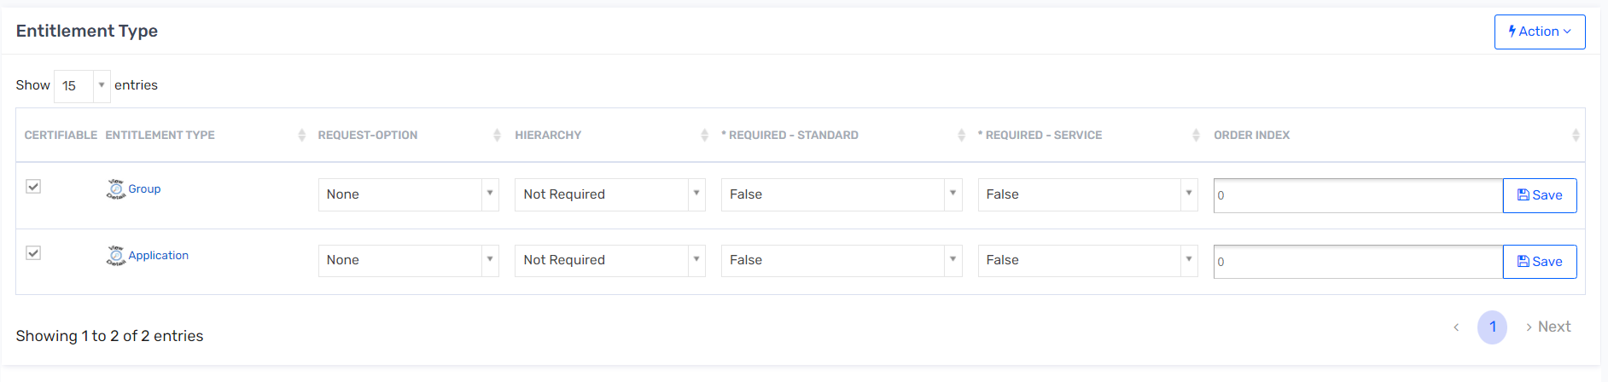

## PSDB Endpoint

### Endpoint Details

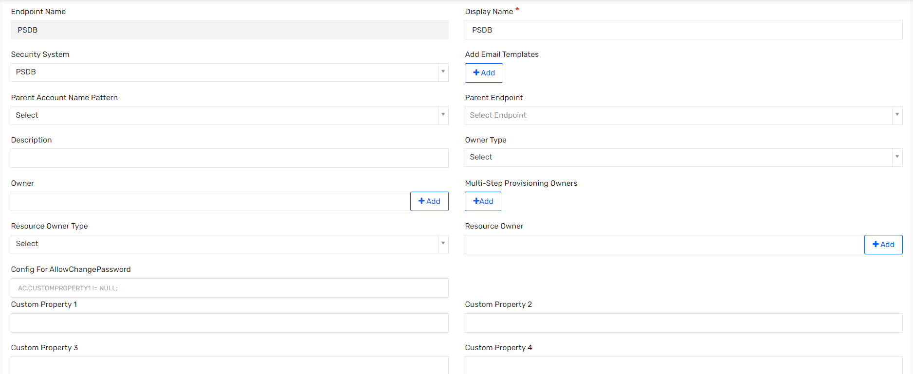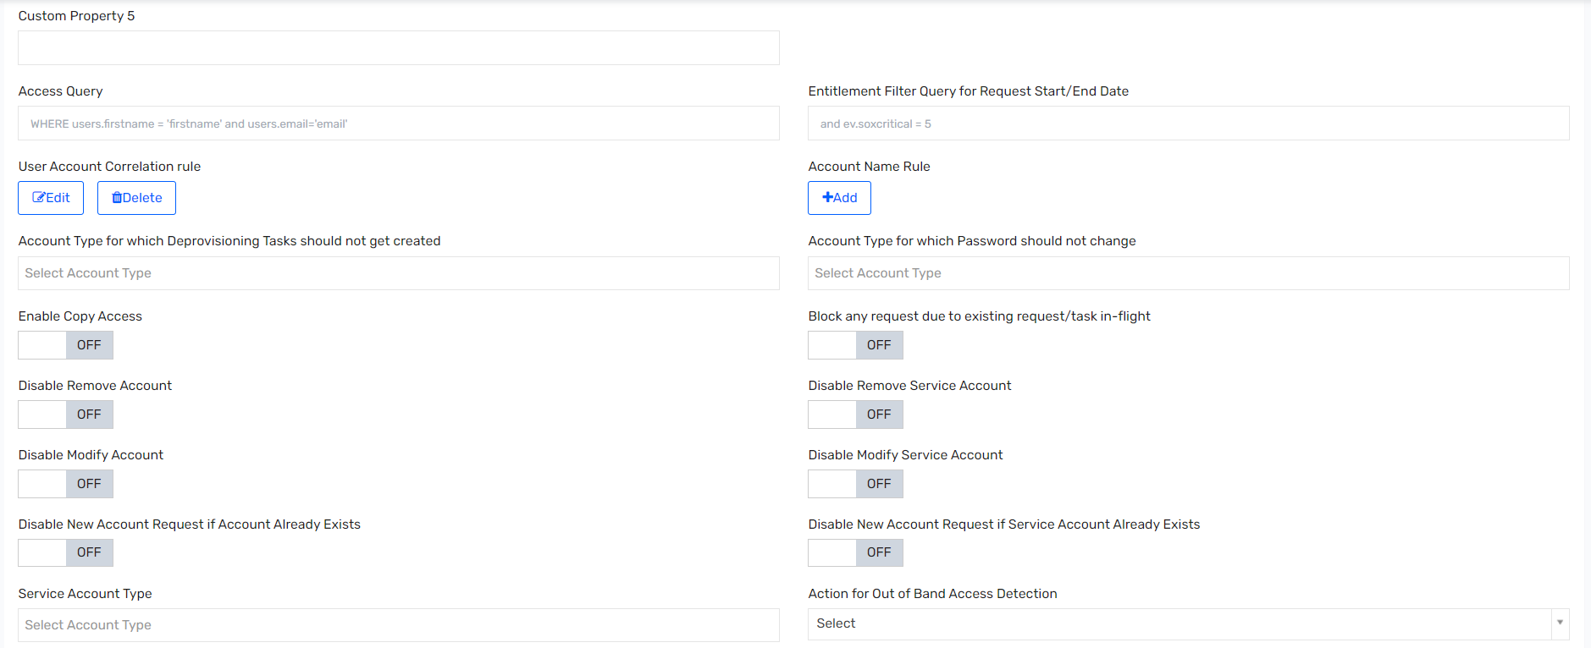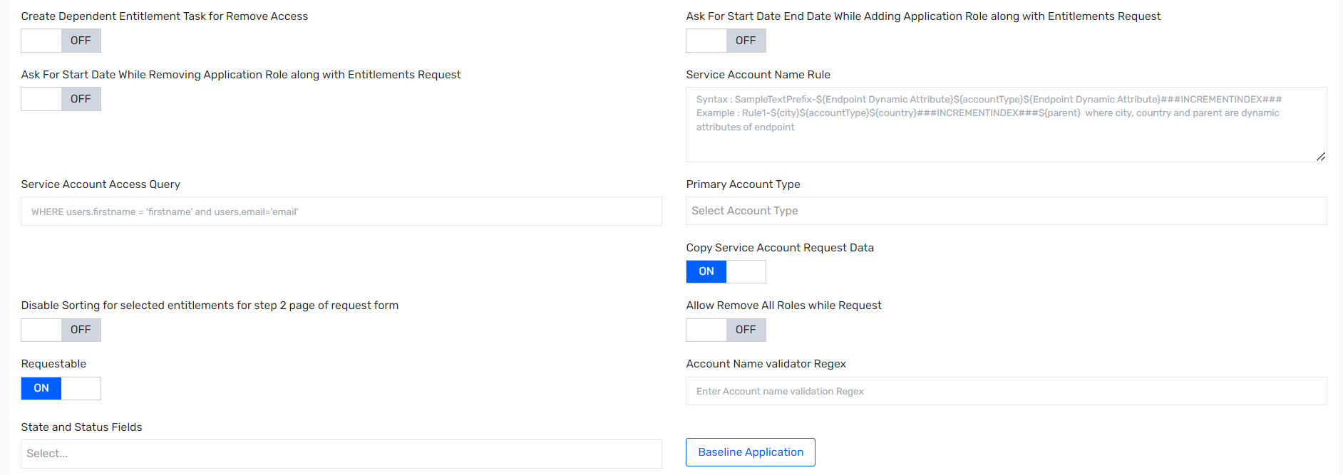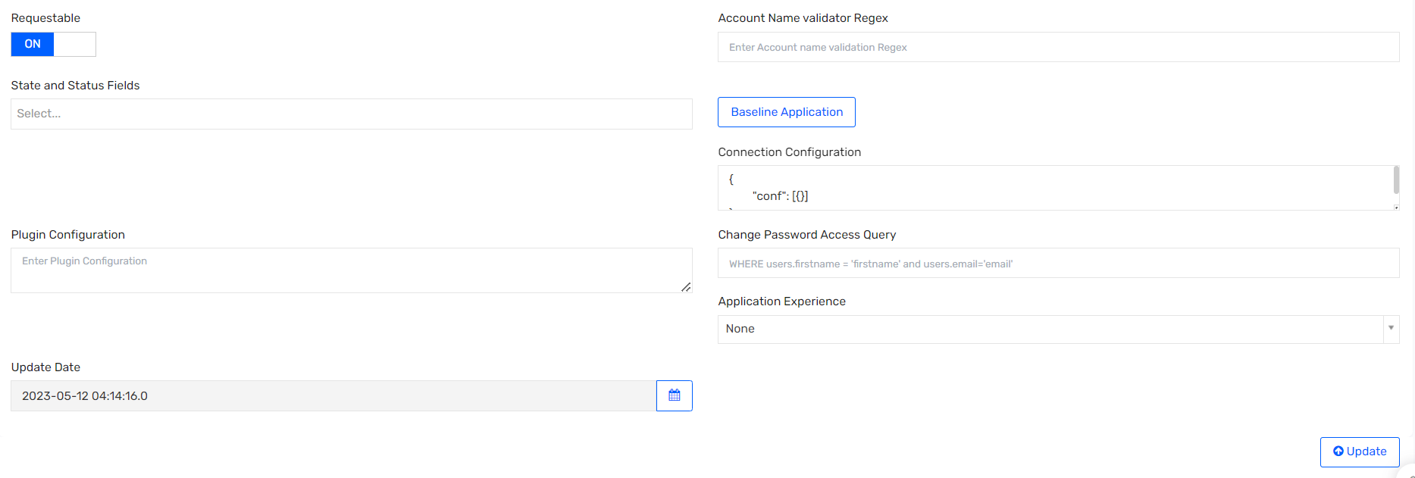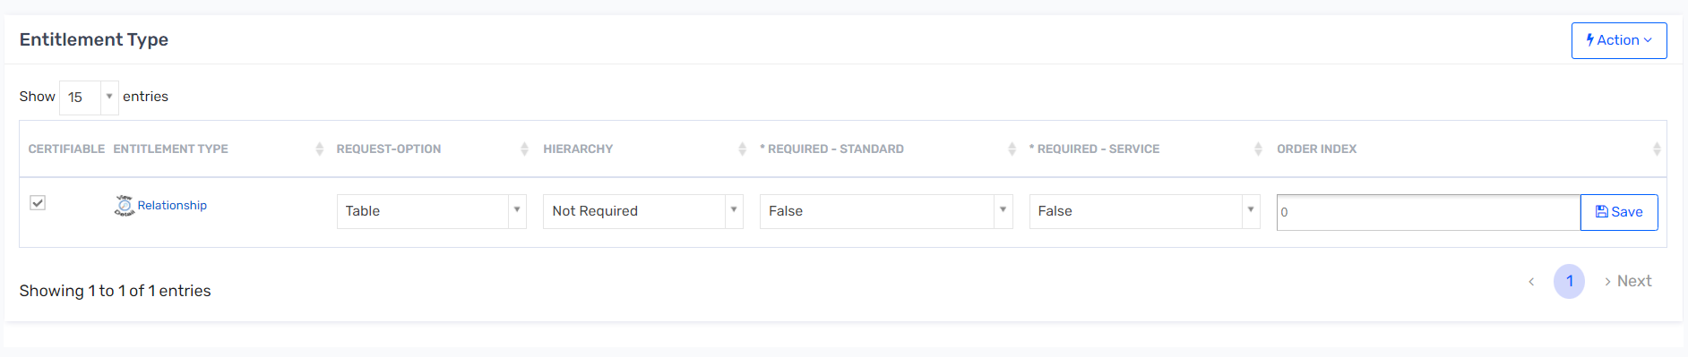

## ServiceNow Endpoint

### Endpoint details

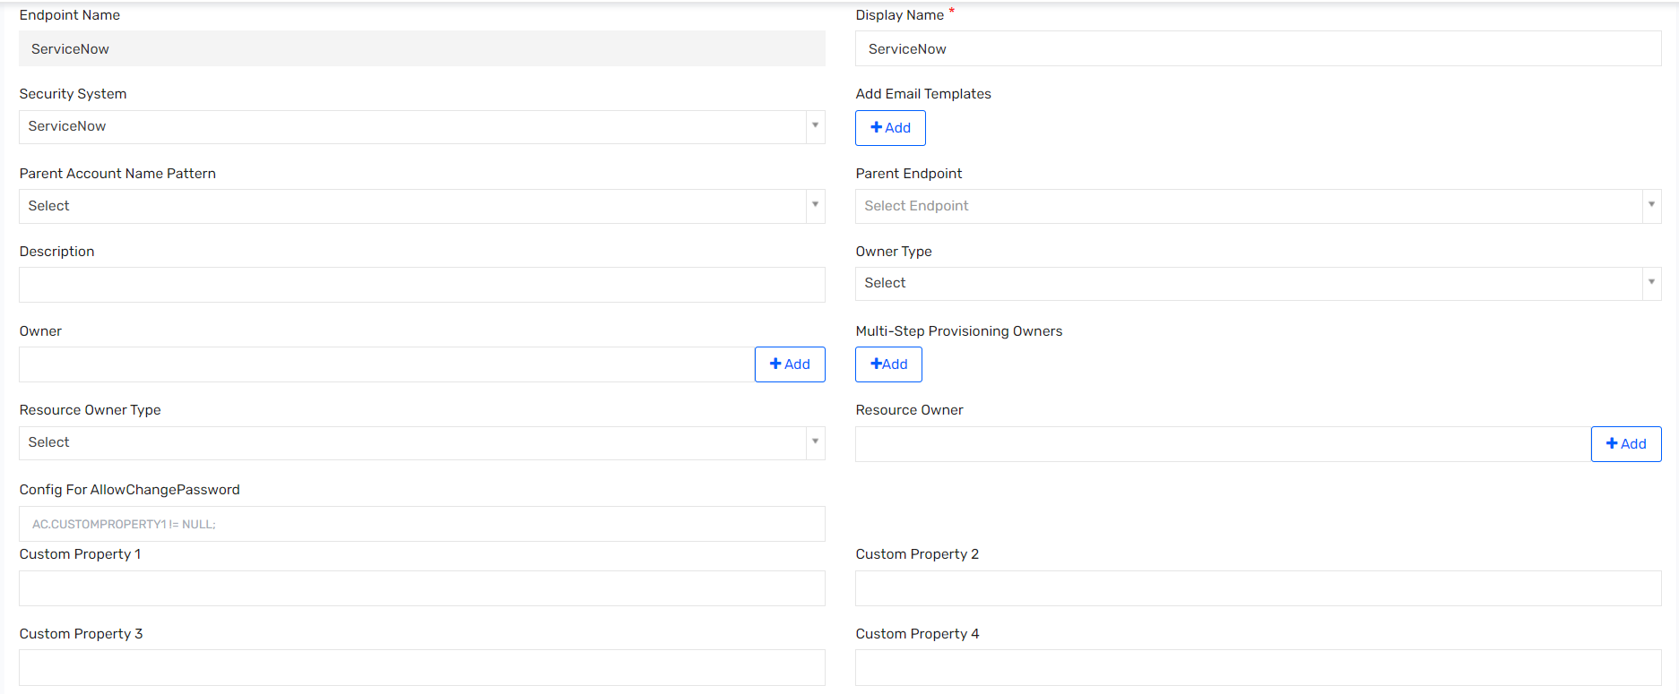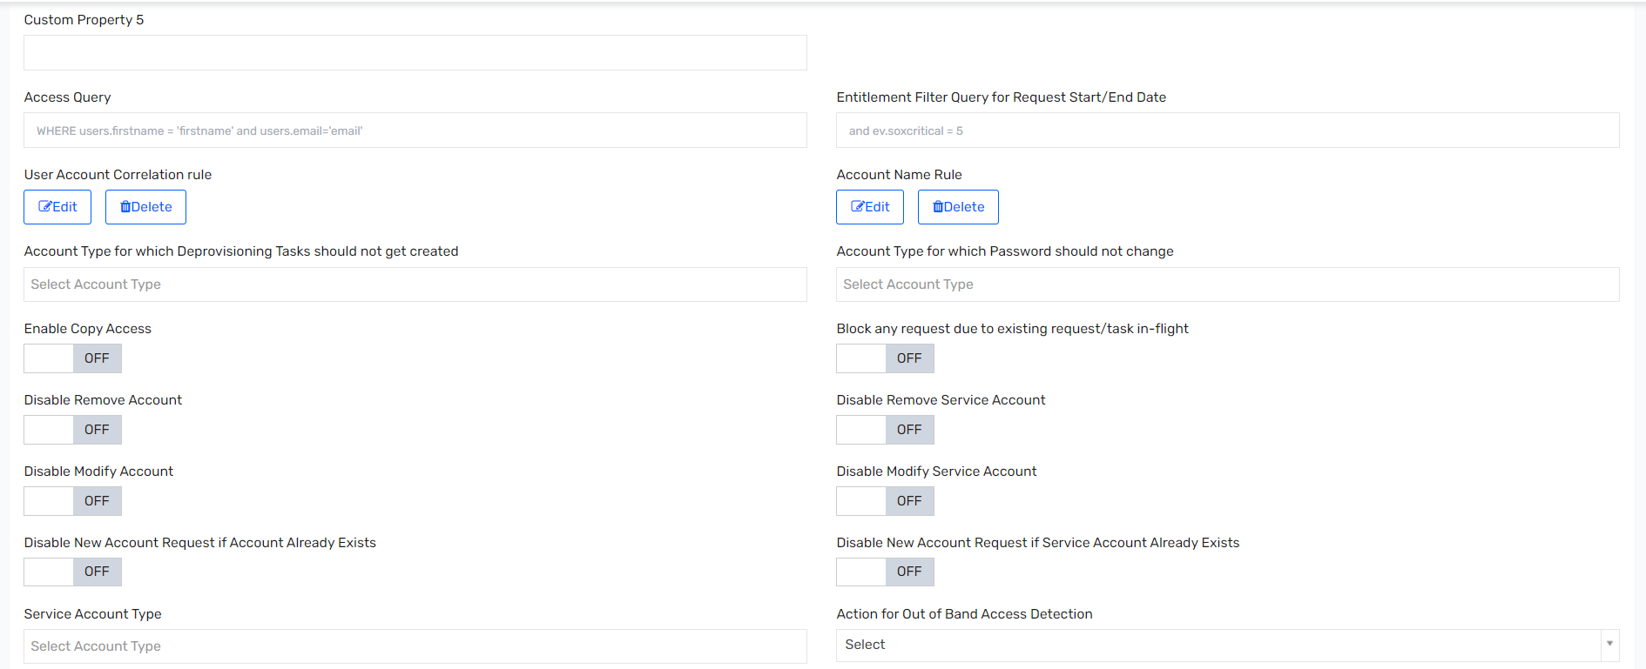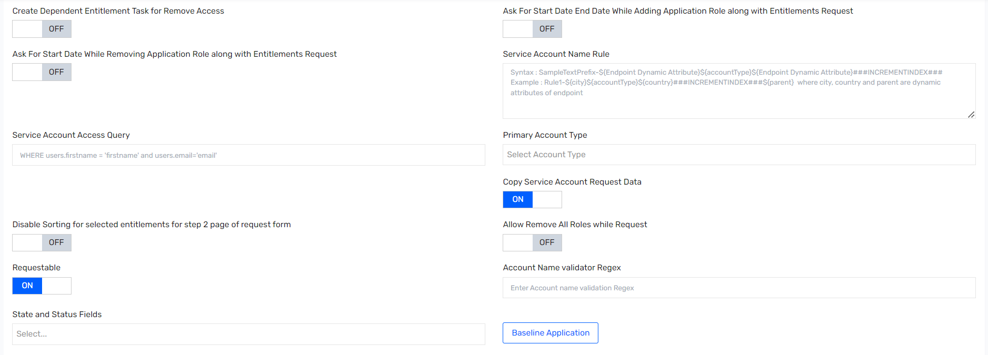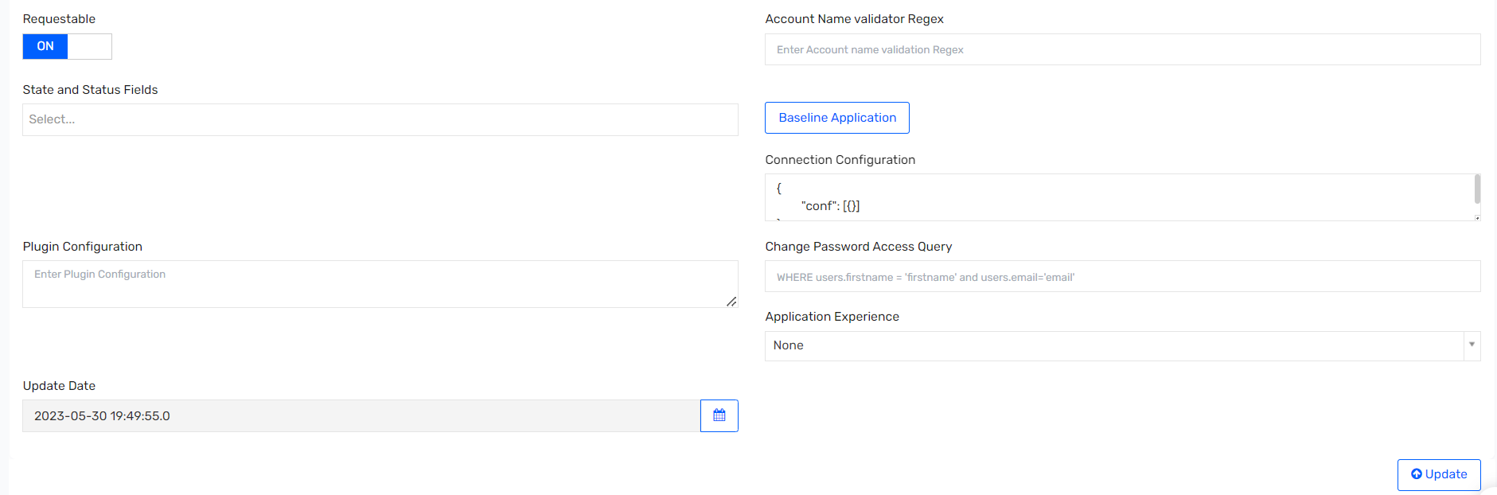

## Saviynt Endpoint

### Endpoint Details

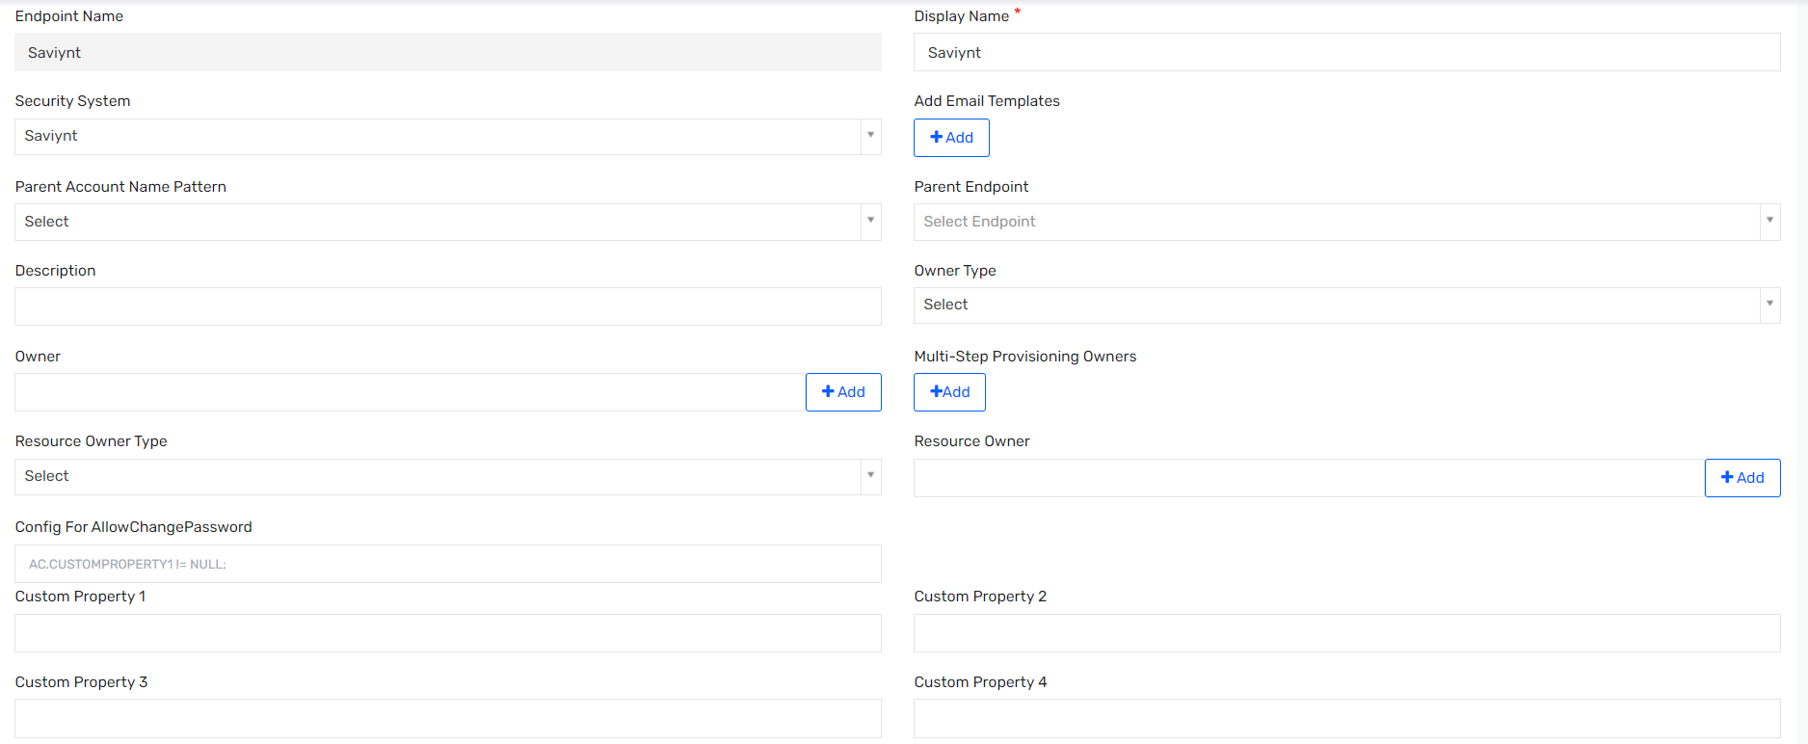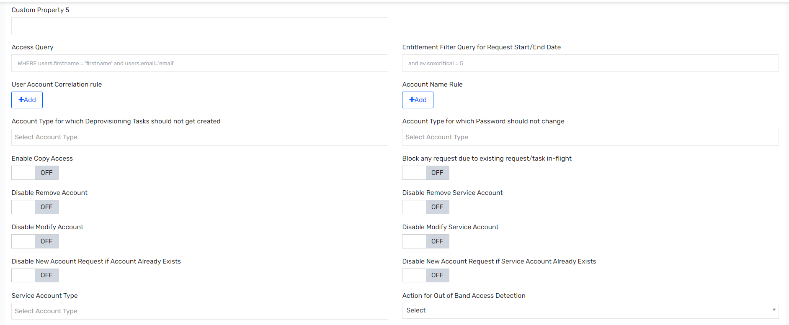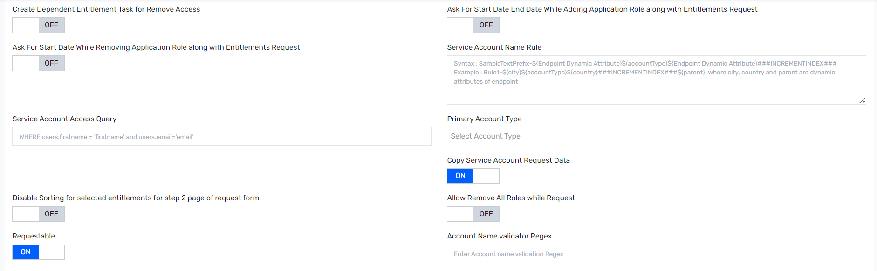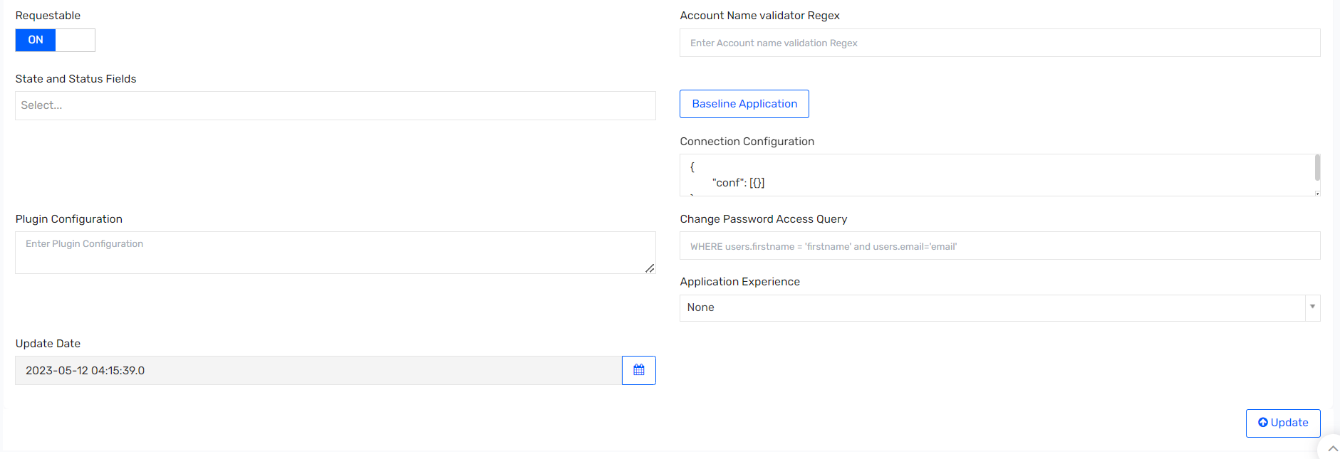

# Technical Rules

## Birthrights

### TR: ENTRole_Credentialed Hospital Physician

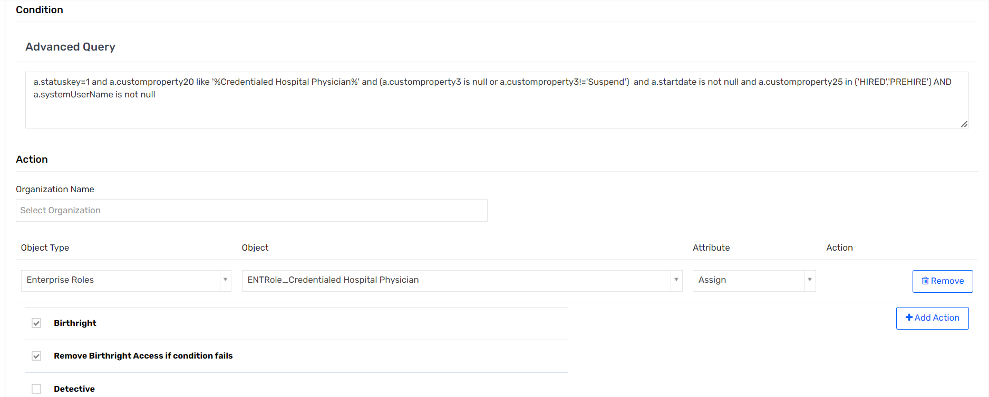

### TR: ENTRole_EVMS Resident Student

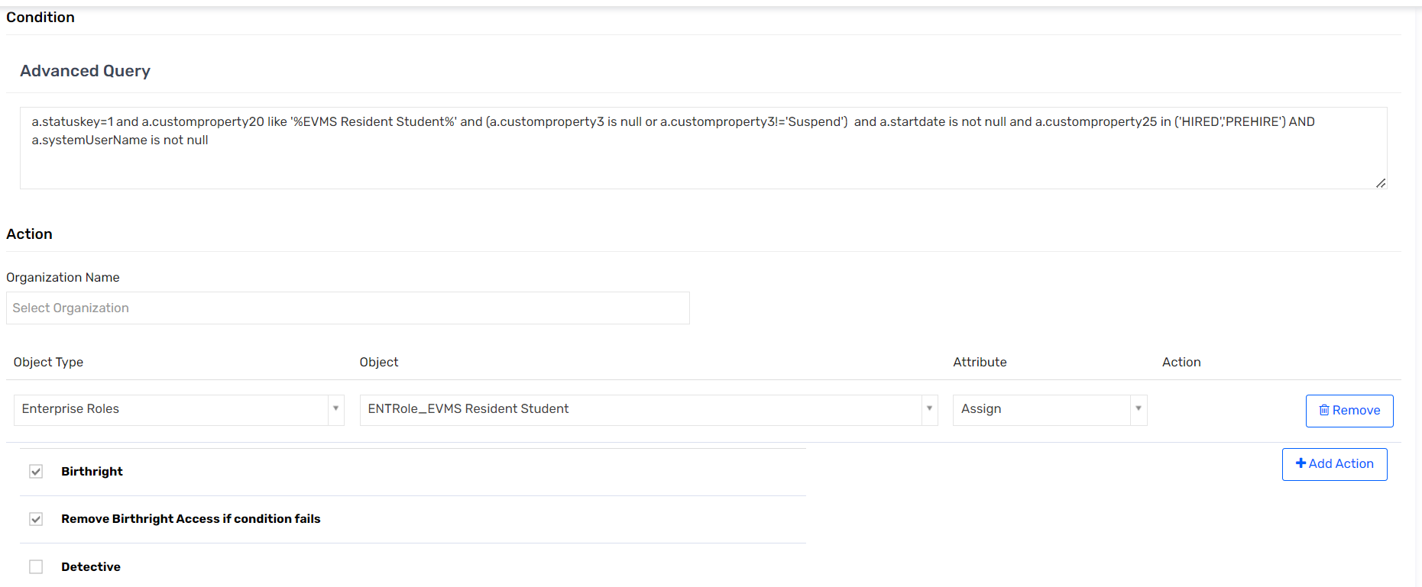

### TR: ENTRole_Group Contact

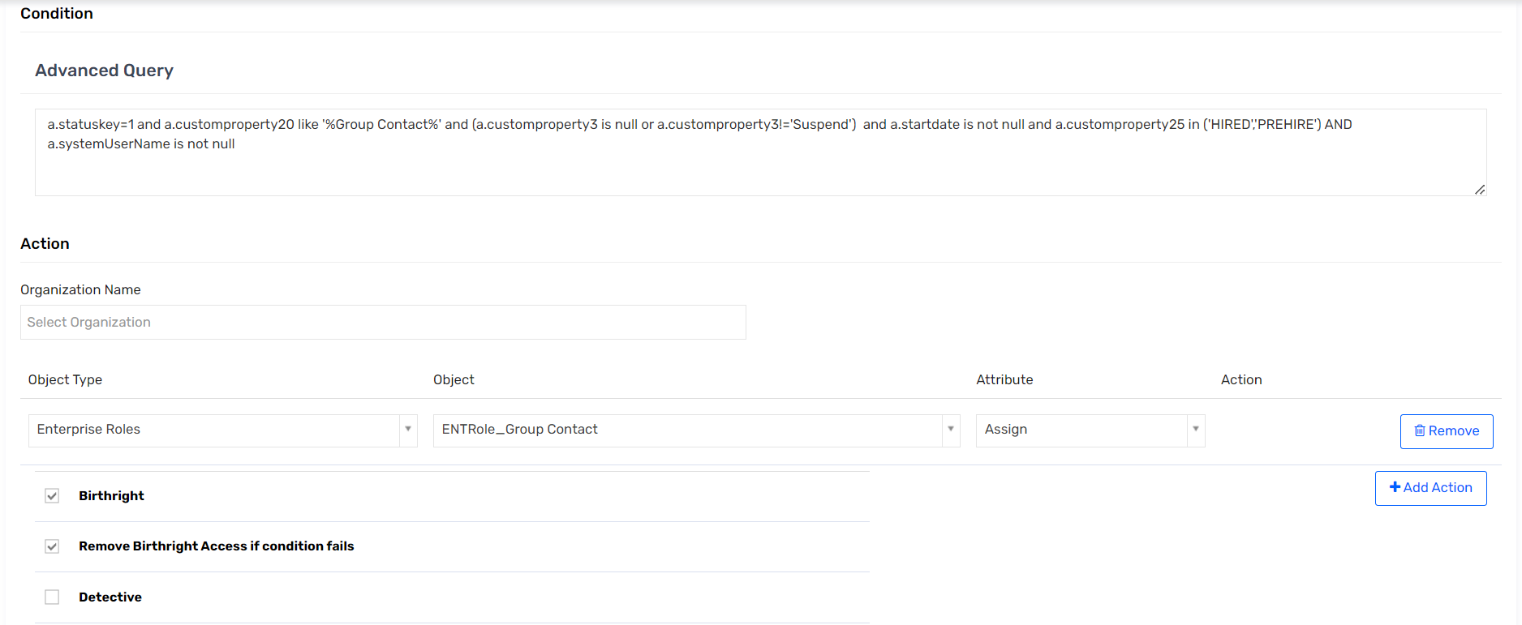

### TR: ENTRole_OHP Physician Office staff

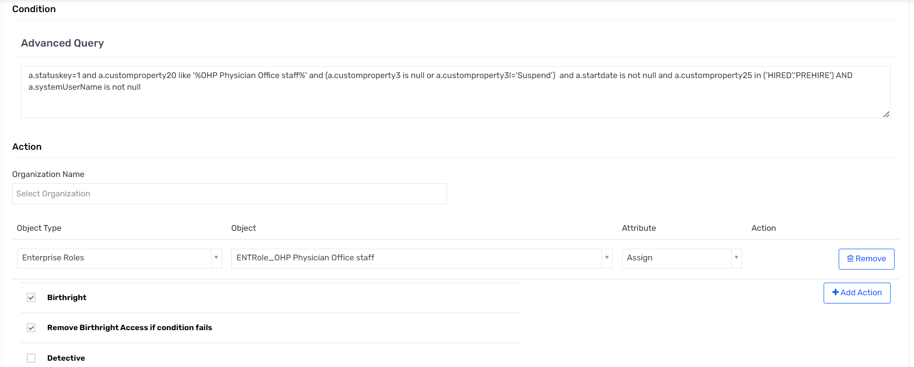

### TR: ENTRole_Ambulatory Scribe

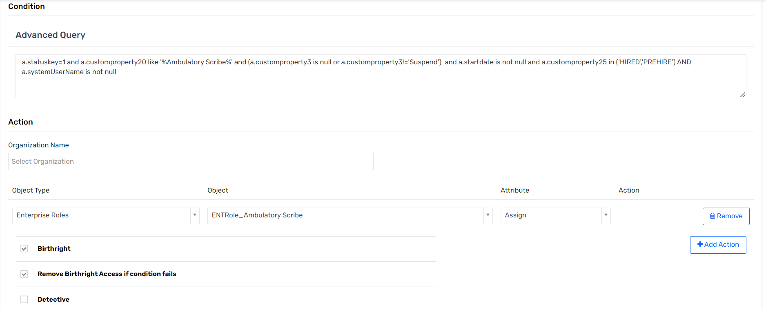

### TR: ENTRole_In Patient Scribe

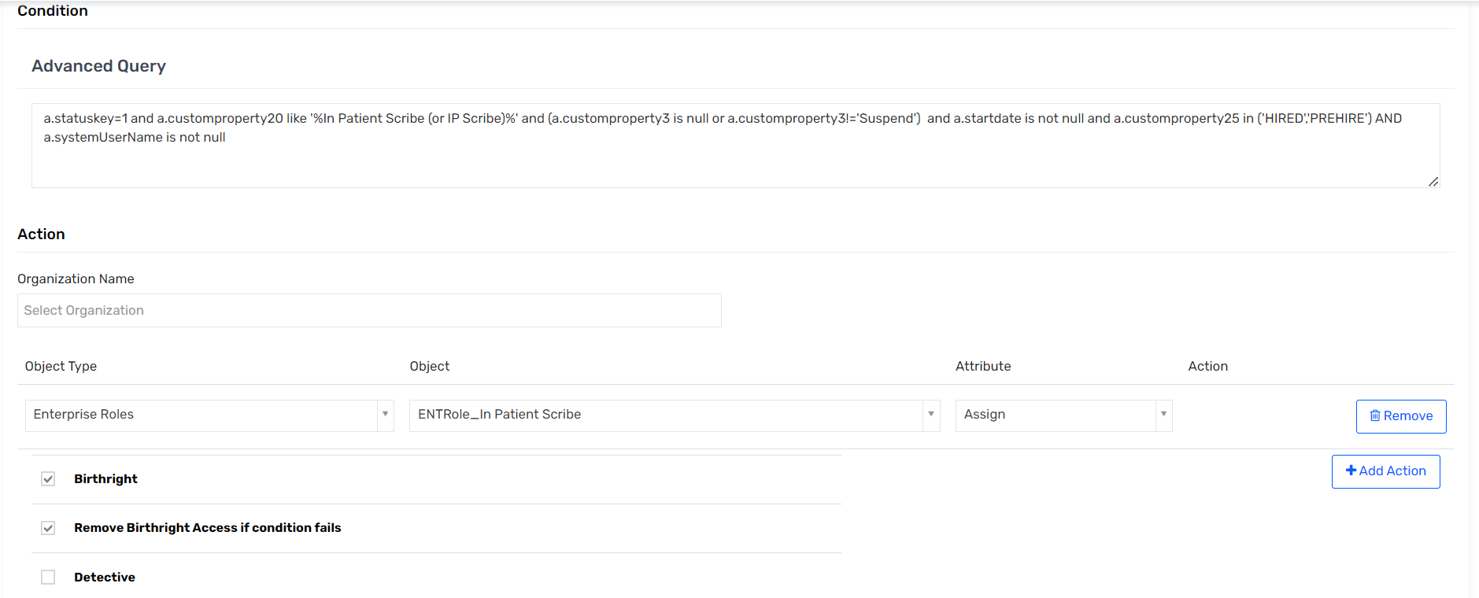

### TR: ENTRole_ED Scribe

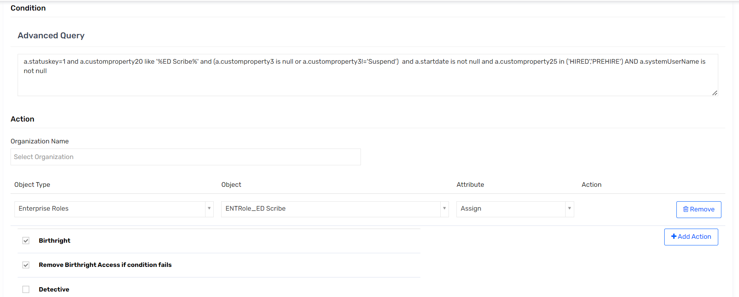

### TR: ENTRole_Research Monitor

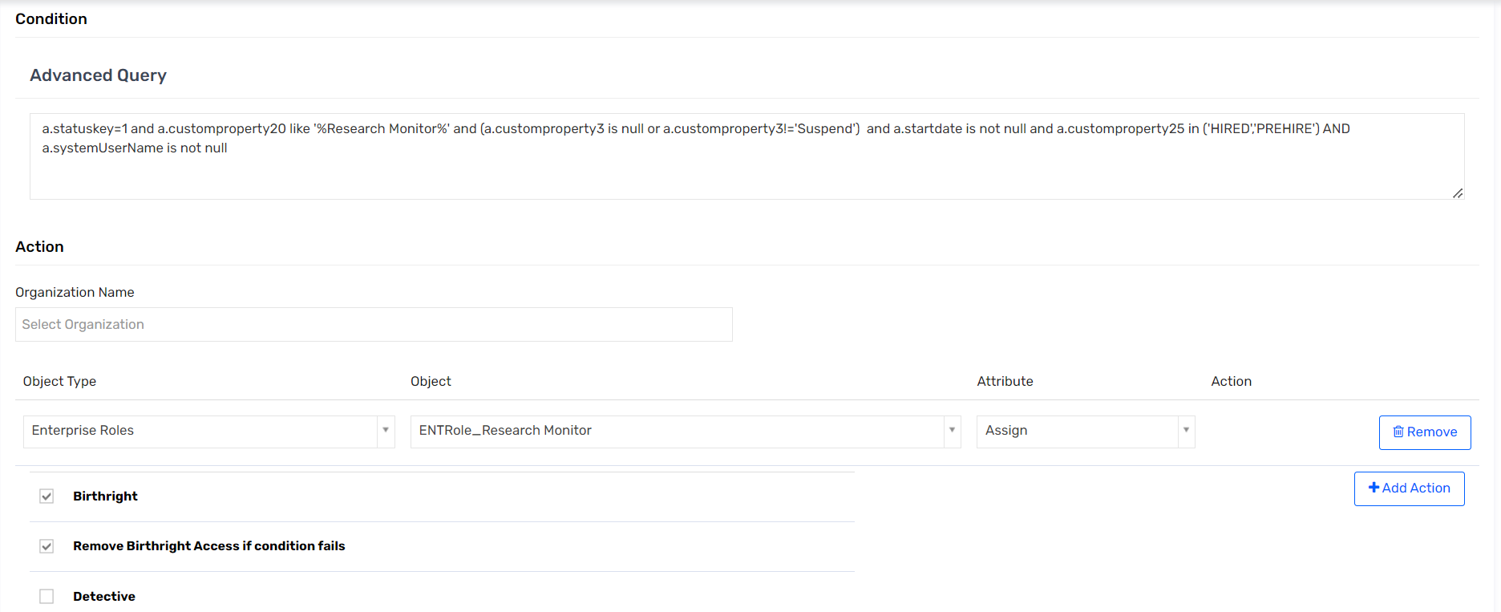

### TR: ENTRole_OHW Physician

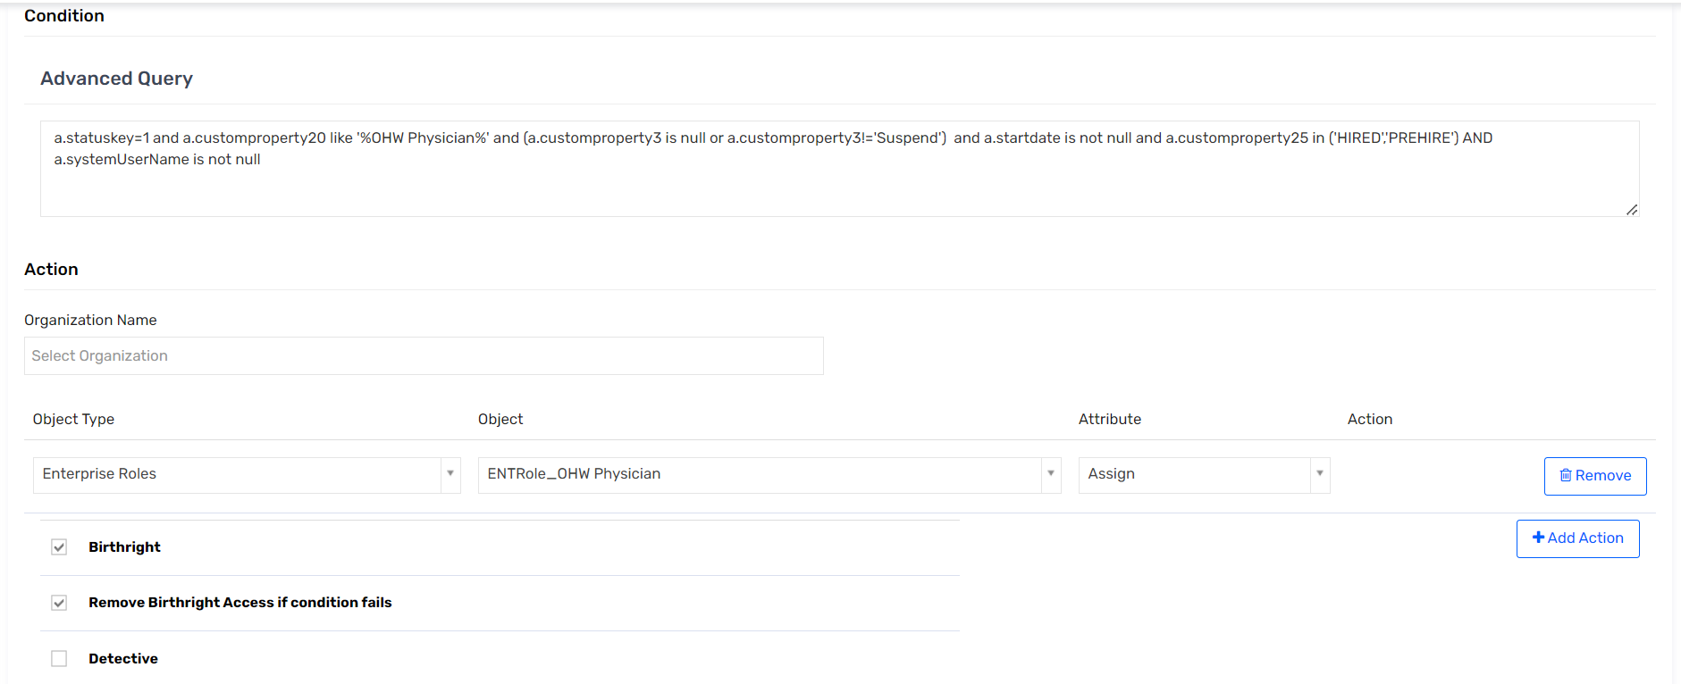

### TR: ENTRole_Employee

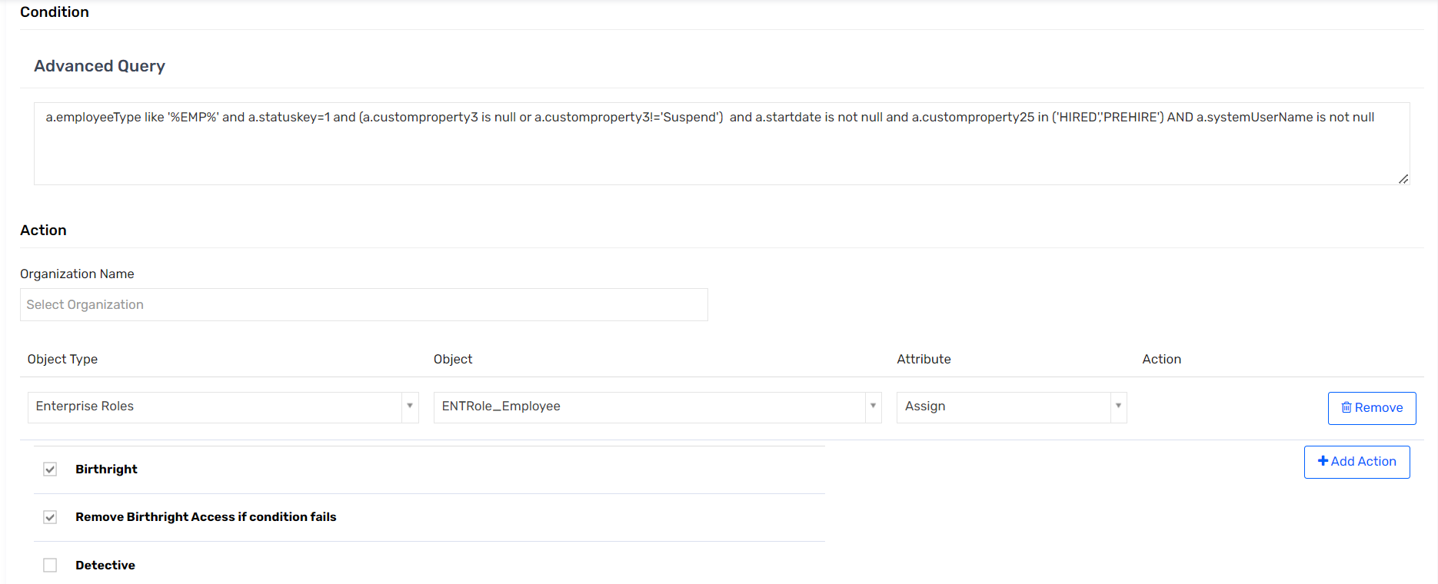

### TR: ENTRole_NonEmployee

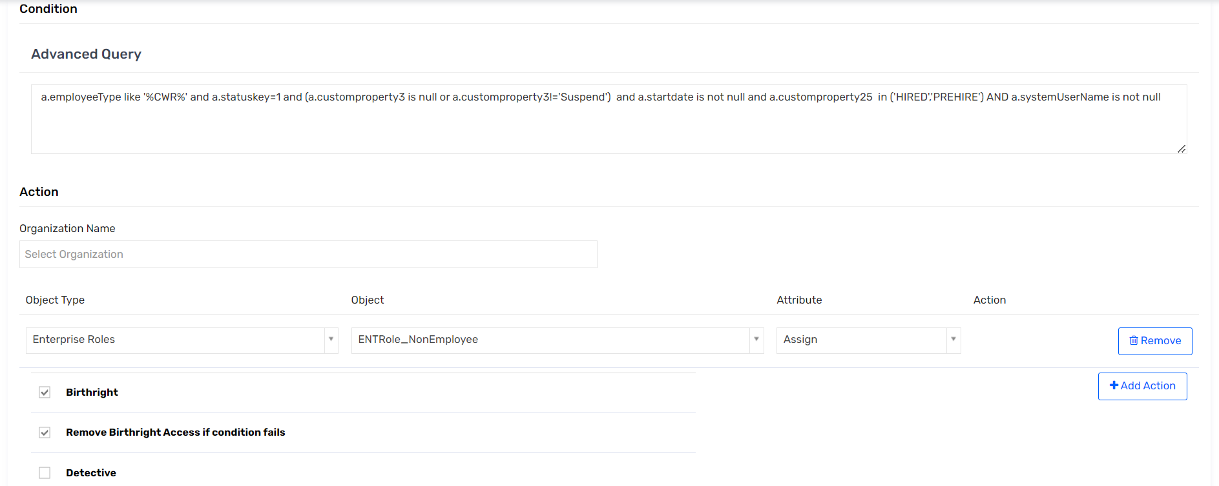

### TR: ENTRole_Credentialed Amb Physician

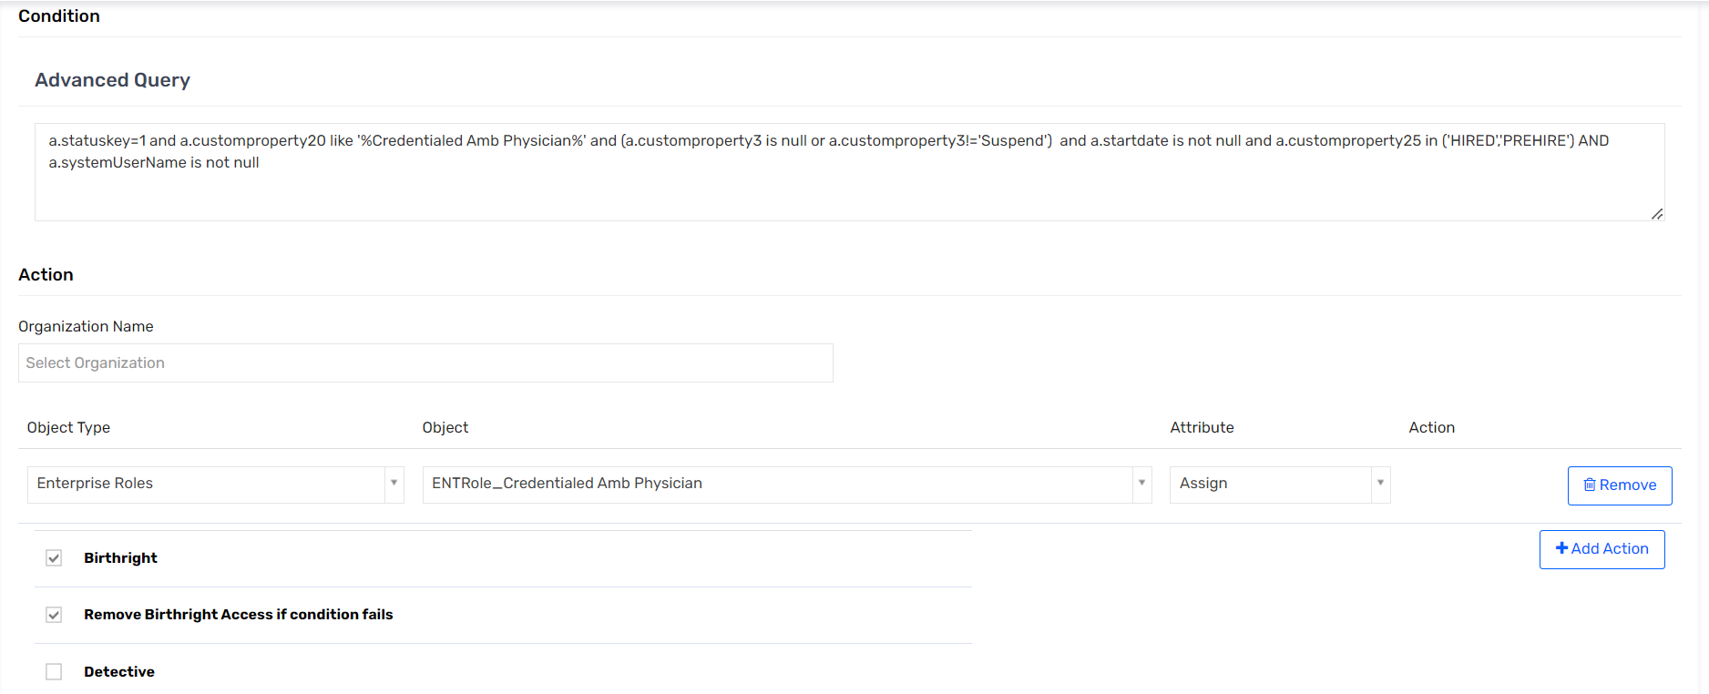

### TR: ENTRole_OHP Broker

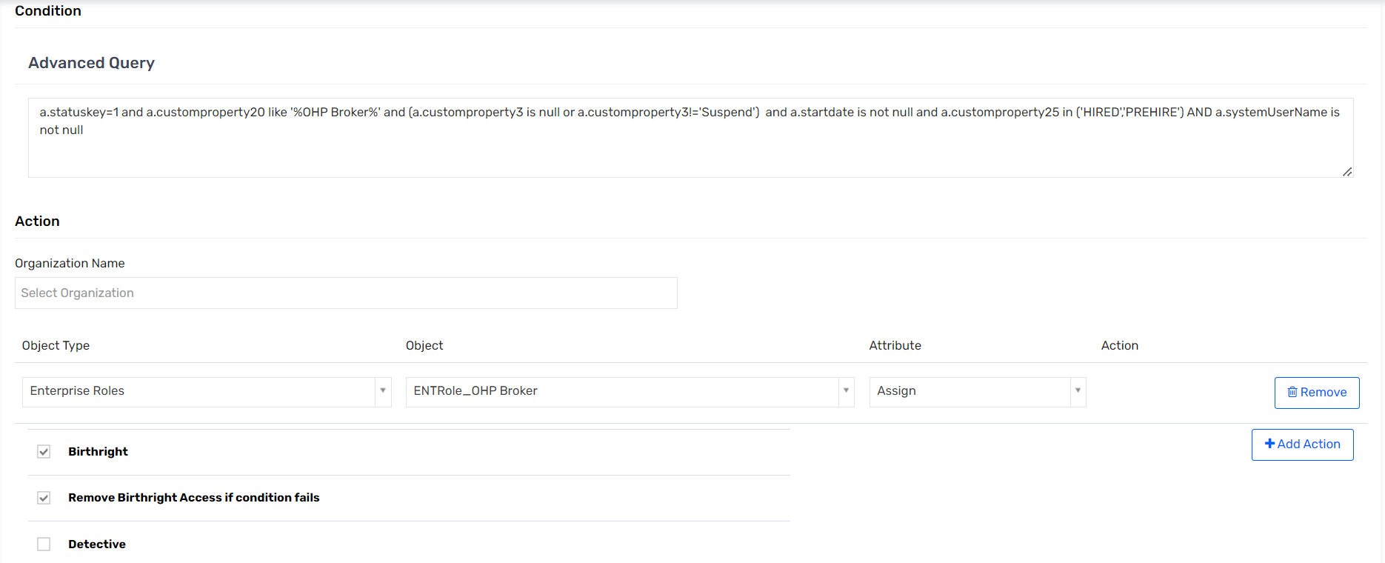

### TR: ENTRole_VAP Broker

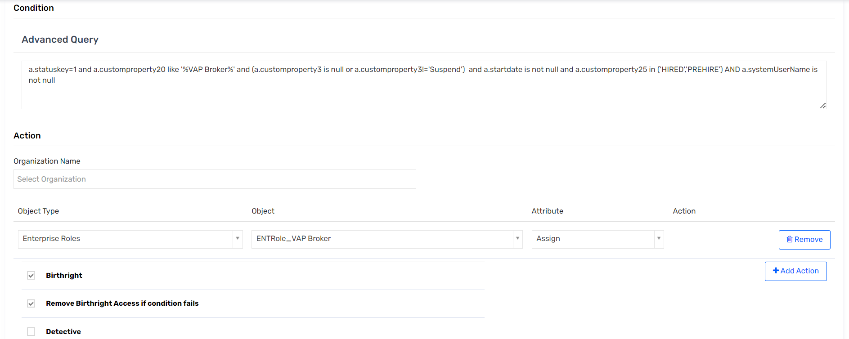

### TR: ENTRole_Benefits Administrators

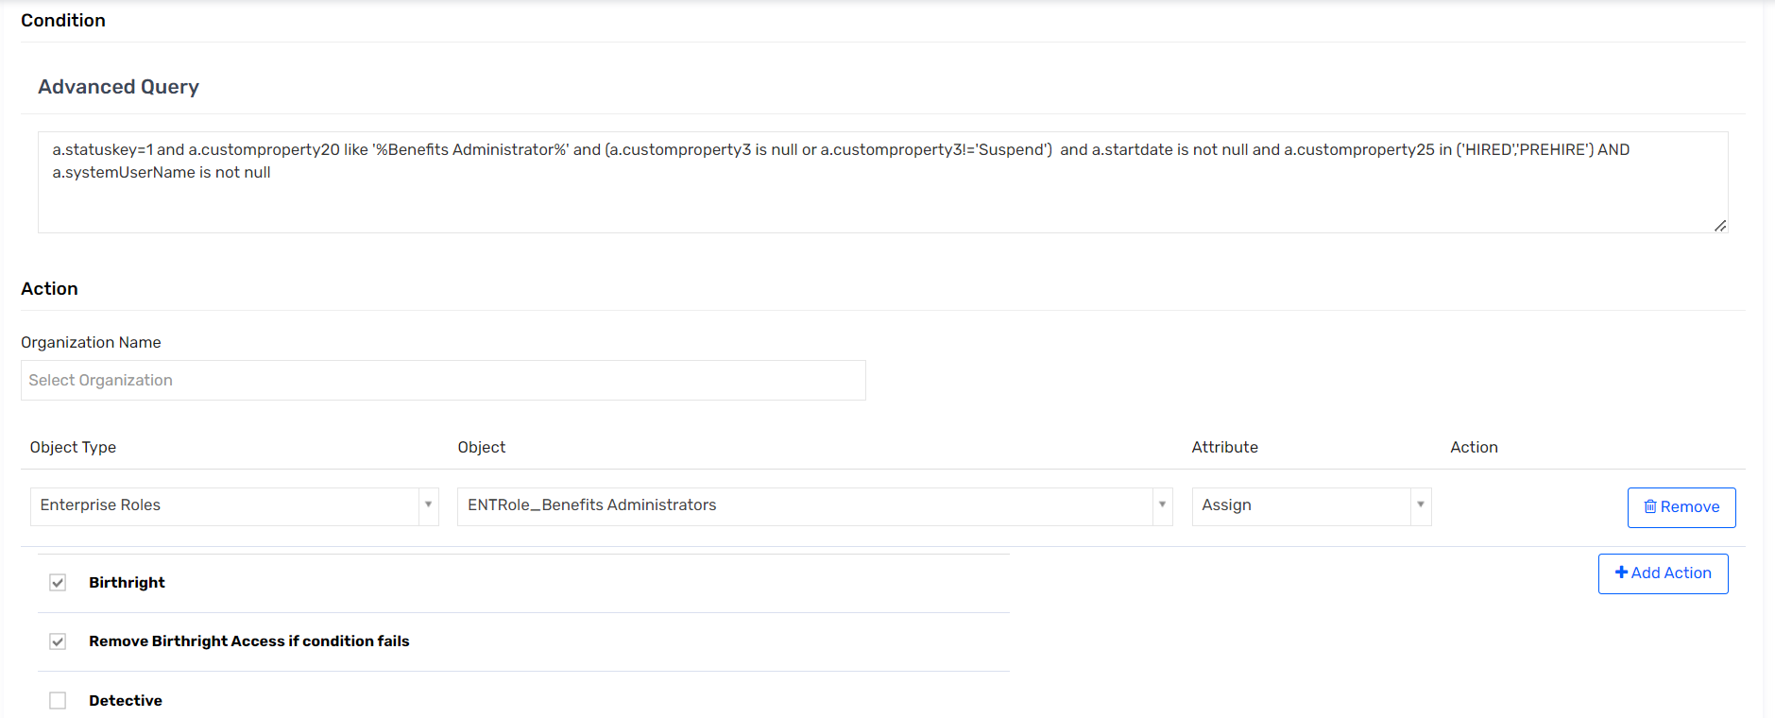

### TR: ENTRole_Community_Physician

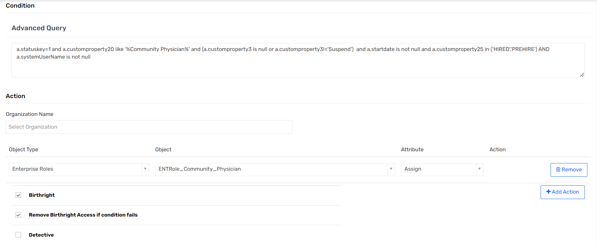

### TR: ENTRole_ Community_Clinical staff

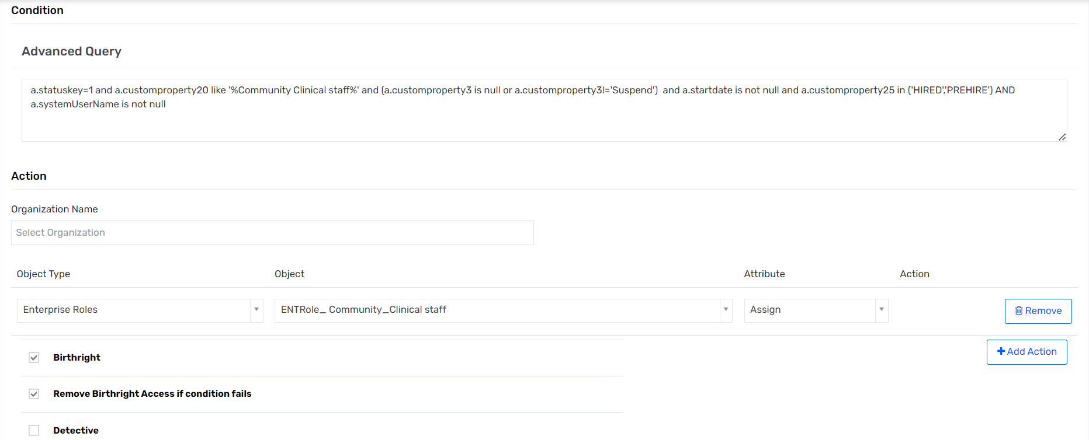

### TR: Assign PSDB Ent Employee

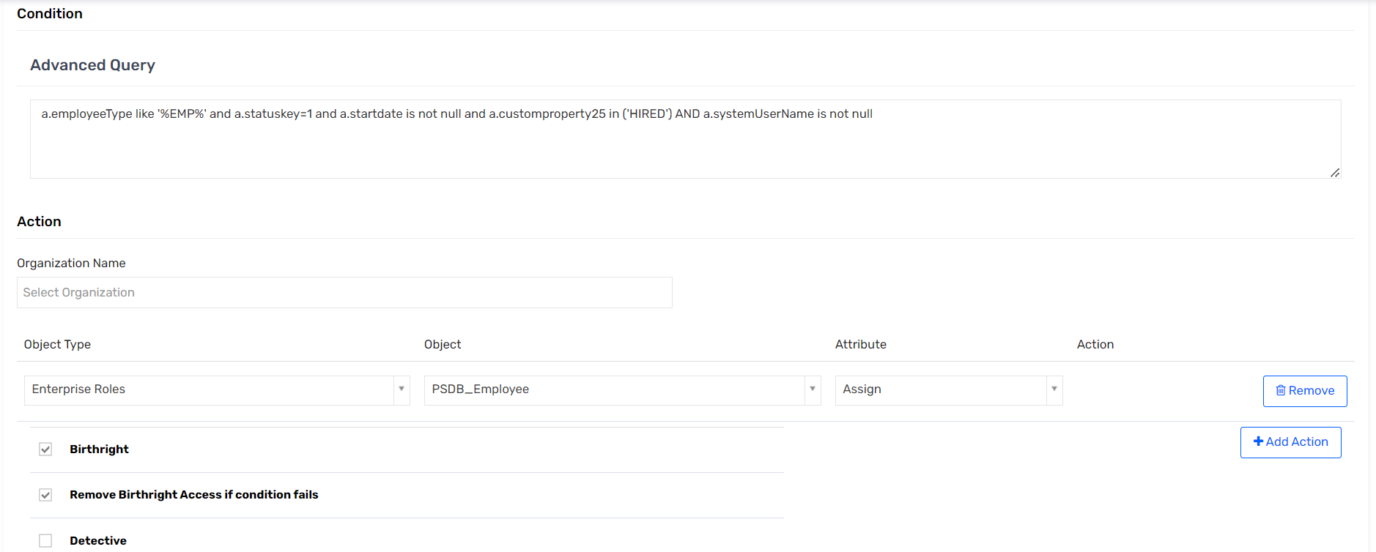

### TR: Assign PSDB Ent NonEmployee

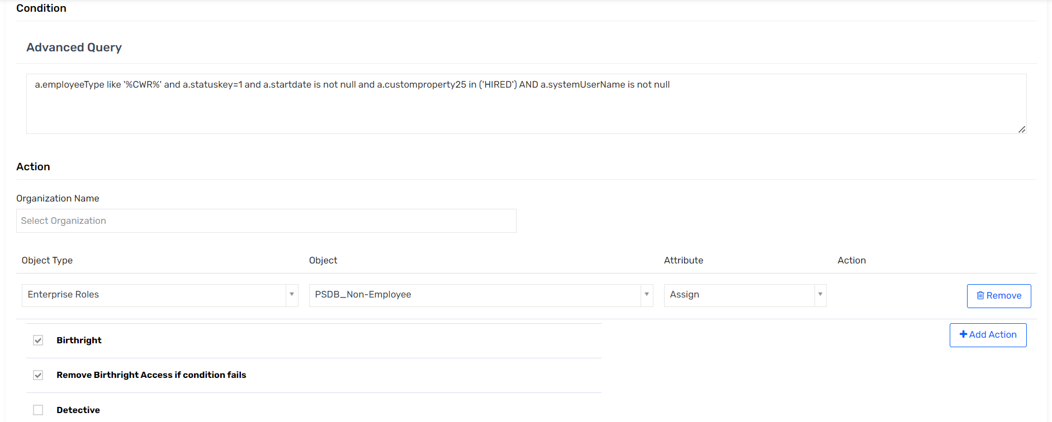

### TR: Assign PSDB Physician

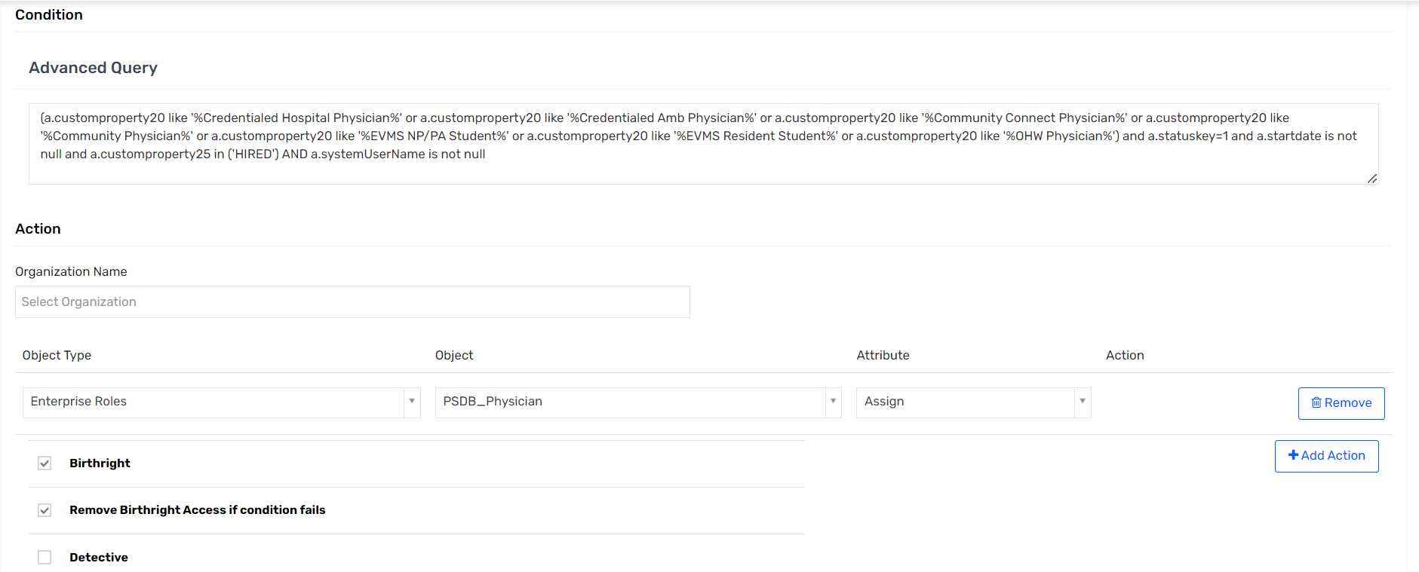

### TR: ENTRole_Community Connect Scribes

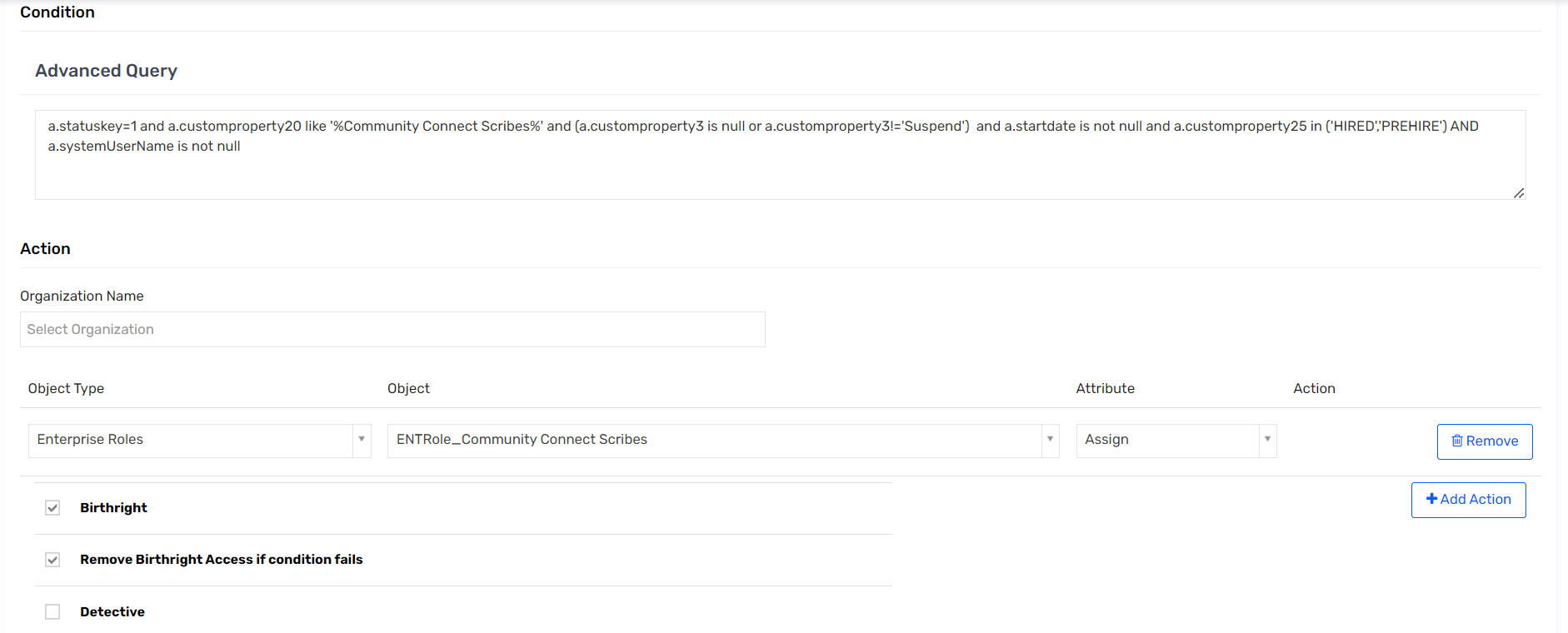

### TR: Birthright Access to Duo_PSDB

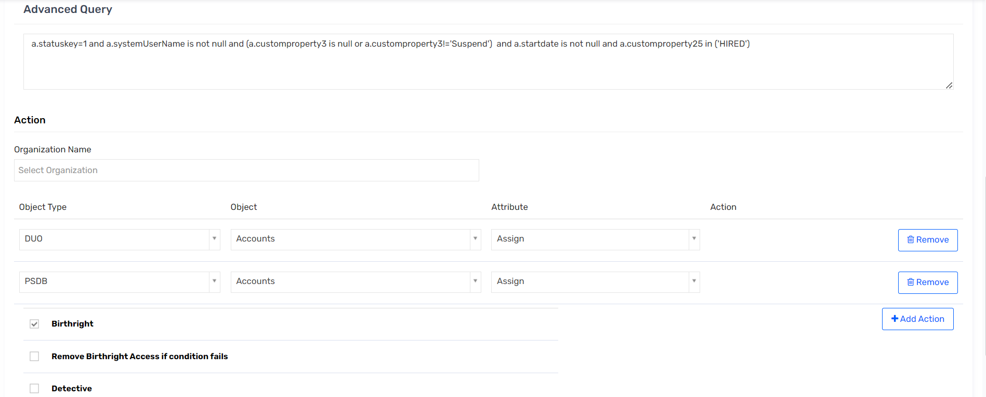

### TR: Assign E3 License

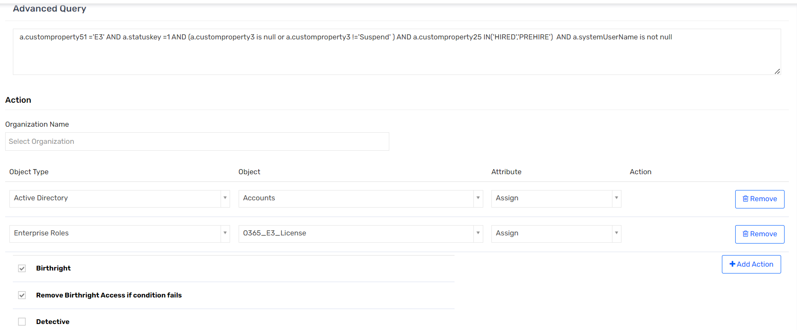

### TR: Assign E5 License

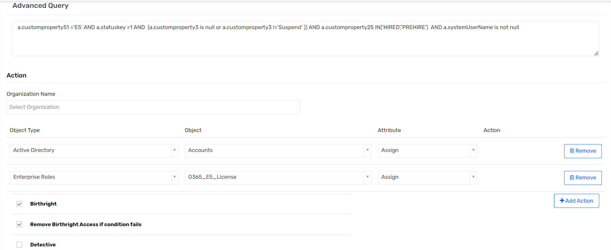

### TR: Assign E5 License

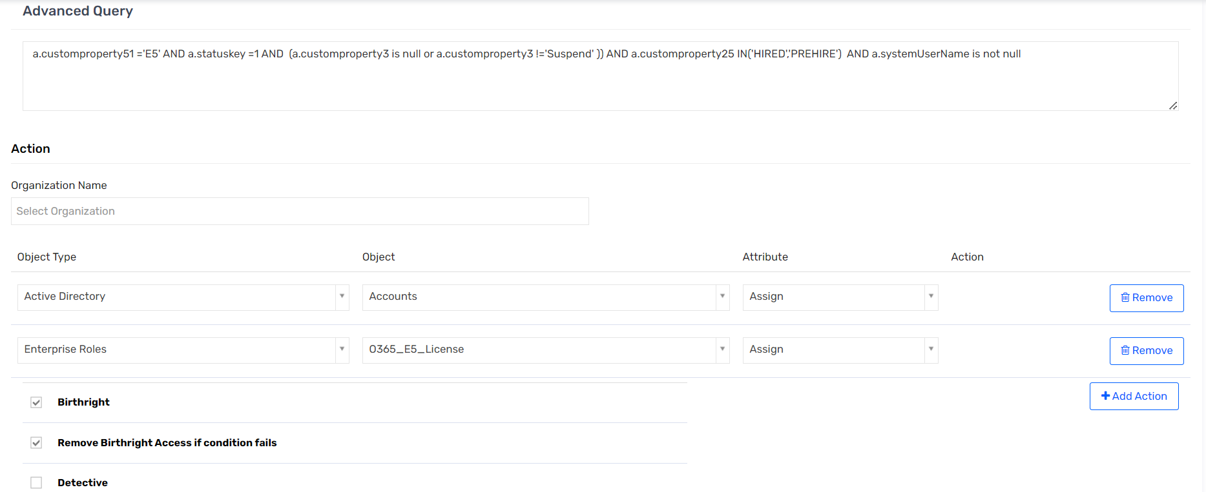

### TR: Birthright Access to SNOW

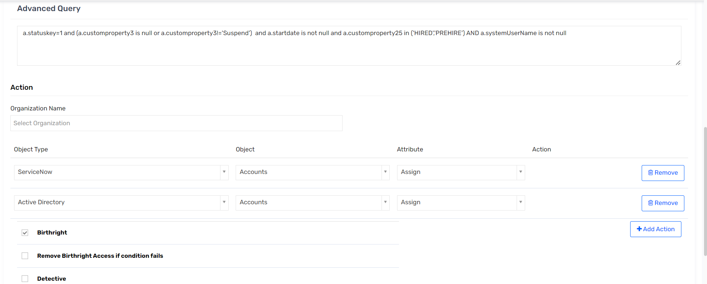

### TR: Assign TEGS AD group

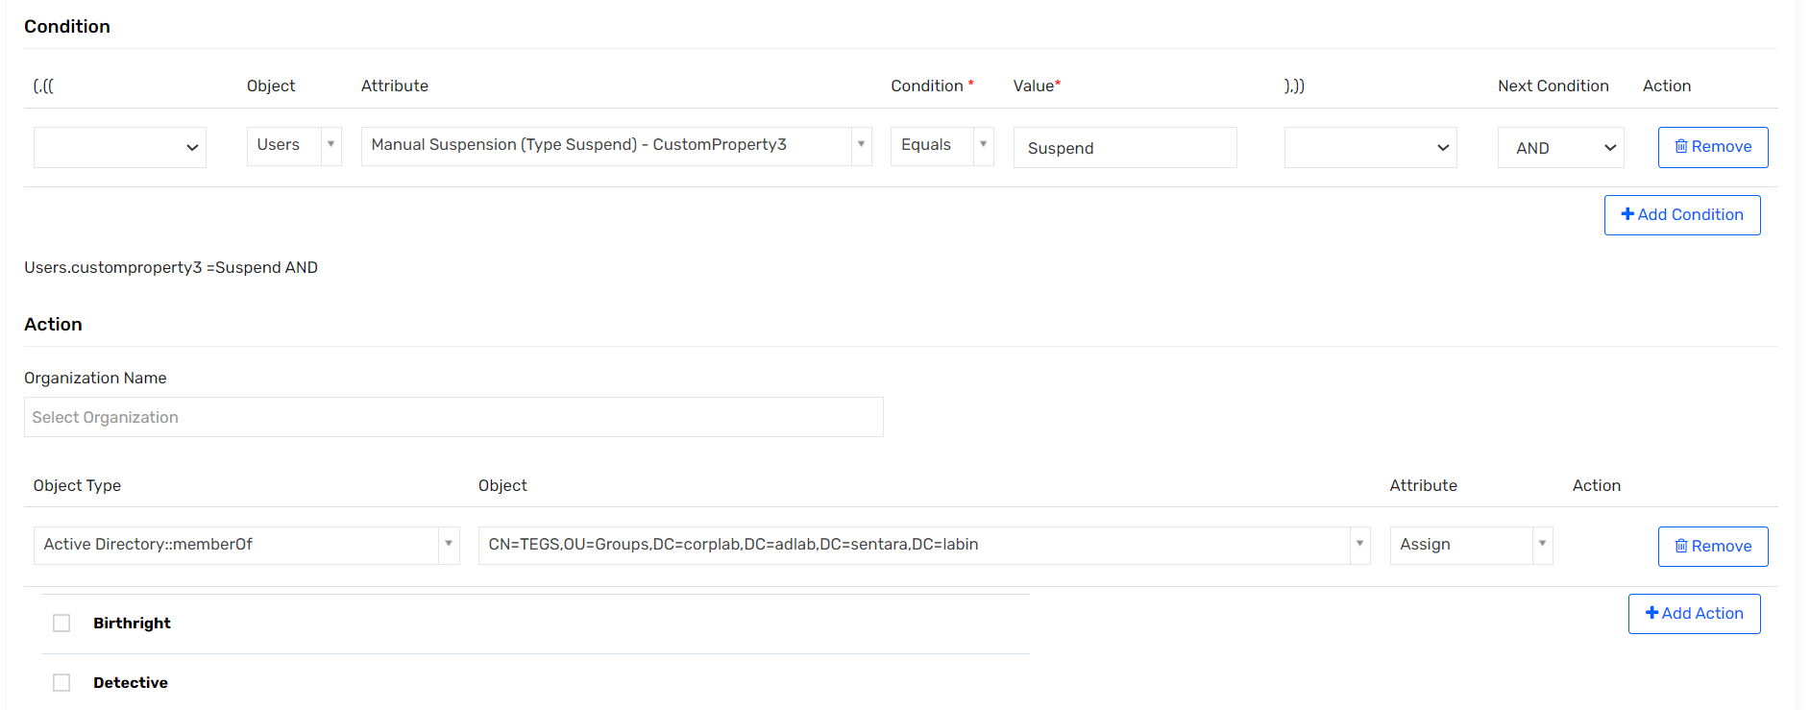

### TR: ENTRole_Community Connect Staff

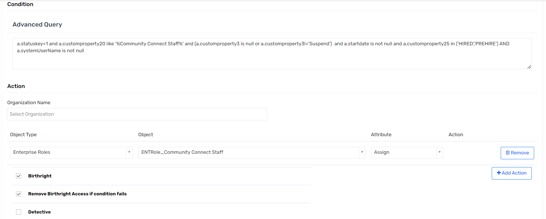

### TR: ENTRole_Community Connect Physicians

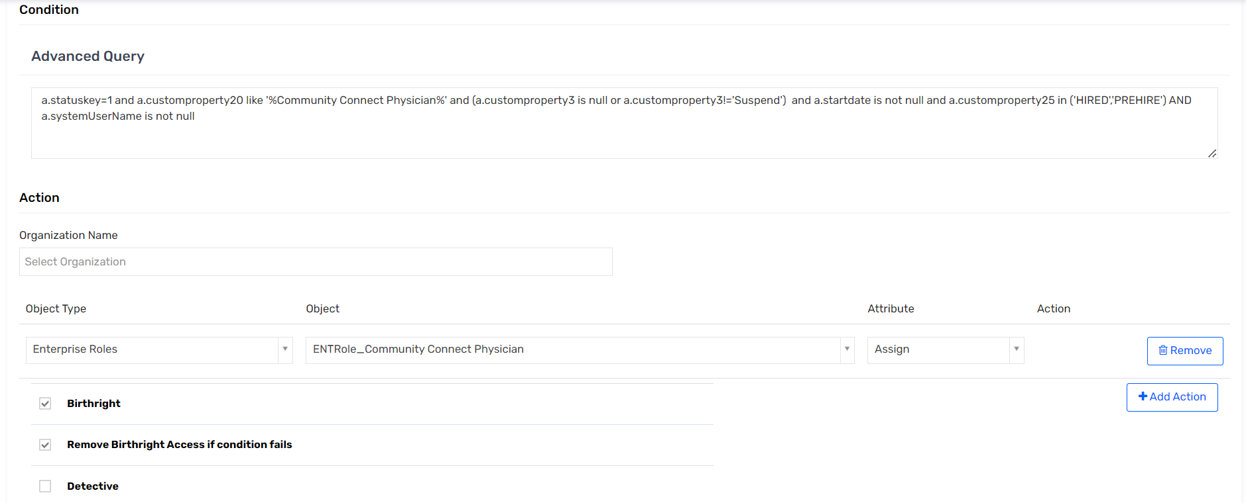

### TR: ENTRole_Community Staff

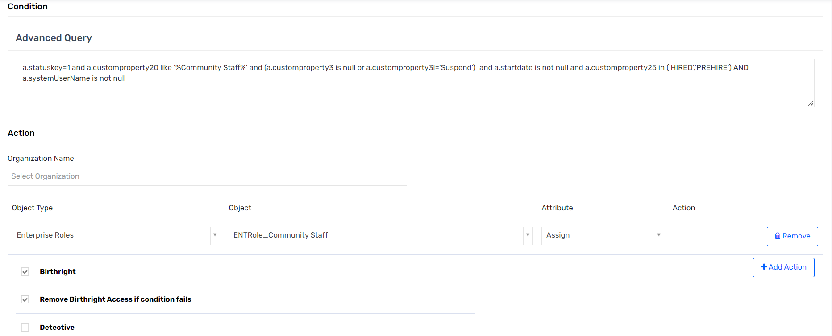

### TR: ENTRole_EVMS 1st-2nd Yr Medical Student

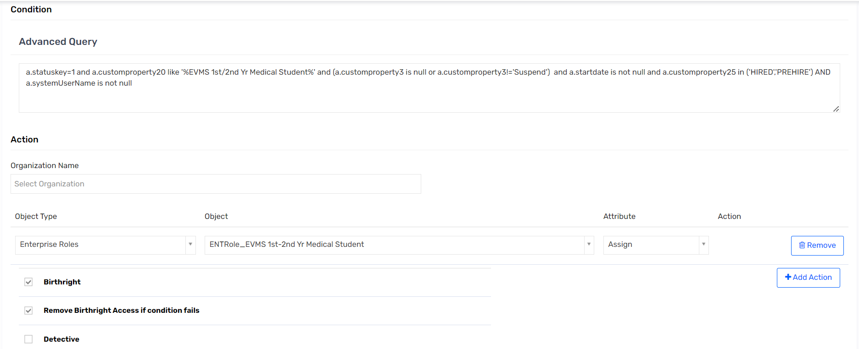

### TR: ENTRole_EVMS 3rd-4th Yr Medical Student

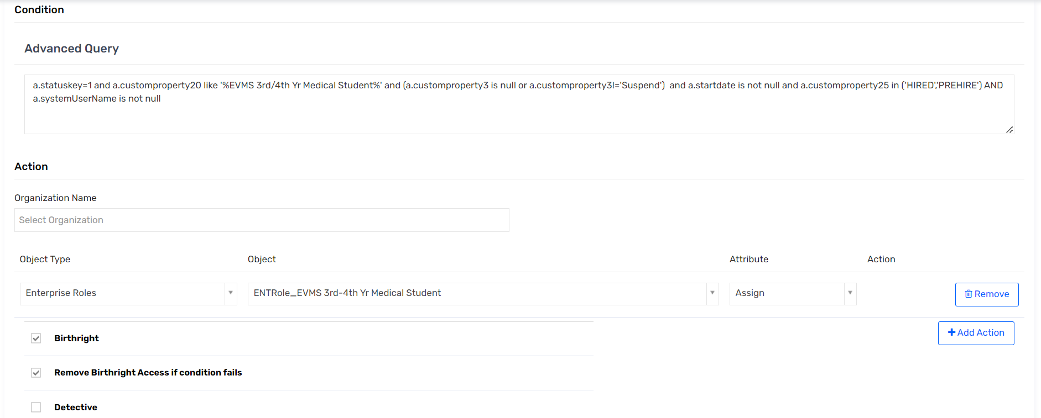

### TR: Assign PSDB Physician Office Staff

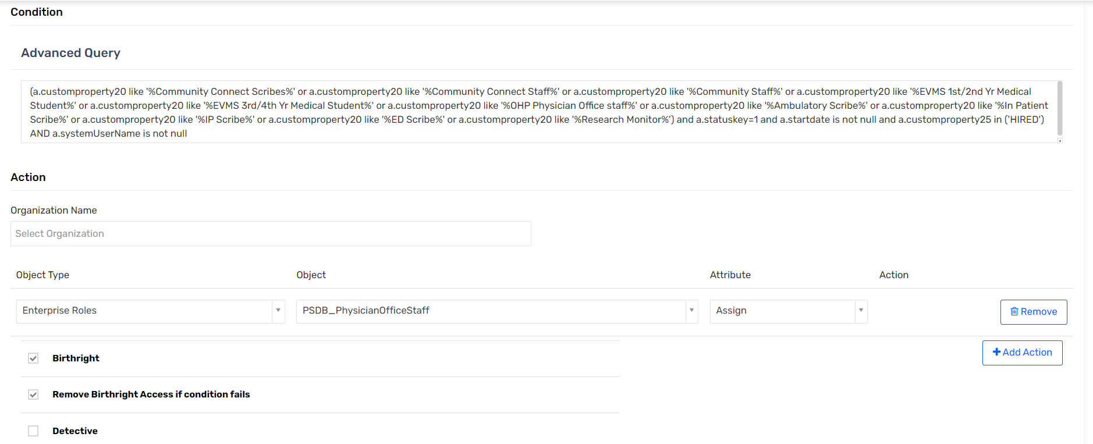

### TR: ENTRole_EVMS NP/PA Student

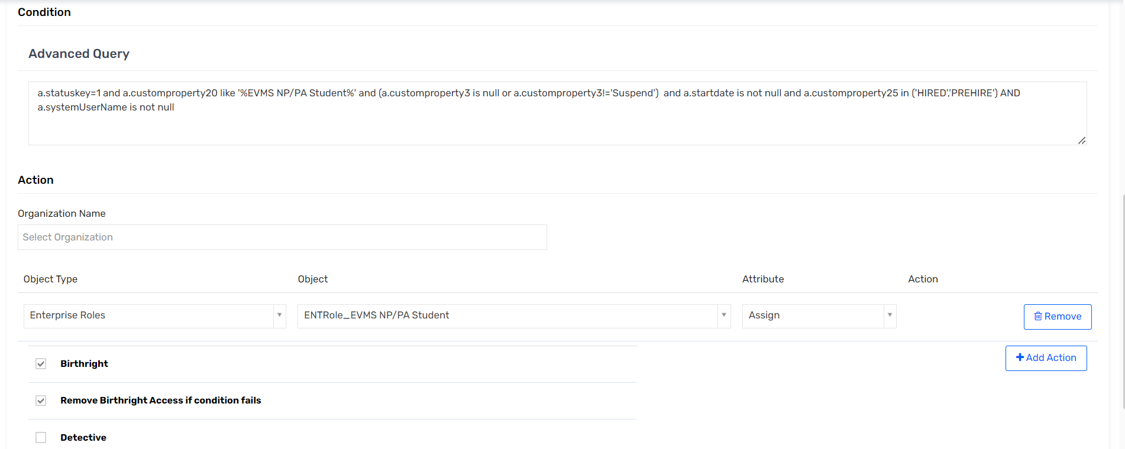

# User Update Rules

### UR: AD Update Account - API

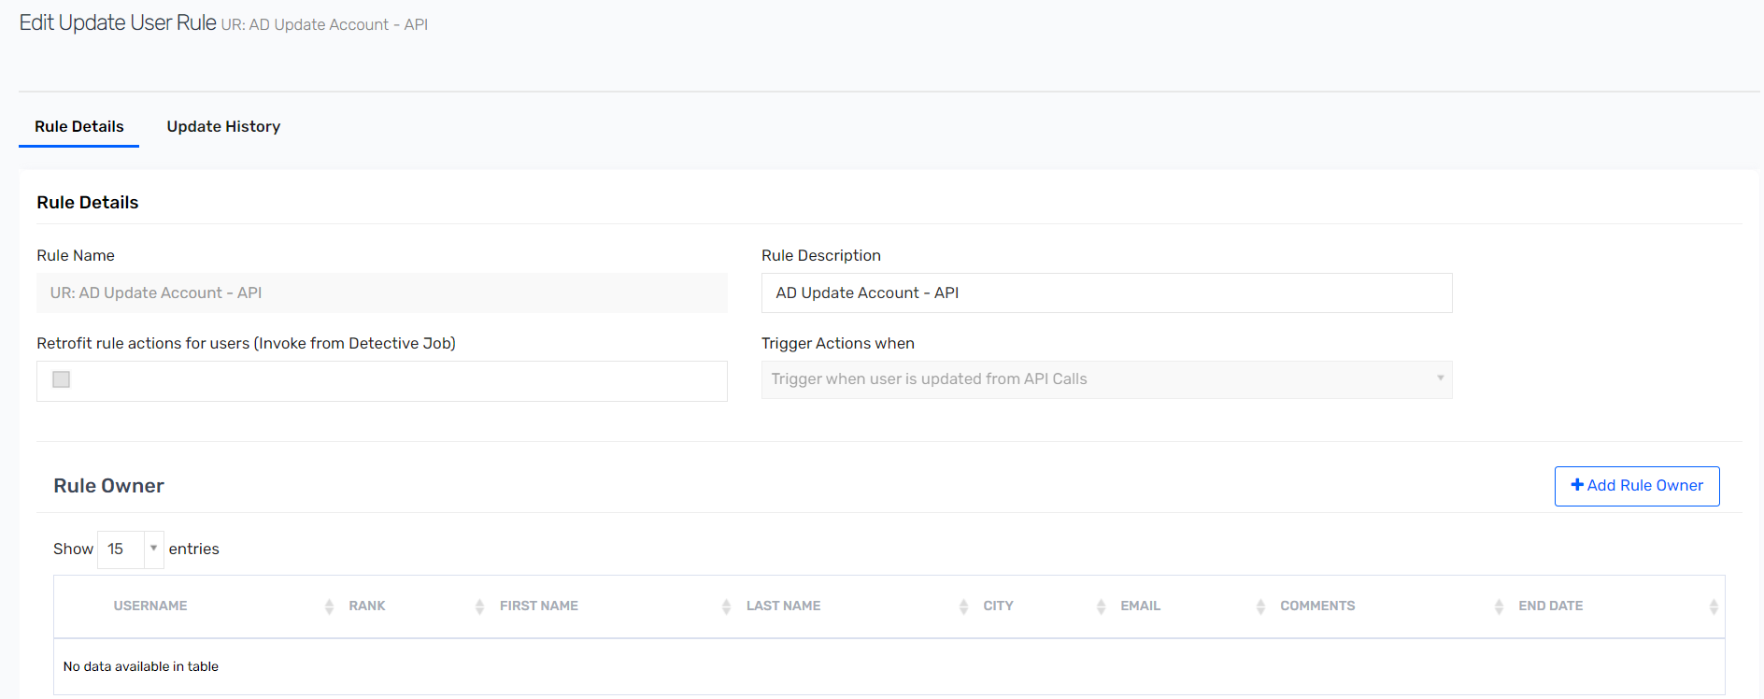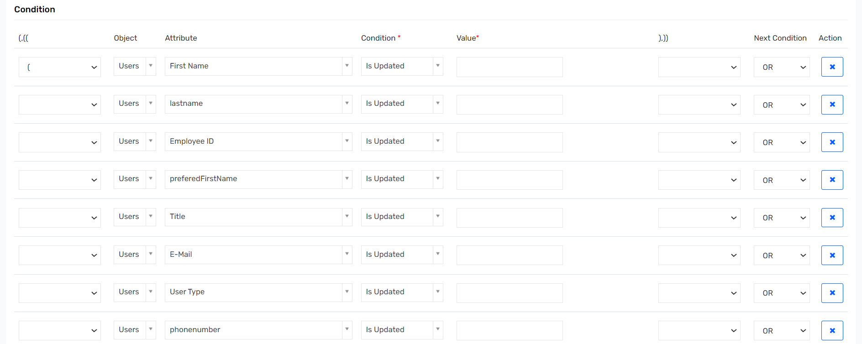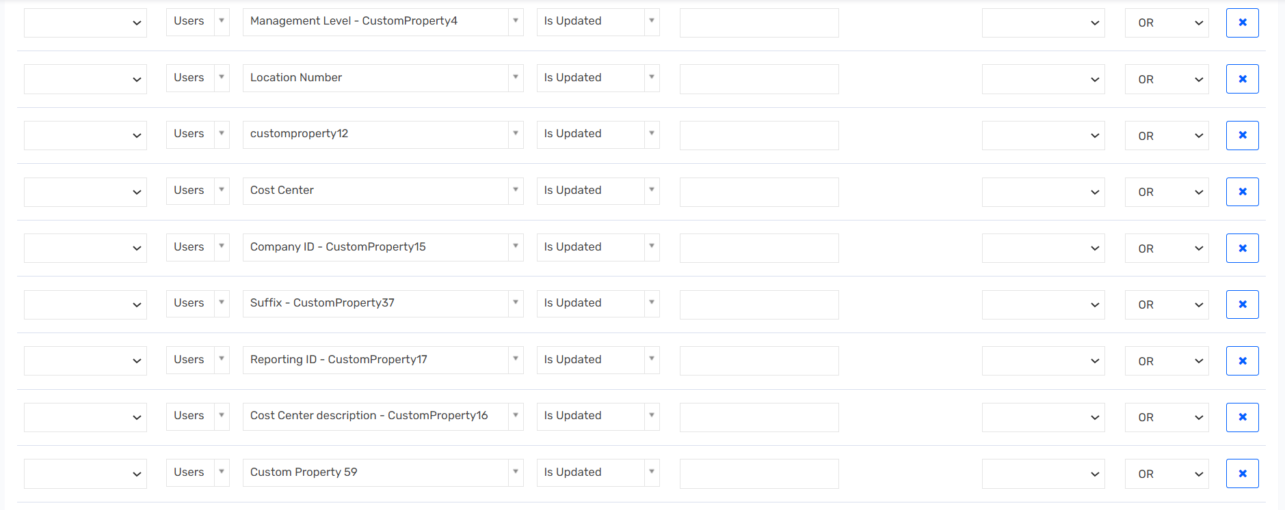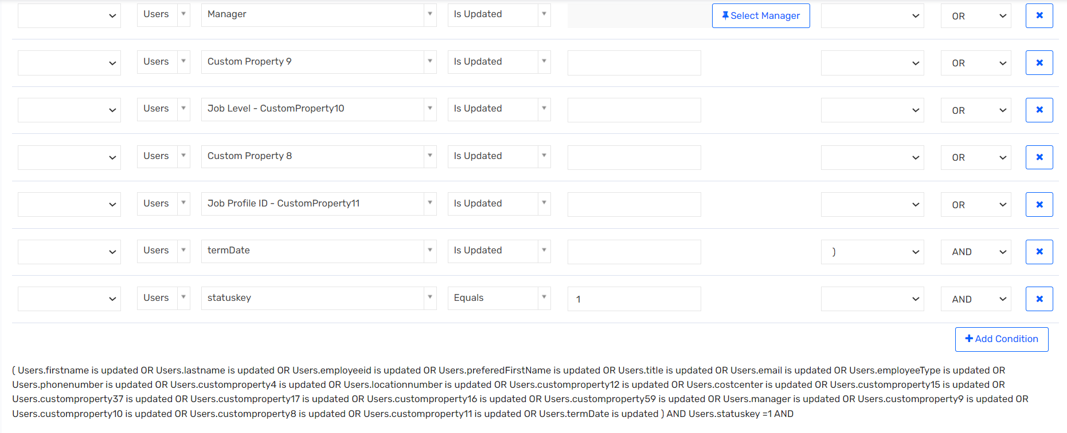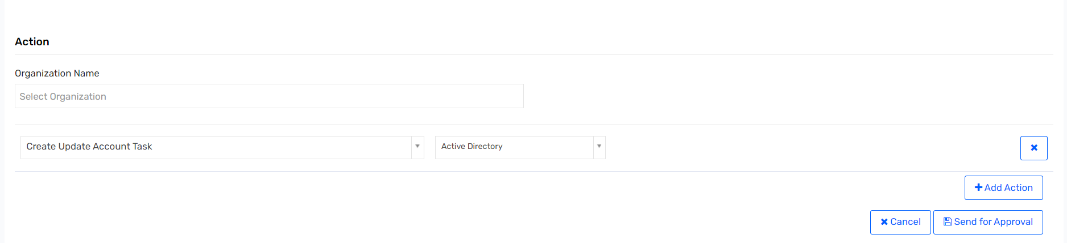

### UR : AD Update Account – Import

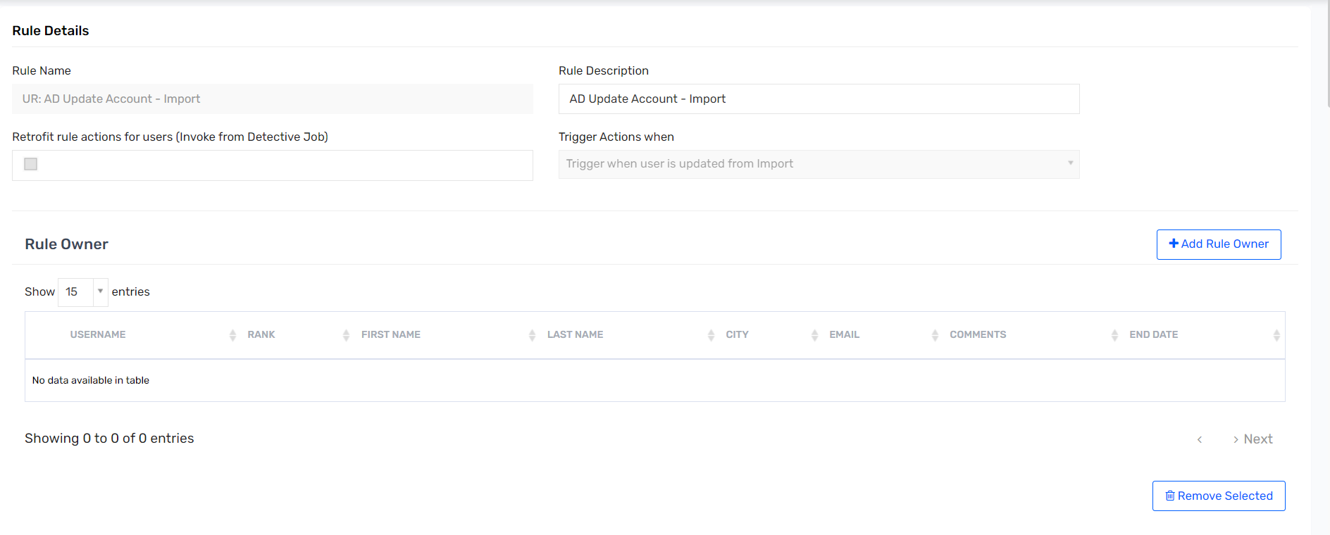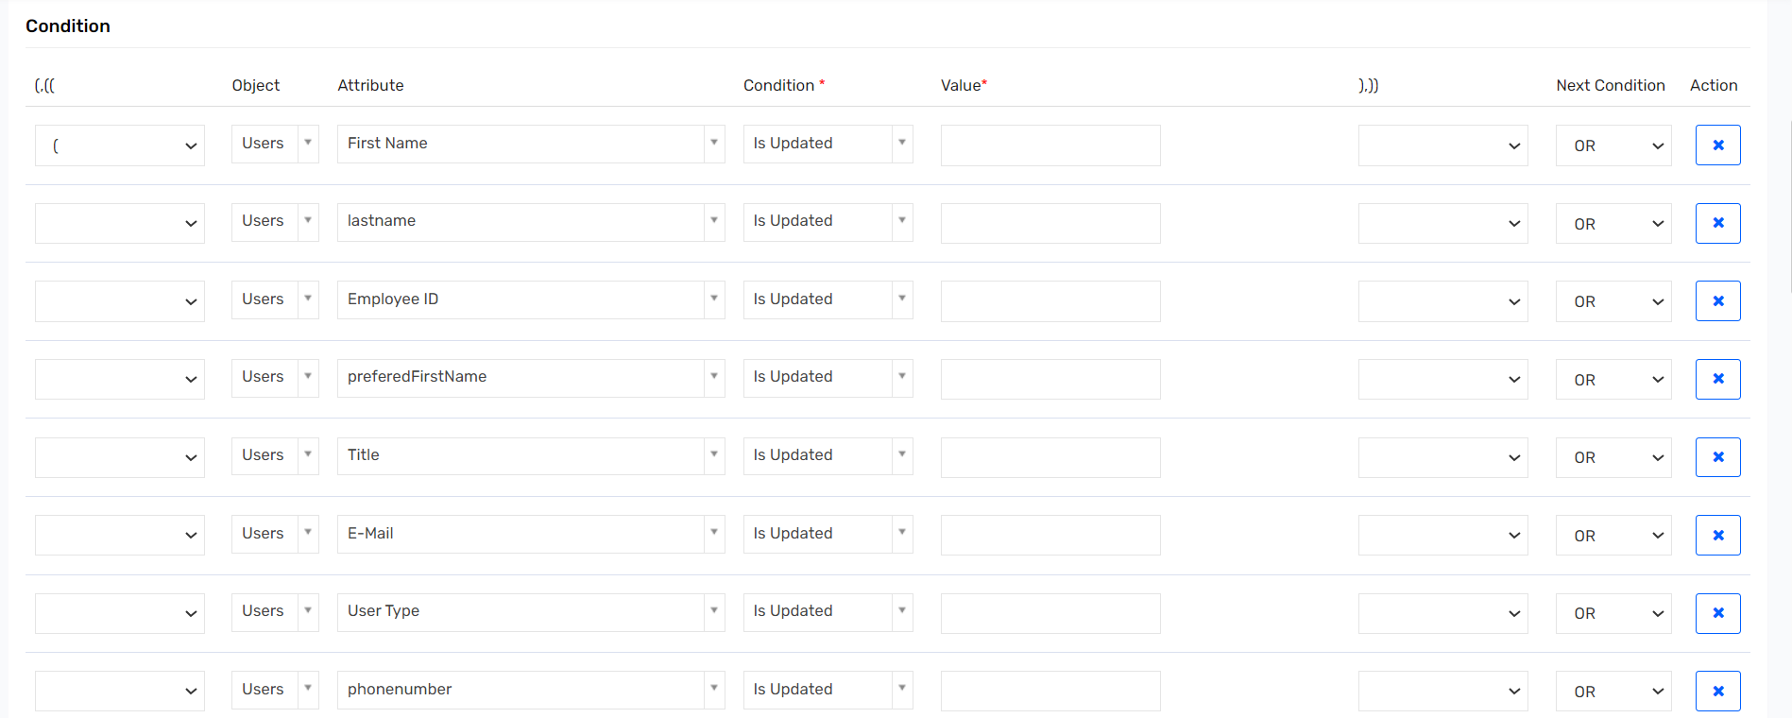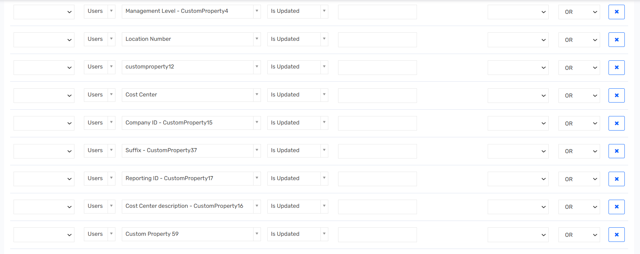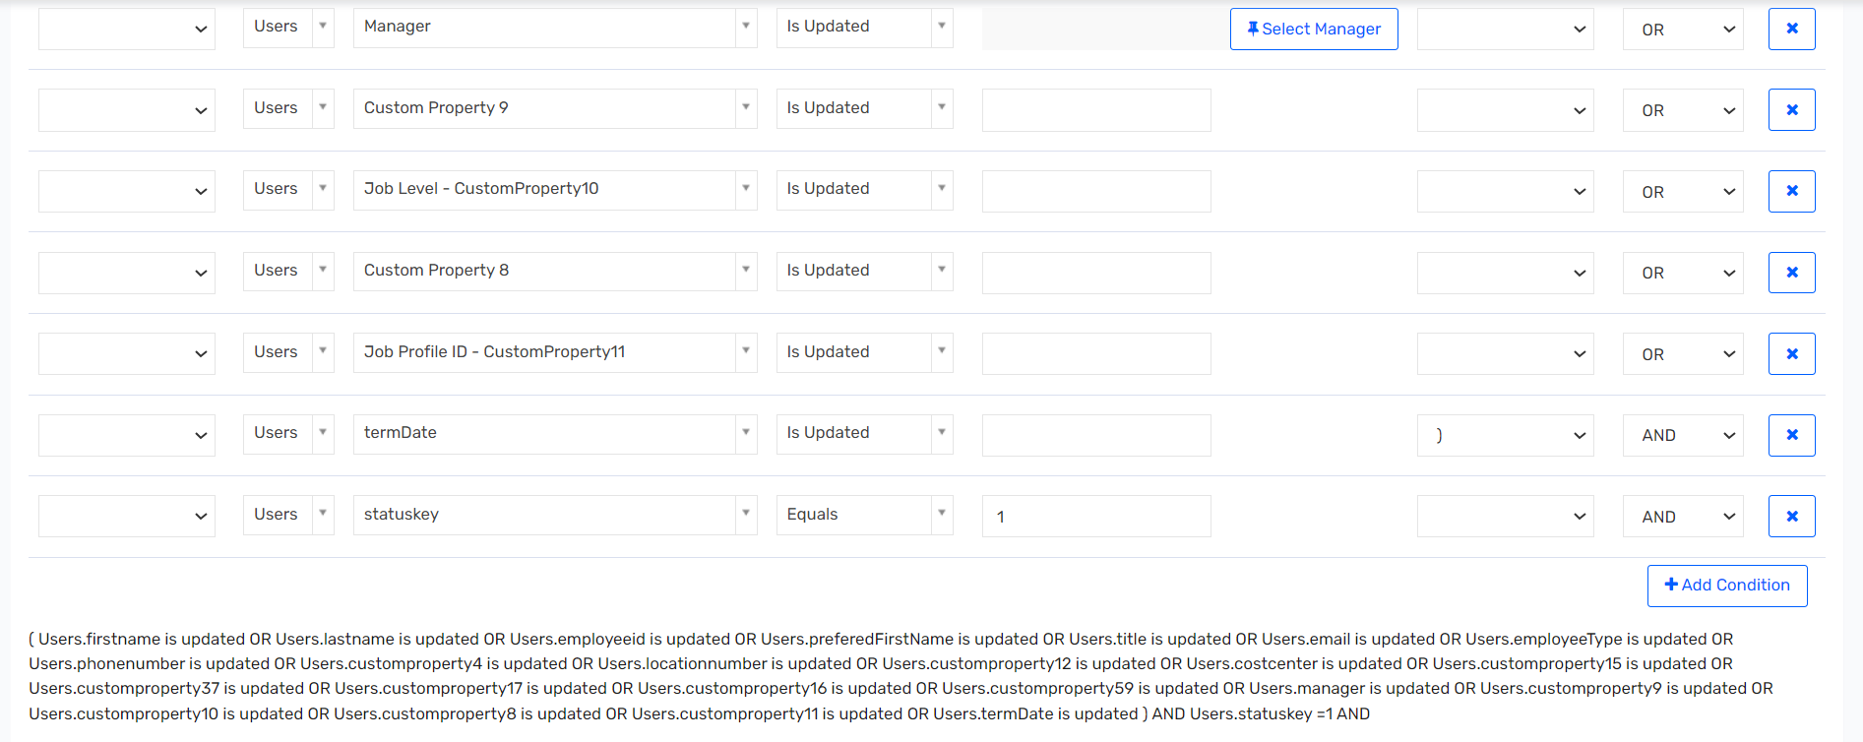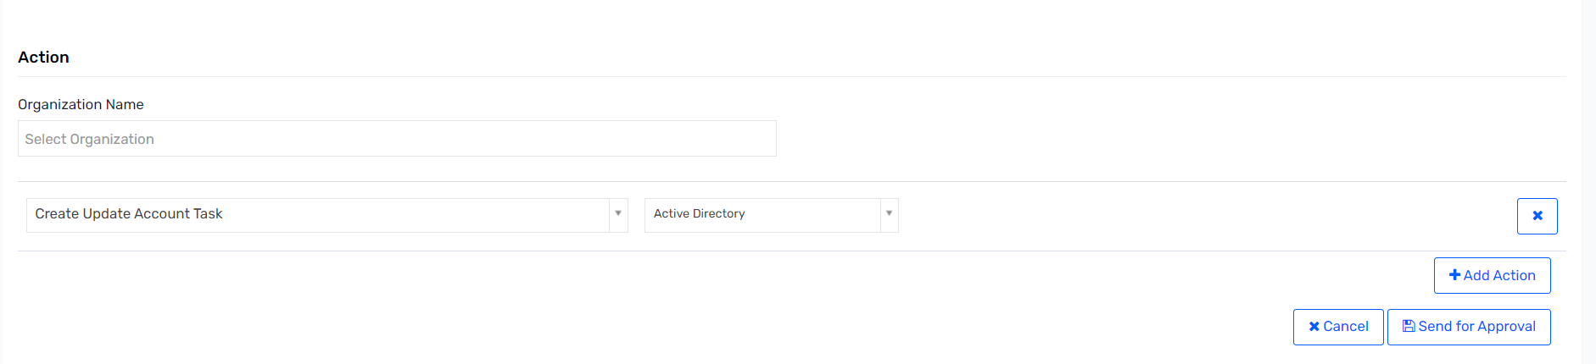

### UR: DUO Update Account – API

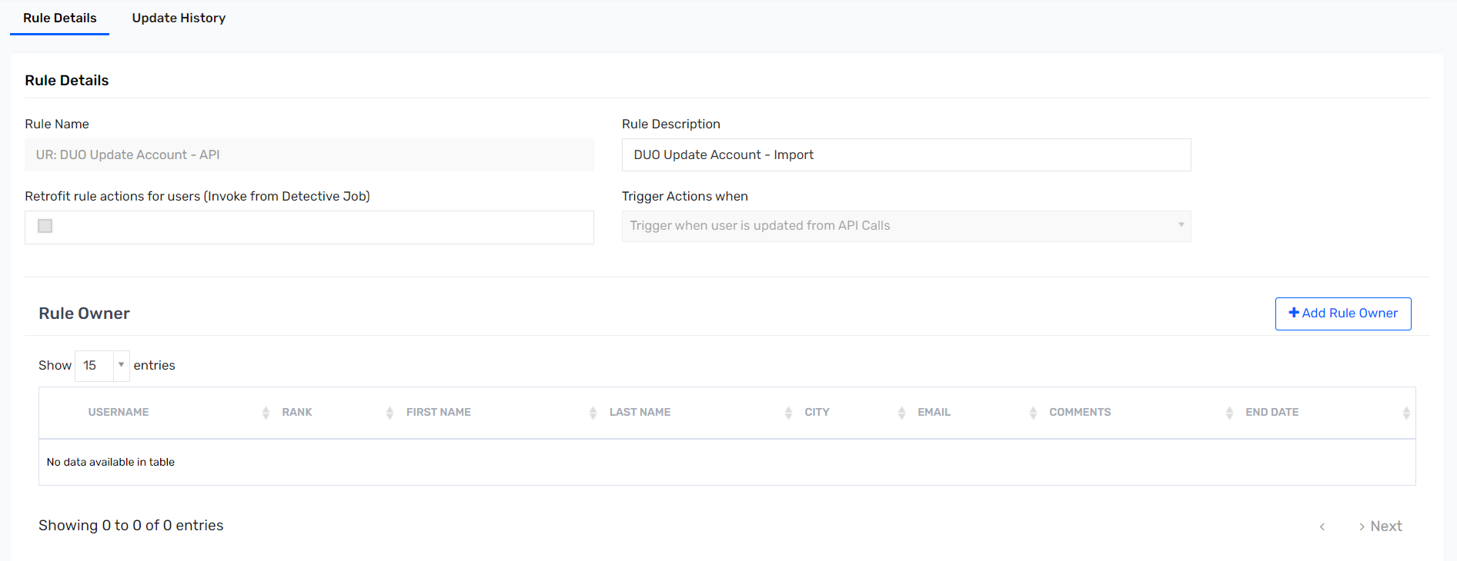 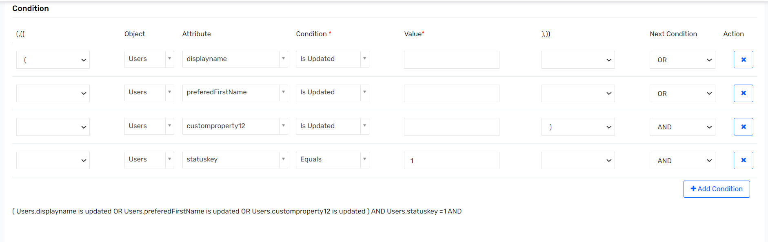 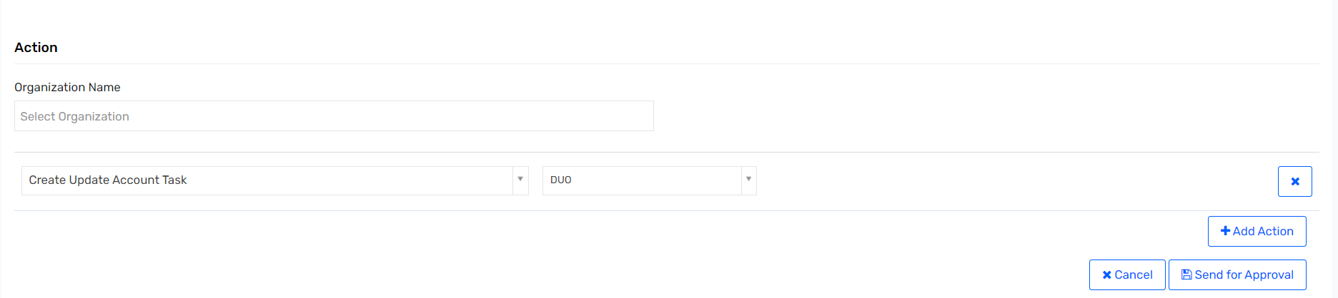

### UR: DUO Update Account – Import

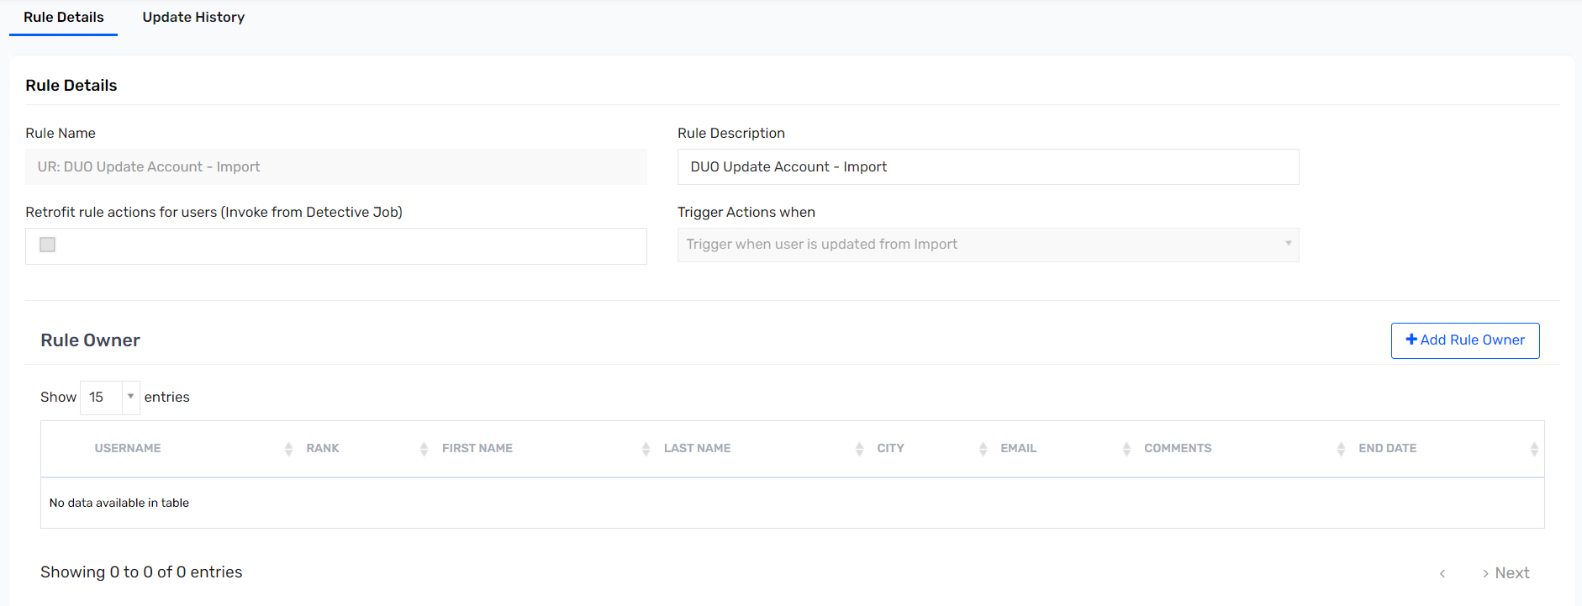 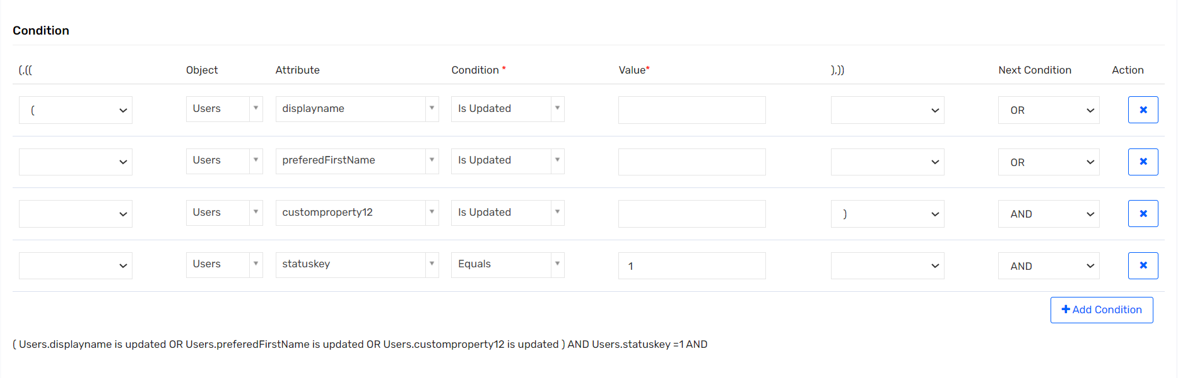 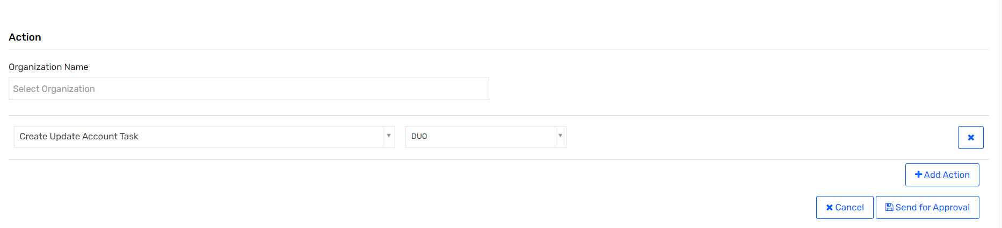

### UR: Emergency Suspension

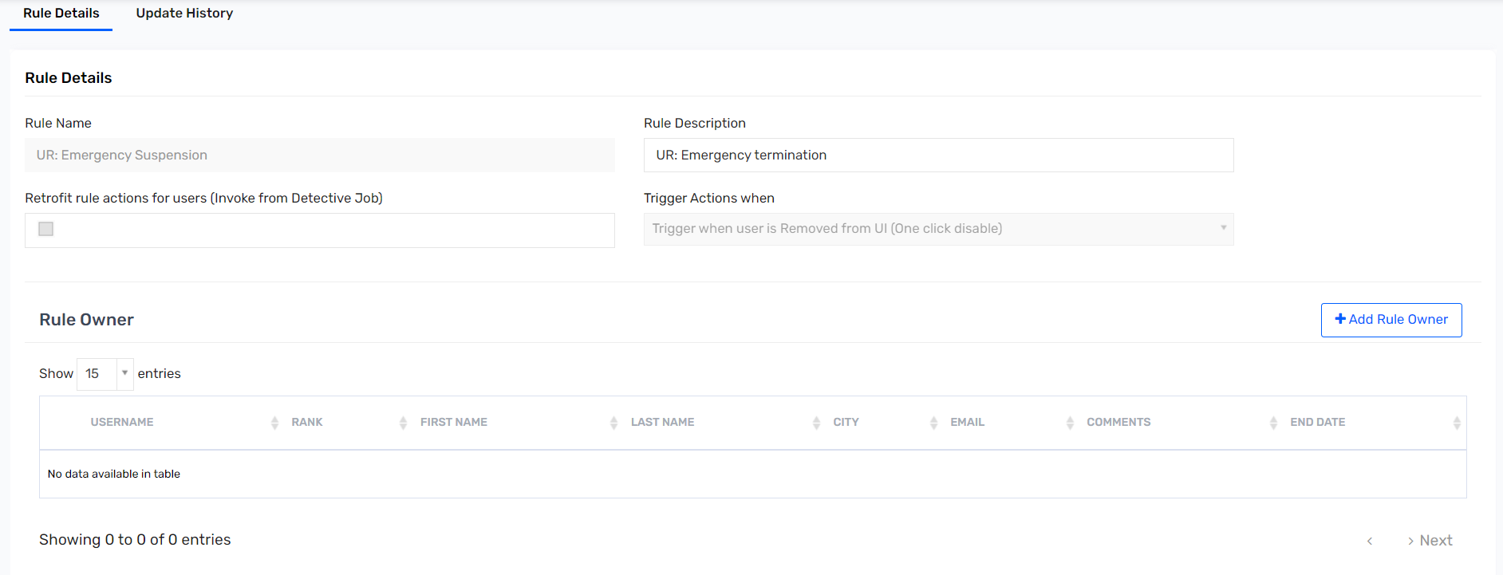 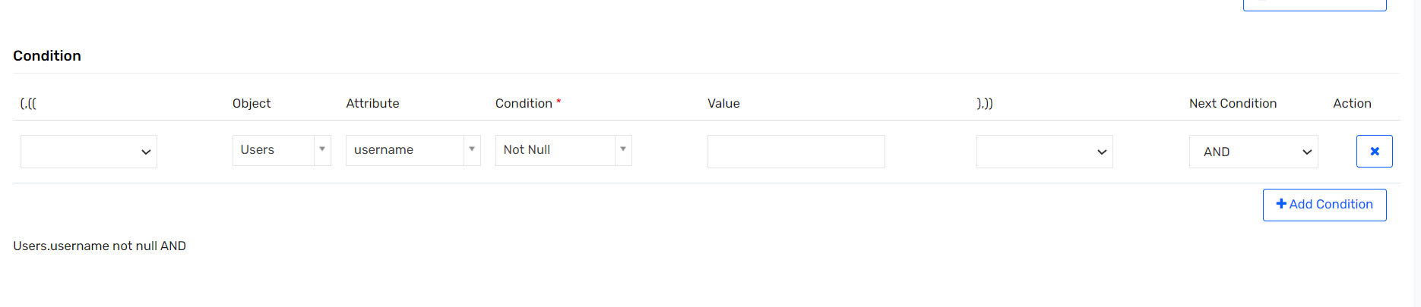 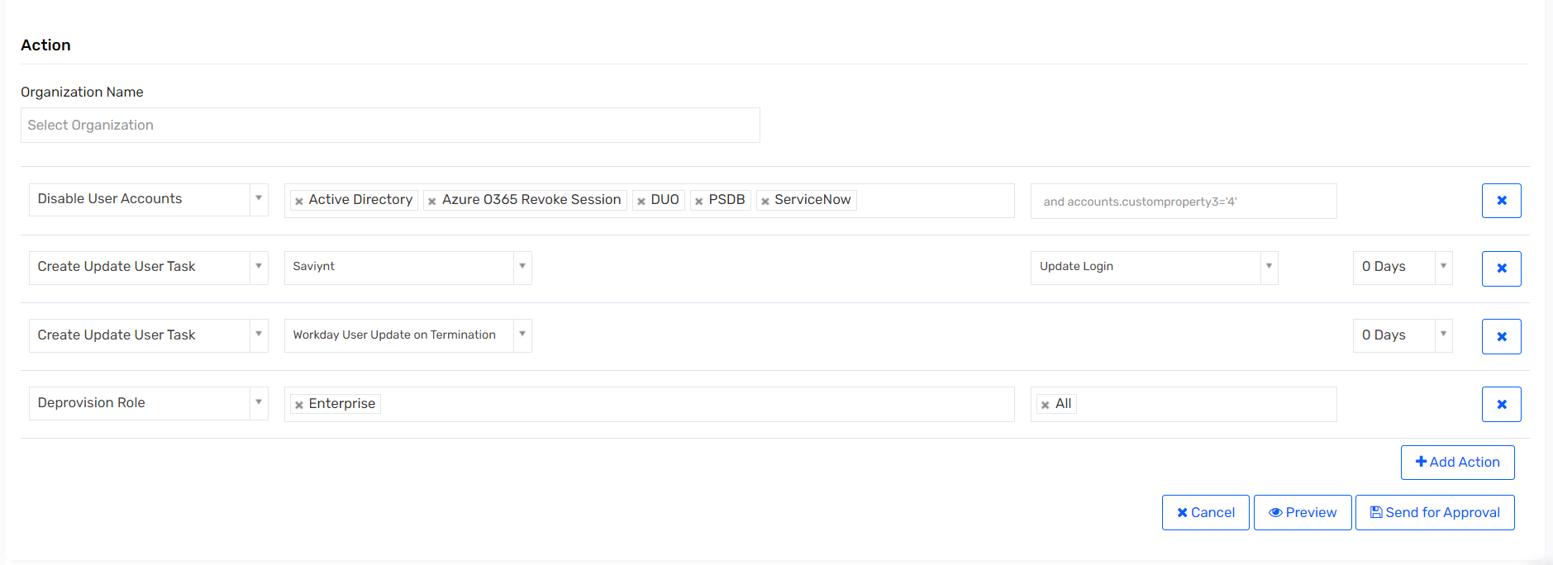

### UR: PSDB Update Account - API

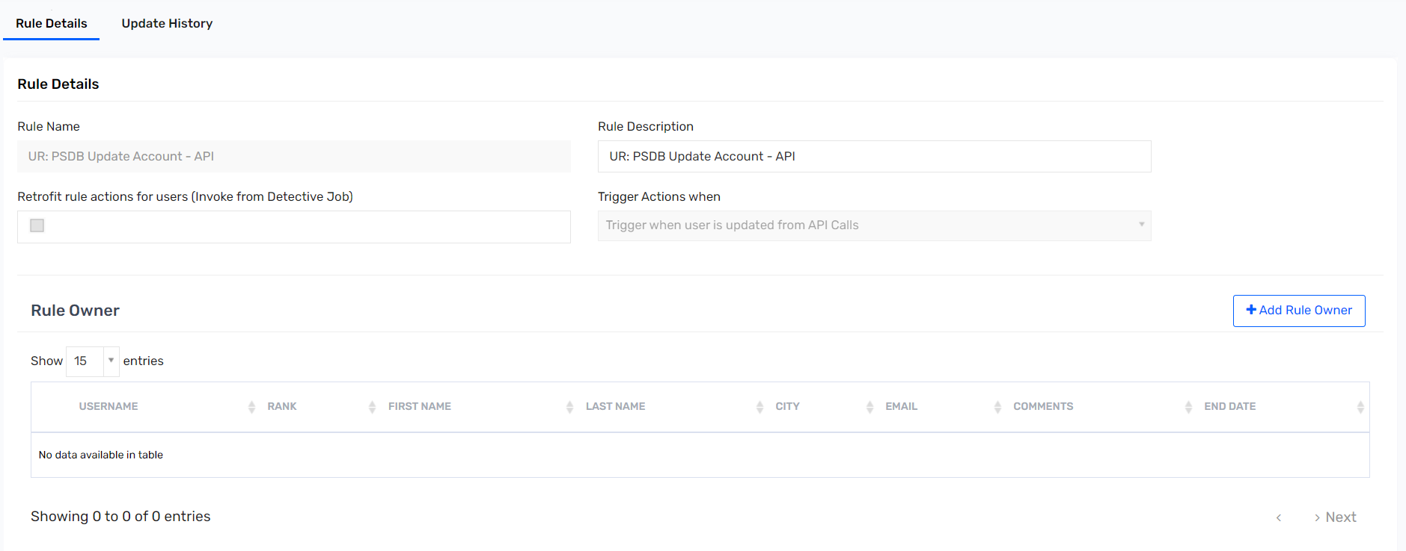 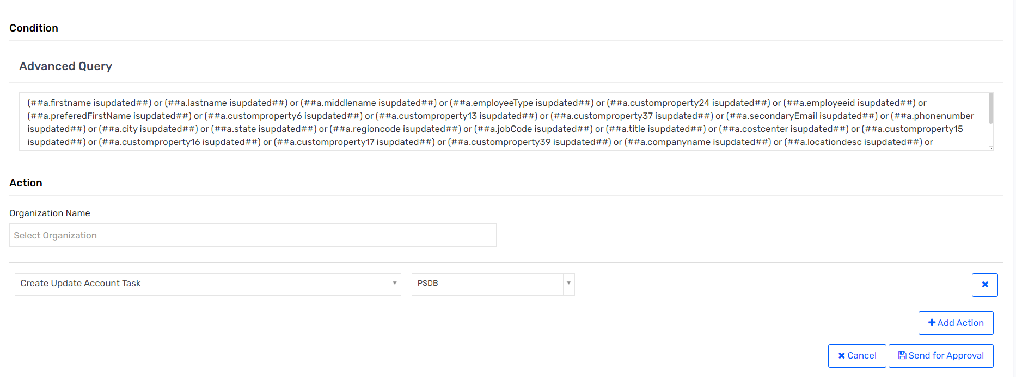

### UR:PSDB Update Account – Import

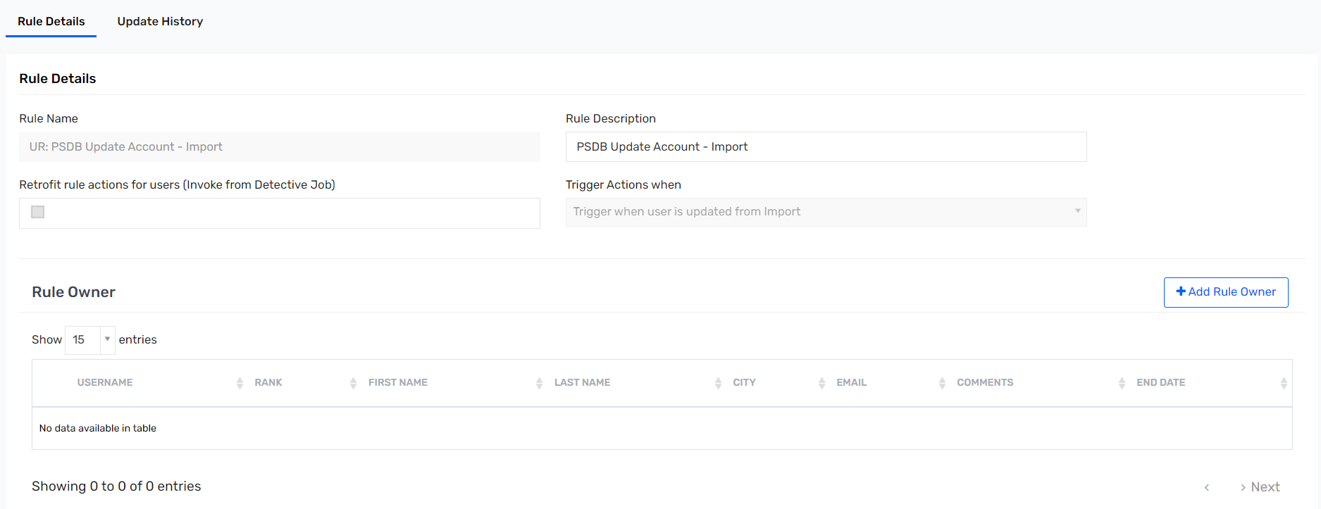 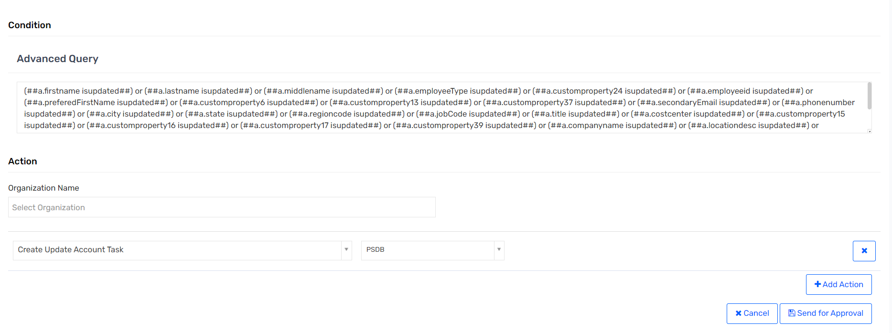

### UR: Rehire After 30 Days – API

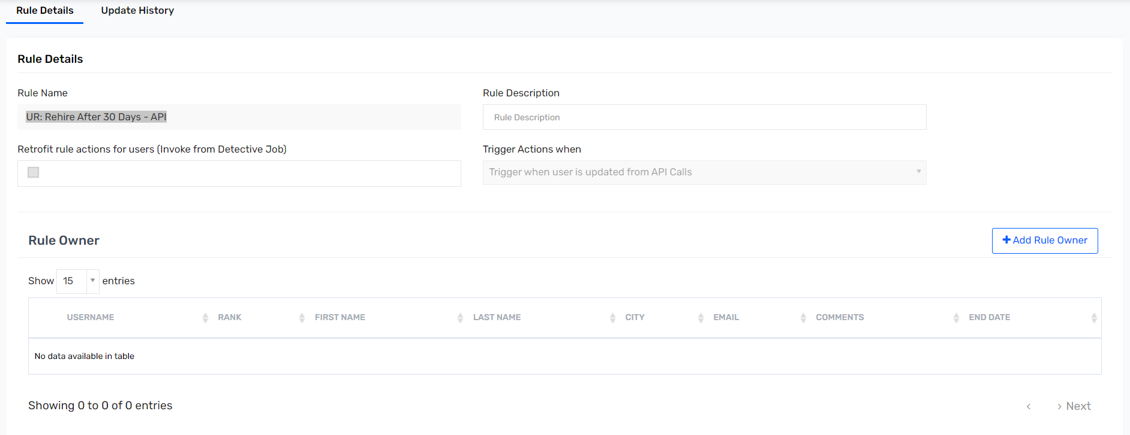 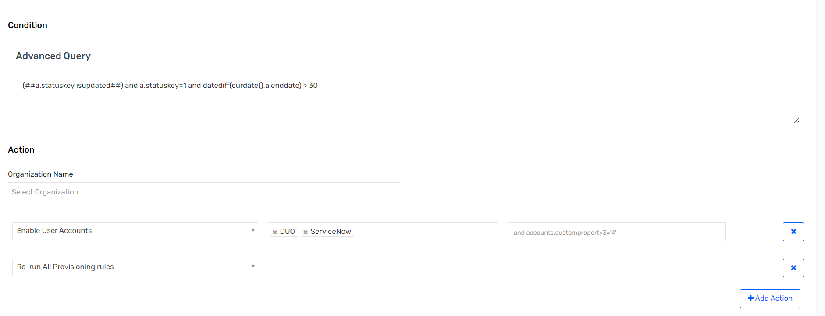

### UR: Rehire After 30 Days – Import

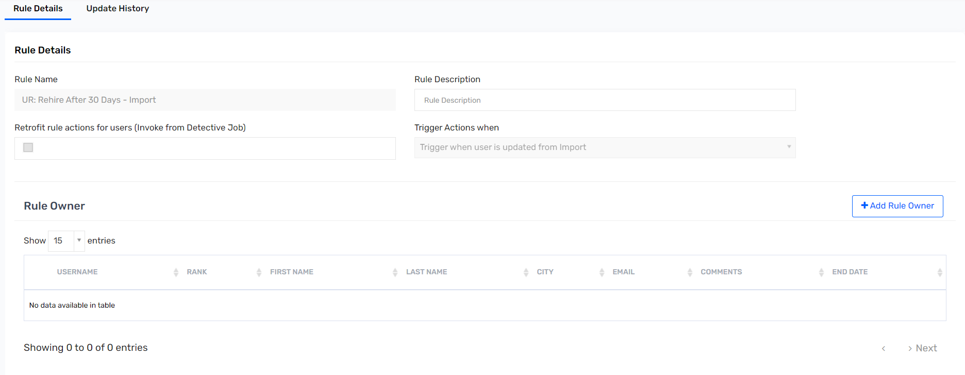 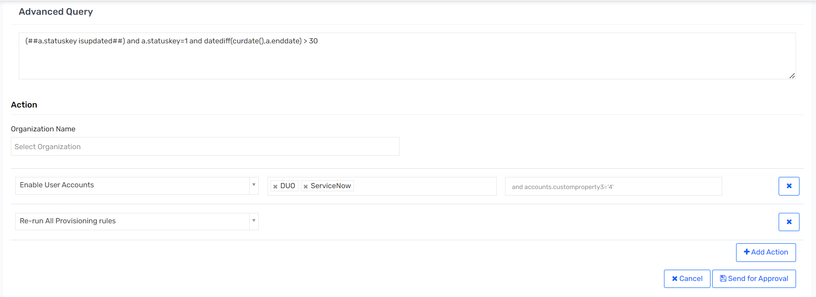

### UR: Rehire Within 30 Days – API

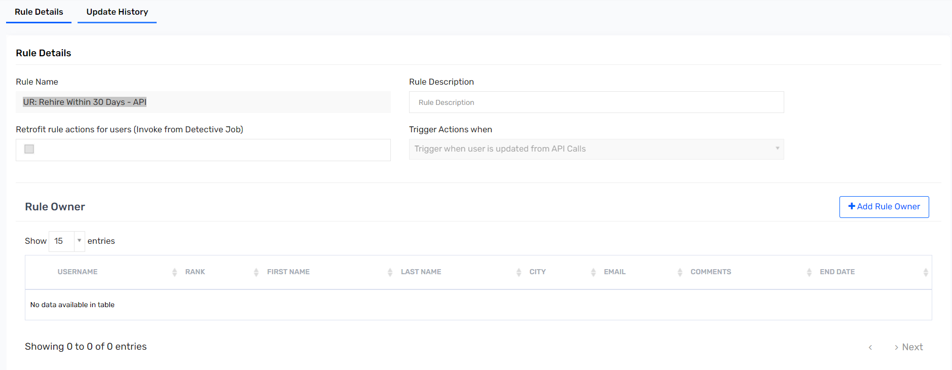 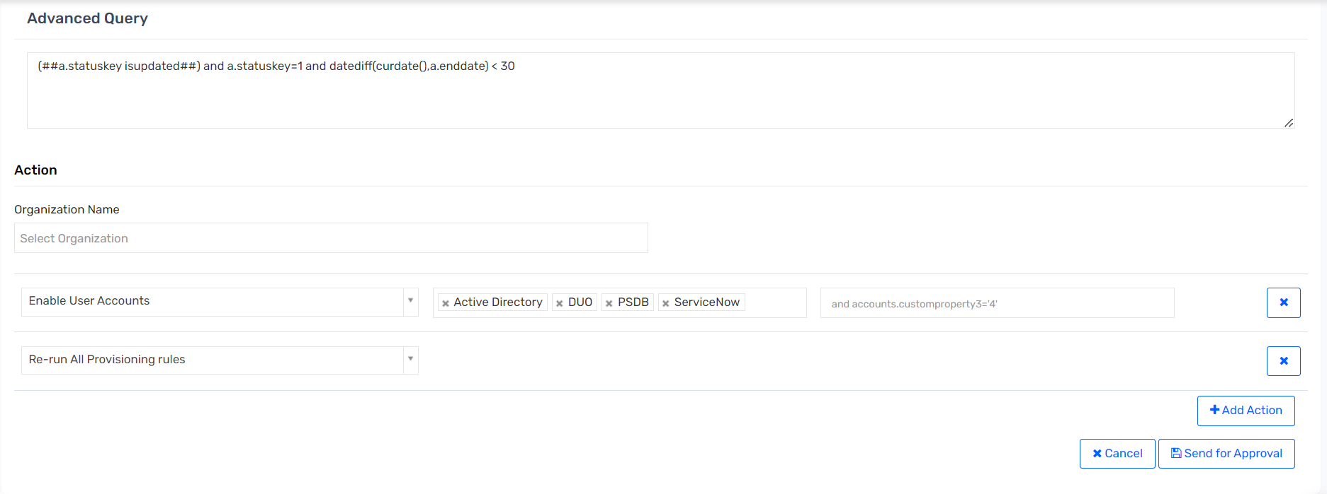

### UR: Rehire Within 30 Days – Import

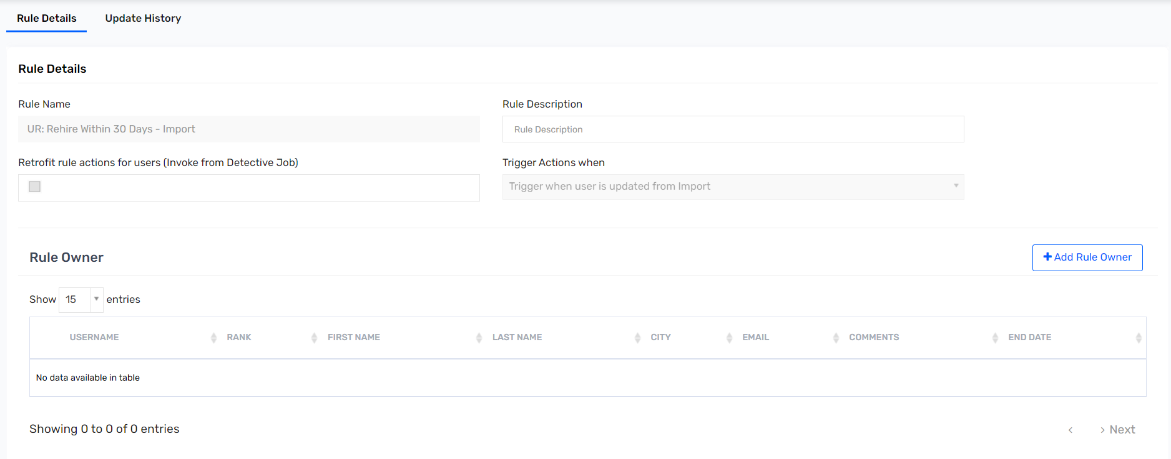 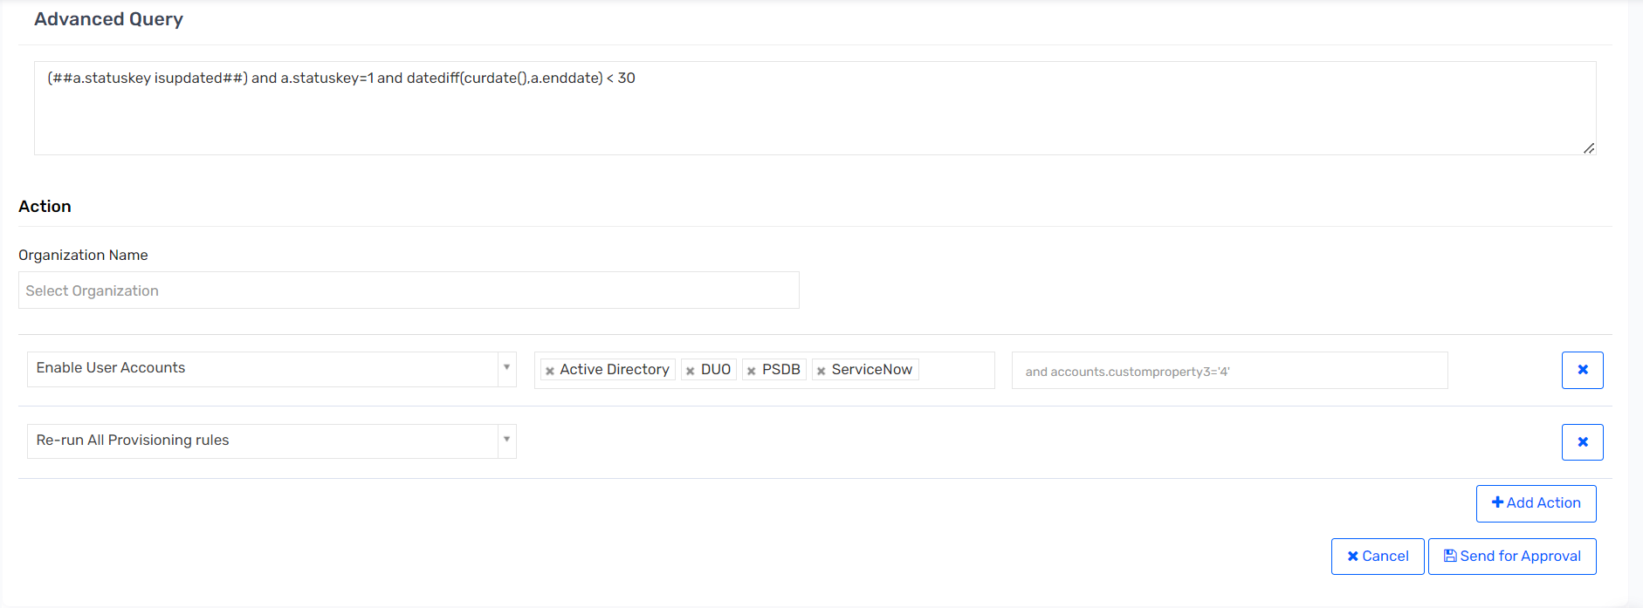

### UR: Rehire Workday Update – API

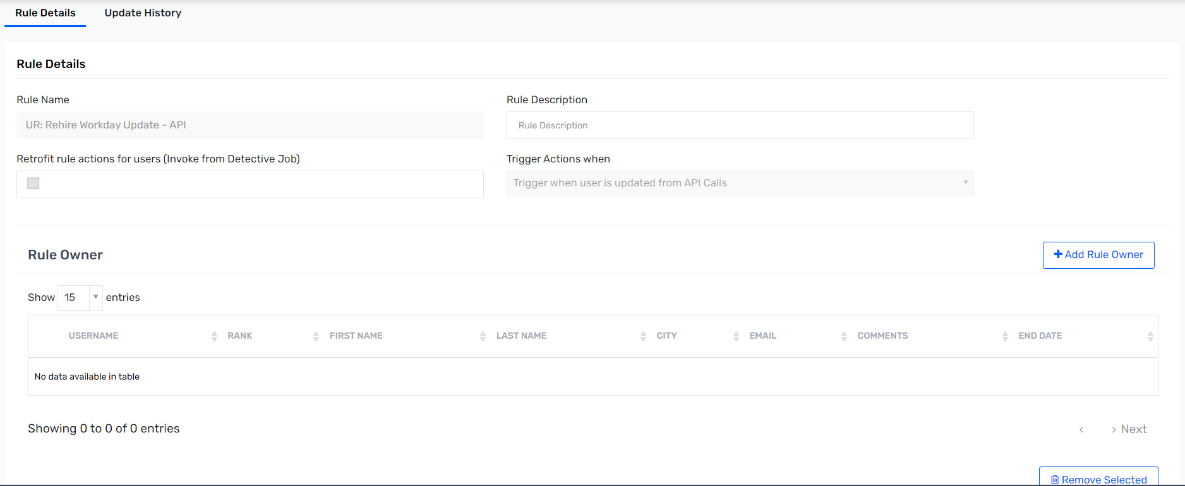 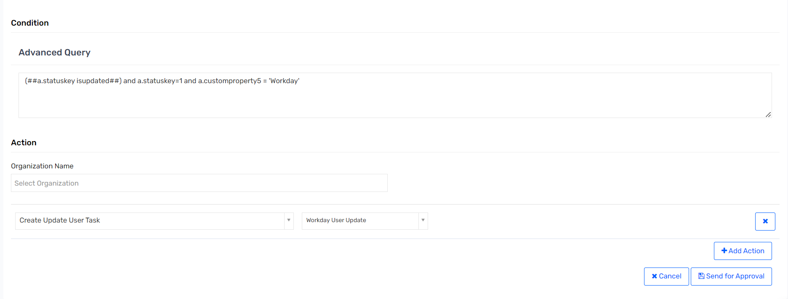

### UR: Rehire Workday Update – Import

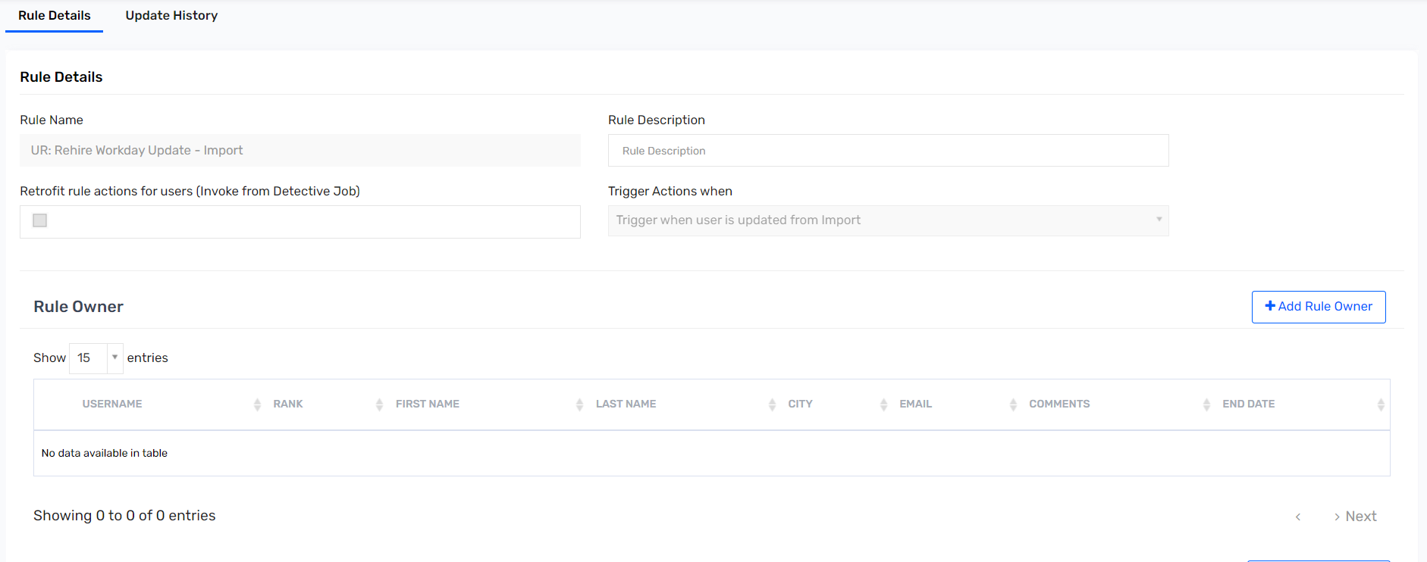 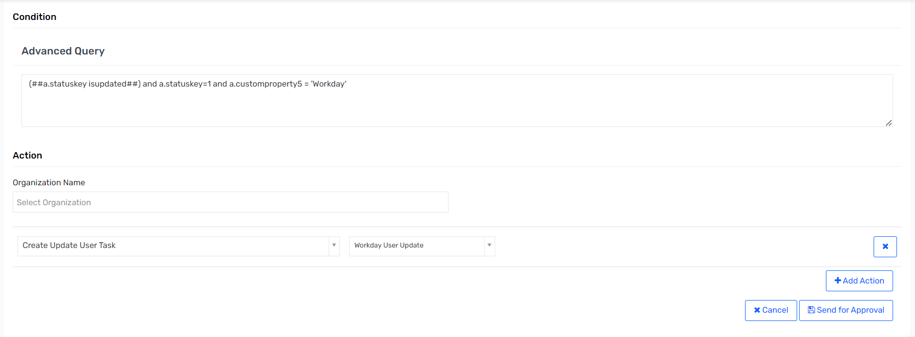

### UR: Retrigger Technical Rules for Persona – API

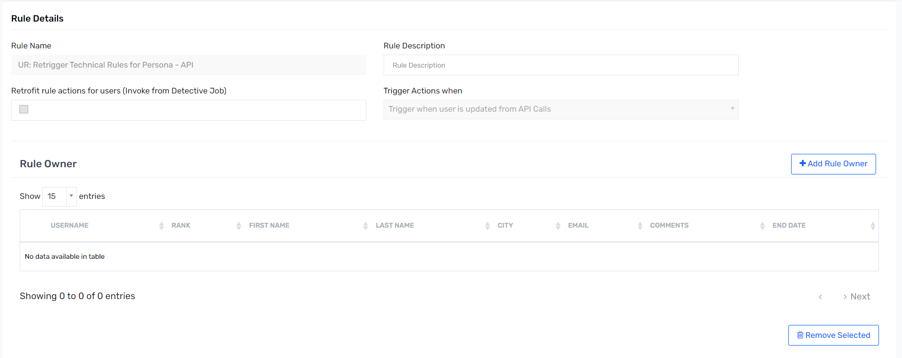 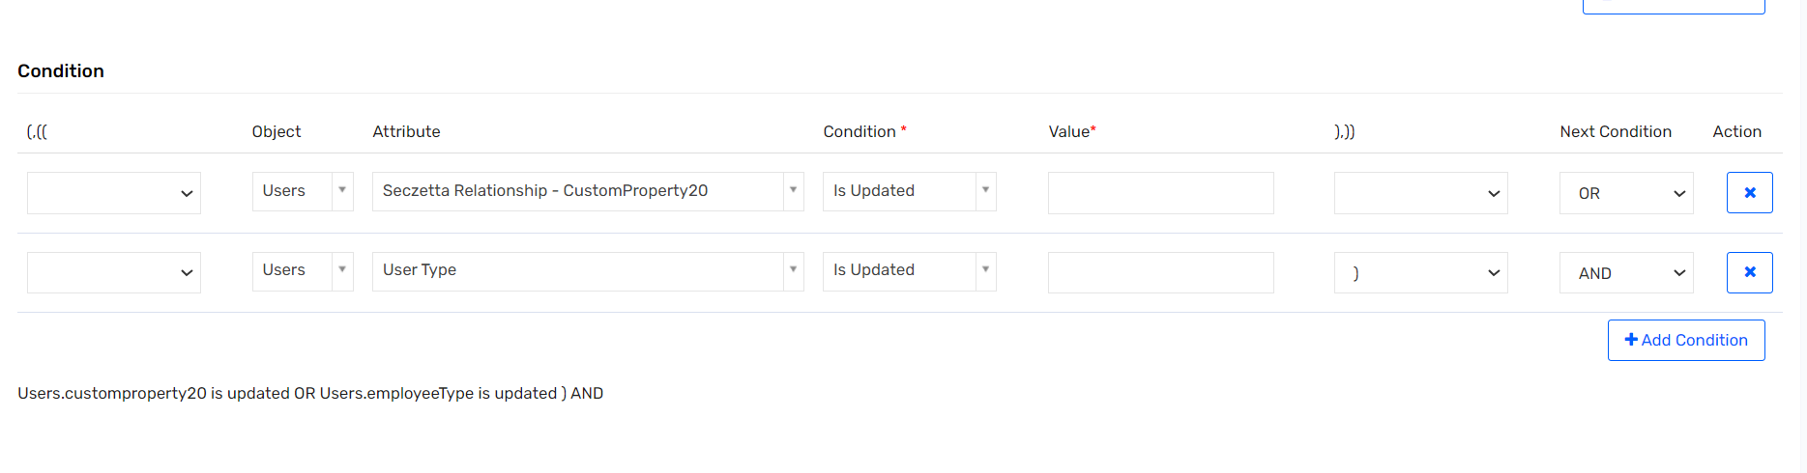 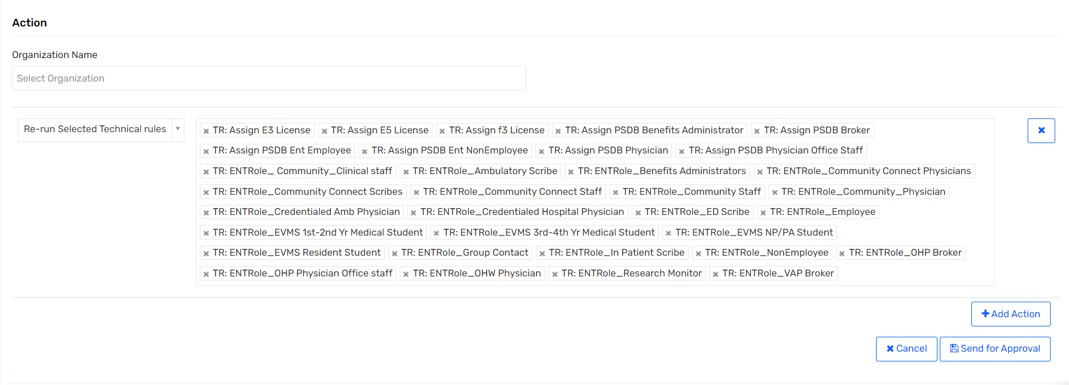

### UR: Retrigger Technical Rules for Persona – Import

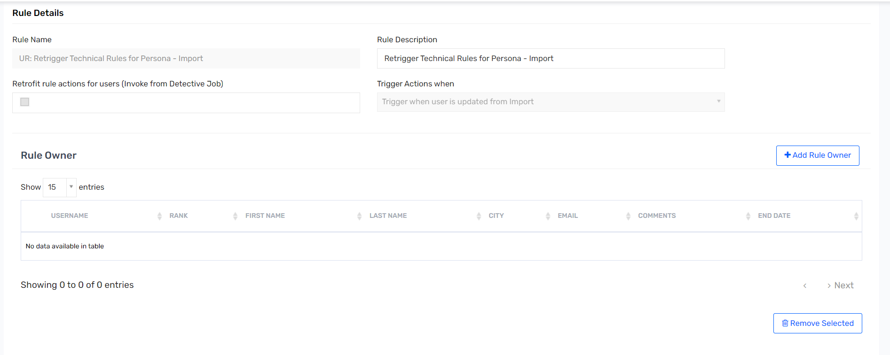 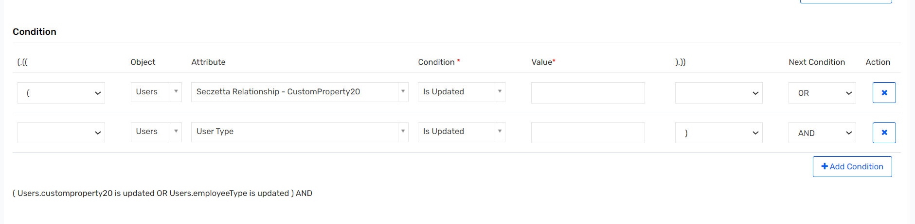 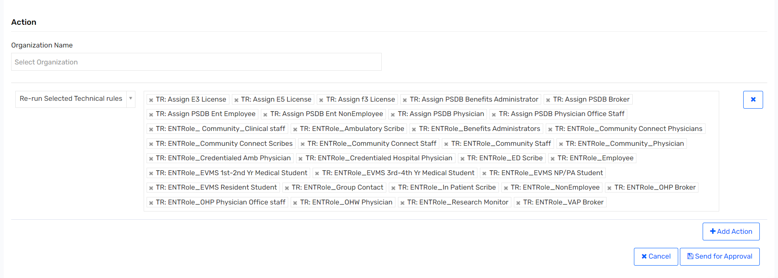

### UR: Retrigger Technical Rules on HIRED – API

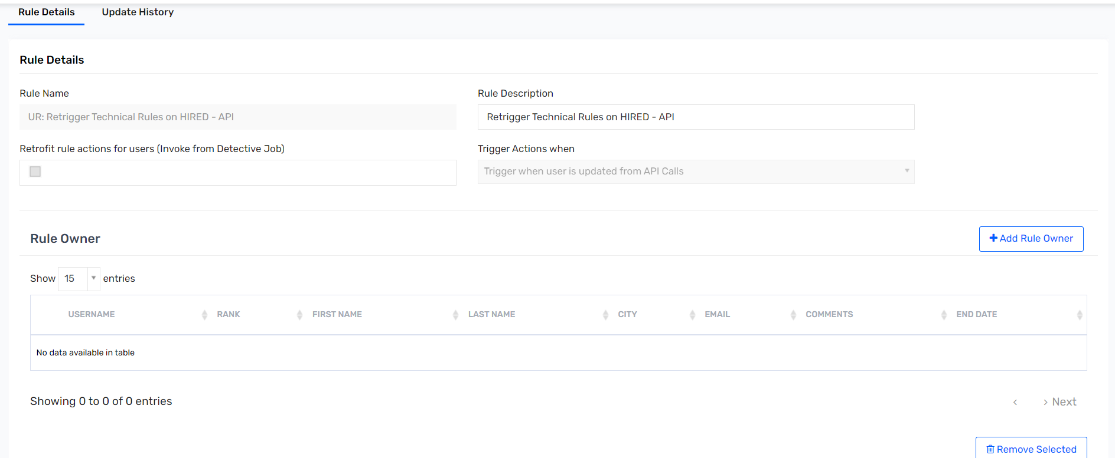 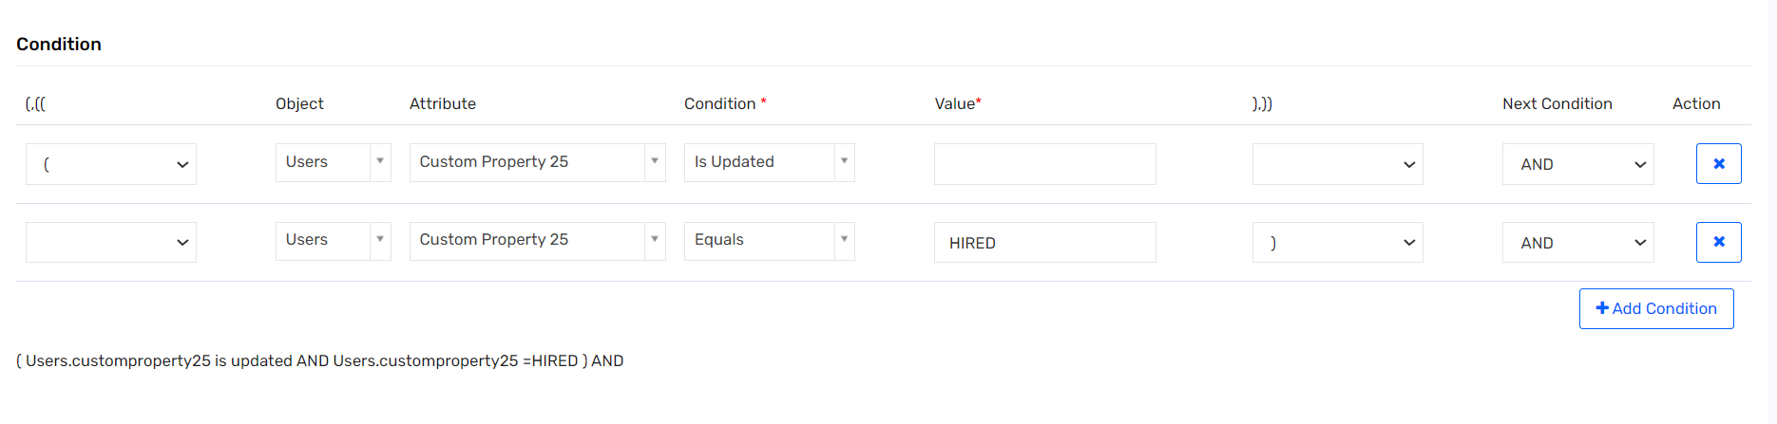 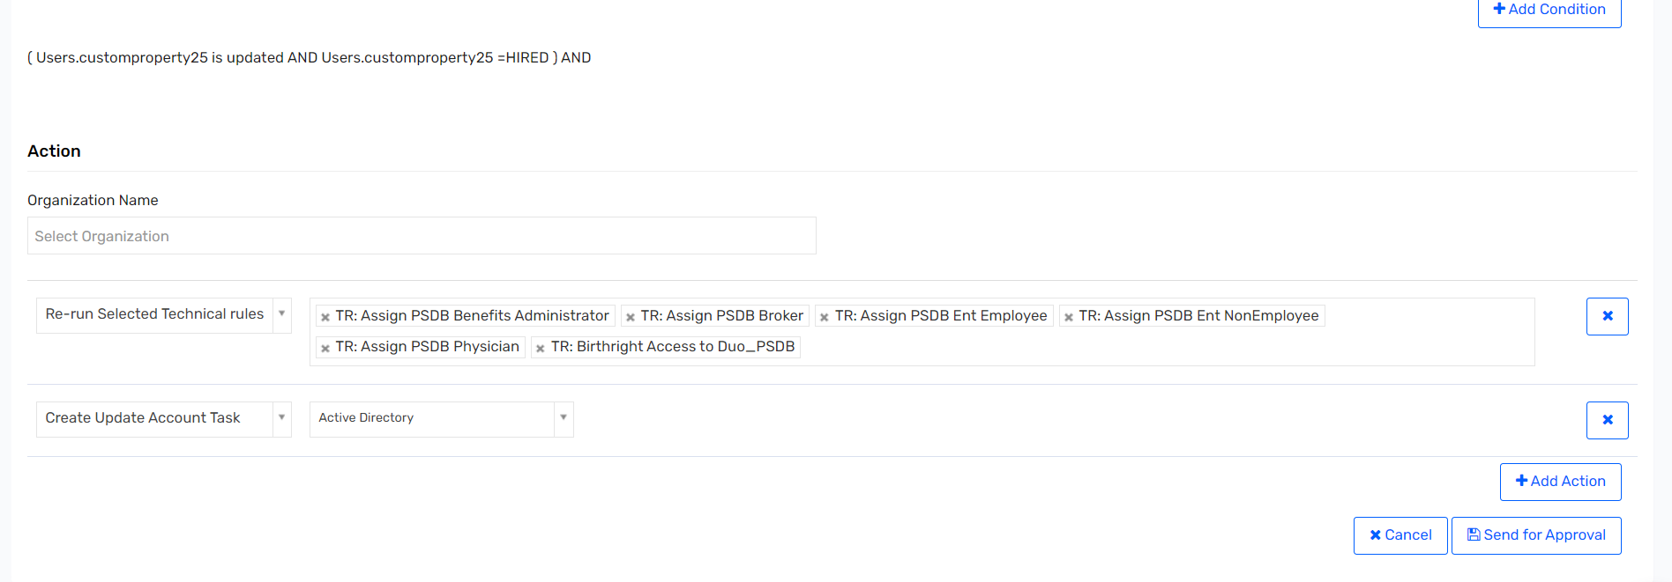

### UR: Retrigger Technical Rules on HIRED – Import

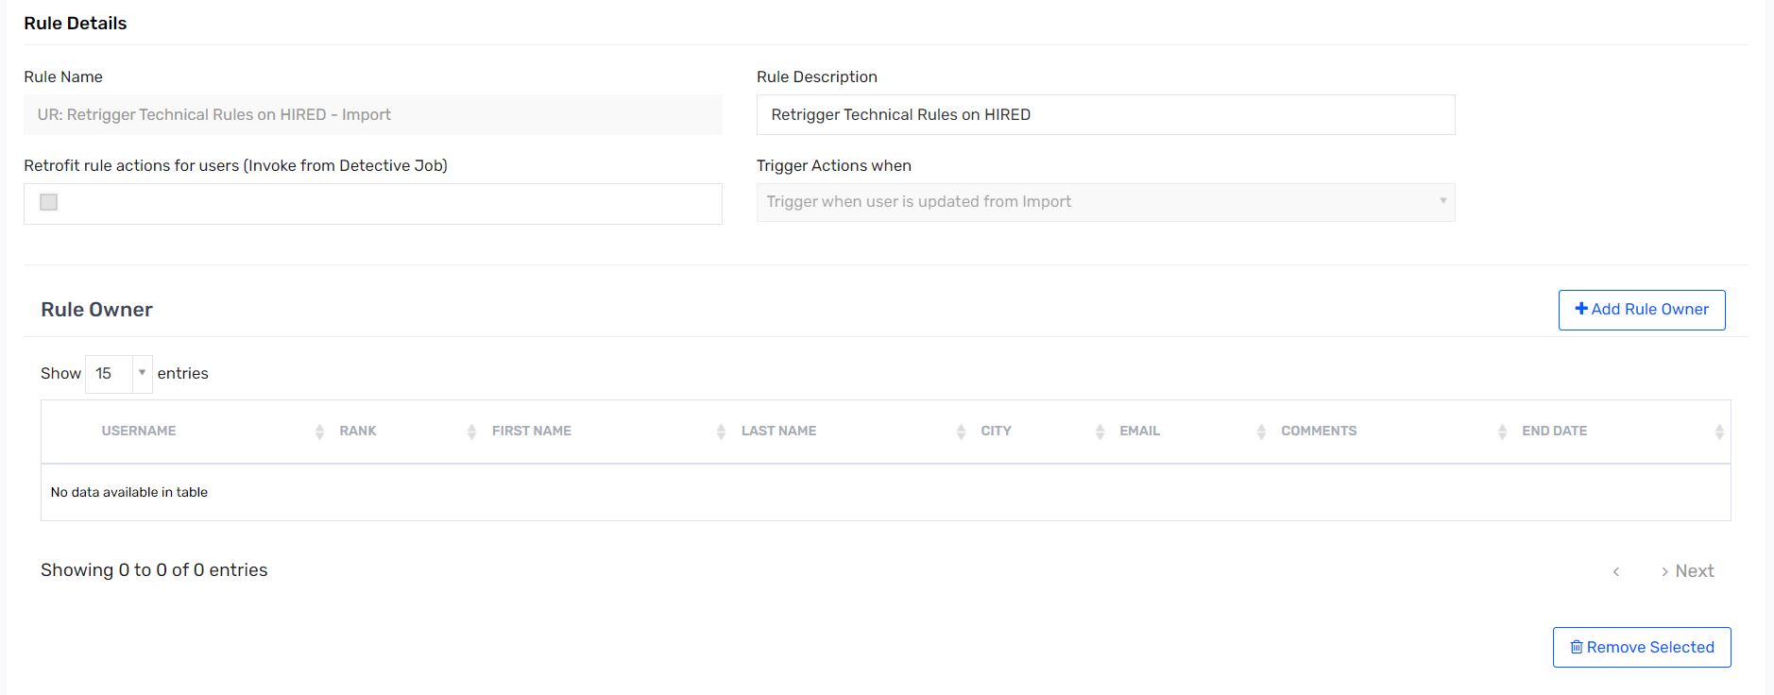 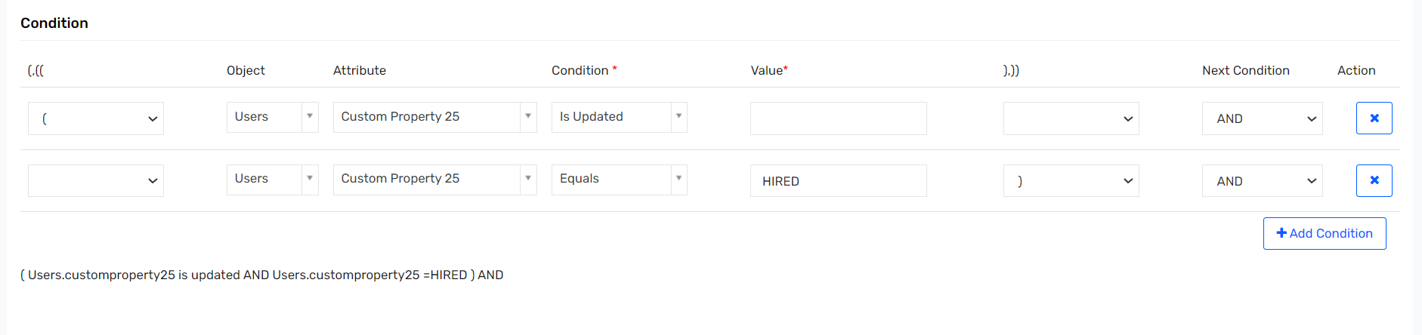 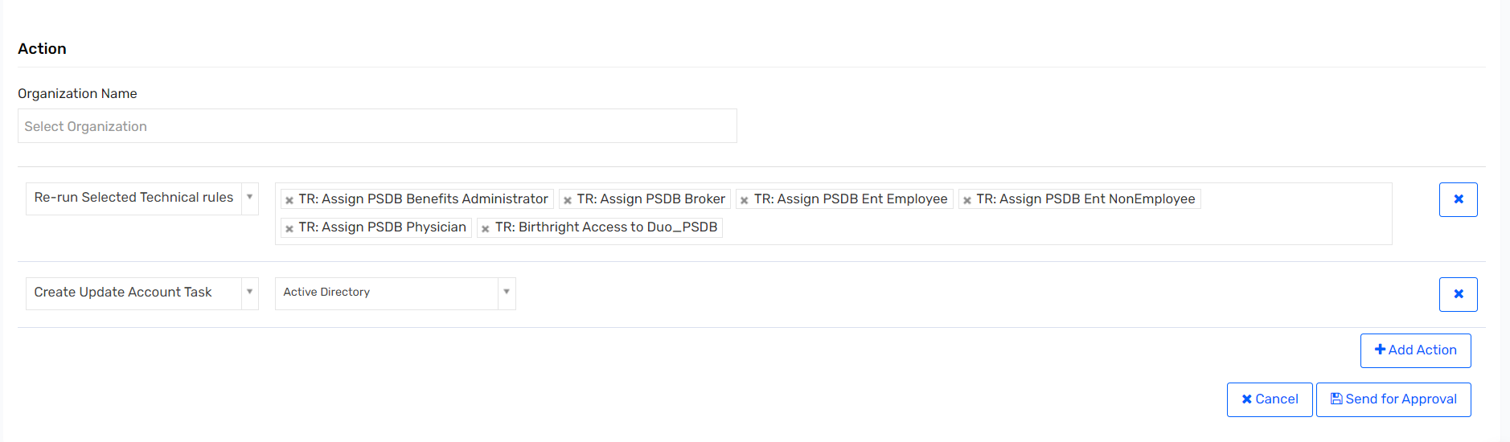

### UR: Retrigger Technical Rules on PREHIRE – API

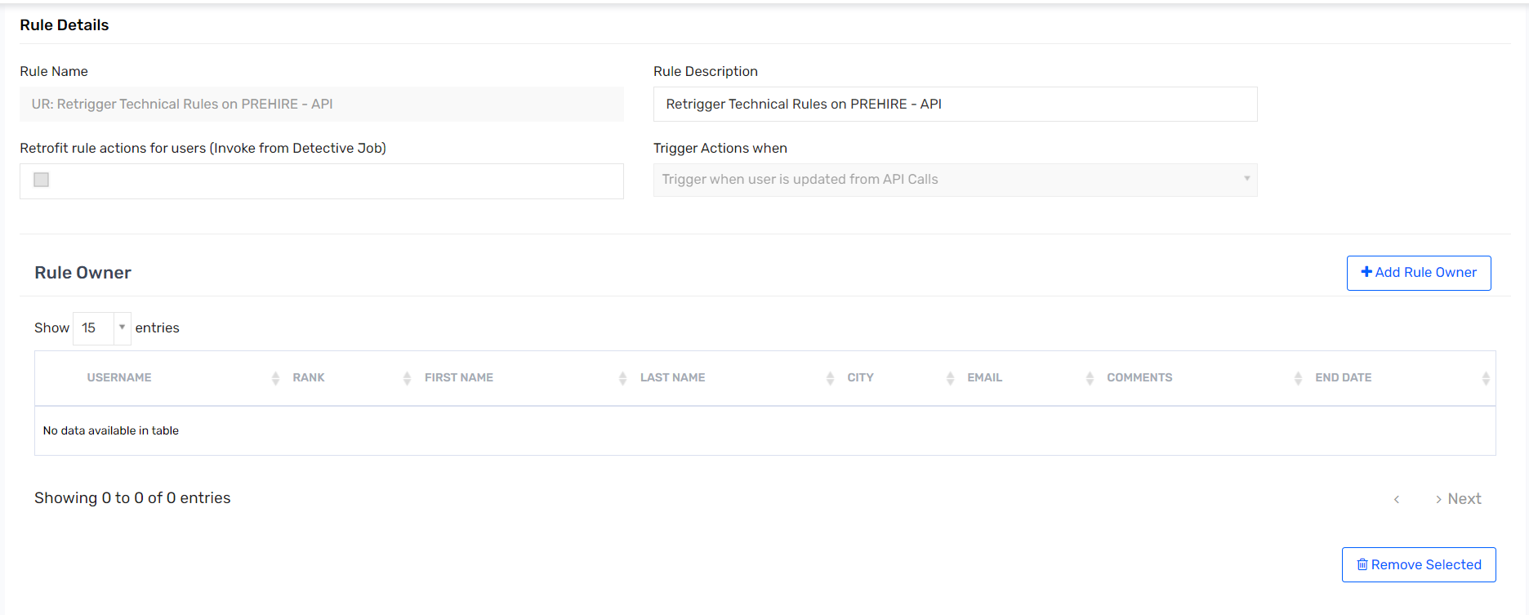 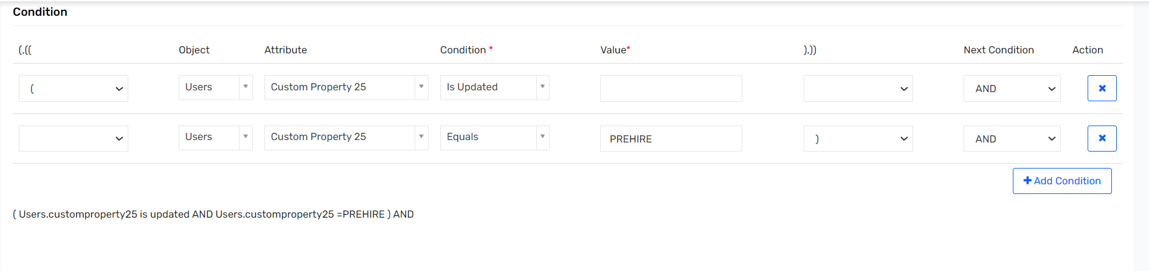 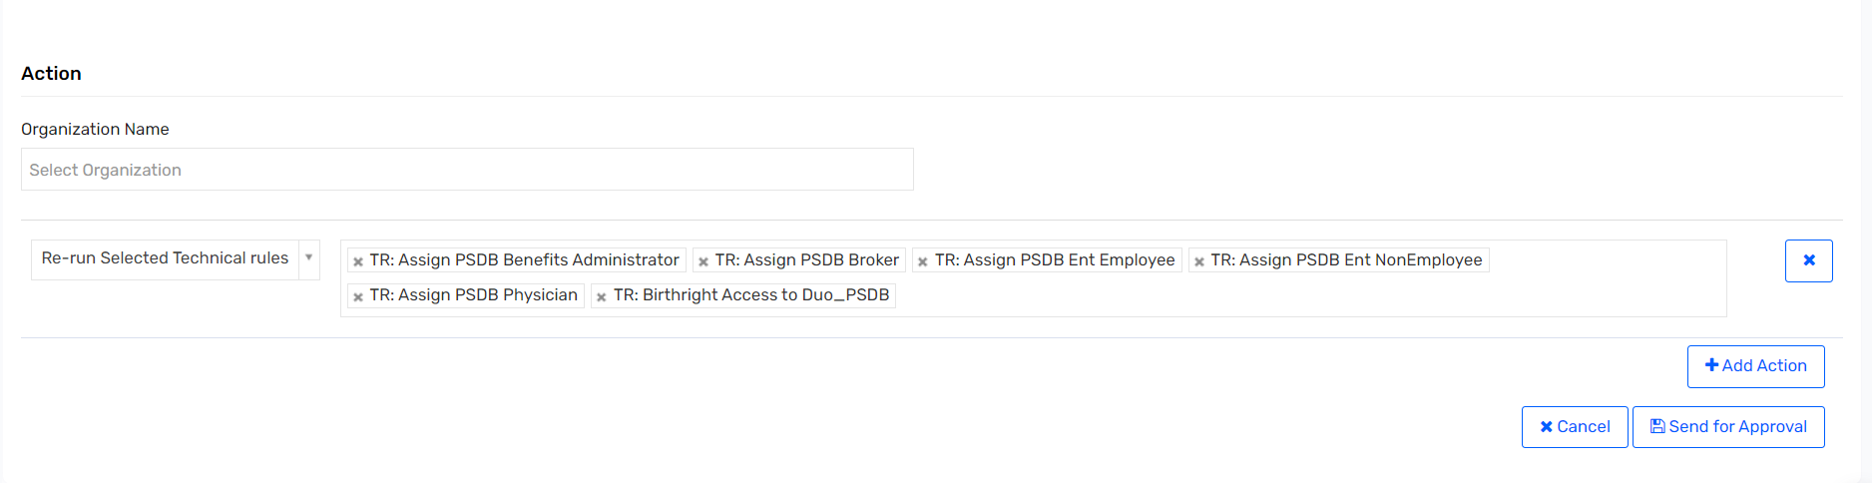

### UR: Retrigger Technical Rules on PREHIRE – Import

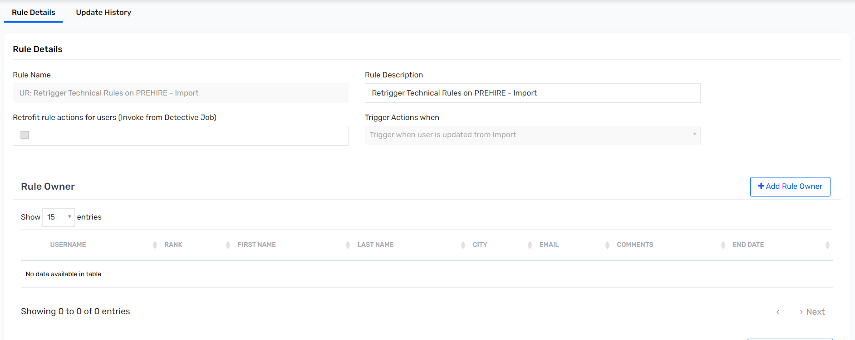 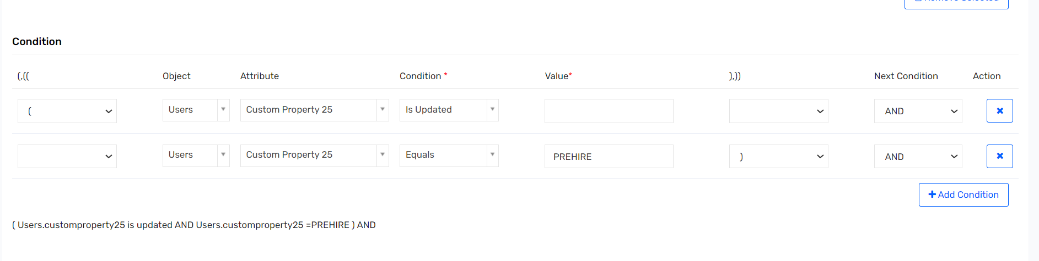 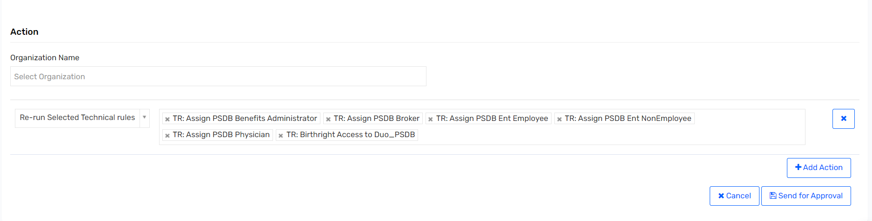

### UR: Revoke_Suspension_ByAdmin

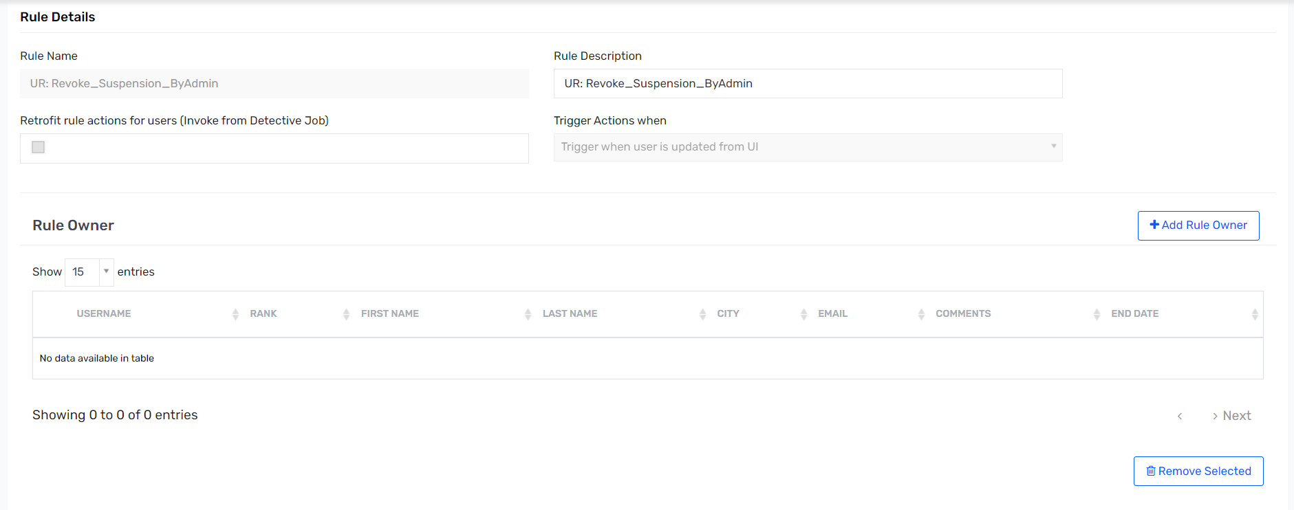 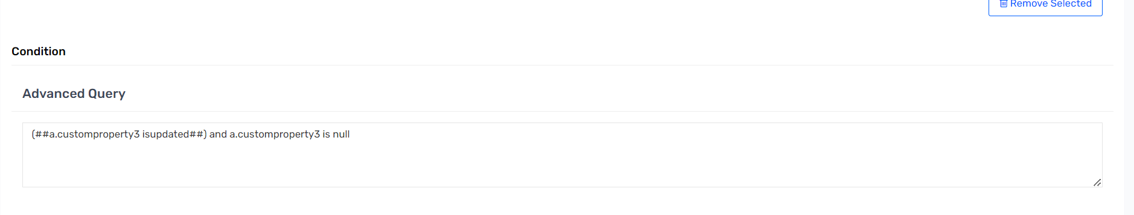 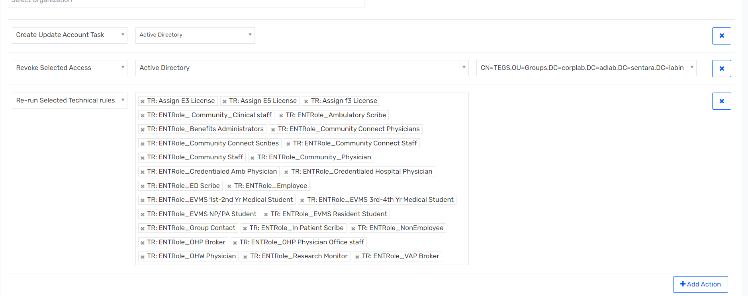

### UR: ServiceNow Update Account – API

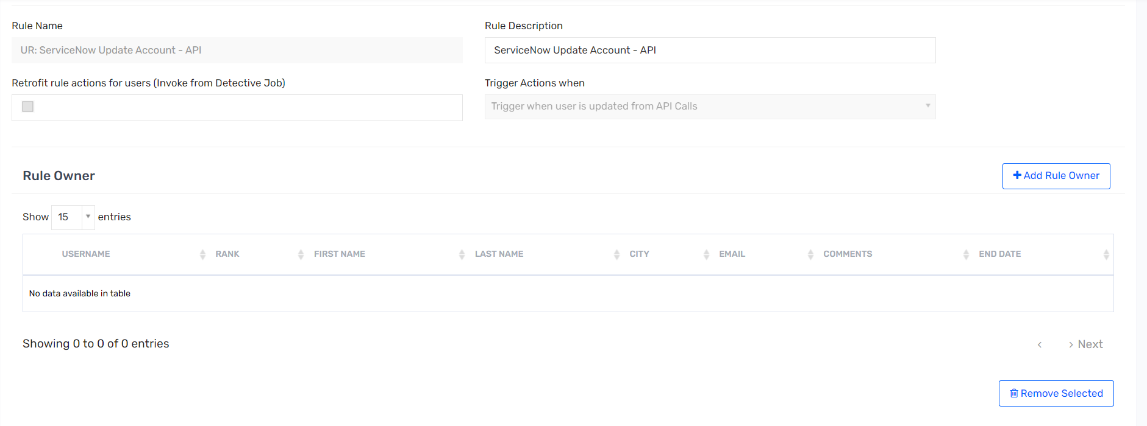 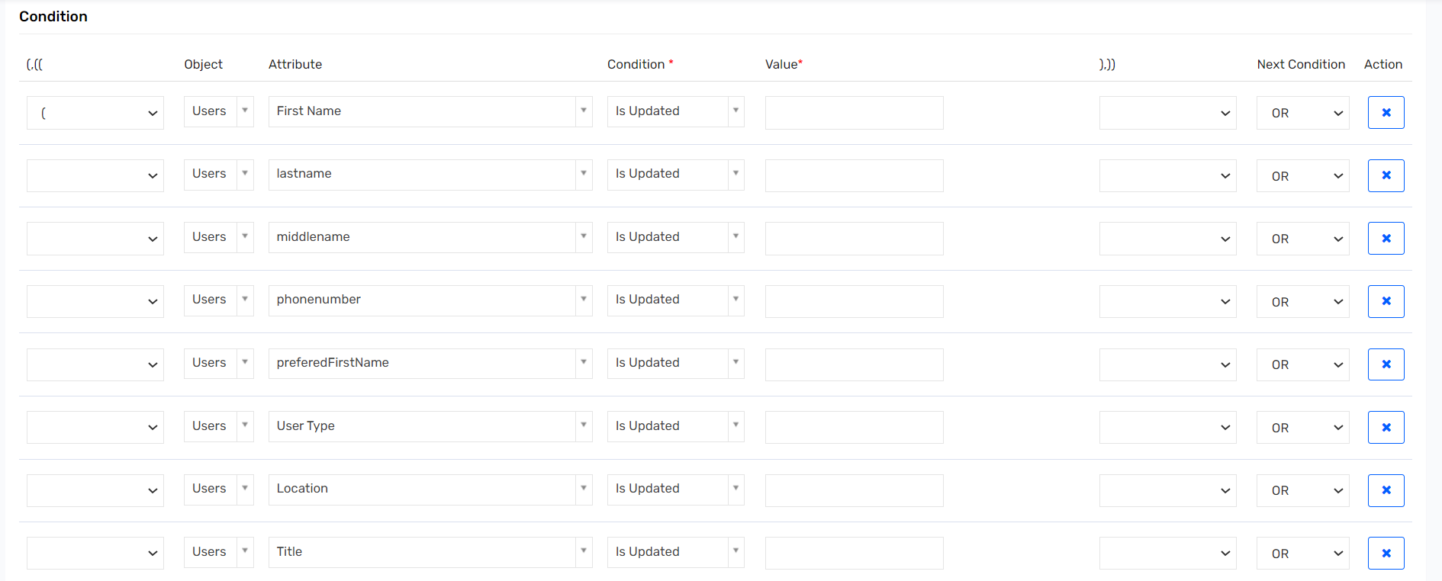 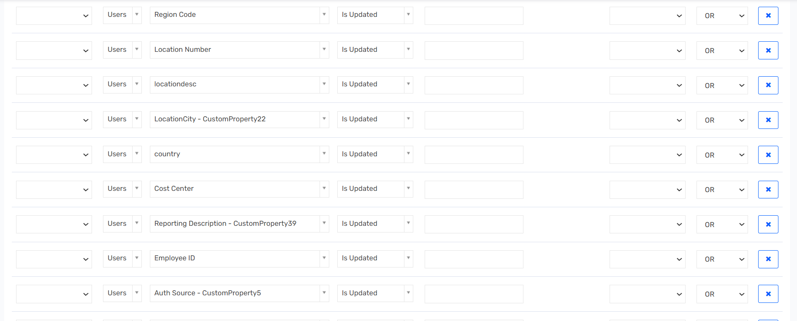 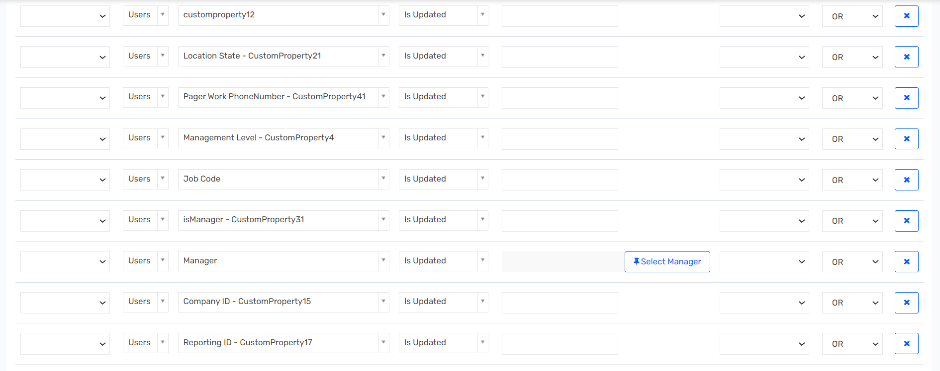 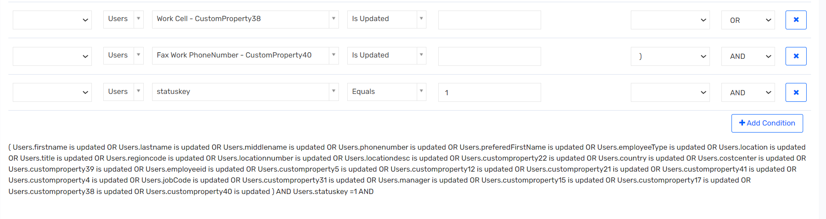 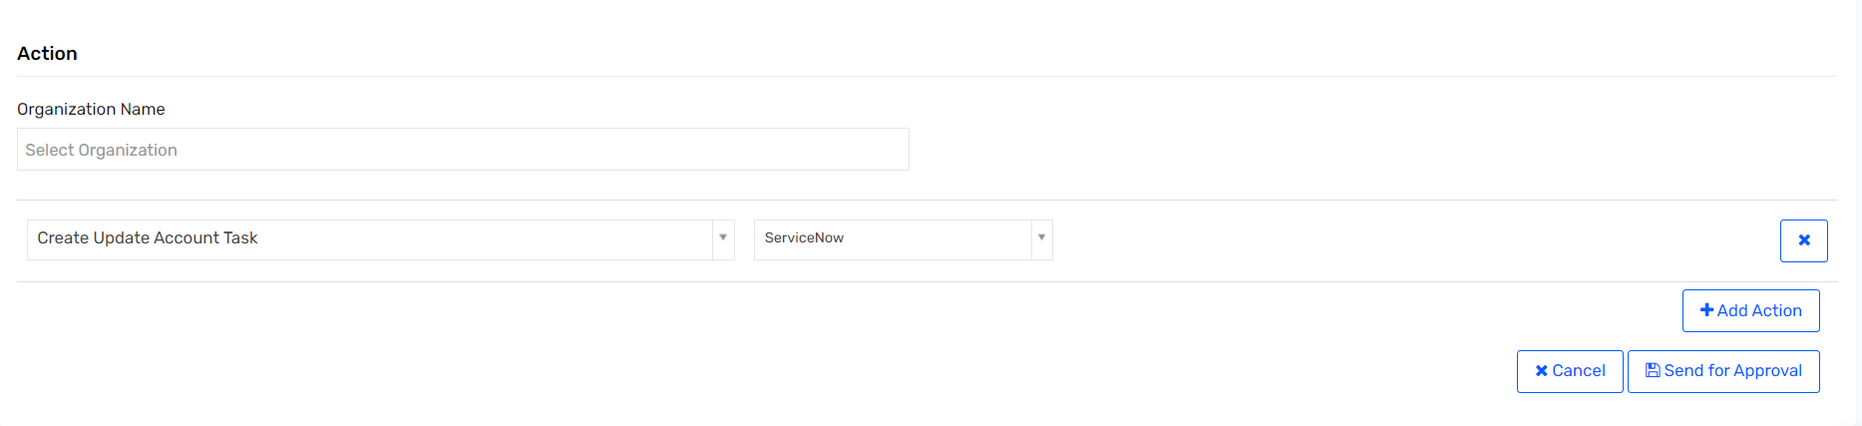

### UR: ServiceNow Update Account – Import

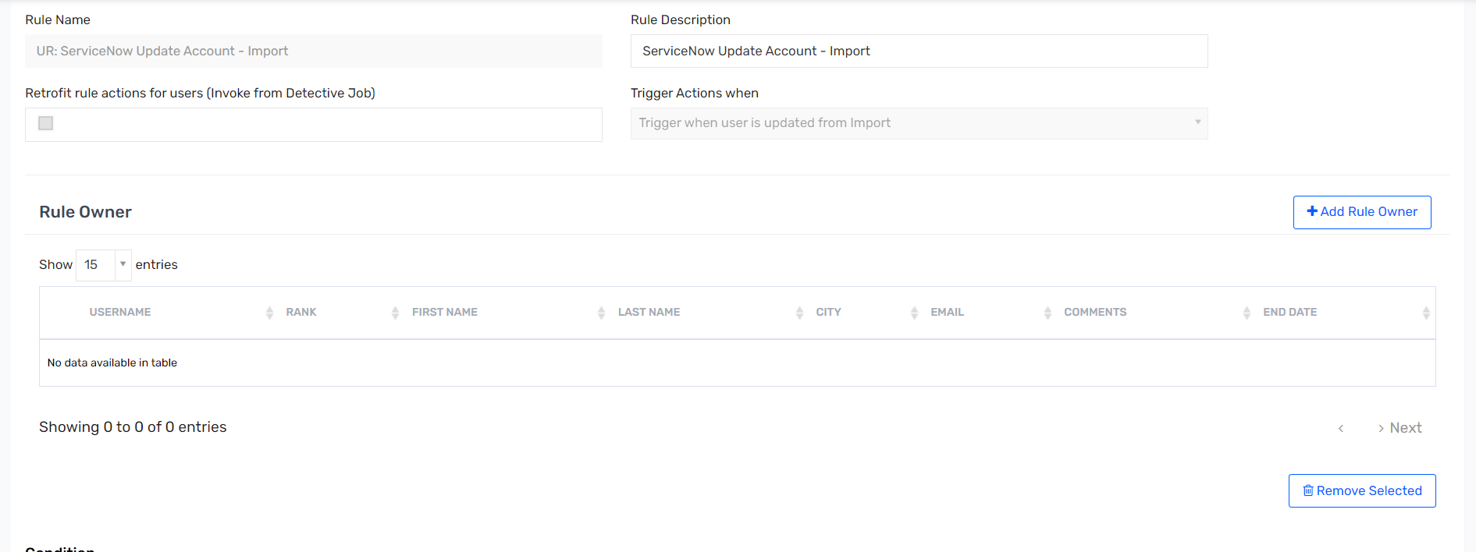 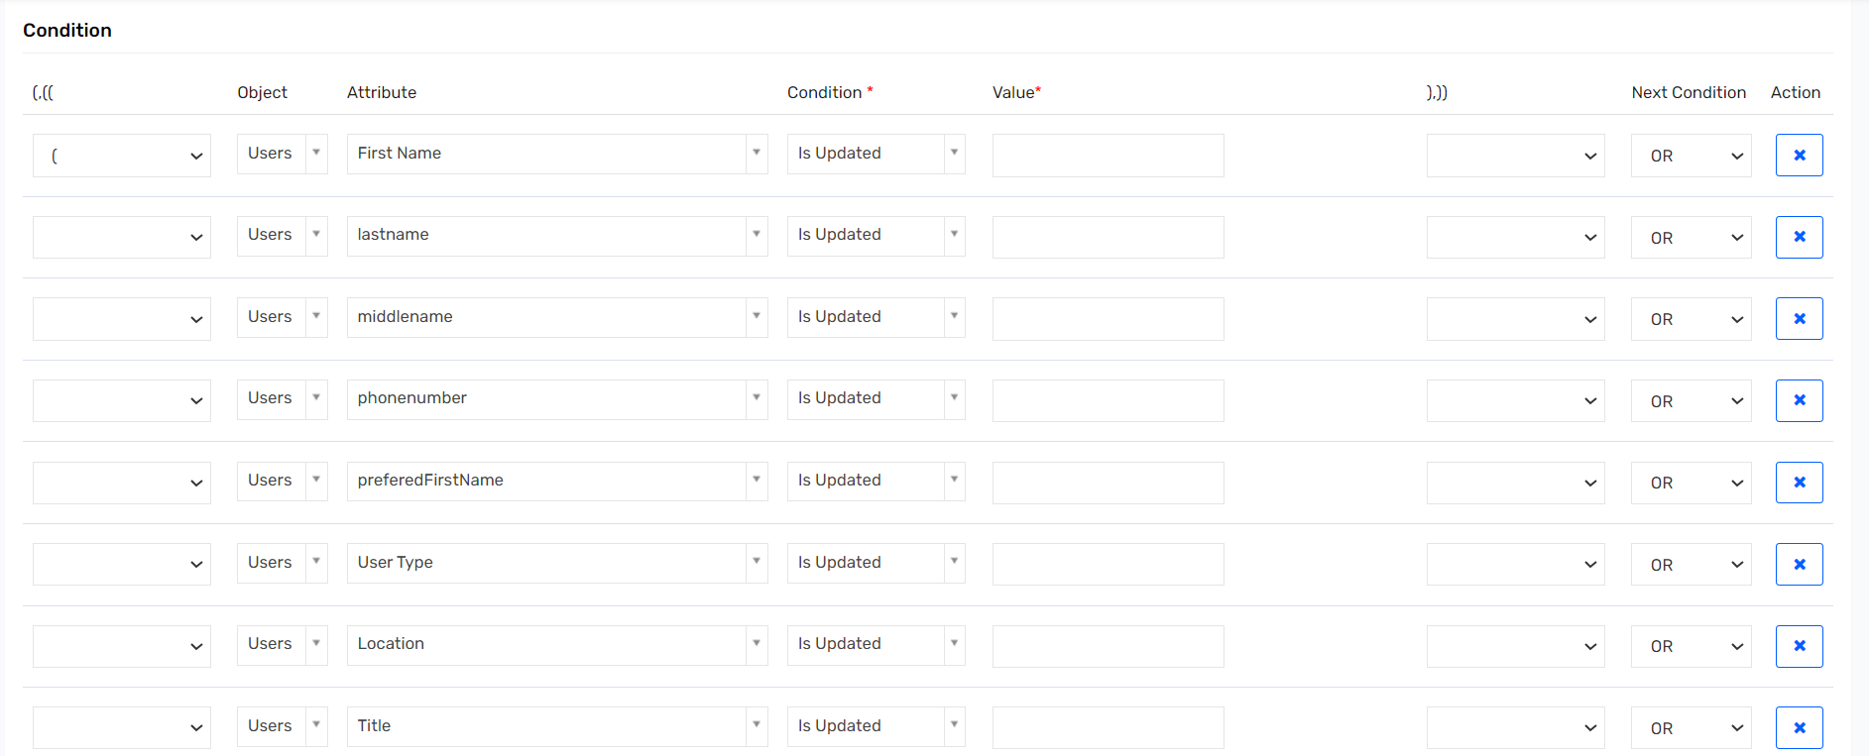 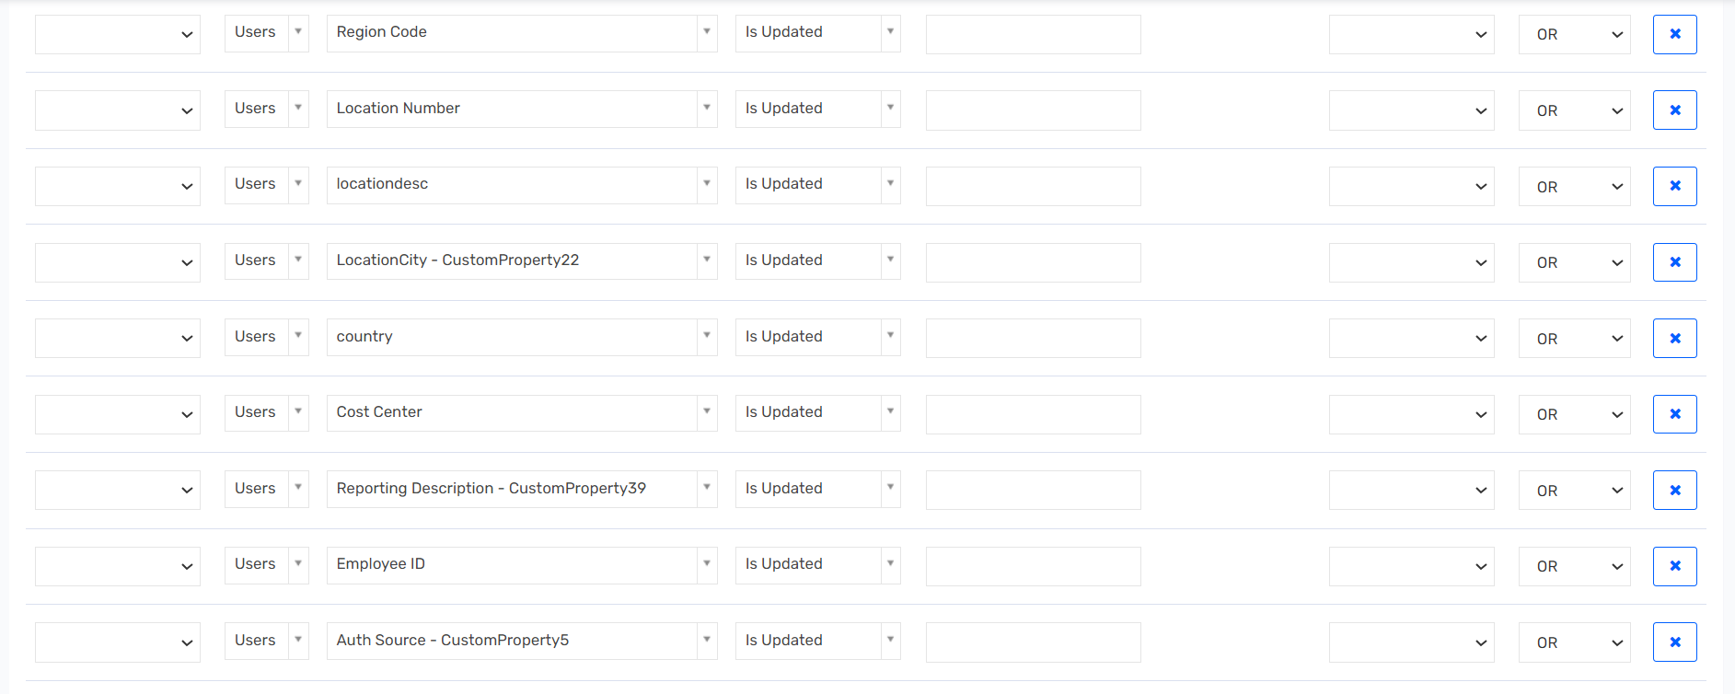 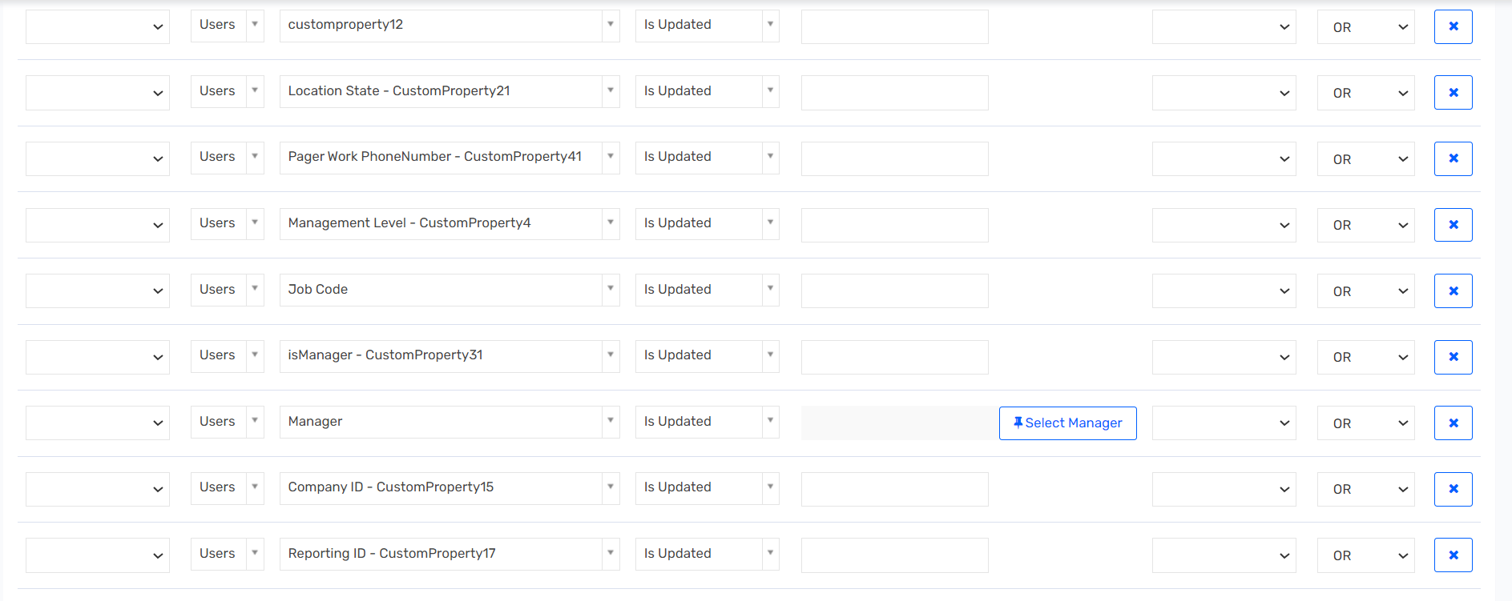 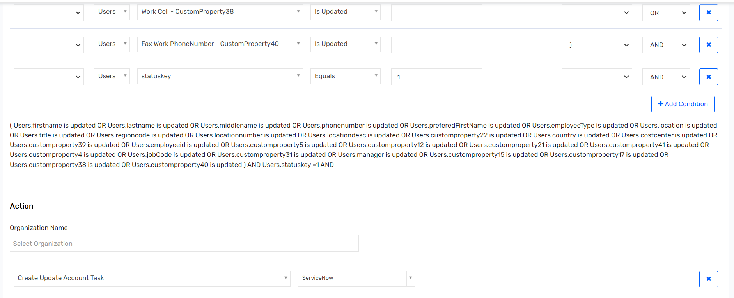

### UR: Suspension_By_Admin

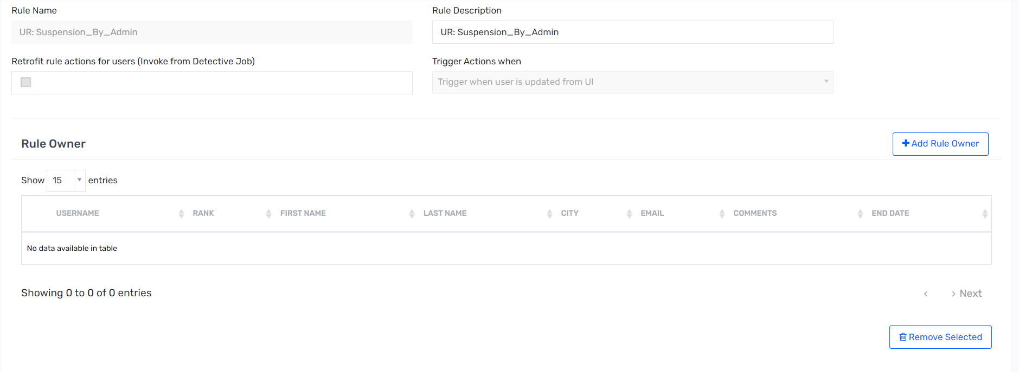 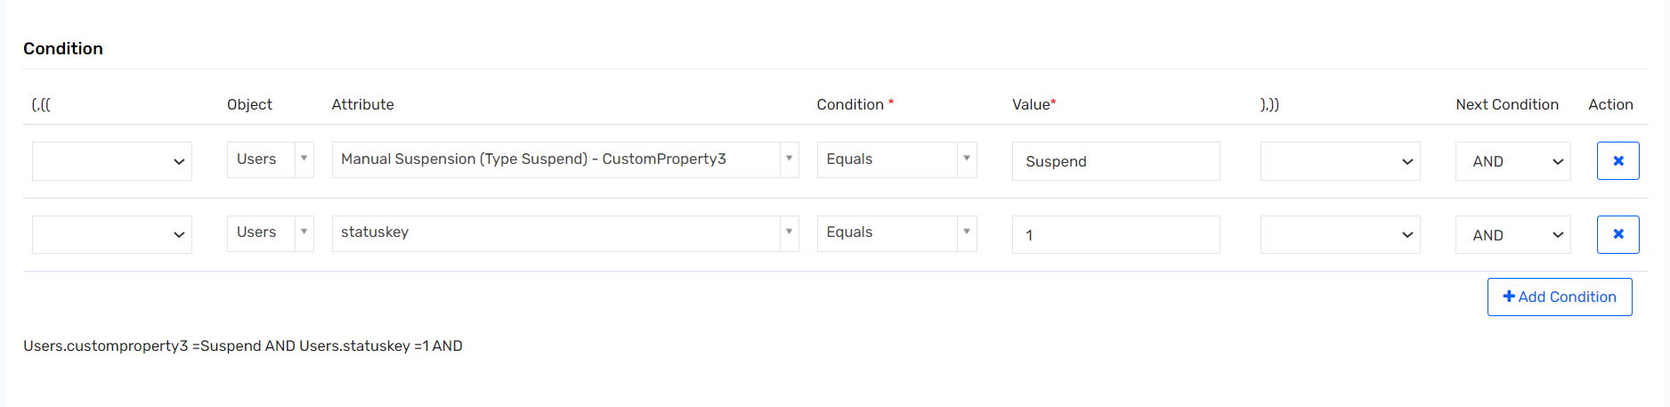 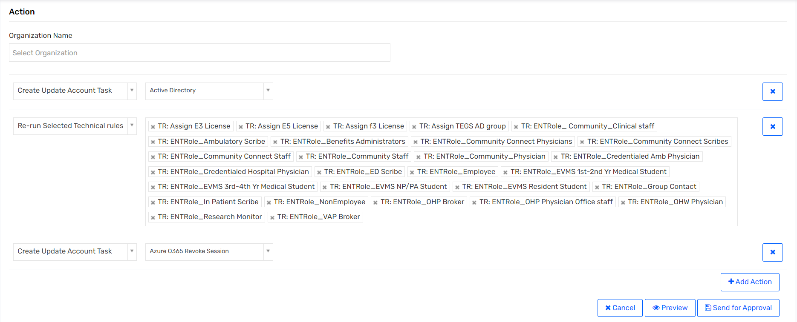

### UR: Termination – API

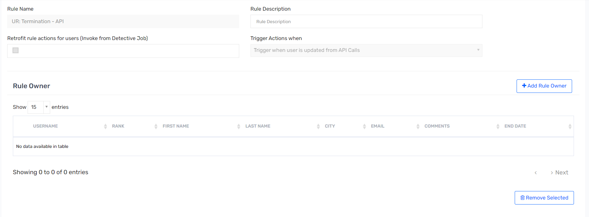 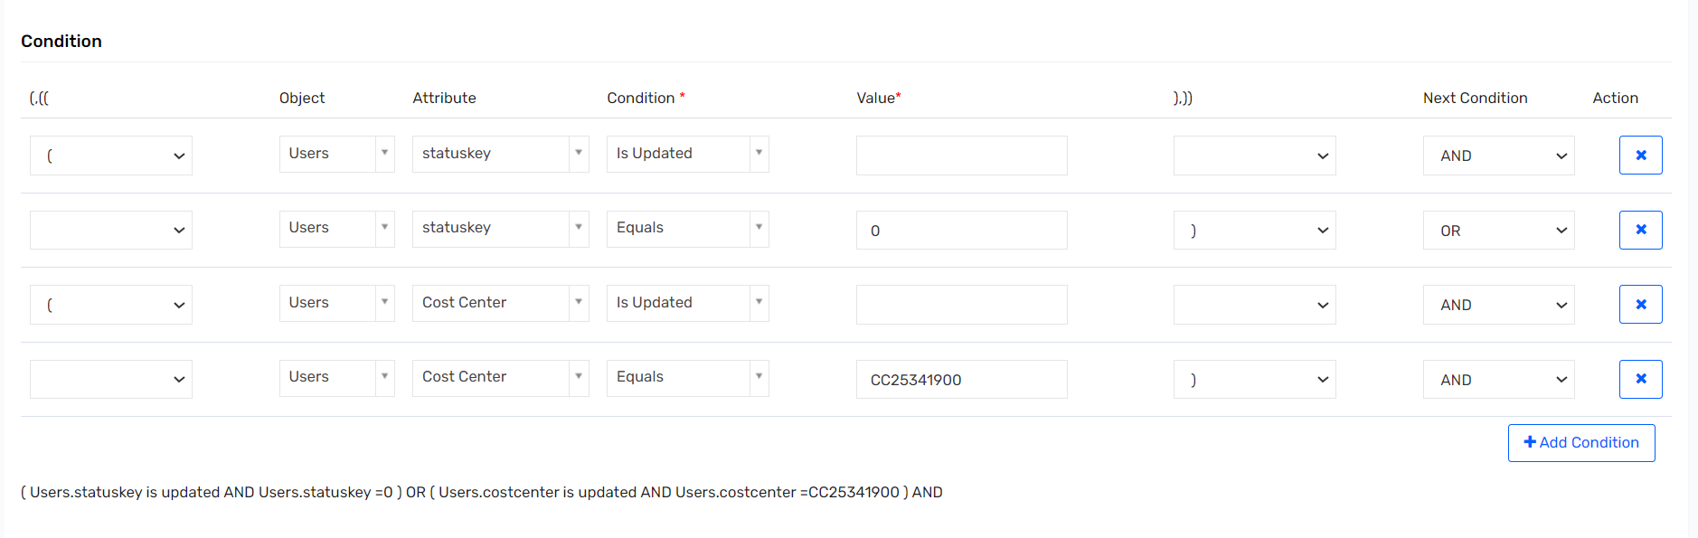

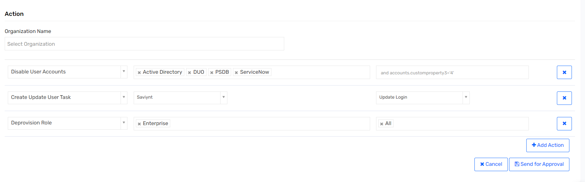

### UR: Termination – Import

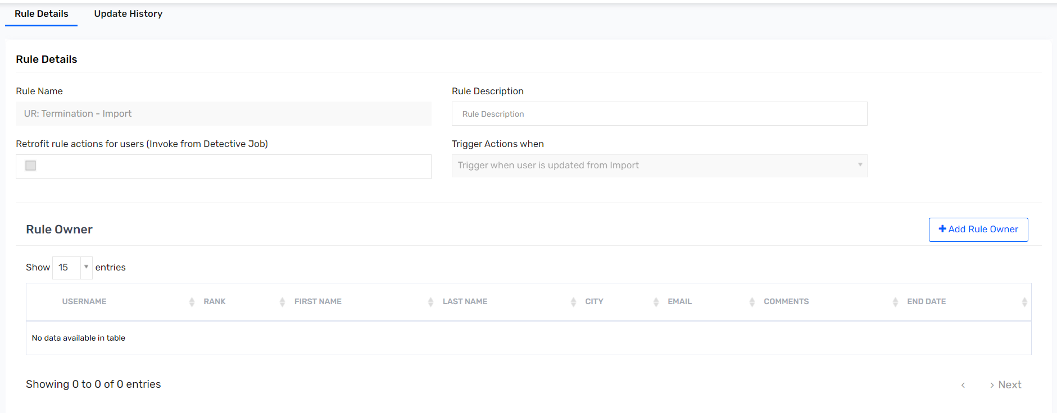 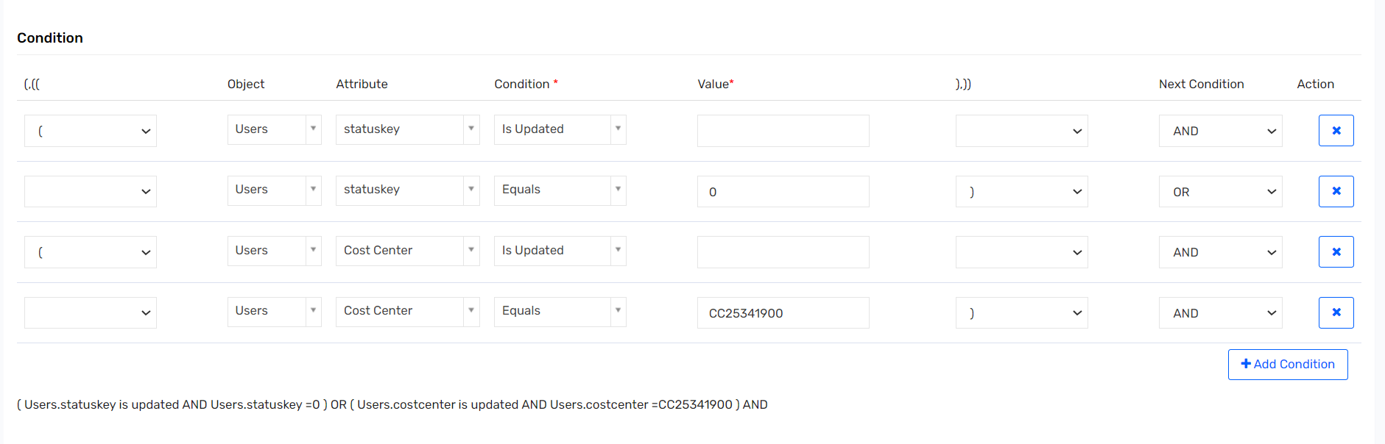 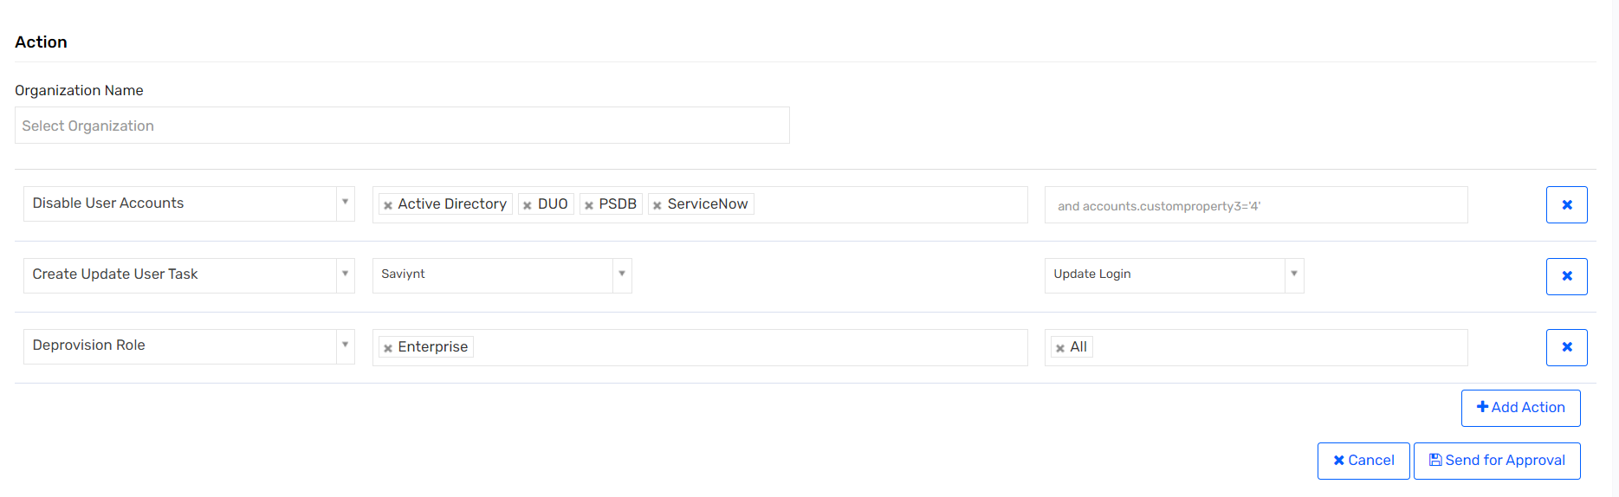

### UR: Termination Workday Write Back – API

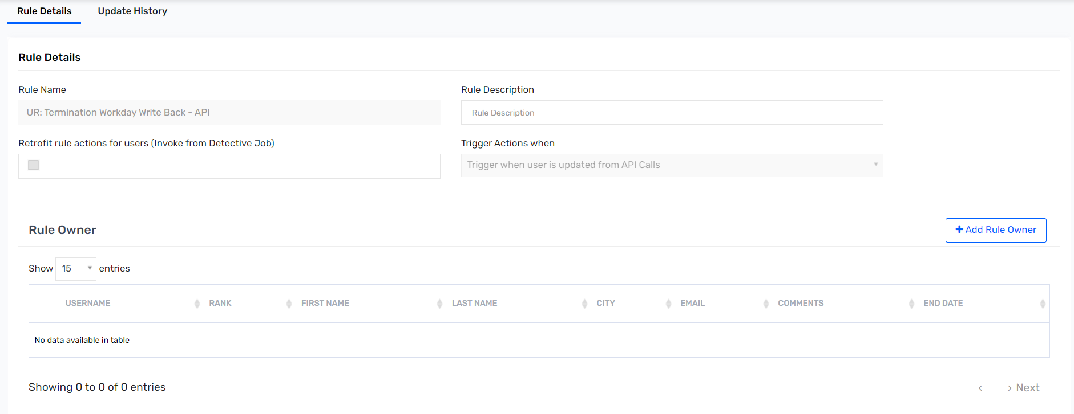 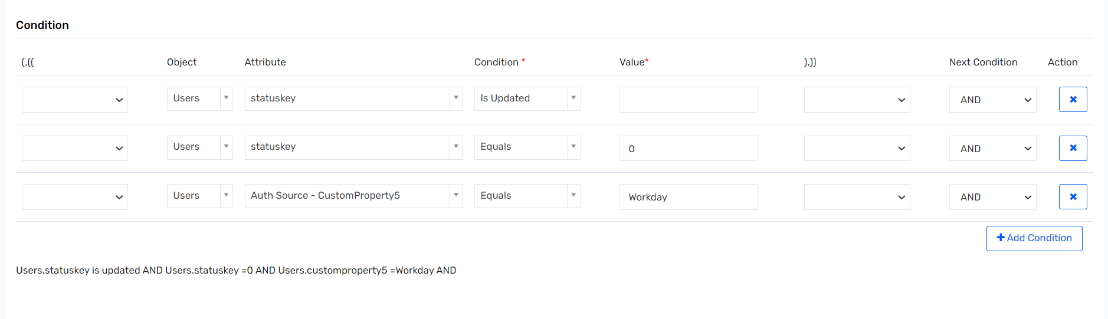 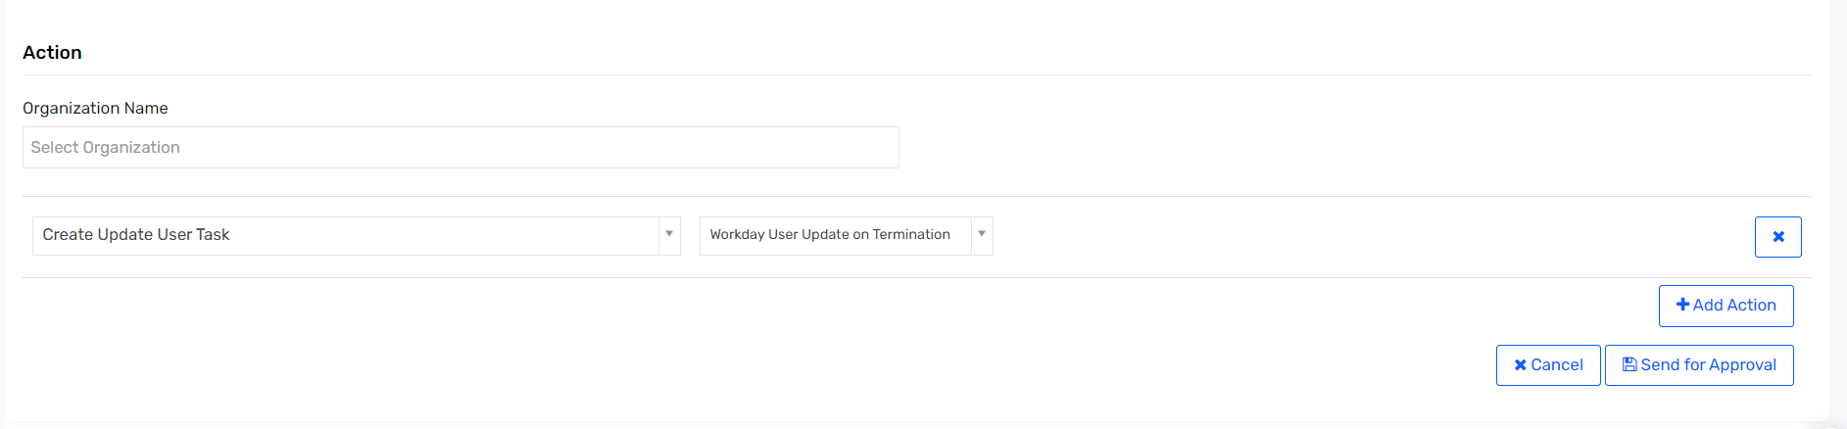

### UR: Termination Workday Write Back – Import

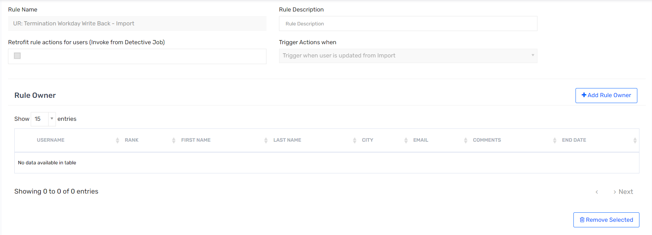 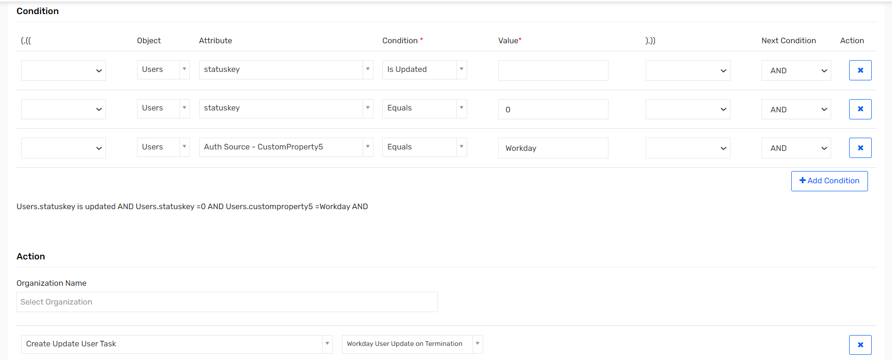

### UR: Workday Attribute Writeback for PREHIRE – API

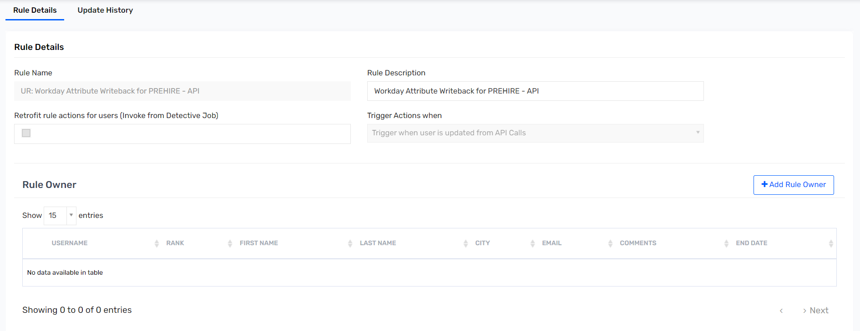 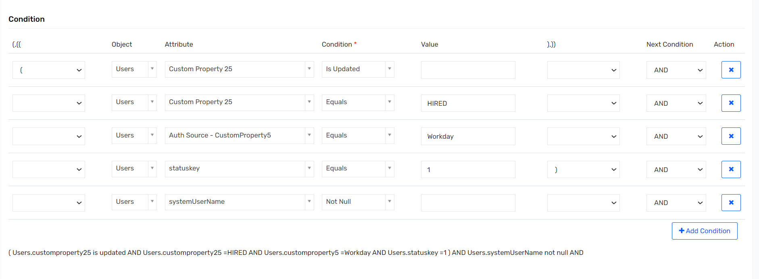 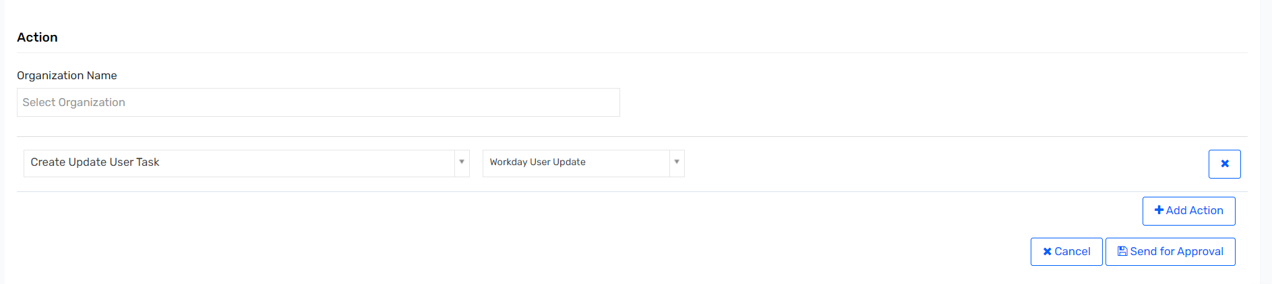

### UR: Workday Attribute Writeback for PREHIRE – Import

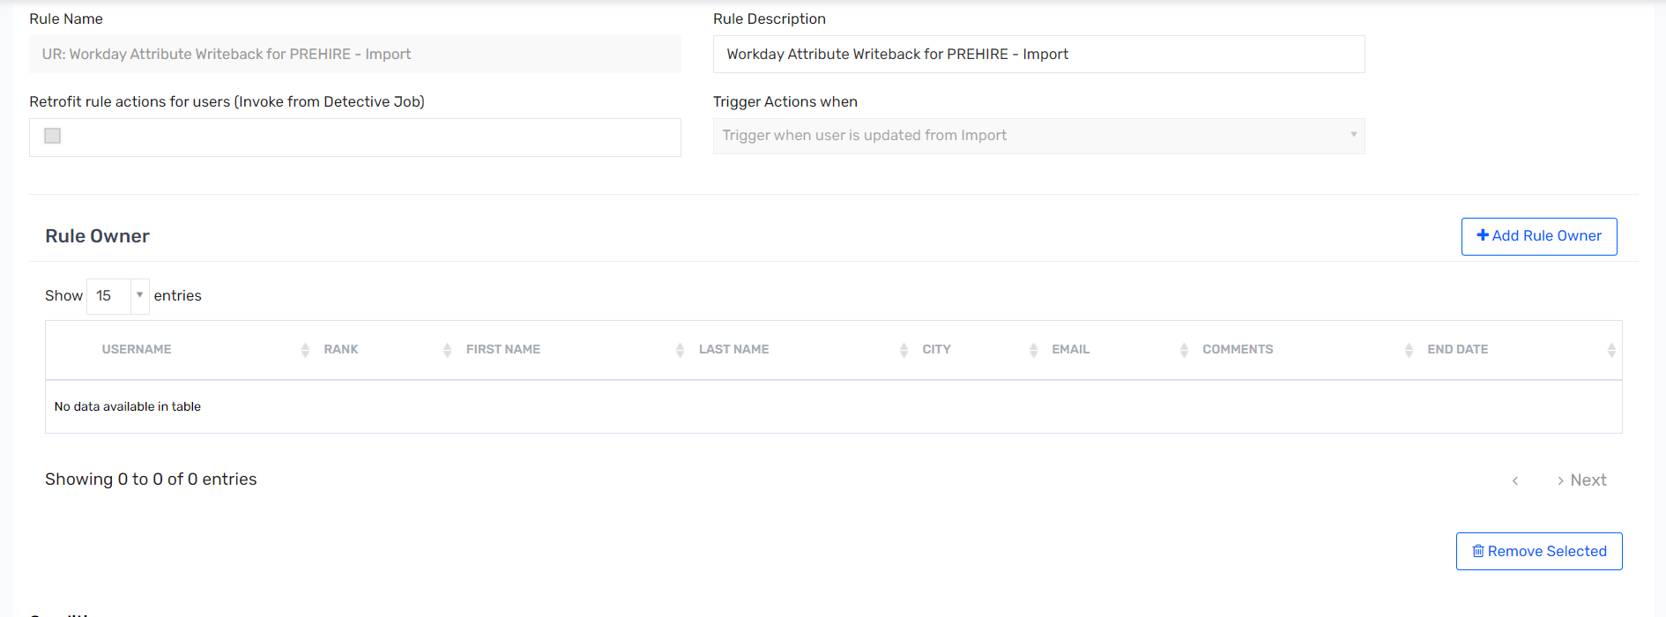 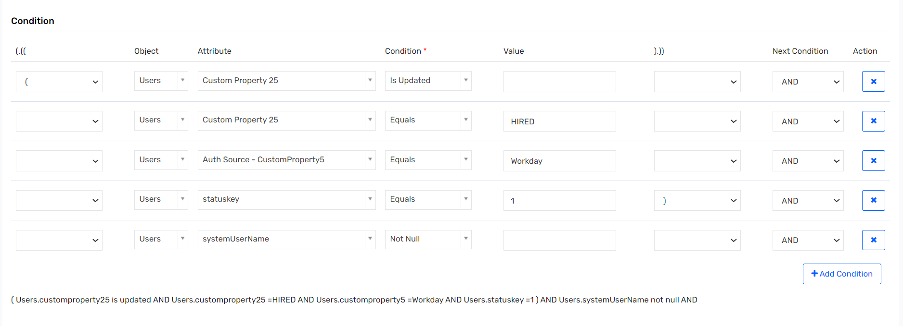 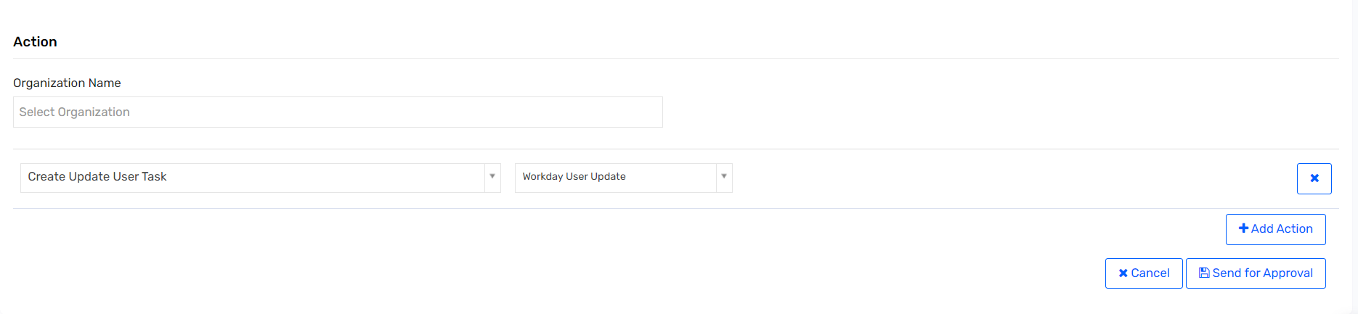

### UR: Termination Cost Center – Import

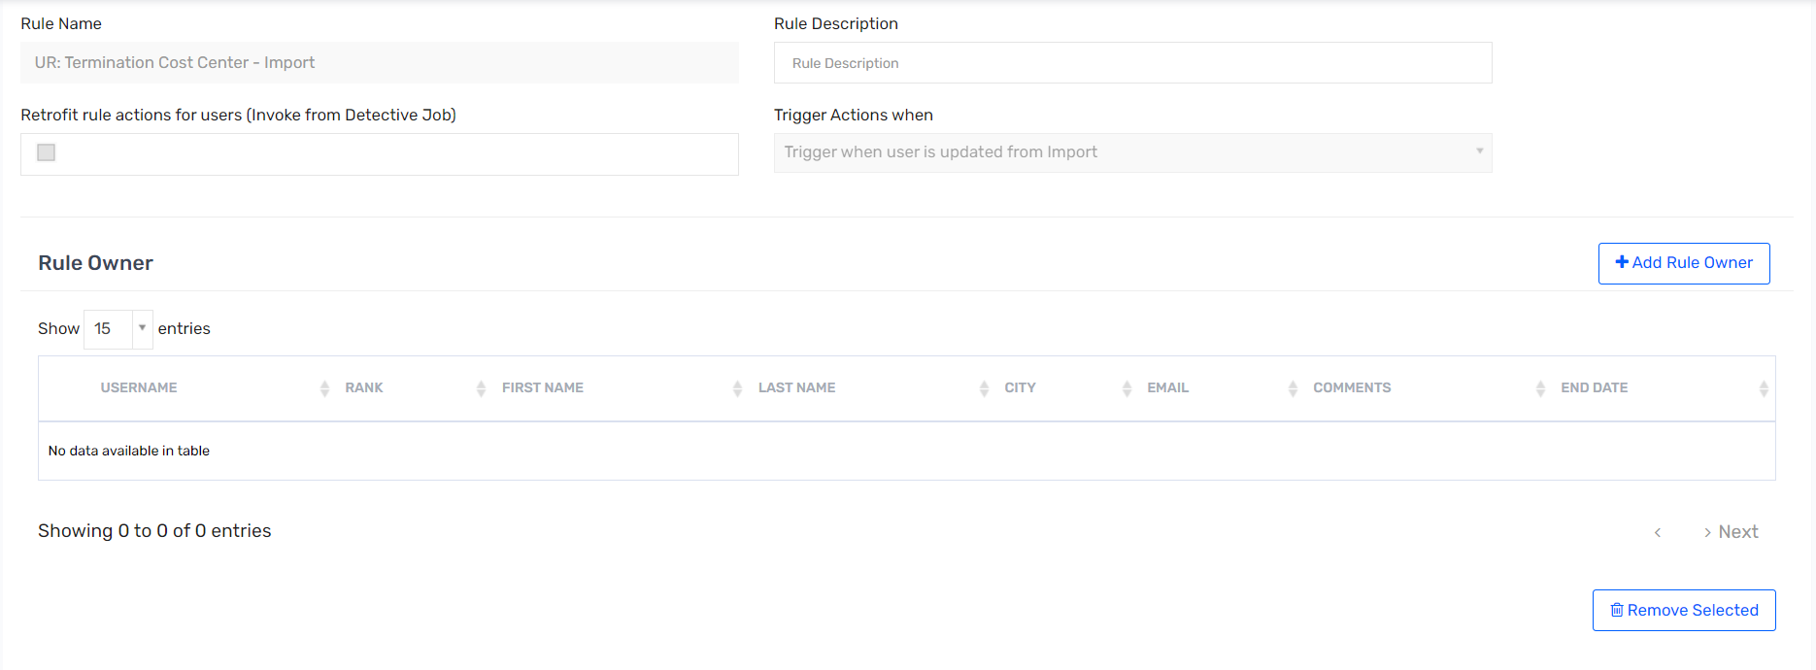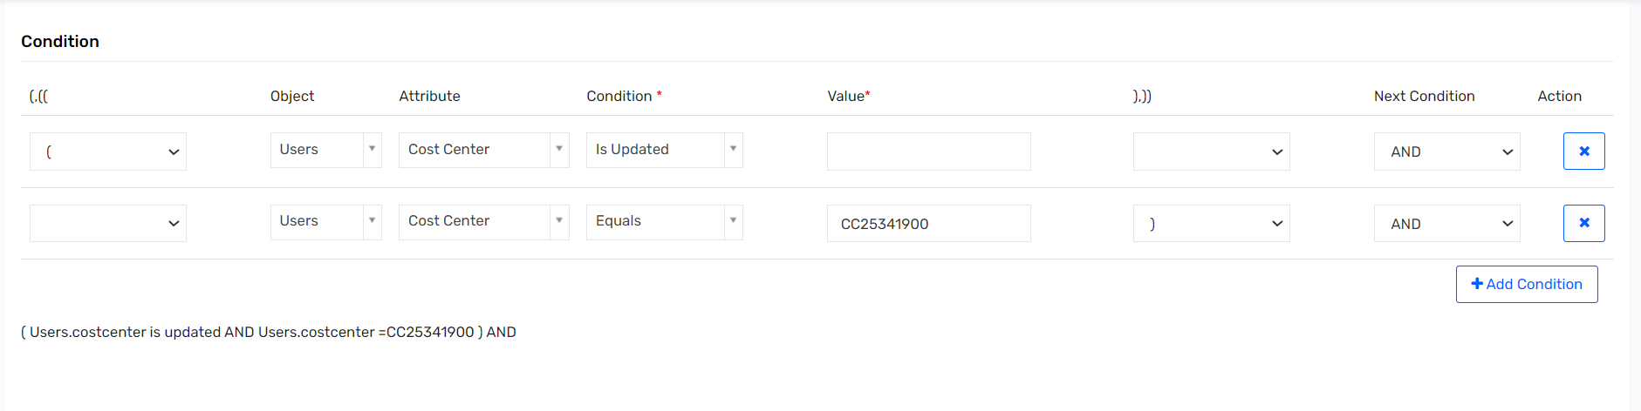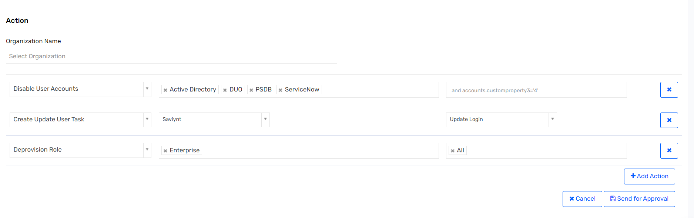

### UR: Termination Cost Center- API

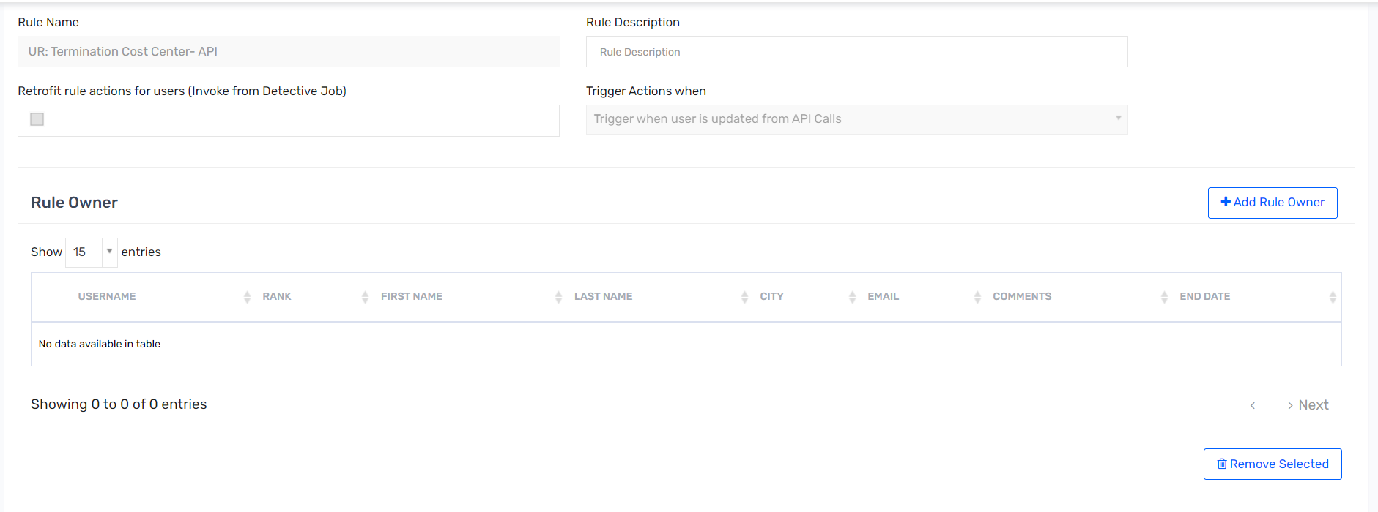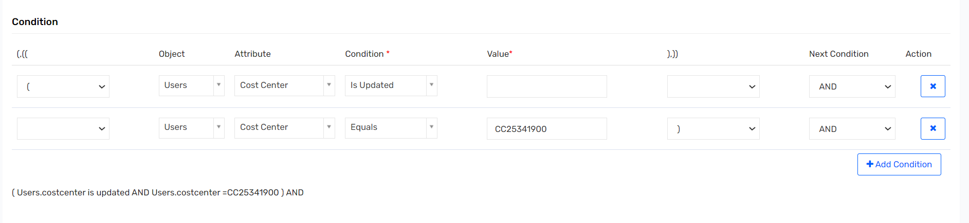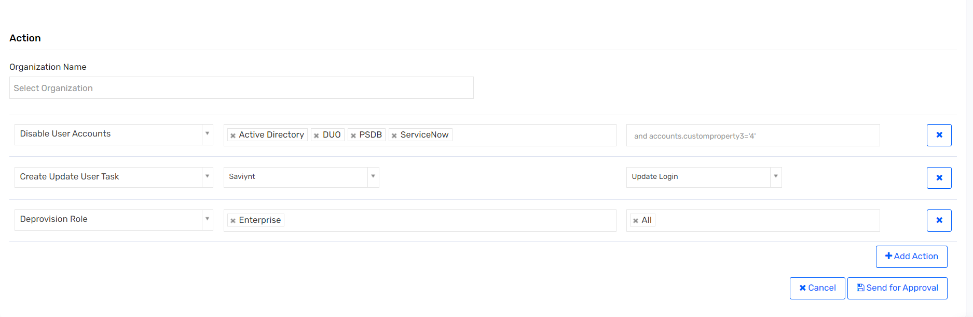

# Admin Configuration

## SAV ROLES

This section describes creating SAV roles in SSM:

Steps:

1. Click on Top Right Corner and Click **Admin**.

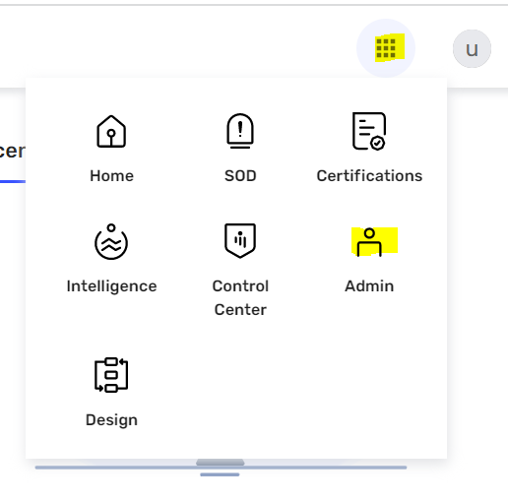

1. From then left pane, Click **SAV Roles** in left panel.

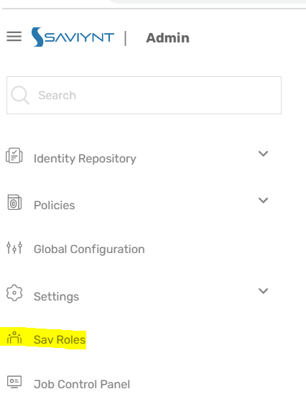

1. Click **Create SAV Role**.

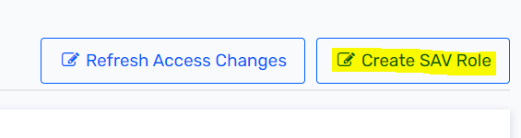

1. Choose appropriate option from the pop-up.

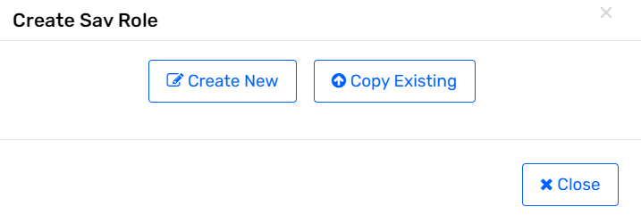

1. Add Role Name and Role Description.

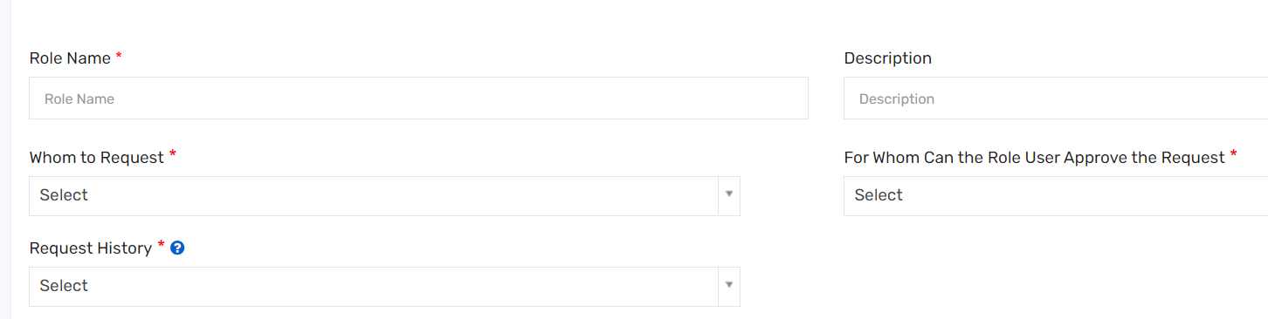

### ROLE_ENDUSER

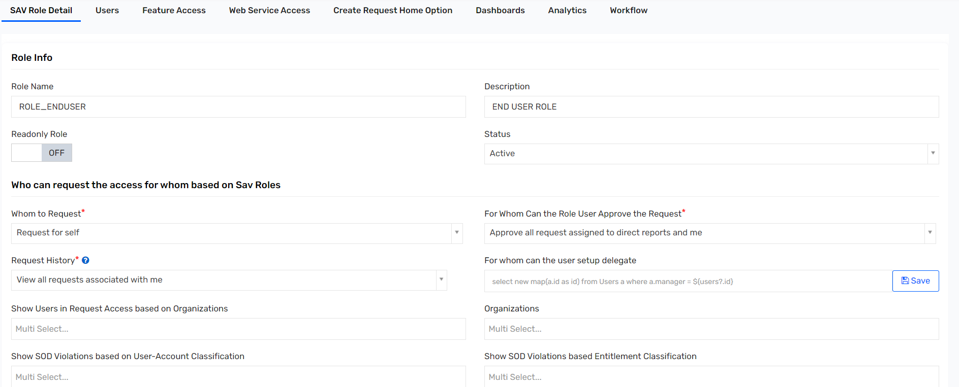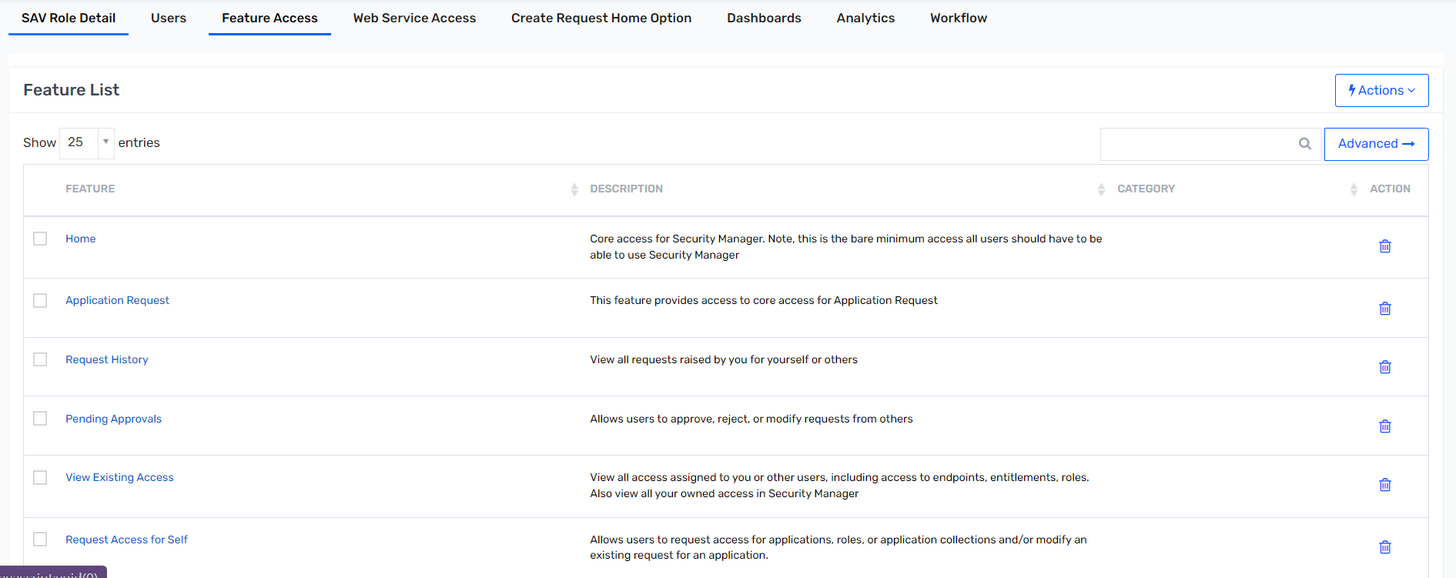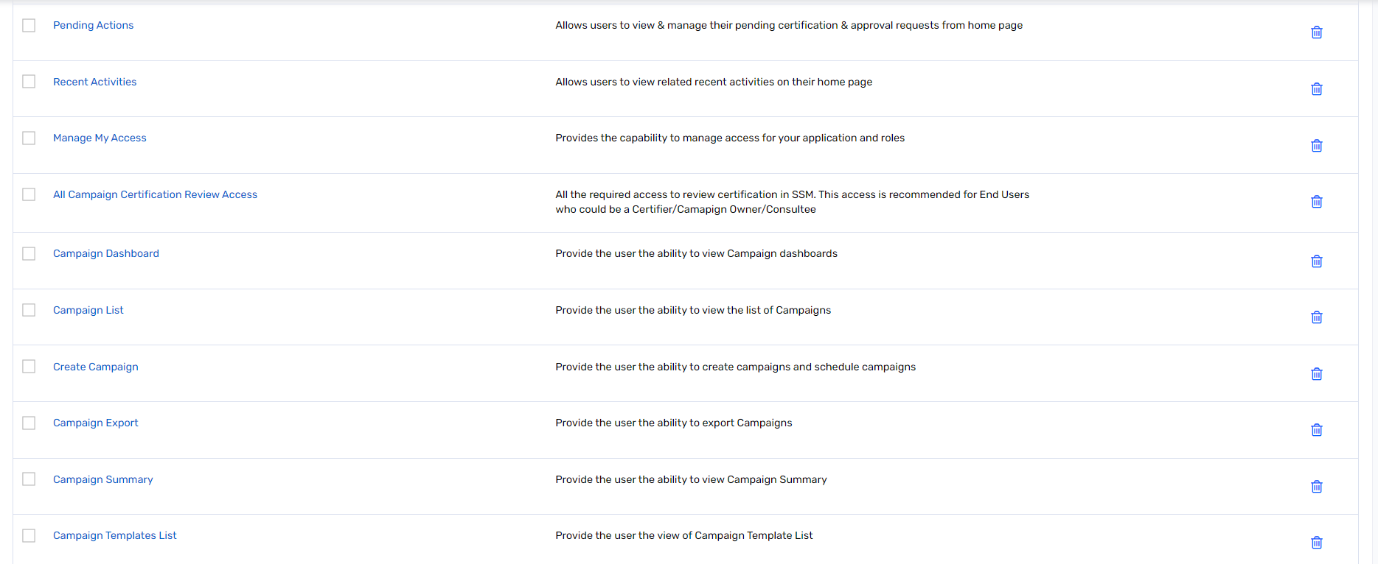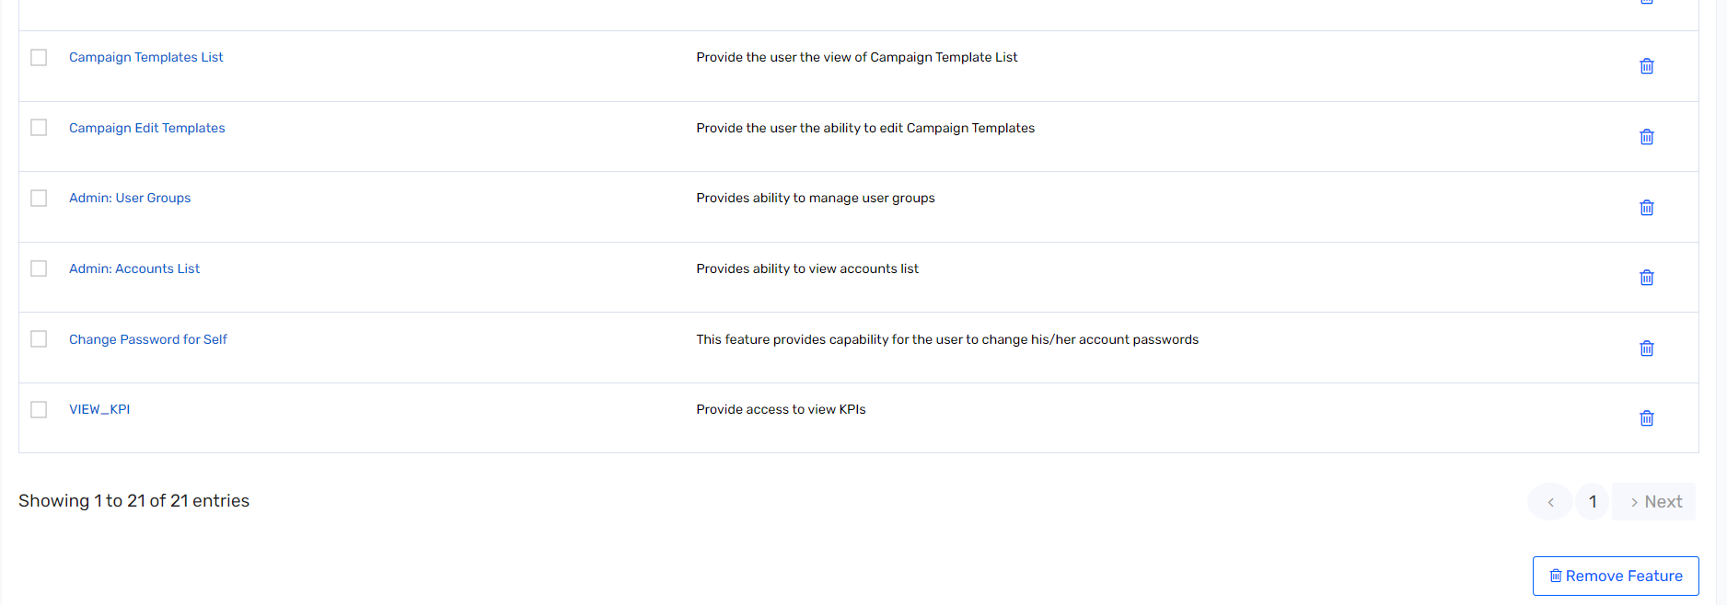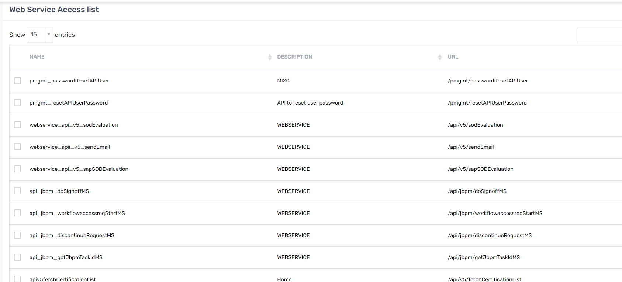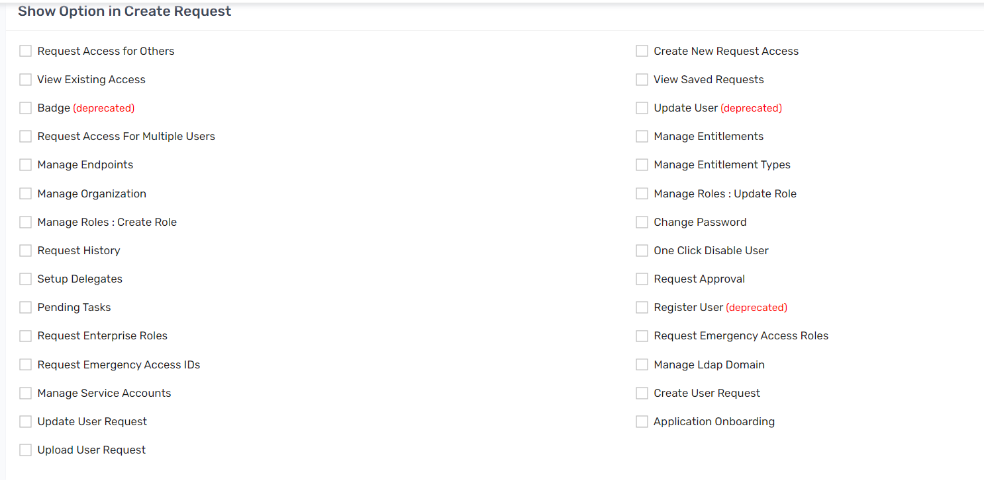

## Steps to Add Users to SAV Role

1. Click **Admin.**
2. Click **SAV Roles**.
3. Click on the role for which you want to add users.
4. Click the **Users** tab.
5. Click **Actions.**
6. Click **Add new user.**
7. Select the user(s) to be added to the SAV Role and click **Save**.
8. Go to **SAV Role Detail** tab.
9. Scroll all the way down and click **Update**.

# JobControl Panel

## Scheduled Jobs

|  |  |  |  |
| --- | --- | --- | --- |
| **JOB NAME** | **CATEGORY** | **JOB TYPE** | **JOB SCHEDULE** |
| DUO_Status | Utility | Execute Extension Queries **DEPRECATED** (CUSTOMQUERYJOB) | At 10:15 AM (UTC), only in 2099 |
| ServiceNow | Data | Application Data Import (Multi Threaded) | At 10:15 AM (UTC), only in 2099 |
| PSDB_Update | Utility | Provisioning Job (WSRETRYJOB) | At 10:15 AM (UTC), only in 2099 |
| DUO_Accounts | Data | Application Data Import (Single Threaded) | At 10:15 AM (UTC), only in 2099 |
| Provisioning_Job | Utility | Provisioning Job (WSRETRYJOB) | At 10:15 AM (UTC), only in 2099 |
| AD_Hoc_Test_Query | Utility | Execute Extension Queries **DEPRECATED** (CUSTOMQUERYJOB) | At 10:15 AM (UTC), only in 2099 |
| EmailNotification | Utility | Email History Job (EmailHistoryJob) | At 10:15 AM (UTC), only in 2099 |
| TestConnectionsJob | Utility | Test Connections Job (TestConnectionsJob) | At 10:15 AM (UTC), only in 2099 |
| AD_Graveyard_Account | Data | Application Data Import (Multi Threaded) | At 10:15 AM (UTC), only in 2099 |
| AD_Import_For_AzureO365 | Data | Application Data Import (Multi Threaded) | At 10:15 AM (UTC), only in 2099 |
| DUO_Account_Import_Chain | Utility | Trigger Chain Job | At 10:15 AM (UTC), only in 2099 |
| Workday_All_Users_Import | Data | User Import via a Connection (UserImportJob) | At 10:15 AM (UTC), only in 2099 |
| AD_Graveyard_Provisioning | Analytics | RunAllAnalyticsJob | At 10:15 AM (UTC), only in 2099 |
| Provisioning_TriggerChain | Utility | Trigger Chain Job | At 10:15 AM (UTC), only in 2099 |
| Provisioning_Job_Writeback | Utility | Provisioning Job (WSRETRYJOB) | At 10:15 AM (UTC), only in 2099 |
| Active_Directory_Access_Full | Data | Application Data Import (Multi Threaded) | At 10:15 AM (UTC), only in 2099 |
| Workday_NewHire_Users_Import | Data | User Import via a Connection (UserImportJob) | At 10:15 AM (UTC), only in 2099 |
| PSDB_Recon_FullAccount_Import | Database | Accounts Import (Complete) from Database (AccountsImportFullJob) | At 10:15 AM (UTC), only in 2099 |
| Tech_Rule_Detective_On_Demand | Utility | Run Detective Rules and Take Action **DEPRECATED** (DETECTIVEPROVISIONINGRULESJOB) | At 10:15 AM (UTC), only in 2099 |
| Active_Directory_Accounts_Full | Data | Application Data Import (Multi Threaded) | At 10:15 AM (UTC), only in 2099 |
| Active_Directory_Access_Incremental | Data | Application Data Import (Multi Threaded) | At 10:15 AM (UTC), only in 2099 |
| Active_Directory_Accounts_Incremental | Data | Application Data Import (Multi Threaded) | At 10:15 AM (UTC), only in 2099 |
| SaviyntForSaviyntAccessImportJobTrigger | Data | Application Data Import (Single Threaded) | At 10:15 AM (UTC), only in 2099 |
| SaviyntForSaviyntAccountImportJobTrigger | Data | Application Data Import (Single Threaded) | At 10:15 AM (UTC), only in 2099 |
| DefaultArchivalJobTrigger | Utility | Archival Job | At 11:00 PM (UTC), only on Saturday |
| DefaultEndpointSyncTrigger | System | MicroserviceJob | At 12:00 AM (UTC) |
| DefaultScheduledJBPMRetry | Utility | JBPM Retry Job (JBPMRetryJob) | Every 2 hours |
| DefaultRequestRetryJob | System | AsyncRequestRetryJob | Every 30 minutes |
| DefaultEndpointDeltaSyncTrigger | System | MicroserviceJob | Every 30 minutes |
| SavforSav | Utility | Provisioning Job (WSRETRYJOB) | Every 15 minutes |

# Global Configurations

## Tasks

1. Click **ADMIN->Configurations->Global Configurations->Identity lifecycle**.

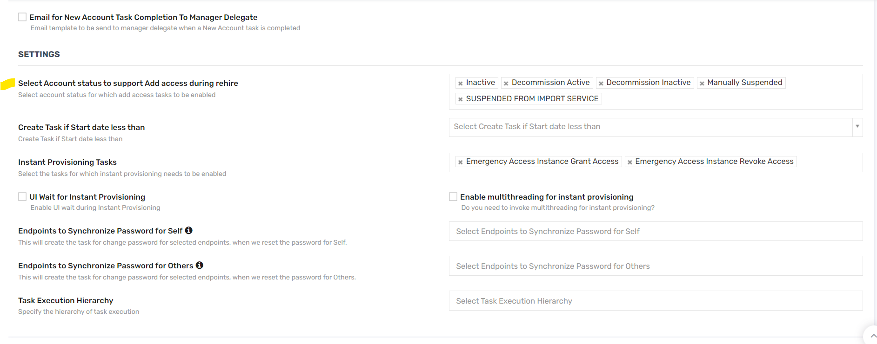

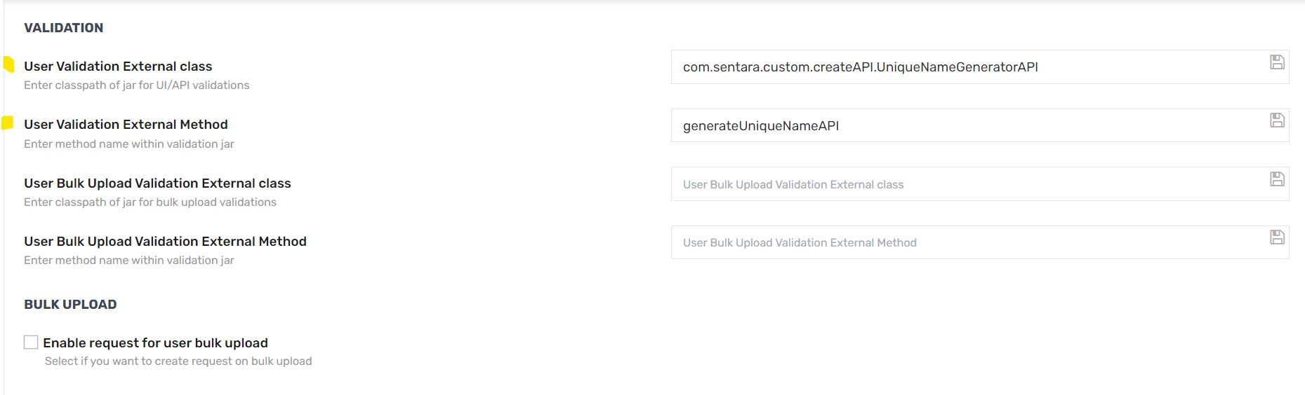

## Rules

1. Click **ADMIN->Configurations->Global Configurations->Analytics**.

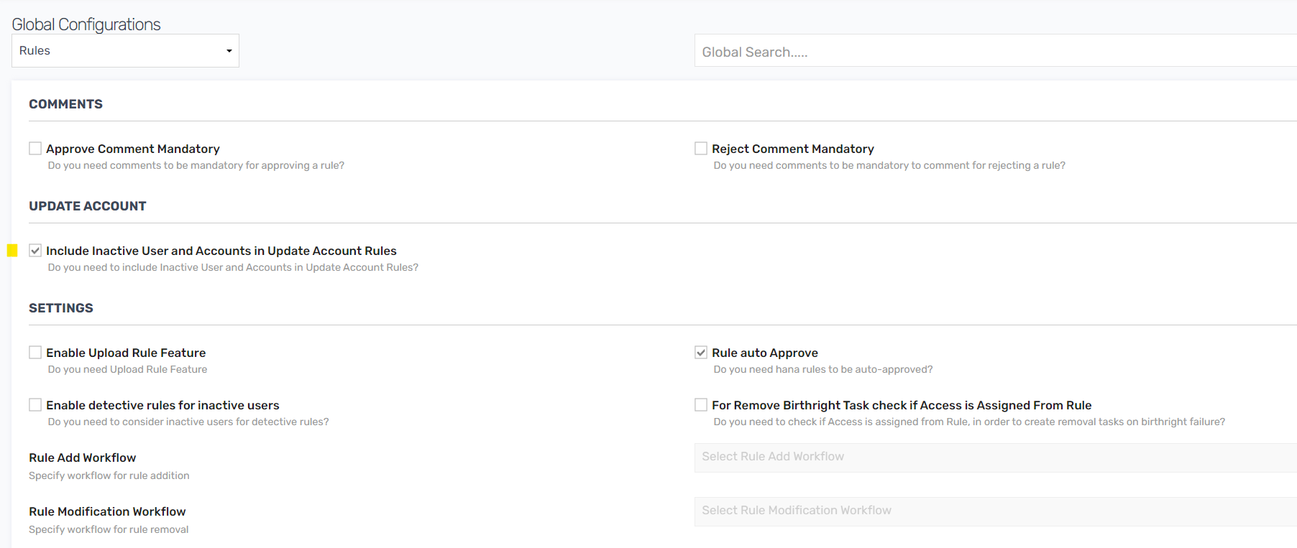

# SMTP Email Configuration

This section shows the SMTP configurations.

1. Click **ADMIN-> Configuration> SMTP**.

| Parameter | Values |
| --- | --- |
| SMTP Server Name |  |
| SMTP User Name |  |
| SMTP Port |  |
| Encoding |  |
| SMTP Authentication |  |
| mail.smtp.starttls.enable |  |
| mail.smtp.starttls.required |  |
| TrustedHosts like mail.company.com |  |
| Email Address |  |

# Workflows

This section describes configuring the workflows.

1. Log in to Sentara Test
2. Click **ADMIN**.
3. Click **Workflows**.
4. Click **Workflow List**.
5. To create new workflow, click **Actions->Create New Workflow**.
6. Create workflow and click **Save** to make changes.

## Auto Approval Workflow

| Parameter | Values |
| --- | --- |
| Workflow Name | AOBAutoApprovalWF |
| Description | <blank> |
| Workflow Type | Parallel |

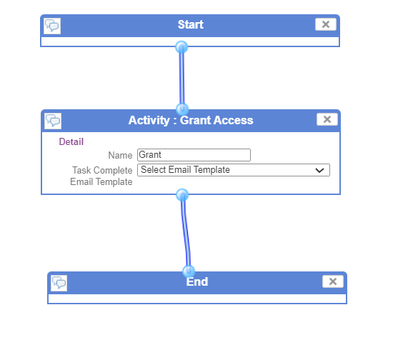

## Manager Approval Workflow

| Parameter | Values |
| --- | --- |
| Workflow Name | AOM Manager Approval |
| Description | <blank> |
| Workflow Type | Parallel |

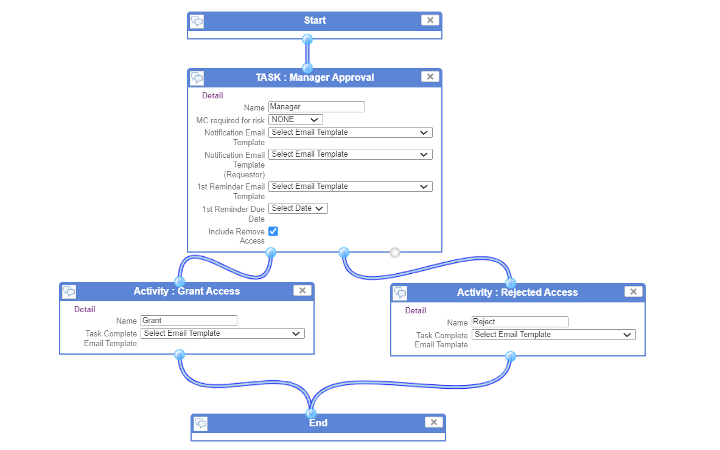

# User Interface Branding

This section describes the steps to do the branding.

1. Click **ADMIN**.
2. Click **Configurations**.
3. Click **UI Branding**.
4. Select the logo that you want to update by referring to the size specification mentioned in the Freshdesk portal (<https://saviynt.freshdesk.com/support/solutions/articles/43000433214-user-interface-branding>).
5. Restart server to reflect any changes after upload.

# Email Templates

## Steps to Configure Email Templates in SSM

This section provides you step by step process configure email templates in SSM.

1. Log in to AG DEV SSM using the URL below with your AD user name and password:
2. Click **ADMIN**.
3. Click **Configurations**.
4. Click **Email Templates**.
5. Click **Create Email Template**.
6. Fill in all the fields and email body and click **Create**.

### List of Email Templates Configured

|  |  |  |
| --- | --- | --- |
| **Name** | **To** | **Subject** |
| User termination email sent to the user manager | ${manager.email} | [Dev] ${user.systemUserName} - Account has expired |
| User Password Expiry Email | ${userEmail} | Your Saviynt Password is about to expire!! |
| Transport Email Template | ${users.email} | Your ${operation} request is complete. |
| SSL Certificate Expiry Email | ${userEmail} | Expiration Notification for SSL Certificate(s) ${ANALYTICSDATA.alias} |
| Service Account Password Expiry Email | ${userEmail} | Service Account Password is about to expire!! |
| Role-Access Mismatch Job Execution Details | ${ownerEmail} | *ALERT* 'Role-Access Mismatch' Job Execution Details |
| Role Expiry Email | ${userEmail} | Your role is about to expire!! |
| Import Failure Notification | kirti.ajrot@saviynt.com, kxajrot@sentara.com | ${importjob.jobStartDate} Job Failure Notification for connection: ${connection?.connectionname} |
| Entitlement Expiry Email | ${userEmail} | Your accesses are about to expire!! |
| Asynchronous Request Email Template | ${requestor.email} | Temporary Request ID: ${tempRequestId} |
| Analytics_Execution_Failure_Email_Template | ${owners} | Your analytics control execution has failed! |
| Analytics Execution Complete Email Default Template | ${USER.email} | Your analytics report ${analyticsConfig.displayName!=null && analyticsConfig.displayName!="" ? analyticsConfig.displayName : analyticsConfig.analyticsName } is ready |
| AccountClaimingPreview | <% if ((user.customproperty5!=null) && user.customproperty5.equalsIgnoreCase('Seczetta')) print"${user.email}" else if ((user.employeeType != null && (user.employeeType.contains('EMP')||user.employeeType.contains('CWR')))&& null!=user.secondaryEmail &&user.secondaryEmail!='') print"${user.secondaryEmail}" else print"${manager.email}" %> | Welcome Email Instructions for - ${user.firstname} ${user.lastname} - READ FIRST  CC : <% if ((user.customproperty5!=null) && user.customproperty5.equalsIgnoreCase('Seczetta')) print"${user.customproperty44}" else print"${manager.email}"%> |
| Account Password Expiry Email | ${userEmail} | Your password is about to expire!! |
| Account Claiming Email - Rehire | <% if ((user.customproperty5!=null) && user.customproperty5.equalsIgnoreCase('Seczetta')) print"${user.email}" else if ((user.employeeType != null && (user.employeeType.contains('EMP')||user.employeeType.contains('CWR')))&& null!=user.secondaryEmail &&user.secondaryEmail!='') print"${user.secondaryEmail}" else print"${manager.email}" %> | [SECURE] Welcome Email - ${user.firstname} ${user.lastname}  CC : <% if ((user.customproperty5!=null) && user.customproperty5.equalsIgnoreCase('Seczetta')) print"${user.customproperty44}" else print"${manager.email}"%> |
| Account Claiming Email | <% if ((user.customproperty5!=null) && user.customproperty5.equalsIgnoreCase('Seczetta')) print"${user.email}" else if ((user.employeeType != null && (user.employeeType.contains('EMP')||user.employeeType.contains('CWR')))&& null!=user.secondaryEmail &&user.secondaryEmail!='') print"${user.secondaryEmail}" else print"${manager.email}" %> | [SECURE] Welcome Email - ${user.firstname} ${user.lastname}  CC: <% if ((user.customproperty5!=null) && user.customproperty5.equalsIgnoreCase('Seczetta')) print"${user.customproperty44}" else print"${manager.email}"%> |

### Account Claiming Email



### Account Claiming Mail – Rehire



### Account Password Expiry Email



### AccountClaimingPreview



### User termination email sent to the user manager



# Analytics

Following analytics reports have been created :

## Actionable Analytics - Create Deprovision Tasks on Graveyarding

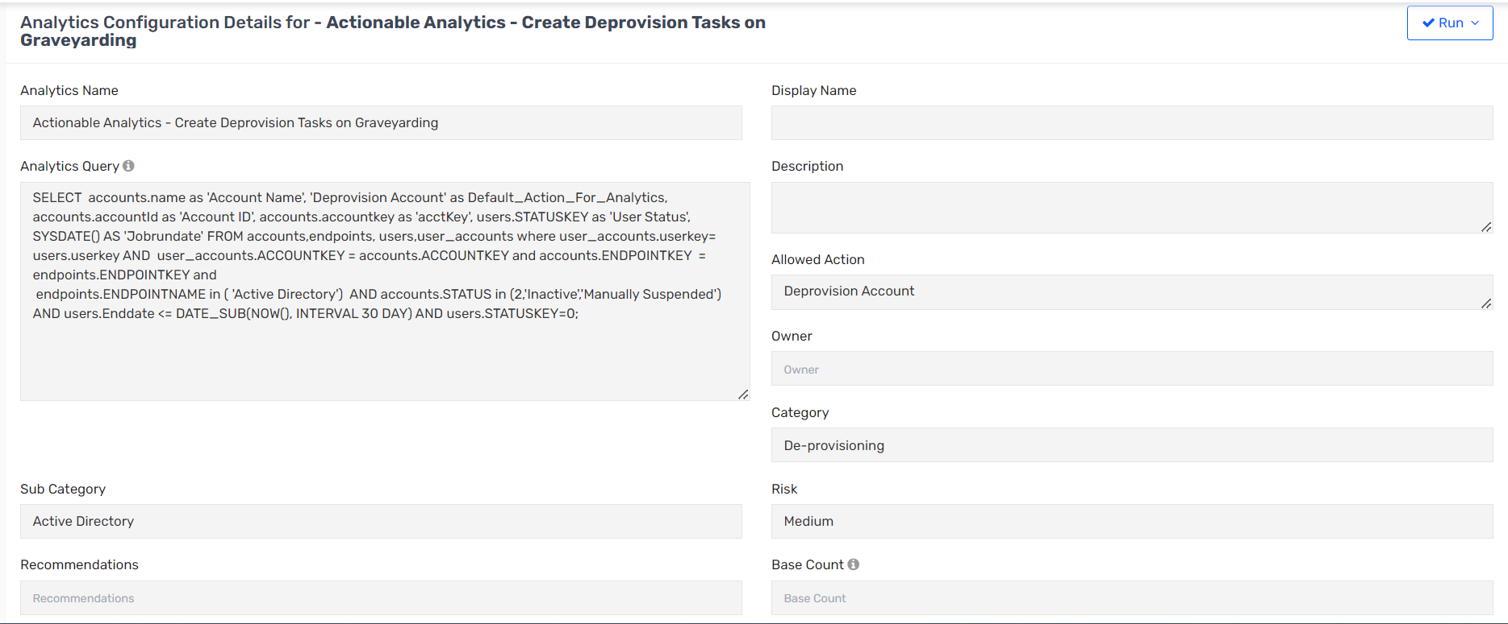 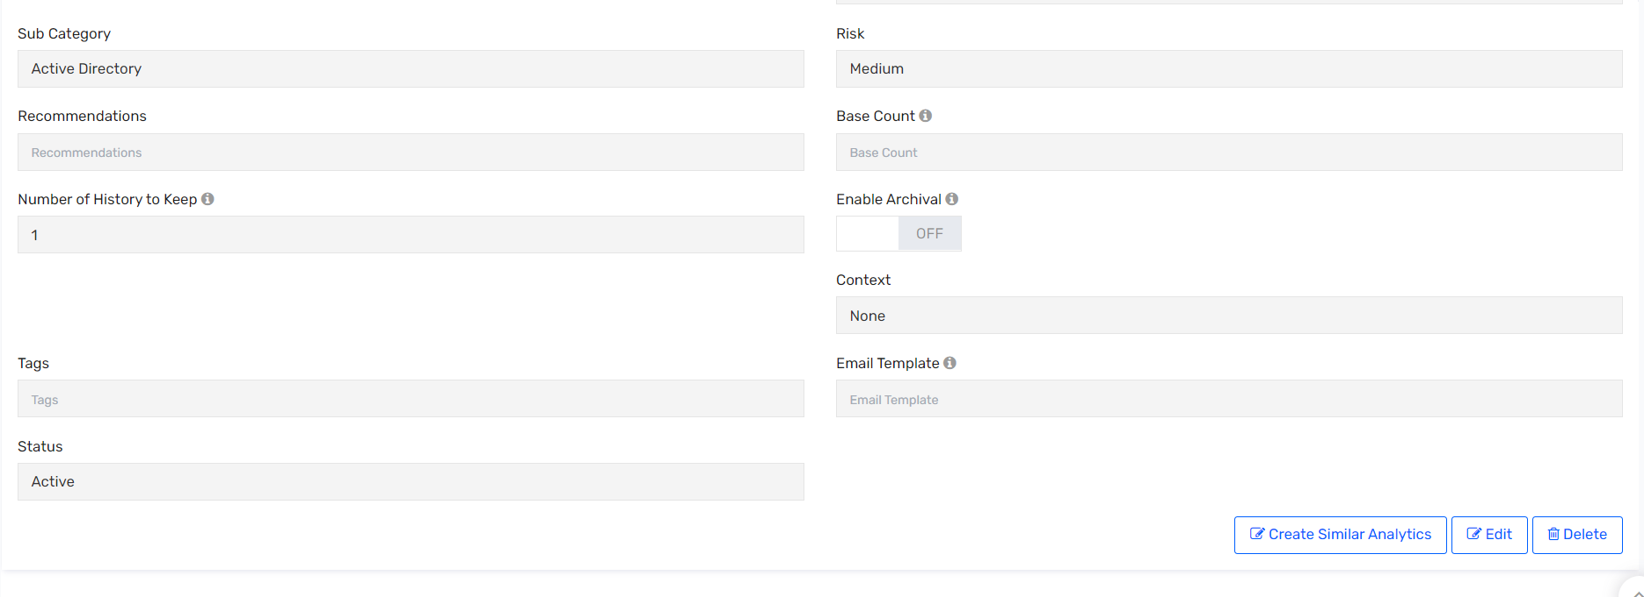

## Workday_Extended_Learner_Report

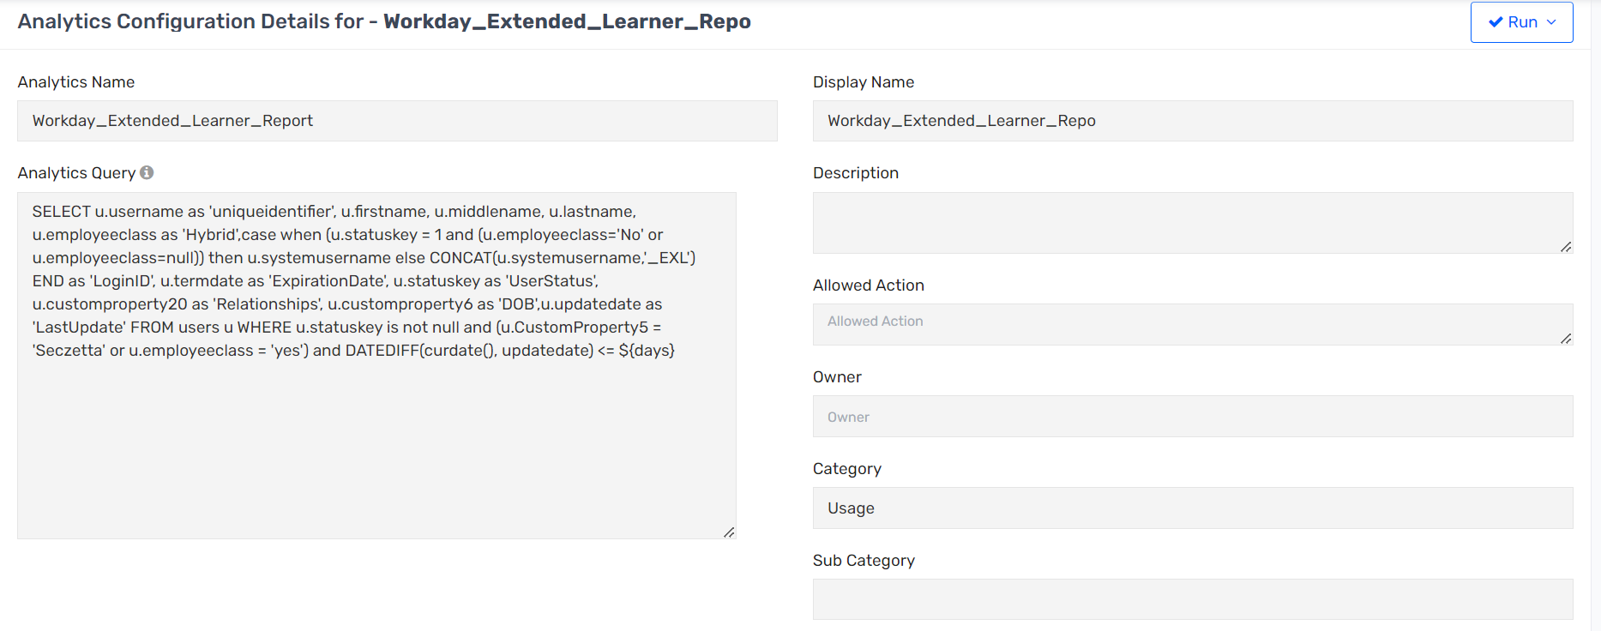

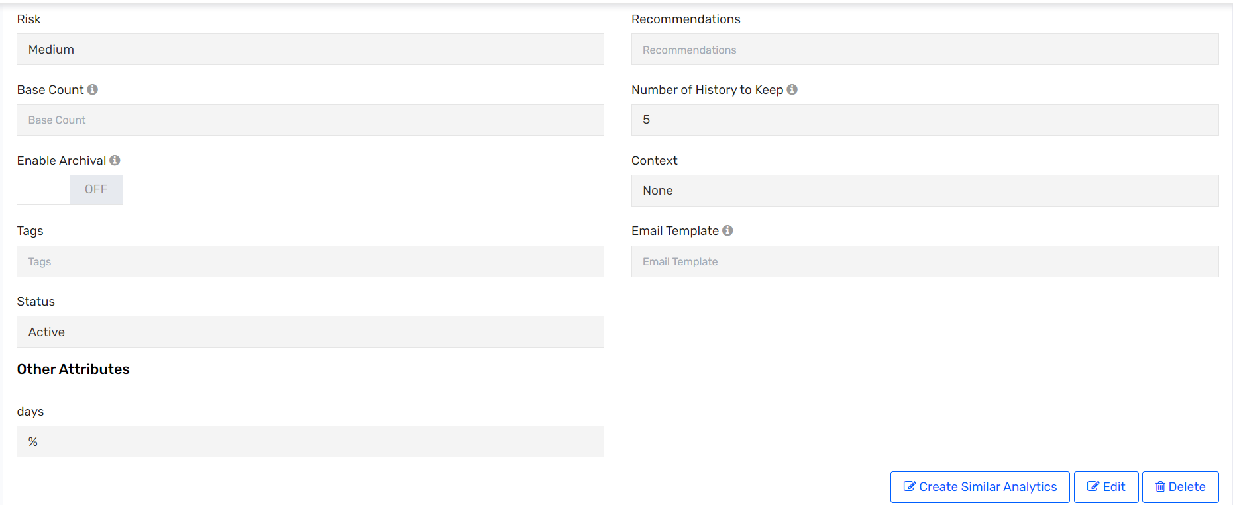

# Use Cases – High level Flow

### Create User – Workday

* Run the job – Workday_New_Hire_Import ( Refer JobControlPanel section )
* Job invokes workday RaaS report – Connection “Workday New Hire Import” ( Refer Connections)
* Pulls data and computes Systemusername , Alias and email
* Accounts created in AD, PSDB, DUO , Snow ( Refer Technical rules section)
* Login ID and email gets updated to Workday
* Send welcome email to user

The user is considered as PREHIRE only when start date is 7 days prior to actual start date.

PREHIRE - Only AD and ServiceNow will be provisioned when the user is received on Saviynt . When the user’s start date becomes current , PSDB and DUO account/access will be granteed .

HIRED – AD/PSDB/DUO/Snow will be provisioned

FUTURE HIRE - All the target accounts will be generated when the hire date becomes current.

### Update User : Workday

* Updates are received through the “All User RaaS Report” from Workday .
* Update account tasks will be created for AD , PSDB, ServiceNow

### Terminate User : Workday

* Updates are received through the “All User RaaS Report” from Workday.
* If the statuskey is inactive ,Termination Rule gets triggered ( Refer User UpdateRules section)
* User gets inactivated
* Roles gets removed from the user
* AD, PSDB , DUO and ServiceNow accounts get deprovisioned
* Update username to Workday based on employee type
* Termination email gets sent out

### Create User : Seczetta

* Seczetta calls the Saviynt API to create user on Saviynt
* Calls Validation.jar to generate systemusername and set term date for user
* User gets - AD , PSDB , DUO & ServiceNow accounts
* User gets PSDB enterprise role
* Send welcome email to User

### Update User : Seczetta

* Updates are received through API calls
* Update account tasks will be created for AD , PSDB, ServiceNow (Refer Technical Rules section)

### Terminate User : Seczetta

* Seczetta calls the Saviynt API to delete user on Saviynt
* Termination Rule gets triggered (Refer User Update Rules section )
* User gets inactivated
* Enterprise Roles gets removed from the user
* AD, PSDB , DUO and ServiceNow accounts get deprovisioned

### Rehire Scenario < 30 days : Workday

* Run the job – Workday_New_Hire_Import ( Refer JobControlPanel section )
* The user will retain the same systemusername and email address
* Enable account tasks will be created for AD , ServiceNow and PSDB
* New DUO account will be created

### Rehire Scenario < 30 days : SecZetta

* Seczetta calls the Saviynt API to update user on Saviynt
* The user will retain the same systemusername and email address
* Enable account tasks will be created for AD , ServiceNow and PSDB
* New DUO account will be created

### Rehire Scenario > 30 days : Workday

* Run the job – Workday_New_Hire_Import (Refer JobControlPanel section )
* New systemusername , email address and alias will be generated for the user
* Create new account in AD & DUO
* Enable account task will be created for ServiceNow and PSDB
* Update user task for workday to update systemusername
* Rehire email will be sent to user

### Rehire Scenario > 30 days : SecZetta

* Seczetta calls the Saviynt API to update user on Saviynt
* New systemusername will be generated for the user
* Create new account in AD & DUO
* Enable account task will be created for ServiceNow and PSDB
* Rehire email will be sent to user

### Hybrid Use Case : Workday user becomes Hybrid user ( with SecZetta Attributes)

* Update API call is made to a Workday user with Seczetta specific attributes ( relationship , CP58 etc) with hybrid flag as True ( EmployeeClass = Yes)
* Relationship specific roles get added for AD and PSDB
* Termdate gets calculated , no change is systemusername , email and alias

### Emergency Suspension

* Admin updates customproperty3 to “Suspend” from the UI
* Suspension rule gets triggered ( Refer to User update rules section)
* Update account tasks generated from AD and Azure O365 Revoke session
* Users is removed from AD groups
* User gets added to TEGS AD group

### Revoke Emergency Suspension

* Admin updates customproperty3 from “Suspend” to blank from the UI
* Revoke Suspension rule gets triggered ( Refer to User update rules section)
* Update account tasks generated for AD
* Users is added to the relevant AD groups
* User gets removed from the TEGS AD group

# General

## Copyright

The information transmitted in this document is intended only for the addressee and may contain confidential and/or privileged material. Any interception, review, retransmission, dissemination or other use of or taking of any action upon this information by persons or entities other than the intended recipient is prohibited by law and may subject them to criminal or civil liability.

Proprietary and Confidential Information shall include, but not be limited to, performance, sales, financial, contractual and special marketing information, ideas, technical data and concepts originated by the disclosing party, its subsidiaries and/or affiliates, not previously published or otherwise disclosed to the general public, not previously available without restriction to the receiving party or others, nor normally furnished to others without compensation, and which the disclosing party desires to protect against unrestricted disclosure or competitive use, and which is furnished pursuant to this document and appropriately identified as being proprietary when furnished.

Copyright © 2019 Saviynt Security, Inc. All rights reserved. The Saviynt Security logo is a registered trademark of Saviynt Security. All other products and company names mentioned herein are trademarks or registered trademarks of their respective owners.

## Version Control

| Saviynt Security Manager Implementation | |
| --- | --- |
| Client Name |  |
| Client Contact |  |
| Document Revision Number | 1.0 |
| Author(s) | Sanjana Nyamathi Vishwanathan |
| Peer Reviewer |  |
| QA Reviewer |  |
| Project Manager |  |
| Delivery Date | November 20, 2023 |
| Data Classification | Client Confidential |

# Document Acknowledgement

This section shall contain the following approving authorities to agree to the Requirement Specification deliverable and give their comments if any.

By signing this page, the [Shortname] Representatives agree that the Requirement and Assessment Specification deliverablestates the known risks, objectives, drivers and high-level functional requirements for the in-scope application and IAM program accurately.

***Project Sponsor/Manager***

**Signature:** _______________________________ **Date:** ___________________________

Comments (optional):

|  |  |
| --- | --- |
|  | |
|  |  |
|  | |
|  |  |
|  | |

***Additional Stakeholder (Optional)***

**Name:** __________________________________ **Title:** ___________________________

**Signature:** _______________________________ **Date:** ___________________________

Comments (optional):

|  |  |
| --- | --- |
|  | |
|  |  |
|  | |